Challenge

1. How many SMTP packets do you see? 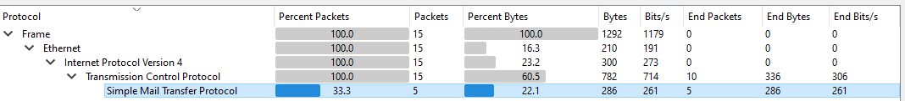

5 packets

1. Results? When you check and uncheck it shows first 6 bytes of a mac address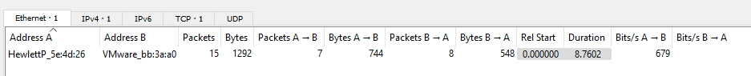
2. First tcp handshake. Packet numbers 1,2,3
3. IP address of host that started handshake? Text

   Description automatically generated
4. Client port? Text

   Description automatically generated
5. Wants to use smtp
6. 64Text, letter

   Description automatically generated
7. Cyan. The colors help identify traffic. Blue indivates chat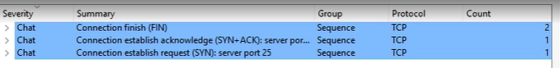
8. Window size is 29312. Indicates true value of window size Text, letter

   Description automatically generated
9. Table

   Description automatically generated