Abstract
Neonatal imitation is a cornerstone in many theoretical accounts of human development, social behavior and cultural change, yet its existence has been debated for the last 40 years. This review synthesizes effect sizes from 31 independent samples of human infants under 6 weeks of age, reported in 24 papers. The meta-analysis revealed that when studies are combined, there is evidence for neonatal imitation (d = 0.74, 95% CI = 0.44 to 1.03, p < .001). However this overall effect is called into question by publication bias analyses which indicate non-reporting or non-publication of null and negative results, t(454) = 13.56, p < .001. Extreme caution is warranted when interpreting the empirical literature on neonatal imitation and pre-registration of future studies is recommended.
Human newborns may not imitate after all: Meta-analysis indicates publication bias

The capacity to imitate is often placed at the foundation of human social interaction (e.g., Meltzoff, 2007; Nadel & Butterworth, 1999). We like people who imitate us and we imitate people whom we like (Chartrand & Bargh, 1999; Lakin et al., 2003). Children’s tendency to faithfully copy other people’s actions underpins cultural learning (Nielsen & Tomaselli, 2010; Whiten et al., 2009) and contributes to the enormous diversity of behavioral traditions observed across human groups (Legare & Nielsen, 2015). This tendency is not observed in the social learning of humans’ closest living great ape relatives, who tend to focus on emulating others’ instrumental outcomes rather than copying specific action sequences (Horner & Whiten, 2005). Imitation, therefore, is often put forward as a leading candidate in explaining the uniqueness of human social behavior and the extraordinary achievements of our cumulative culture (e.g., Boyd & Richerson, 1996; Henrich & McElreath, 2003; Legare & Nielsen, 2015; Tomasello, Kruger, & Ratner, 1993).
The ubiquity and significance of imitation in human social life prompts the question of whether the capacity to imitate is innate in our species. If newborns imitate, that would suggest that we are born with a neurological solution to the ‘correspondence problem’ of matching and coordinating one’s own motor behaviors with those of a model (Brass & Heyes, 2005). Some have suggested that mirror neurons provide us with that inborn solution (Lepage & Theoret, 2007; Meltzoff & Decety, 2003). The absence of neonatal imitation, on the other hand, implies that the capacity to imitate emerges later, perhaps as a product of both innate and environmental factors (Ray & Heyes, 2011; Jones, 2017). Forty years ago, a striking finding published in Science appeared to settle this question. In direct contradiction to dominant theories at the time (e.g., Piaget, 1962; Uzgiris & Hunt, 1975), Meltzoff and Moore (1977) reported that human infants could copy adults’ facial and manual gestures in the first weeks of life. This finding was followed by a similar result published in the same outlet five years later, suggesting that neonates could reliably imitate facial expressions even in their first few days (Field et al., 1982). Thus, it was generally concluded that human infants possess an inbuilt solution to the correspondence problem, namely, a pre-wired representational system that links their own actions with those of others (e.g., Meltzoff, 2007).
Neonatal imitation has been incorporated into influential theories of human development, social psychology and neuroscience. In developmental psychology, it is argued to form the basis of a lifelong capacity to reproduce others’ actions with high fidelity, which in turn supports the grand scale of human social learning and cultural evolution (Meltzoff & Moore, 1997; Nadel & Butterworth, 1999). In social psychology, neonatal imitation has been put forward as a precursor to ‘nonconscious mimicry’ (Cheng & Chartrand, 2003; Lakin et al., 2003), whereby adults imitate the actions of others even without awareness of having done so (e.g., Chartrand & Bargh, 1999; van Baaren et al., 2004). In the neurosciences, the phenomenon has become intricately associated with the existence and function of a mirror neuron system that is proposed to provide the neurological substrate for representing self-other equivalences (e.g., Gallese, 2001; Nagy & Molnar, 2004; Simpson, Paukner, Suomi, & Ferrari, 2014). Comparative psychological theories assume that neonatal imitation in non-human primates (e.g., Ferrari et al., 2006, 2009; Myowa-Yamakoshi, Tomonaga, Tanaka, & Matsuzawa, 2004) draws on the same neuronal and cognitive mechanisms as the human phenomenon (Simpson et al., 2014; Iacobini, 2009), even given the striking differences between the imitative styles of humans and primates (see Tennie, Call & Tomasello, 2009)). Indeed, neonatal imitation is a necessary component of some integrative theoretical proposals on social cognition and behaviour (e.g., Meltzoff & Decety, 2003; Trevarthen & Aitken, 2001).
However, even as this sensational phenomenon was being incorporated into many fields, the possibility was quietly raised that neonatal imitation might not, in fact, exist. Citing methodological and statistical concerns, commentaries by Anisfeld (1979), Masters (1979), and Jacobson and Kagan (1979) suggested that Meltzoff and Moore’s (1977) findings might be false positives. Several failures to replicate the phenomenon appeared in specialised outlets, but attracted far less attention (see, e.g., Koepke et al., 1983; McKenzie et al., 1983; each with fewer than 100 citations) than the original, striking results (combined, the two Science publications have accumulated nearly 5000 citations; Google Scholar, May 2017).
Thus, the initial positive findings may have been inordinately attributed with authoritative clout by most readers of the literature, including the authors of this review. Presuming its existence, we set out to test theories about neonatal imitation’s foundational role in human social development with the largest-ever longitudinal study (see Suddendorf, Oostenbroek, Nielsen, & Slaughter, 2013). To our surprise we found no evidence that 106 neonates imitated any of nine gestures at any of four timepoints between one and nine weeks of age (Oostenbroek et al., 2016). We therefore saw a need to examine carefully the existing empirical basis of neonatal imitation. To that end, this meta-analysis aims to answer two questions: (1) Is there an average overall effect for neonatal imitation in the literature? and (2) Is this effect genuine, or are there reasons to think it is an artefact of methodology, publication bias, or p-hacking?
Method
Systematic Search Method
We located studies through an online search (detailed in the Supplementary Material), an on-search of references to relevant papers, and direct solicitations for unpublished data. We discontinued our literature search in May 2016.

Inclusion Criteria
Studies were included as long as they (1) included data on imitation in neonates aged 6 weeks or younger, (2) included any gesture modelled by humans, (3) examined gestures in an imitation condition compared to gestures in a comparison condition, (4) used gestures produced by the infant as the unit of analysis, and (5) included sufficient information to allow an effect size to be calculated. See the Supplementary Material for more information.
Analyses
Comprehensive details of all statistical analyses are in the Supplementary Material.
Meta-analysis model. Effect sizes were converted using standard meta-analysis procedures (Borenstein et al., 2009; Lipsey & Wilson, 2001), with positive effects indicating the presence of imitation. Studies were allowed to contribute effect sizes for more than one gesture, and correlation between study results was accounted for using a multilevel meta-analysis model in the R metafor package (Viechtbauer, 2010).
Methodology moderators. We tested for four possible moderators of the size of the imitation effect: length of gesture presentation time, length of infant response time, comparison condition (baseline or active control), and whether imitation was measured during behavioral modelling (thus giving the experimenter an opportunity to respond to the neonate). Because tongue protrusion is the most commonly presented gestures in these studies and some have suggested that it functions differently to other gestures (Anisfeld, 1996; Jones, 1996; Keven & Akins, in press), we also conducted a separate meta-analysis of tongue protrusion imitation alone.
Publication bias. Meta-analyses are vulnerable to skewed results if studies with large effects and/or statistically significant results are published, and therefore accessed, at a higher rate than studies with smaller effects or null results (Sutton, Duval, Tweedie, Abrams, & Jones, 2000). A series of funnel plots and corresponding regression tests (Egger, Smith, Schneider, & Minder, 1997) assessed whether the effect sizes differed for small and large studies. We also tested for p-hacking using a procedure reported by Simonsohn, Nelson, & Simmons (2014).
Results
Description of Studies included in the Analysis
The final set of 24 papers eligible for the meta-analysis contained 31 independent samples and 326 effect sizes for all gestures (see the Supplementary Material for full systematic search results). Study characteristics are summarized in Table 1.

Table 1. Summary of Studies Included in the Neonatal Imitation Meta-analysis.
Study  Subgroup (if applicable) | Mean age (days) | Infant gestures | N
Anisfeld, Turkewitz, & Rose, 2001 | 2 | Tongue protrusion  Mouth opening | 83
Coulon, Hemimou, & Streri, 2013  Visual-only condition  Congruent condition  Incongruent condition (no data) | 2 | Mouth opening  Lip spreading | 12  12  12
Field et al., 1982 | 1 | Happy expression (wide lips)  Sad expression (pouting lips)  Surprised expression (wide open mouth) | 96
Field et al., 1983 | 1 | Happy expression (wide lips)  Sad expression (pouting lips)  Sad expression (furrowed brow)  Surprised expression (wide open mouth)  Surprised expression (widened eyes) | 74
Fontaine, 1984 | 30 | Tongue protrusion  Mouth opening  Cheek swelling  Eye closing  Hand opening  Index finger point | 83
Heimann & Schaller, 1985 | 18 | Tongue protrusion  Mouth opening | 11
Heimann, Nelson, & Schaller, 1989  Time 1  Time 2 | 3  21 | Tongue protrusion  Mouth opening | 23  24
Heimann, 1998 | 2 | Tongue protrusion  Mouth opening | 33
Kennedy-Costantini, 2017 (unpublished) | 8 | Tongue protrusion  Mouth opening | 48
Koepke, Hamm, & Legerstee, 1983 | 19 | Tongue protrusion  Mouth opening | 14
Legerstee, 1991 | 46 | Tongue protrusion  Mouth opening | 12
McKenzie & Over, 1983 | 23 | Tongue protrusion  Mouth opening  Arm raising  Hand to mouth | 14
Meltzoff & Moore, 1977  Experiment 1  Experiment 2 | 14  14 | Lip protrusion  Mouth opening  Tongue protrusion  Sequential finger movement  Mouth opening | 6  12
Meltzoff & Moore, 1983 | 1 | Tongue protrusion  Mouth opening | 40
Meltzoff & Moore, 1989 | 2 | Tongue protrusion  Head movement | 40
Meltzoff & Moore, 1992 | 43 | Tongue protrusion  Mouth opening | 32
Meltzoff & Moore, 1994 | 42 | Tongue protrusion  Mouth opening | 40
Nagy et al., 2007 | 2 | Hand movement  Finger movement | 41
Nagy, Pal, & Orvos, 2014  Left condition  Right condition  Both condition | 2  2  2 | Index finger point | 37  43  41
Oostenbroek et al., 2016  1 week old  3 weeks old  6 weeks old | 7  21  42 | Tongue protrusion  Mouth opening  Happy face  Sad face  Index finger point  Grasp  MMM sound  EEE sound  Tongue click | 74  80  83
Reissland, 1988 | 1 | Wide lips  Pursed lips | 12
Sho et al, 2014 (unpublished) | 0.7 | Tongue protrusion  Mouth opening | 136
Soussignan et al., 2011 | 2 | Tongue protrusion | 18
Ullstadius, 1998 | 1 | Tongue protrusion  Mouth opening | 14

Meta-Analysis Results
Primary meta-analysis, all gestures. The multilevel meta-analysis of neonatal imitation across all gestures revealed that, when all studies were combined, infants produced the target gesture more to the model than to the comparison, and this effect was statistically significant (d = 0.74, 95% CI = 0.44 to 1.03, p < .001, σ²₁ = 0.39, σ²₂ = 0.16, I² = 65.96%). Figure 1 presents the meta-analysis results in a forest plot, with one estimate per independent sample.

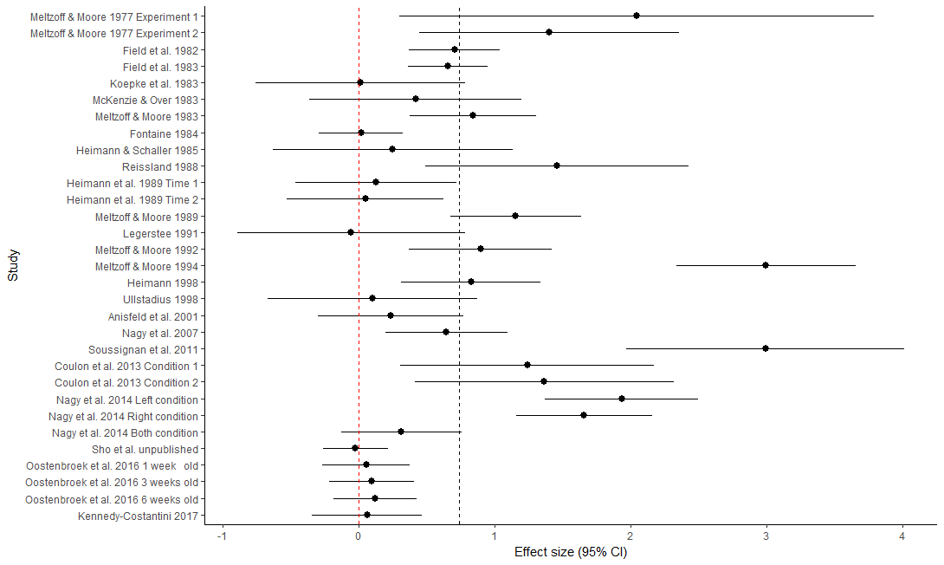
Figure 1. Forest plot of imitation studies showing one estimate per study. The red dotted line indicates a zero effect; the black dotted line indicates the overall estimated effect.

Tongue protrusion only. The multilevel meta-analysis of neonatal imitation of tongue protrusion included a total of 63 effect sizes. Neonates produced more tongue protrusions in response to a tongue protrusion model than in response to other models (d = 0.86, 95% CI = 0.32 to 1.41, p = .002, σ²₁ = 1.30, σ²₂ = 0.00). See Supplementary Materials for more details.

Moderator Analyses
Moderators of neonatal imitation. Our meta-analysis revealed that, across the included studies, the methodological variations we accounted for had no impact on the overall neonatal imitation effect (see Table 2).

Table 2. Summary of the Impact of Methodological Variations.
Methodological variation | Meta-regression result
Length of time given for the infant to observe the behavioural model | b = 0.01, se = 0.01, p = .451
Length of time given for the infant to respond | b < 0.01, se = 0.01, p = .571
Model presented at the same time as response | b = 0.15, se = 0.13, p = .257
Baseline control or active control | b = -0.04, se = 0.13, p = .733
Setting of the data collection | Home: b = 0.16, se = 0.85, p = .852  Hospital: b = 0.99, se = 0.78, p = .202  University: b = 0.81, se = 0.84, p = .329  Not reported: b = 0.95, se = 0.81, p = .245  Several settings: b = 0.04, se = 1.05, p = .969  Total effect: QM(5) = 5.40, p = .369
Who delivered the behavioural model | Experimenter: b = 0.76, se = 0.72, p = .291  Mother: b = 0.21, se = 0.87, p = .246  Video: b = 3.16, se = 1.12, p = .005  Multiple: b = 0.89, se = 1.00, p = .375  Not reported: b = 0.87, se = 1.00, p = .383  Total effect: QM(5) = 9.93, p = .077
Total exposure time | b < -0.01, se = 0.01, p = .970
Total response time | b < -0.01, se < 0.01, p = .310
Trials-to-criterion | b = -0.07, se = 0.38, p = .845
How infant alertness was measured | Behavioural criterion: b = 0.86, se = 0.91, p = .342  Experimenter judgement: b = 0.49, se = 0.76, p = .519  Looking time: b = 1.35, se = 0.82, p = .098  Not reported: b = 0.98, se = 0.78, p = .211  Total effect: QM(4) = 5.80, p = .217
Statistical methods | Total effect: QM(12) = 18.20, p= .111
Participant attrition | b = 0.11, se = 0.40, p = .772

Publication Biases
Our combined tests revealed patterns matching those that would be expected in a literature that has been affected by publication bias, selective reporting, or other biases.
Funnel plot. The tests revealed significant asymmetry, such that studies with larger variances reported larger effect sizes, b = 2.50, se = 0.48, QM(1) = 27.15, p < .001, although there was still significant heterogeneity, QE(324) = 27.15, p < .001. A visual inspection of the funnel plot (Figure 2) reveals the expected pattern of variance compared to precision for the majority of effect estimates, with a relatively symmetrical distribution. Notably, however, the plot shows several smaller studies (with greater standard errors) that exhibit large positive effect sizes and no corresponding smaller studies that show null or negative effect sizes. This pattern is characteristic of a literature in which smaller studies have been conducted, found no evidence of neonatal imitation, and then were not published. Figure 2 also shows that the original and most highly cited study to date (Meltzoff & Moore, 1977) reported exceptionally large effects (indicated in red on Figure 2), which were rarely replicated by later investigations. Experimental and statistical methods have substantially improved since that study was conducted, and there has been a corresponding reduction in the proportion of significant effects obtained.

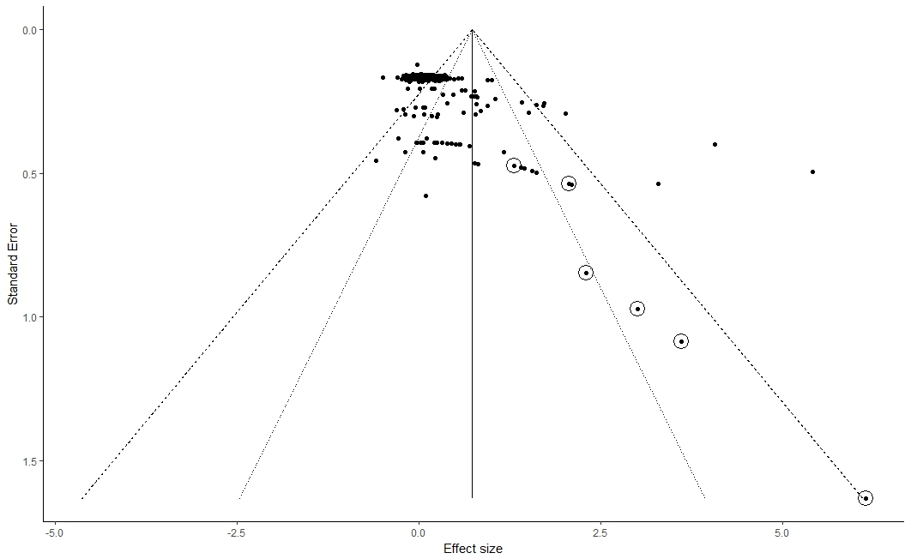
Figure 2. Funnel plot for all reported effect sizes of neonatal imitation of all gestures, showing significant asymmetry. Dotted lines show the 95% and 99% confidence intervals for the funnel plot. The vertical line shows the estimated overall effect size from the meta-analysis. The six effects reported in the original study (Meltzoff & Moore, 1977) are circled (note: within the circle containing two effects, one comes from a different publication).

P-curves. “P-hacking”, or conducting multiple analyses on the same data until a statistically significant effect is revealed, may be identified through examination of simulated p curves constructed from the corpus of published data. Our investigations found no evidence of p-hacking in the neonatal imitation literature (see Supplementary Material). Together with the funnel plot analyses, these results suggest the presence of bias in the literature that is likely to be a result of null and negative studies being suppressed, and not likely to be a result of bias within individual studies.
Discussion
Our systematic review found that (1) there is an average overall effect for neonatal imitation in the literature, but (2) this effect is likely to be an artefact of publication bias, especially suppression of null or negative results. The widely accepted phenomenon of neonatal imitation, and the influential theories based on it, must now be placed in further doubt (cf. Oostenbroek et al., 2016).
We do not suggest that research is being conducted in an unscientific or unethical manner – indeed, our analysis uncovered no evidence of p-hacking. Furthermore, post-hoc statistical methods for assessing publication bias in meta-analysis can only indicate correlational evidence; they cannot establish causality or any proof of bias. We do, however, propose that publication bias may be a natural outcome of conditions like those observed in the study of neonatal imitation, which we discuss next.
Logistical constraints on studies with infants mean that the samples are necessarily small. Adding to that, a certain number of false positives would be expected in an experimental paradigm such as the one typically used in these studies, where infants’ gestures are counted and sorted into two categories: match and mismatch. Given the pressures within academic publishing to find and report only “interesting” research, it is expected that chance positive findings will take precedence in the published literature while null or negative findings are sidelined (Rothstein et al., 2006).
Another consideration is the large researcher degrees of freedom available in neonatal imitation studies (see Gelman & Loken, 2013; Ioannidis, 2005). For example, while the target gesture is usually a carefully defined behaviour, the method of measuring it varies widely. Different studies report raw frequencies of the gesture (e.g., Fontaine, 1984), mean frequencies (e.g., Oostenbroek et al., 2016; Ullstadius, 1998), mean rates per minute (e.g., Legerstee, 1991), duration (e.g., McKenzie & Over, 1983), or number of matches and mismatches (e.g., Abranavel & Sigafoos, 1984). Recent advances in our understanding of the susceptibility of psychological studies to Type I error under conditions of statistical ambiguity suggest that these sorts of variations may be just as problematic as variations in experimental procedures (Simonsohn et al., 2014).
These features – small samples, research designs that simplify complex behaviours, and unstandardized analytical procedures – are not unique to neonatal imitation. Researchers investigating psychological phenomena that share these characteristics should pay close attention to the possibility of false positives and suppression of null results.
No Evidence that Non-Replication is Due to Study-Level Moderators
Asymmetric funnel plots are not necessarily due to publication bias (Sterne, Egger, & Moher, 2011; Renkewitz, Fuchs, & Fiedler, 2011). A plausible alternative explanation for results like ours could be true heterogeneity among the study results, introduced by some moderating variable. Our moderator analyses, however, found that reported effect sizes did not depend on the length of time that was allocated for presentation of the gesture, length of time that was allowed for the infant to respond, the type of control condition, or whether infant responses were measured at the same time as the model presented the gesture. These findings suggest that these methodological variations are not responsible for the failure of some studies to replicate findings on neonatal imitation.
Conclusions
In summary, our meta-analysis uncovered evidence of potential publication bias in the neonatal imitation literature, and therefore the overall effect must be interpreted with extreme caution. In addition to the problem of publication bias that currently plagues the field of psychology (Open Science Collaboration, 2015; Rosenthal, 1979), the case of neonatal imitation may have been affected by additional biases. Unlike many novel psychological effects, early evidence for the phenomenon appeared in Science (Field et al., 1982; Meltzoff & Moore, 1977), which may have branded the findings as definitive. One may also argue that the idea of neonatal imitation appeals to a human tendency to attribute newborns with characteristics that we cherish as adults (cf. Haith, 1998) or that its presence at birth evinces our uniquely cooperative human nature (cf. Heinrich, 2015). Alternative accounts, on the other hand, which emphasize the importance of associative learning (Ray & Heyes, 2011) or a combination of innate and environmental factors (e.g., Jones, 2017), may be seen to ‘steal the soul’ of imitation (Heyes, 2016).
We could not conclude, based on the null findings of our comprehensive longitudinal study (Oostenbroek, et al., 2016), that neonates do not imitate. However, when considered alongside the current analyses of the wider available evidence, that is presently the most plausible conclusion. The nature of science makes it impossible to prove such a negative; somewhat self-defeatingly, this means that positive results will always come to the forefront of a discipline’s consciousness. To guard against this bias, we reaffirm the need for timely and independent replication, ideally in well-controlled pre-registered studies, of apparently ground-breaking psychological effects (e.g., Nosek et al., 2015; Simons, 2014; Lindsay, 2015). Failing to implement this suggestion will lead to further clouding of the literature with empirically questionable claims.
References
Studies used in the meta-analysis are marked with *
Abranavel, E., & Sigafoos, A. D. (1984). Exploring the presence of imitation during early infancy. Child Development, 55(2), 381-392.
Anisfeld, M. (1979). Interpreting “imitative” responses in early infancy. Science, 205(4402), 214-215.
Anisfeld, M. (1996). Only tongue protrusion modelling is matched by neonates. Developmental Review, 16(2), 149-161.
* Anisfeld, M., Turkewitz, G., & Rose, S. A. (2001). No compelling evidence that newborns imitate oral gestures. Infancy, 2(1), 111-122.
Borenstein, M., Hedges, L. V., Higgins, J. P. T., & Rothstein, H. R. (2009). Introduction to meta-analysis. Chichester, UK: John Wiley & Sons.
Boyd, R., & Richerson, P. J. Why culture is common, but cultural evolution is rare. Proceedings of the British Academy, 88(1), 77-93.
Brass, M., & Heyes, C. (2005). Imitation: Is cognitive neuroscience solving the correspondence problem?. Trends in Cognitive Sciences, 9(10), 489-495.
Chartrand, T. L., & Bargh, J. A. (1999). The chameleon effect: The perception-behavior link and social interaction. Journal of Personality and Social Psychology, 76(6), 893-910.
Cheng, C. M., & Chartrand, T. L. (2003). Self-monitoring without awareness: Using mimicry as a nonconscious affiliation strategy. Journal of Personality and Social Psychology, 85(6), 1170-1179.
* Coulon, M., Hemimou, C., & Streri, A. (2013). Effects of seeing and hearing vowels on neonatal facial imitation. Infancy, 18(5), 782-796.
Egger, M., Smith, G. D., Schneider, M., & Minder, C. (1997). Bias in meta-analysis detected by a simple, graphical test. BMJ, 315(7109), 629-634.
Ferrari, P. F., Visalberghi, E., Paukner, A., Fogassi, L., Ruggiero, A., et al., (2006). Neonatal imitation in rhesus macaques. PLoS Biology, 4(9), e302.
Ferrari, P. F., Paukner, A., Ruggiero, A., Darcey, L., Unbehagen, S., & Suomi, S. J. (2009). Interindividual differences in neonatal imitation and the development of action chains in rhesus macaques. Child Development, 80(4), 1057-1068.
* Field, T. M., Woodson, R., Cohen, D., Greenberg, R., Garcia, R., & Collins, K. (1983). Discrimination and imitation of facial expressions by term and preterm neonates. Infant Behavior and Development, 6(4), 485-489.
* Field, T. M., Woodson, R., Greenberg, R., & Cohen, D. (1982). Discrimination and imitation of facial expressions neonates. Science, 218(4568), 179-181.
* Fontaine, R. (1984). Imitative skills between birth and six months. Infant Behavior and Development, 7(3), 323-333.
Gallese, V. (2001). The ‘shared manifold’ hypothesis: From mirror neurons to empathy. Journal of Consciousness Studies, 8(5-6), 33-50.
Gelman, A., & Loken, E. (2013). The garden of forking paths: Why multiple comparisons can be a problem, even when there is no “fishing expedition” or “p-hacking” and the research hypothesis was posited ahead of time. Department of Statistics, Columbia University.
Haith, M. M. (1998). Who put the cog in infant cognition? Is rich interpretation too costly?. Infant Behavior and Development, 21(2), 167-179.
* Heimann, M., & Schaller, J. (1985). Imitative reactions among 14-21 day old infants. Infant Mental Health Journal, 6(1), 31-39.
* Heimann, M., Nelson, K. E., & Schaller, J. (1989). Neonatal imitation of tongue protrusion and mouth opening: Methodological aspects and evidence of early individual differences. Scandinavian Journal of Psychology, 30(2), 90-101.
* Heimann, M. (1998). The story of neonatal imitation: New facts and old conclusions. Infant Behavior and Development, 21(Supplement), 454.
Henrich, J. (2015). Culture and social behaviour. Current Opinion in Behavioral Sciences, 3, 84–89
Henrich, J., & McElreath, R. (2003). The evolution of cultural evolution. Evolutionary Anthropology: Issues, News, and Reviews, 12(3), 123-135.
Heyes, C. (2016). Homo imitans? Seven reasons why imitation couldn't possibly be associative. Philosophical Transactions of the Royal Society B: Biological Sciences, 371(1686), 20150069.
Horner, V., & Whiten, A. (2005). Causal knowledge and imitation/emulation switching in chimpanzees (Pan troglodytes) and children (Homo sapiens). Animal Cognition, 8(3), 164-181.
Iacobini, M. (2009). Imitation, empathy, and mirror neurons. Annual Review of Psychology, 60, 653-670.
Ioannidis, J. P. A. (2005). Why most published research findings are false. PLoS Medicine, 2(8), e124.
Jacobson, S. W., & Kagan, J. (1979). Interpreting “imitative” responses in early infancy. Science, 205(4402), 215-217.
Jones, S. S. (1996). Imitation or exploration? Young infants' matching of adults' oral gestures. Child Development, 67(5), 1952-1969.
Jones, S. S. (2017). Can newborn infants imitate? Wiley Interdisciplinary Reviews: Cognitive Science, 8(1-2), e1410.
* Kennedy-Costantini, S. (2017). Very early social learning within the context of the mother-baby relationship. University of Queensland: Unpublished PhD dissertation.
Keven, N., & Akins, K. (in press). Neonatal imitation in context : Sensory-motor development in the perinatal period. Behavioral and Brain Sciences, Behavioral and Brain Sciences. doi:10.1017/S0140525X16000911.
* Koepke, J. E., Hamm, M., & Legerstee, M. (1983). Neonatal imitation: Two failures to replicate. Infant Behavior and Development, 6(1), 97-102.
Lakin, J. L., Jefferis, V. E., Cheng, C. M., & Chartrand, T. L. (2003). The chameleon effect as social glue: Evidence for the evolutionary significance of nonconscious mimicry. Journal of Nonverbal Behavior, 27(3), 145-162.
Legare, C. H., & Nielsen, M. (2015). Imitation and innovation: The dual engines of cultural learning. Trends in Cognitive Sciences, 19(11), 688-699.
* Legerstee, M. (1991). The role of person and object in eliciting early imitation. Journal of Experimental Child Psychology, 51(3), 423-433.
Lepage, J. F., & Théoret, H. (2007). The mirror neuron system: Grasping others’ actions from birth?. Developmental Science, 10(5), 513-523.
Lindsay, D. S. (2015). Replication in Psychological Science. Psychological Science, 26(12), 1827-1832.
Lipsey, M. W., & Wilson, D. B. (2001). Practical meta-analysis (Vol. 49). Thousand Oaks, CA: Sage Publications.
Masters, J. C. (1979). Interpreting “imitative” responses in early infancy. Science, 205(4402), 215.
* McKenzie, B., & Over, R. (1983). Young infants fail to imitate facial and manual gestures. Infant Behavior and Development, 6(1), 85-95.
Meltzoff, A. N. (2007). ‘Like me’: A foundation for social cognition. Developmental Science, 10(1), 126-134.
Meltzoff, A. N., & Decety, J. (2003). What imitation tells us about social cognition: A rapprochement between developmental psychology and cognitive neuroscience. Philosophical Transactions of the Royal Society of London B: Biological Sciences, 358(1431), 491-500.
* Meltzoff, A. N. & Moore, M. K. (1977). Imitation of facial and manual gestures by human neonates. Science, 198(4312), 75-78.
* Meltzoff, A. N. & Moore, M. K. (1983). Newborn infants imitate adult facial guestures. Child Development, 54(3), 702-709.
* Meltzoff, A. N., & Moore, M. K. (1989). Imitation in newborn infants: Exploring the range of gestures imitated and the underlying mechanisms. Developmental Psychology, 25(6), 954-962
* Meltzoff, A. N. & Moore, M. K. (1992). Early imitation within a functional framework: The importance of person identity, movement, and development. Infant Behavior and Development, 15(4), 479-505.
* Meltzoff, A. N. & Moore, M. K. (1994). Imitation, memory, and the representation of persons. Infant Behavior and Development, 17(1), 83-99.
Myowa-Yamakoshi, M., Tomonaga, M., Tanaka, M., & Matsuzawa, T. (2004). Imitation in neonatal chimpanzees (Pan troglodytes). Developmental Science, 7(4), 437-442.
Nadel, J., & Butterworth, G. (1999). Imitation in infancy. Cambridge: Cambridge University Press.
Nagy, E., & Molnar, P. (2004). Homo imitans or homo provocans? Human imprinting model of neonatal imitation. Infant Behavior & Development, 27(1), 54-63.
* Nagy, E., Kompagne, H., Orvos, H., & Pal, A. (2007). Gender-related differences in neonatal imitation. Infant and Child Development, 16(3), 267-276.
* Nagy, E., Pal., A., & Orvos, H. (2014). Learning to imitate individual finger movements by the human neonate. Developmental Science, 17(6), 841-857.
Nielsen, M., & Tomaselli, K. (2010). Overimitation in Kalahari Bushman children and the origins of human cultural cognition. Psychological Science, 21(5), 729-736.
Nosek, B. A., Alter, G., Banks, G. C., Borsboom, D., Bowman, S. D., Breckler, S. J., ... & Contestabile, M. (2015). Promoting an open research culture. Science, 348(6242), 1422-1425.
* Oostenbroek, J., Suddendorf, T., Nielsen, M., Redshaw, J., Kennedy-Costantini, S., Davis, J., Clark, S., & Slaughter, V. (2016). Comprehensive longitudinal study challenges the existence of neonatal imitation in humans. Current Biology, 26(10), 1334-1338.
Open Science Collaboration (2015). Estimating the reproducibility of psychological science. Science, 349(6251), aac4716.
Piaget, J. (1962). Play, dreams and imitation in childhood. New York: Norton.
Ray, E., & Heyes, C. (2011). Imitation in infancy: The wealth of the stimulus. Developmental Science, 14(1), 92-105.
* Reissland, N. (1988). Neonatal imitation in the first hour of life: Observations in rural Nepal. Developmental Psychology, 24(4), 464-489.
Renkewitz, F., Fuchs, H. M., & Fiedler, S. (2011). Is there evidence of publication biases in JDM research? Judgement and Decision Making, 6(6), 870-881.
Rizzolatti, G., Fogassi, L., & Gallese, V. (2001). Neurophysiological mechanisms underlying the understanding and imitation of action. Nature Reviews Neuroscience, 2(9), 661-670.
Rothstein, H. R., Sutton, A. J., & Borenstein, M. (Eds.). (2006). Publication bias in meta-analysis: Prevention, assessment and adjustments. Hoboken, NJ: John Wiley & Sons.
Rosenthal, R. (1979). The file drawer problem and tolerance for null results. Psychological Bulletin, 86(3), 638-641.
* Sho, S-E., Tint, M. T., Gluckman, P. D., Godfrey, K. M., Rifkin-Graboi, A., Chan, Y. H., Stünkel, W., Holbrook, J. D., Kewk, K., Chong, Y-S., Saw, S. M., The GUSTO Study Group. (2014). Growing up in Singapore towards healthy outcomes (GUSTO) birth cohort study. The GUSTO Study Group: Unpublished data set.
Simons, D. J. (2014). The value of direct replication. Perspectives on Psychological Science, 9(1), 76-80.
Simonsohn, U., Nelson, L. D., & Simmons, J. P. (2014). P-curve: A key to the file-drawer. Journal of Experimental Psychology: General, 143(2), 534-547.
Simpson, E. A., Paukner, A., Suomi, S. J., & Ferrari, P. F. (2014). Visual attention during neonatal imitation in newborn macaque monkeys. Developmental Psychobiology, 56(4), 864-870.
* Soussignan, R., Courtial, A., Canet, P., Danon-Apter, G., & Nadel, J. (2011). Human newborns match tongue protrusion of disembodied human and robotic mouths. Developmental Science, 14(2), 385-394.
Sterne, J. A. C., Egger, M., & Moher, D. (Eds.) (2011). Chapter 10: Addressing reporting biases. In Higgins, J. P T. & Green, S. (Eds.) Cochrane Handbook for Systematic Reviews of Interventions. Version 5.1.0 (updated March 2011), The Cochrane Collaboration.
Suddendorf, T., Oostenbroek, J., Nielsen, M., & Slaughter, V.P. (2013). Is newborn imitation developmentally homologous to later social-cognitive developments? Developmental Psychobiology, 55, 52-58.
Sutton, A. J., Duval, S. J., Tweedie, R. L., Abrams, K. R., & Jones, D. R. (2000). Empirical assessment of effect of publication bias on meta-analyses. BMJ, 320(7249), 1574-1577.
Tennie, C., Call, J., * Tomasello M (2009) Ratcheting Up the ratchet: On the evolution of cumulative culture. Philosophical Transactions of the Royal Society of London B: Biological Sciences, 364, 2405–2415.
Tomasello, M., Kruger, A. C., & Ratner, H. H. (1993). Cultural learning. Behavioral and Brain Sciences, 16(3), 495-552.
Trevarthen, C., & Aitken, K. J. (2001). Infant intersubjectivity: Research, theory, and clinical applications. The Journal of Child Psychology and Psychiatry, 42(1), 3-48.
* Ullstadius, E. (1998). Neonatal imitation in a mother-infant setting. Early Development and Parenting, 7(1), 1-8.
Uzgiris, I. C., & Hunt, J. M. (1975). Assessment in infancy: Ordinal scales of psychological development. Urbana, IL: University of Illinois Press.
van Baaren, R. B., Holland, R. W., Kawakami, K., & Van Knippenberg, A. (2004). Mimicry and prosocial behavior. Psychological Science, 15(1), 71-74.
Viechtbauer, W. (2010). Conducting meta-analyses in R with the metafor package. Journal of Statistical Software, 36(3), 1-48.
Whiten, A., McGuigan, N., Marshall-Pescini, S., & Hopper, L. M. (2009). Emulation, imitation, over-imitation and the scope of culture for child and chimpanzee. Philosophical Transactions of the Royal Society of London B: Biological Sciences, 364(1528), 2417-2428.

