Project Sprint #1

The Solitaire game is described in CS449HomeworkOverview. You should read the description very carefully.

Git Hub Link: https://github.com/jtmelookaran-umkc/CS449_Spring2026

In this assignment, you aim to specify the requirements (i.e., user stories and acceptance criteria) of the target software that allows a human player to play a Solitaire game. These requirements will be fully implemented by the end of sprint 3. The minimum features include choosing the board size and type, starting a new game, making a move, determining if a game is over. The following is a sample GUI layout.



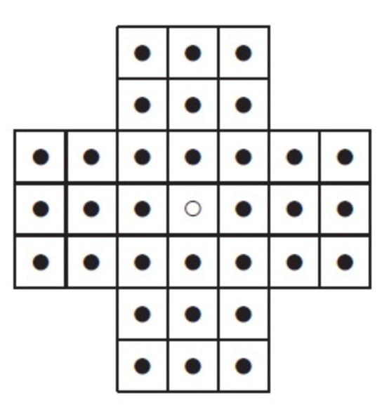

Board size

Board Type

English

Hexagon

Diamond

New Game

7

ID | User Story Name | User Story Description | Priority | Estimated effort (hours)
1 | Choose a board size | As a player, I need to be able to choose the size of the game board so that I can play a solitaire game that changes in difficulty | High | 2
2 | Choose the board type | As a player, I would like to be able to select between Hexagon, Diamond, and English as different types of boards | High | 2
3 | Start a new game of the chosen board size and type | As a player, I would like to start a new game with the chosen board size and type in order to control the settings of the game as a user | High | 2
4 | Make move in a game (LLM) | As a player, I want to select a peg and jump it over an adjacent peg into an empty hole so that I can remove pegs and progress through the game. | High | 4
5 | Finish the game(LLM) | As a player, I want the game to automatically detect when no more valid moves are available so that I know when the game has ended and whether I won or lost. | High | 3
Figure 1. Sample GUI layout of the first working program by the end of Sprint 3

Use the following tables to document your user stories and acceptance criteria.

You are required to use the free ChatGPT or another LLM to complete two user stories and two of their respective acceptance criteria. You must ensure that the generated user stories are correct and fix them if not. At the end of the submission, provide screenshots of your LLM prompts and answers, along with the description of errors the LLM made that you had to correct. Points will be deducted if no screenshots/description are provided.

For the other user stories and acceptance criteria, you are not required to use LLM.

Acceptance Criteria (AC) (12 points): Add/delete rows as needed.

User Story ID and Name | AC ID | Description of Acceptance Criterion | Status (completed, toDo, inPprogress)
1. Choose a board size | 1.1 | AC 1.1 Correct board size entered  Given the player has started the program  When the player enters a valid board size in the respective box  Then the board size field will subsequently be altered and be ready to use in the ensuing game | toDo
 | 1.2 | AC 1.2 Wrong board size used  Given the player has started the program  When the player enters an invalid or incorrect value for the board size  Then the user will be prompted by an error message and reason for the input being incorrect | toDo
 | …
2. Choose the board type | 2.1 | AC 2.1 Player selects board type  Given the player has started the program  When the players selects one of the possible board types (English, Hexagon, or Diamond)  Then the respective board will be used when the new game starts | toDo
 | 2.2 | AC 2.2 Default board  Given the program has been started  When the interface is displayed while the game starts  Then the default mode for the game will be English if nothing is changed | toDo
3.Start a new  game | 3.1 | Starting a new game in the middle  Given the player has been playing and is in the middle of a game  When the player clicks new game  Then the current game is ended and a new board is displayed for the new game | toDo
 | 3.2 | Starting a game with chosen settings  Given the player has a selected a particular board type and size  When they have clicked start  Then the board will be populated and ready to play | toDo
4.Make a move(LLM) | 4.1 | Valid move execution —  Given a game is in progress, when the player selects a peg and jumps it over an adjacent peg into a valid empty hole, then the jumping peg moves to the empty hole, the jumped-over peg is removed, and the board updates accordingly. | toDo
 | 4.2 | Invalid move rejected — Given a game is in progress, when the player attempts a move where there is no adjacent peg to jump over or no empty landing hole, then the move is rejected and the board remains unchanged, with a visual or textual indication that the move is invalid. | toDo
 | 4.3 | Move direction constraint — Given a game is in progress, when the player attempts a diagonal move on an English or Diamond board, then the move is rejected since only horizontal and vertical jumps are permitted on those board types. | toDo
Finish the Game (LLM) | 5.1 | Win condition detected — Given a game is in progress, when the player makes a move that results in exactly one peg remaining on the board, then the game displays a win message and no further moves are accepted. | toDo
 | 5.2 | Loss condition detected — Given a game is in progress, when after any move there are no remaining valid jumps possible for any peg on the board, then the game displays a loss or "no moves remaining" message and the game ends. | toDo
 | 5.3 | Game over state locks input — Given the game has ended (win or loss), when the player attempts to select or move any peg, then no action is taken and the board remains in its final state until the player starts a new game. | toDo

