Preventing Silent Errors in Clinical Data Analysis Before the Code Runs: Design and Evaluation of a Novel Data Analysis Framework

Abstract

Objective
Mistakes in clinical and translational research data analytics are common, often challenging to identify, and lead to inaccurate research outputs. Developing means to minimize these errors is an established priority for clinical research. We designed and evaluated Tidy-TS, a TypeScript data analysis framework, to address this gap.

Materials and Methods
Tidy-TS was developed to closely track how data is expected to change throughout a data analysis workflow. Prior to executing code, it clearly identifies suspect data operations and instances where missing or undefined values may have been introduced yet are not addressed. We evaluated this framework against standard Python (pandas) and R (tidyverse) workflows using 65 reproducible error scenarios across five common error categories. For external validation, we tested Tidy-TS against an independent collection of 79 published real-world data analysis bugs.

Results
Tidy-TS caught 62 of 65 analytical errors before code execution and halted code execution for the remaining 3 immediately after flawed data was imported. Conversely pandas and tidyverse silently executed for 39 of 65 and 32 of 65 error scenarios respectively, leading to inaccurate outputs. The gap was largest in errors related to potentially missing data values. Pandas and tidyverse permitted silent, flawed calculations in all 17 missing value scenarios and 15 of 17 missing value scenarios respectively. Tidy-TS further detected all 79 real-world bugs from the external bug collection.
Discussion

These analyses demonstrate how subtle errors in conventional workflows in Python and R can lead to impactful and often silent errors in output. Our analysis implemented in a type-safe language tracked these structural changes and prevent type-related errors in an analysis.

Conclusion
Tidy-TS is a first-of-its-kind, open-source data analysis framework that prevents a common class of silent errors in clinical data analysis before code execution. By catching vulnerabilities that routinely propagate undetected in standard Python and R workflows, Tidy-TS offers a guardrail that directly addresses a well-documented source of error in clinical and translational research.

Background and Significance
Whether for research studies, quality improvement, or clinical operations, clinical data analysis involves many individual data processing steps. A standard workflow might query patient data from a database or import it from a CSV file, reorganize it, combine it with data from other sources, calculate new values, summarize the results, and run statistical tests.
While these steps are routine, they are also error-prone. Some errors may be small and benign such as a typo when spelling the name of a CSV file. Others can have consequences large enough to change study conclusions. One review of 884 retracted articles in clinical and translational research found that 28% described problems preparing or analyzing data.[Baldridge 2024] Minimizing these types of errors has been identified as a priority for clinical research.
Errors in analytical code can manifest in one of several ways. Some errors lead the code to halt as soon as the error is encountered. Some are more insidious, silently allowing code to run fully but corrupting results in ways that can be nuanced and hard to detect. These silent errors commonly involve issues related to the underlying type of data that code is trying to access or change. Non-technical researchers might be surprised to find that it is altogether an easy mistake to accidentally multiply a word by a number or combine two datasets in a way that silently drops hundreds of patients from a study.
Although these mistakes pose serious risks to clinical research, they stem from a broader challenge found across all of software development. This challenge is now accelerating as analysts increasingly rely on AI-assisted programming tools that frequently hallucinate plausible but logically flawed code. To minimize these errors the software industry has introduced safeguards like automated test suites, strict validation frameworks, and peer reviews. While these development practices can significantly reduce bugs, they cannot fully eliminate risks that are inherent to the design of the programming languages themselves.
Most clinical data analysis is performed in the Python or R programming languages. Both languages can surface errors during code execution, but these checks typically only confirm whether a given line of code can technically run with some data. There is no inherent mechanism for broadly enforcing that the data accessed when the code runs actually aligns with the data an analyst expected throughout an analytical pipeline. For example, in Python, the numeric value `1` and the boolean value “True” can be used interchangeably in many operations. A string of characters, such as “MISSING”, can technically be multiplied by 2 and results in a value “MISSINGMISSING”. As a result, logically incorrect operations may still execute successfully without warning and lead to downstream incorrect results.
In contrast to Python and R, some programming languages are designed to catch these kinds of silent errors before the code runs. They use a compiler to keep track of what kind of data each variable is expected to contain. Prior to running the code, the compiler can pre-emptively detect if there are operations that do not align with the expected data types. It does this by monitoring how operations, throughout a program, may change the data type or introduce missing values. This kind of pre-execution type check is known as compile-time checking, and its theoretical foundation is well established.[18][19] [20][21].
Catching errors before any analytical code run provides additional safeguards particularly relevant to clinical data processing. Even if a programming language like Python or R halts when an error is encountered, there still may be erroneous outputs generated prior to the error that can lead to downstream complications. For example, a file may be corrupted, a database partially updated, or an incorrect clinical alert may be sent.
TypeScript is a programming language with compile-time type checking, and it is already used in clinical informatics for health data standards, web dashboards, and data services.[26][27][28]. Despite this adoption, TypeScript has not traditionally been used as a primary language for data analysis itself. Extending TypeScript to support typical data analysis needs may therefore offer a way to reduce certain categories of analysis errors. Such an approach would also support increasing regulatory expectations for formal evaluation of data quality in clinical software [29][30].
We therefore evaluate whether a novel data analysis framework built in TypeScript can detect common clinical data processing errors that would otherwise remain undetected in conventional Python and R workflows, and characterize the practical limits of this approach.

Objective
The evaluation of Tidy-TS addressed three questions.
- Can TypeScript's compile-time checking track column names, types, and whether values may be missing through clinical data processing steps, and catch errors before the code runs?
- How are equivalent clinical data errors caught in Tidy-TS compared to Python, using the pandas data analysis library, and R, using the tidyverse data analysis library?
- Where does compile-time checking end and runtime checking remain necessary?

Materials and Methods

System Design
Tidy-TS is a TypeScript framework for working with datasets. It represents the dataset as a dataframe, with data represented as a table with a collection of rows and named columns. Each column contains a specific type of data – numeric, boolean, text, etc. – that are specifically tracked by Tidy-TS. For the purposes of this study, the terms dataset and dataframe will be used interchangeably.
Compile-Time Checking
When a dataset is manipulated or edited, Tidy-TS tracks how the type of data contained in columns may change. For example, when one dataset is joined to another dataset – say a patient demographics dataset and a patient lab results data set – it may be that some patients only appear in one of the two datasets. Tidy-TS keeps track of this possibility, marking data values as possibly missing and requiring that code address potentially missing values explicitly.

Each common dataset operation follows a defined rules that determines how the column data types may change. The full set of type rules covering all operations is provided in Supplementary Table 2.
When importing external data, such as from a database or from files like CSV, XLSX, or Parquet, Tidy-TS ensures that any imported data matches the expected data types prior to proceeding with built-in data validation checks.
System Validation
Tidy-TS supports an array of common dataset operations, such as filtering, summarizing, modifying columns, and replacing missing values. It also provides functionalities to calculate descriptive statistics, hypothesis testing, and regression modeling. The accuracy of these operations, both related to tracking data types and the quantitative outputs, are validated by a suite of over 1,700 separate, reproducible, publicly-accessible tests. Functionalities for hypothesis testing and regression modeling are validated directly against R, with outputs aligning within a tolerance of 10⁻⁶.
A figure illustrating features of a data analysis in Tidy-TS can be viewed in Figure 1.

Language Comparison Suite
To compare error detection across Tidy-TS, Python, and R, we created a standalone, reproducible comparison suite of 65 common error scenarios for clinical data analysis. The test cases were derived from error patterns described in published clinical data quality literature[4][6][7][11][14] and from errors encountered during common data analysis tasks at the University of Utah.
Tests were organized into five common error categories for clinical data analysis: column reference errors, value type errors, missing value errors, dataset join errors, and dataset loading errors.
We implemented the error scenarios in Tidy-TS, pandas (3.0.3) with Python 3.14.5 and tidyverse (2.0.0) with R 4.6.0. Tidy-TS tests were run with TypeScript 5.9.2 on Deno 2.7.14, a runtime environment for TypeScript. The output of the error scenarios for each language were classified into one of four categories: compile-time error, error during execution, warning during execution, or silent continuation (Table 1).
For completeness, the 65 error scenarios were also implemented in the Python Polars (1.30.0) data analysis library due to its increasing popularity, as well as with the mypy and pyright static type checking libraries intended to augment the base Python language and catch errors prior to code execution.
External Validation Against an Independent Bug Collection
To validate that the error scenarios suite translate to real-world bugs and do not selectively favor Tidy-TS, we evaluated Tidy-TS against a published collection of Python and R data analytics bugs.[Ahmed 2023] The collection manually classified bugs from online forums and code repositories, labeling each bug by type, root cause, and effect. We selected the 164 bugs whose root cause was labeled Type Mismatch caused the failure.
Among the Type Mismatch bugs, we exclude those with features that are inherently specific to a particular language or library and do not have a direct equivalent across programming languages. Each included bug is reproduced in a self-contained file that runs the original Python or R code and demonstrates the equivalent Tidy-TS implementation. For each bug, we also determine whether or not the original bug is reproducible in modern versions of Python and R libraries.

Results

Language Comparison Suite
The comparison suite included 65 tests across five error categories, including 16 (25%) column reference errors, 14 (22%) value type errors, 17 missing value errors (26%), 8 (12%) join errors, and 10 (15%) data loading errors. Each test was run in Tidy-TS, pandas, and tidyverse.
Tidy-TS caught 62 of 65 errors (95%) before code execution and caught the remaining 3 by halting code execution when external data files were first loaded. Pandas halted code execution for 26 (40%) and allowed silent continuation for 39 (60%). Tidyverse halted code execution for 29 (45%), provided a text-based warning for 4 (6%), and allowed silent continuation for 32 (49%) (Table 2, Figure 2).
The Python static checking libraries mypy and pyright did not catch any of the 65 errors prior to code execution (Supplemental Table 1). The Polars data analysis library halted code execution for 28 of 65 errors (43%), slightly more than pandas and slightly fewer than tidyverse (29 of 65, 45%). Like pandas, Polars allowed for silent continuation for 17 missing value errors.
If pre-code execution checks are explicitly bypassed by an analyst, Tidy-TS halted code execution for 36 (55%) of the 65 errors.
The largest detection gap was in the missing values. Where pandas allowed all 17 error scenarios to continue silently and tidyverse allowed 15 to continue silently.
Column reference errors, where a provided column name was misspelled or non-existent, showed the smallest detection gap. Pandas and tidyverse both halted code execution for 14 of 16 (88%).
External Validation Against an Independent Bug Collection
Of the 164 Type Mismatch bugs, 79 met the inclusion requirement of having a direct equivalent across programming languages applicable to general data analytics. Among the 79 included bugs, there were 60 (76%) data type errors, 9 (11%) missing value errors, 5 (6%) data loading errors, 4 (5%) column reference errors, and 1 (1%) dataset join error. All 79 bugs were caught by Tidy-TS before code execution.
Of the 79 included bugs, 62 (80%) still trigger the original failure in current versions of the original Python and R libraries. The remaining 17 no longer reproduce the original silent failure, reflecting upstream changes in those libraries since the bugs were originally reported.

Discussion
Both our publicly-available comparison suite and an external collection of real-world bugs illustrate how a novel compile-time safe data analytics library catches numerous silent errors that occur in two of the most commonly used programming languages for clinical data analytics. The gap was most prominent in cases where missing values might enter an analysis, potentially producing plausible but systematically incorrect output.
Python's optional static analysis tools did not address this limitation. Even with the most thorough settings enabled, mypy and pyright failed to detect any of the 65 errors. While these tools can describe the types of individual values, they do not integrate with pandas to track how dataset columns and missing values change throughout a data analysis. The increasingly popular Polars data analysis library for Python likewise did not meaningfully outperform pandas or tidyverse.
These findings are situated within a broader literature documenting the prevalence and consequences of analytical errors in clinical research. Broad analyses of over thousands of retracted medical publications have found that data concerns were the single most common reason for retraction at 31.5%.[1] An earlier study of 395 retracted articles found that unintentional errors — mistakes in sampling, procedures, or data analysis — accounted for more than twice as many retractions as scientific misconduct.[2] A survey of 97 researchers whose papers were retracted due to unintentional errors found that inattention was the most frequently cited cause, and that errors could occur at any stage of the data management workflow.[3] Taken together, these findings suggest that a substantial share of retracted clinical research may stem from the kind of routine, silent processing errors that compile-time type systems are specifically designed to prevent.
As clinical research and informatics increasingly makes use of AI-assisted programming, the risk of silent errors is magnified. AI outputs frequently hallucinate APIs and generate plausible but logically flawed code that languages like Python or R will execute without warning.[Wang 2026] We anticipate that data analysis tools that incorporate pre-execution type checks like Tidy-TS can serve as an important guardrail to permit AI agents to author increasingly complex, error-free clinical data analysis. Further work is intended to assess the real-world utility of Tidy-TS in this regard.
Tidy-TS occupies a different domain of error prevention than existing tools that primarily evaluate the completeness, conformance, or plausibility of existing clinical data repositories, such as the OHDSI Data Quality Dashboard.[Blacketer 2021] Data handling during analysis has been identified as a distinct source of error that these approaches do not address.[Sauer 2022][Kohane 2021]. Tidy-TS and compile-time data analytics help directly address this gap.
Runtime validation libraries in Python and R, such as pandera and pointblank, also target errors within the analysis workflow. However, these systems depend on analysts anticipating each possible failure condition and adding checks manually. Tidy-TS applies equivalent checks automatically through the compiler, whether or not the analyst anticipated the problem in advance. This distinction is most important for errors that are difficult to predict before the analysis is written.
Limitations
While compile-time programming languages can prevent the implementation of accidental analytical errors related to unexpected data types, there remain other analytical errors that can remain undetected. For example, if an analyst mistakenly replaces one date value for another date value – perhaps referencing a medication order date rather than a medication start date – Tidy-TS cannot alone account for this error. Likewise, Tidy-TS cannot necessarily prevent an analyst from selecting an incorrect hypothesis test or incorrectly specifying a logistic regression. This limitation reflects a distinction between verifying analytical correctness and scientific validity. The latter still requires domain expertise regardless of the programming environment. Still, there is immense versatility in type-safe programming languages, and the foundation that Tidy-TS provides could potentially be extended to help address an additional set of these errors.
Languages that provide pre-execution type checks are also sometimes perceived as adding friction to the software development process. In practice, many of these checks correspond to steps that will ultimately be required for a correct clinical analysis, regardless of programming language. Indeed, the discussed literature on the prevalence of errors in clinical research would imply that analysts may be too quick to accept code that runs as correct code. It is the experience of the authors that requiring that these issues be addressed prior to code execution helps uncover numerous assumptions and is ultimately time saving.
As noted in the analysis, languages that provide pre-execution type checks alone cannot verify that external data actually aligns with the expected shape. This necessitates additional checks performed during code execution, which Tidy-TS has incorporated as a standard requirement during data loading that furthermore supports other downstream type checks.
TypeScript also has practical limits. Programmers can bypass the compiler, and workflows with particularly complex or poorly designed types can exceed compiler capacity. Tidy-TS has been optimized to minimize compiler burden and actively supports ongoing projects at the University of Utah using complex type systems.

Conclusion
Tidy-TS is a novel, open-source data analytics library that prevents a common class of errors in clinical data analysis before code is executed. It catches numerous errors that continue silently in Python and R workflows, with the largest detection gap related to potentially missing values introduced during analysis. In doing so, it represents a first-of-its-kind tool designed to directly address a well-documented source of error in clinical and translational research.
Acknowledgements
Multiple AI tools (Anthropic Claude, Google Gemini, OpenAI ChatGPT) were used throughout the project, to various extents, for library development and manuscript-related analyses. All scientific content, study design, analysis, interpretations, and manuscript decisions were made by the authors, who take full responsibility for the work.
Tidy-TS builds on ideas and infrastructure from several open-source projects, including R, Python, pandas, Polars, tidyverse, arquero, and zod. The authors are grateful to these communities for their work.
Data Availability
The Tidy-TS library, the full comparison suite of 65 error scenarios with equivalent implementations in Tidy-TS, pandas, tidyverse, and Polars, the external validation bug collection, and the library’s extensive testing suite to validate accuracy are publicly available at https://github.com/jtmenchaca/tidy-ts (release 2.0.0). All outcomes reported in this paper can be reproduced from the published source code.

References
1. Why Are Data Missing in Clinical Data Warehouses? A Simulation Study of How Data Are Processed (And Can Be Lost). Priou S, Lame G, Jankovic M, et al. Studies in Health Technology and Informatics. 2023;302:202-206. doi:10.3233/SHTI230103.
2. Unintended Adverse Consequences of a Clinical Decision Support System: Two Cases. Stone EG. Journal of the American Medical Informatics Association : JAMIA. 2018;25(5):564-567. doi:10.1093/jamia/ocx096.
3. Targeted Data Quality Analysis for a Clinical Decision Support System for SIRS Detection in Critically Ill Pediatric Patients. Tute E, Mast M, Wulff A. Methods of Information in Medicine. 2023;62(S 01):e1-e9. doi:10.1055/s-0042-1760238.
4. Beyond Missingness: Systematizing Methods for Comprehensive Data Fitness Assessment in Clinical Research. Razzaghi H, Wieand K, Dickinson KL, et al. Journal of Medical Internet Research. 2026;28:e76398. doi:10.2196/76398.
5. Automated Testing to Improve Data Quality in Clinical Study Databases. Hussein E, Dugas M, Ganzinger M, et al. Studies in Health Technology and Informatics. 2025;329:1718-1719. doi:10.3233/SHTI251180.
6. Implications of Data Extraction and Processing of Electronic Health Records for Epidemiological Research: Observational Study. van Essen MHJ, Twickler R, Weesie YM, et al. Journal of Medical Internet Research. 2025;27:e64628. doi:10.2196/64628.
7. “Goldmine” or “Big Mess”? An Interview Study on the Challenges of Designing, Operating, and Ensuring the Durability of Clinical Data Warehouses in France and Belgium. Priou S, Kempf E, Jankovic M, Lamé G. Journal of the American Medical Informatics Association : JAMIA. 2024;31(11):2699-2707. doi:10.1093/jamia/ocae244.
8. The METRIC-framework for Assessing Data Quality for Trustworthy AI in Medicine: A Systematic Review. Schwabe D, Becker K, Seyferth M, Klaß A, Schaeffter T. NPJ Digital Medicine. 2024;7(1):203. doi:10.1038/s41746-024-01196-4.
9. Detecting and Remediating Harmful Data Shifts for the Responsible Deployment of Clinical AI Models. Subasri V, Krishnan A, Kore A, et al. JAMA Network Open. 2025;8(6):e2513685. doi:10.1001/jamanetworkopen.2025.13685.
10. Opportunities, Pitfalls, and Alternatives in Adapting Electronic Health Records for Health Services Research. Taksler GB, Dalton JE, Perzynski AT, et al. Medical Decision Making : An International Journal of the Society for Medical Decision Making. 2021;41(2):133-142. doi:10.1177/0272989X20954403.
11. Validating the Extract, Transform, Load Process Used to Populate a Large Clinical Research Database. Denney MJ, Long DM, Armistead MG, Anderson JL, Conway BN. International Journal of Medical Informatics. 2016;94:271-4. doi:10.1016/j.ijmedinf.2016.07.009.
12. Tracking Provenance in Clinical Data Warehouses for Quality Management. Johns M, Baum L, Prasser F. International Journal of Medical Informatics. 2025;193:105690. doi:10.1016/j.ijmedinf.2024.105690.
13. Methods and Dimensions of Electronic Health Record Data Quality Assessment: Enabling Reuse for Clinical Research. Weiskopf NG, Weng C. Journal of the American Medical Informatics Association : JAMIA. 2013;20(1):144-51. doi:10.1136/amiajnl-2011-000681.

14. Challenges for Data Quality in the Clinical Data Life Cycle: Systematic Review. An D, Lim M, Lee S. Journal of Medical Internet Research. 2025;27:e60709. doi:10.2196/60709.
15. Analysis of Clinical Decision Support System Malfunctions: A Case Series and Survey. Wright A, Hickman TT, McEvoy D, et al. Journal of the American Medical Informatics Association : JAMIA. 2016;23(6):1068-1076. doi:10.1093/jamia/ocw005.
16. The Impact of Data Quality Defects on Clinical Decision-Making in the Intensive Care Unit. Kramer O, Even A, Matot I, Steinberg Y, Bitan Y. Computer Methods and Programs in Biomedicine. 2021;209:106359. doi:10.1016/j.cmpb.2021.106359.
17. Increasing Trust in Real-World Evidence Through Evaluation of Observational Data Quality. Blacketer C, Defalco FJ, Ryan PB, Rijnbeek PR. Journal of the American Medical Informatics Association : JAMIA. 2021;28(10):2251-2257. doi:10.1093/jamia/ocab132.

18. A Harmonized Data Quality Assessment Terminology and Framework for the Secondary Use of Electronic Health Record Data. Kahn MG, Callahan TJ, Barnard J, et al. EGEMS (Washington, DC). 2016;4(1):1244. doi:10.13063/2327-9214.1244.
Baldridge AS, Bellinger GC, Fleming OM, Rasmussen LV, Whitley EW, Welty LJ. The epidemiology of errors in data capture, management, and analysis: A scoping review of retracted articles and retraction notices in clinical and translational research. Journal of Clinical and Translational Science. 2024;8(1):e174. doi:10.1017/cts.2024.533.
Ziemann M, Eren Y, El-Osta A. Gene name errors are widespread in the scientific literature. Genome Biology. 2016;17(1):177. doi:10.1186/s13059-016-1044-7.

1. Fifty Years of Retracted Medical Publications From 1975 to 2024: A Comprehensive Analysis of Trends, Reasons, and Countries Using the Retraction Watch Database. Okyay RA, Kocyigit BF, Qumar AB, Yessirkepov M, Sumbul HE. Journal of Korean Medical Science. 2025;40(46):e300. doi:10.3346/jkms.2025.40.e300.
2. Retractions in the Research Literature: Misconduct or Mistakes?. Nath SB, Marcus SC, Druss BG. The Medical Journal of Australia. 2006;185(3):152-4. doi:10.5694/j.1326-5377.2006.tb00504.x.
3. Opening the Black Box of Article Retractions: Exploring the Causes and Consequences of Data Management Errors. Kovacs M, Varga MA, Dianovics D, Poldrack RA, Aczel B. Royal Society Open Science. 2024;11(12):240844. doi:10.1098/rsos.240844.

Figure 1. Tidy-TS Clinical Data Workflow

In a Tidy-TS workflow, external data is validated against an expected structure when first loaded, processed through a series of steps checked by the compiler before the code runs, and then used in later outputs.

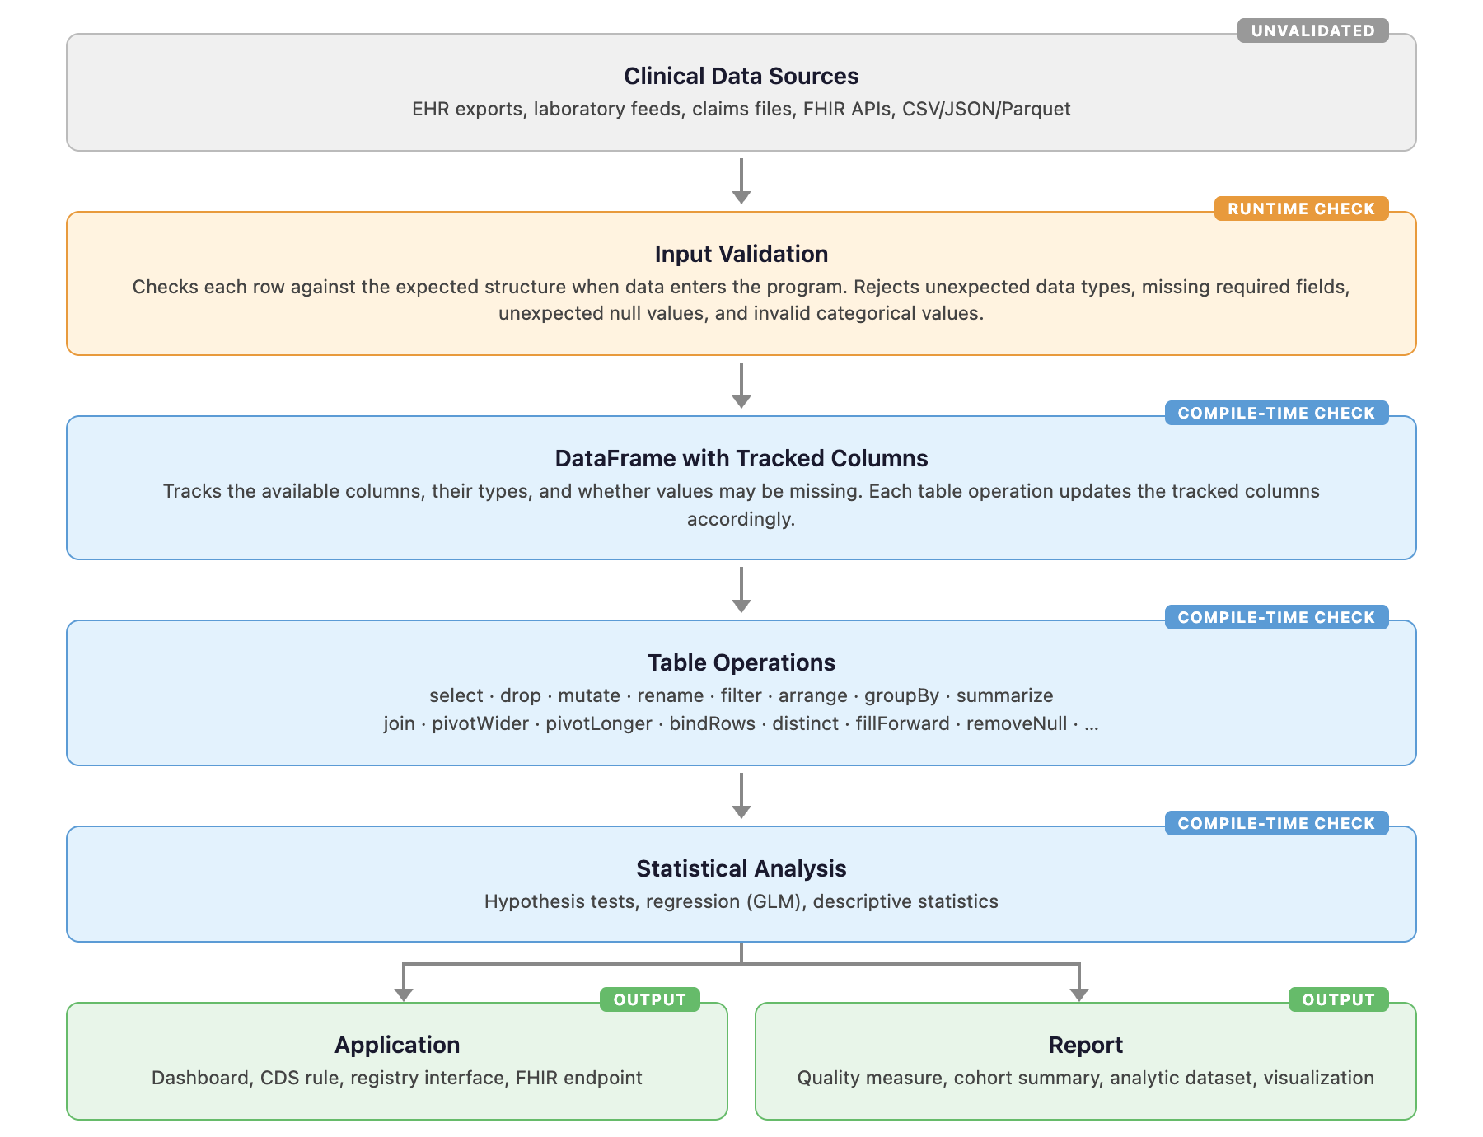

Figure 2. Detection Rates by Error Category and Language

Each cell shows how many intentional errors were detected (compile-time error, runtime error, or warning) before producing incorrect output. Green = all detected. Yellow = some detected. Red = most went undetected.

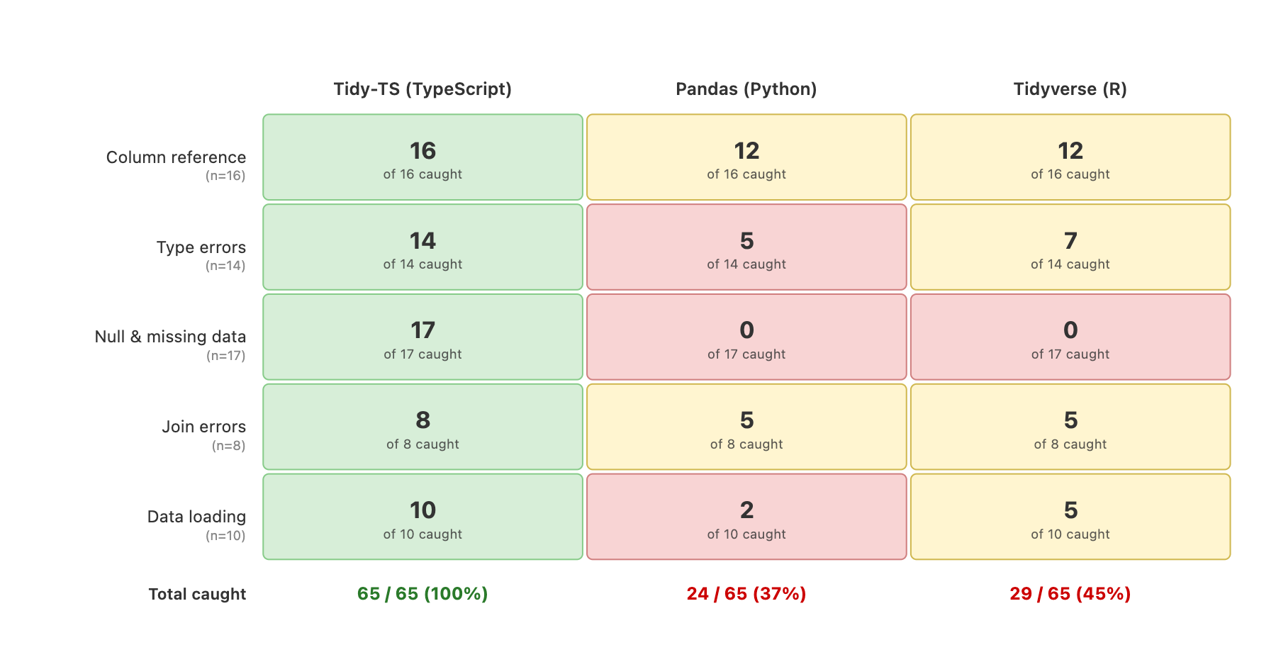

Figure 3. Example silent error across Tidy-TS, pandas, and tidyverse: arithmetic on a laboratory value stored as text.

Laboratory data sometimes contains text values such as "MISSING" or "pending" where a number is expected. Each panel multiplies this column by 2. Tidy-TS (TypeScript) catches the error before the code runs. Pandas (Python) continues silently and produces "MISSINGMISSING." Tidyverse (R) stops with an error when the code runs.

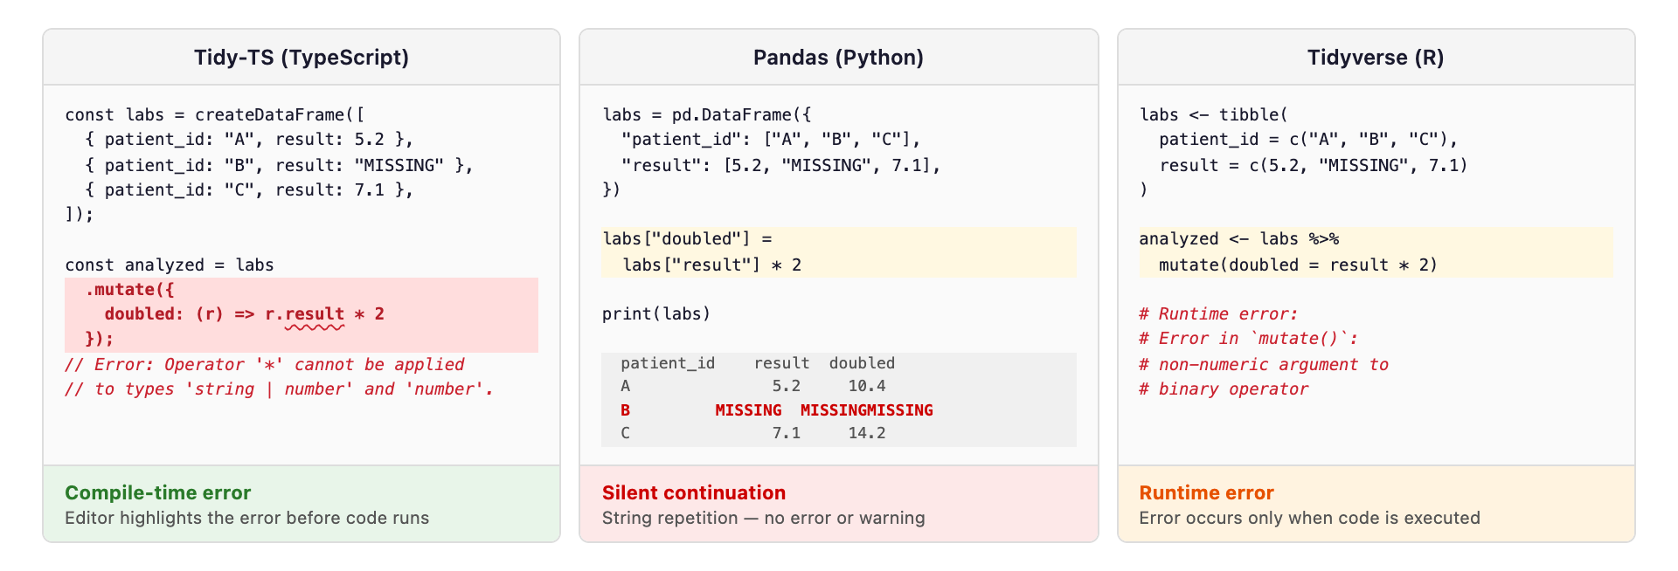

Table 1: Error Outcome Definitions

Outcome | Meaning
Compile-time error | The compiler identifies the error before the code runs
Runtime error | Program runs and stops with an error message
Runtime warning | Program prints a warning but continues and may produce an incorrect result
Silent continuation | Program continues without error or warning and produces incorrect output

Table 2. Detection Outcomes by Error Category
Detection outcomes for 65 tests across five error categories and three languages. For Tidy-TS, 'compile' shows errors caught before the code runs. 'Runtime' shows errors that would also produce an error or stop the program when the code runs, including validation of external data.
 |  |  | Tidy-TS (TypeScript) |  | Pandas (Python) |  |  | Tidyverse (R)
 |  |  | compile | runtime | runtime |  |  | runtime
Category | Example error | n | error | error | error | warn | silent | error | warn | silent
Column reference | Use ‘patientId’ instead of ‘patient_id’ | 16 | 16 | 16 | 14 | 0 | 2 | 14 | 0 | 2
Value type errors | Lab result imported as text instead of number, then used in arithmetic | 14 | 13 | 3 | 5 | 0 | 9 | 4 | 3 | 7
Missing value errors | Divide by a reference range value that may be missing | 17 | 17 | 3 | 0 | 0 | 17 | 2 | 0 | 15
Join errors | Use a department column that may be missing after joining patients to encounters | 8 | 8 | 6 | 5 | 0 | 3 | 5 | 0 | 3
Data loading | Load lab results where a numeric column contains text like "pending" | 10 | 8 | 8 | 2 | 0 | 8 | 4 | 1 | 5
Total |  | 65 | 62 | 36 | 26 | 0 | 39 | 29 | 4 | 32

Supplementary File A
/**
* Type-System Guarantee Audit for Tidy-TS
*
* This file is a compile-time test: it type-checks but never runs.
* Every Expect<IsExact<Actual, Expected>> asserts bidirectional type equality.
* A @ts-expect-error comment asserts that something is correctly rejected.
*
*/

import {
createDataFrame,
stats,
type DataFrame,
} from "@tidy-ts/dataframe";
import { z } from "zod";

// ═══════════════════════════════════════════════════════════════════════
// Test utilities — bidirectional type equality
// ═══════════════════════════════════════════════════════════════════════

type IsExact<A, B> =
(<T>() => T extends A ? 1 : 2) extends (<T>() => T extends B ? 1 : 2)
? (<T>() => T extends B ? 1 : 2) extends (<T>() => T extends A ? 1 : 2)
? true
: false
: false;

type Expect<_T extends true> = true;

type RowOf<T> = T extends DataFrame<infer R> ? R : never;

// ═══════════════════════════════════════════════════════════════════════
// Test data
// ═══════════════════════════════════════════════════════════════════════

const df = createDataFrame([
{ name: "Alice", age: 25, city: "NYC", score: 85 },
{ name: "Bob", age: 30, city: "LA", score: 92 },
]);

type BaseRow = { name: string; age: number; city: string; score: number };

// ═══════════════════════════════════════════════════════════════════════
// 1. SCHEMA PRESERVATION — row type unchanged
// ═══════════════════════════════════════════════════════════════════════

// 1a. filter — preserves row shape, only removes rows
const filtered = df.filter((r) => r.age > 25);
type _1a = Expect<IsExact<RowOf<typeof filtered>, BaseRow>>;

// ═══════════════════════════════════════════════════════════════════════
// 2. SCHEMA NARROWING — columns removed
// ═══════════════════════════════════════════════════════════════════════

// 2a. select — Pick<Row, ColName>
const selected = df.select("name", "age");
type _2a = Expect<IsExact<RowOf<typeof selected>, { name: string; age: number }>>;

// 2b. drop — Omit<Row, ColName>
const dropped = df.drop("city", "score");
type _2b = Expect<IsExact<RowOf<typeof dropped>, { name: string; age: number }>>;

// 2c. distinct — Pick<Row, Cols> (SQL DISTINCT narrows to selected columns)
const distinct = df.distinct("city", "score");
type _2c = Expect<IsExact<RowOf<typeof distinct>, { city: string; score: number }>>;

// 2d. select rejects nonexistent columns
// @ts-expect-error — "nonexistent" is not a key of BaseRow
df.select("nonexistent");

// 2e. drop rejects nonexistent columns
// @ts-expect-error — "nonexistent" is not a key of BaseRow
df.drop("nonexistent");

// 2f. accessing dropped column is rejected
const afterDrop = df.drop("score");
// @ts-expect-error — "score" no longer exists
afterDrop.mutate({ bad: (r) => r.score * 2 });

// ═══════════════════════════════════════════════════════════════════════
// 3. SCHEMA EXTENSION — columns added or replaced
// ═══════════════════════════════════════════════════════════════════════

// 3a. mutate — adds new columns, preserves existing
const mutated = df.mutate({
revenue: (r) => r.score * r.age,
label: (r) => `${r.name}: ${r.city}`,
});
type _3a = Expect<IsExact<
RowOf<typeof mutated>,
{ name: string; age: number; city: string; score: number; revenue: number; label: string }
>>;

// 3b. mutate — replaces existing column type
const replaced = df.mutate({
age: (r) => String(r.age),
});
type _3b = Expect<IsExact<
RowOf<typeof replaced>,
{ name: string; age: string; city: string; score: number }
>>;

// 3c. rename — replaces key names, preserves types
const renamed = df.rename({ name: "fullName", city: "location" });
type _3c = Expect<IsExact<
RowOf<typeof renamed>,
{ fullName: string; age: number; location: string; score: number }
>>;

// 3d. accessing old name after rename is rejected
// @ts-expect-error — "name" no longer exists after rename
renamed.mutate({ bad: (r) => r.name });

// ═══════════════════════════════════════════════════════════════════════
// 4. SCHEMA REPLACEMENT — entirely new row type
// ═══════════════════════════════════════════════════════════════════════

// 4a. summarise (ungrouped) — output schema is only the summary columns
const summary = df.summarise({
avg_age: (g) => stats.mean(g.age),
count: (g) => g.nrows(),
});
type _4a = Expect<IsExact<
RowOf<typeof summary>,
{ avg_age: number; count: number }
>>;

// 4b. groupBy.summarise — output schema is group keys + summary columns
const groupedSummary = df
.groupBy("city")
.summarise({
avg_score: (g) => stats.mean(g.score),
n: (g) => g.nrows(),
});
type _4b = Expect<IsExact<
RowOf<typeof groupedSummary>,
{ city: string; avg_score: number; n: number }
>>;

// 4c. accessing non-summary column after summarise is rejected
// @ts-expect-error — "name" was consumed by summarise
summary.mutate({ bad: (r) => r.name });

// ═══════════════════════════════════════════════════════════════════════
// 5. JOINS — merged schema from L, R, K
// ═══════════════════════════════════════════════════════════════════════

const employees = createDataFrame([
{ id: 1, name: "Alice", dept_id: 10 },
{ id: 2, name: "Bob", dept_id: 20 },
]);
const departments = createDataFrame([
{ dept_id: 10, dept_name: "Engineering" },
{ dept_id: 20, dept_name: "Sales" },
]);

// 5a. innerJoin — no undefined introduction (both sides matched)
const innerJoined = employees.innerJoin(departments, "dept_id");
type _5a = Expect<IsExact<
RowOf<typeof innerJoined>,
{ id: number; name: string; dept_id: number; dept_name: string }
>>;

// 5b. leftJoin — right-side non-key columns become T | undefined
const leftJoined = employees.leftJoin(departments, "dept_id");
type _5b = Expect<IsExact<
RowOf<typeof leftJoined>,
{ id: number; name: string; dept_id: number; dept_name: string | undefined }
>>;

// 5c. rightJoin — left-side non-key columns become T | undefined
const rightJoined = employees.rightJoin(departments, "dept_id");
type _5c = Expect<IsExact<
RowOf<typeof rightJoined>,
{
dept_id: number;
dept_name: string;
id: number | undefined;
name: string | undefined;
}
>>;

// 5d. outerJoin — both sides' non-key columns become T | undefined
const outerJoined = employees.outerJoin(departments, "dept_id");
type _5d = Expect<IsExact<
RowOf<typeof outerJoined>,
{
dept_id: number;
id: number | undefined;
name: string | undefined;
dept_name: string | undefined;
}
>>;

// 5e. leftJoin with column collision — shared non-key cols get _x/_y suffix
const left = createDataFrame([
{ time: 1, symbol: "AAPL", quantity: 100 },
]);
const right = createDataFrame([
{ time: 1, symbol: "AAPL", price: 150 },
]);
const collisionJoin = left.leftJoin(right, "time");
type _5e = Expect<IsExact<
RowOf<typeof collisionJoin>,
{
time: number;
symbol_x: string;
quantity: number;
price: number | undefined;
symbol_y: string | undefined;
}
>>;

// 5f. arithmetic on left-join-introduced undefined is rejected
// @ts-expect-error — dept_name is string | undefined, can't call toUpperCase
leftJoined.mutate({ bad: (r) => r.dept_name.toUpperCase() });

// ═══════════════════════════════════════════════════════════════════════
// 6. MISSING VALUE HANDLING — narrow or substitute field types
// ═══════════════════════════════════════════════════════════════════════

// 6a. replaceNull — removes null from column type
const nullableData = createDataFrame(
[{ id: 1, value: 10 }, { id: 2, value: null }],
z.object({ id: z.number(), value: z.number().nullable() }),
);
const cleaned = nullableData.replaceNull({ value: 0 });
type _6a = Expect<IsExact<
RowOf<typeof cleaned>,
{ id: number; value: number }
>>;

// 6b. replaceUndefined — removes undefined from column type
const pipelineWithJoin = employees
.leftJoin(departments, "dept_id")
.replaceUndefined({ dept_name: "Unknown" });
type _6b = Expect<IsExact<
RowOf<typeof pipelineWithJoin>,
{ id: number; name: string; dept_id: number; dept_name: string }
>>;

// 6c. removeNull — narrows column type by removing null, drops rows
const nullableDF = createDataFrame(
[{ id: 1, value: "a" }, { id: 2, value: null }],
z.object({ id: z.number(), value: z.string().nullable() }),
);
const narrowedByFilter = nullableDF.removeNull("value");
type _6c = Expect<IsExact<RowOf<typeof narrowedByFilter>, { id: number; value: string }>>;

// 6d. removeUndefined — removes undefined from column type, drops rows
const withUndefined = createDataFrame([
{ id: 1, tag: "a" as string | undefined },
{ id: 2, tag: undefined as string | undefined },
]);
const noUndef = withUndefined.removeUndefined("tag");
type _6d = Expect<IsExact<
RowOf<typeof noUndef>,
{ id: number; tag: string }
>>;

// 2e. drop rejects nonexistent columns
// @ts-expect-error — "nonexistent" is not a key of BaseRow
df.drop("nonexistent");

// 2f. accessing dropped column is rejected
const afterDrop = df.drop("score");
// @ts-expect-error — "score" no longer exists
afterDrop.mutate({ bad: (r) => r.score * 2 });

// ═══════════════════════════════════════════════════════════════════════
// 3. SCHEMA EXTENSION — columns added or replaced
// ═══════════════════════════════════════════════════════════════════════

// 3a. mutate — adds new columns, preserves existing
const mutated = df.mutate({
revenue: (r) => r.score * r.age,
label: (r) => `${r.name}: ${r.city}`,
});
type _3a = Expect<IsExact<
RowOf<typeof mutated>,
{ name: string; age: number; city: string; score: number; revenue: number; label: string }
>>;

// 3b. mutate — replaces existing column type
const replaced = df.mutate({
age: (r) => String(r.age),
});
type _3b = Expect<IsExact<
RowOf<typeof replaced>,
{ name: string; age: string; city: string; score: number }
>>;

// 3c. rename — replaces key names, preserves types
const renamed = df.rename({ name: "fullName", city: "location" });
type _3c = Expect<IsExact<
RowOf<typeof renamed>,
{ fullName: string; age: number; location: string; score: number }
>>;

// 3d. accessing old name after rename is rejected
// @ts-expect-error — "name" no longer exists after rename
renamed.mutate({ bad: (r) => r.name });

// ═══════════════════════════════════════════════════════════════════════
// 4. SCHEMA REPLACEMENT — entirely new row type
// ═══════════════════════════════════════════════════════════════════════

// 4a. summarise (ungrouped) — output schema is only the summary columns
const summary = df.summarise({
avg_age: (g) => stats.mean(g.age),
count: (g) => g.nrows(),
});
type _4a = Expect<IsExact<
RowOf<typeof summary>,
{ avg_age: number; count: number }
>>;

// 4b. groupBy.summarise — output schema is group keys + summary columns
const groupedSummary = df
.groupBy("city")
.summarise({
avg_score: (g) => stats.mean(g.score),
n: (g) => g.nrows(),
});
type _4b = Expect<IsExact<
RowOf<typeof groupedSummary>,
{ city: string; avg_score: number; n: number }
>>;

// 4c. accessing non-summary column after summarise is rejected
// @ts-expect-error — "name" was consumed by summarise
summary.mutate({ bad: (r) => r.name });

// ═══════════════════════════════════════════════════════════════════════
// 5. JOINS — merged schema from L, R, K
// ═══════════════════════════════════════════════════════════════════════

const employees = createDataFrame([
{ id: 1, name: "Alice", dept_id: 10 },
{ id: 2, name: "Bob", dept_id: 20 },
]);
const departments = createDataFrame([
{ dept_id: 10, dept_name: "Engineering" },
{ dept_id: 20, dept_name: "Sales" },
]);

// 5a. innerJoin — no undefined introduction (both sides matched)
const innerJoined = employees.innerJoin(departments, "dept_id");
type _5a = Expect<IsExact<
RowOf<typeof innerJoined>,
{ id: number; name: string; dept_id: number; dept_name: string }
>>;

// 5b. leftJoin — right-side non-key columns become T | undefined
const leftJoined = employees.leftJoin(departments, "dept_id");
type _5b = Expect<IsExact<
RowOf<typeof leftJoined>,
{ id: number; name: string; dept_id: number; dept_name: string | undefined }
>>;

// 5c. rightJoin — left-side non-key columns become T | undefined
const rightJoined = employees.rightJoin(departments, "dept_id");
type _5c = Expect<IsExact<
RowOf<typeof rightJoined>,
{
dept_id: number;
dept_name: string;
id: number | undefined;
name: string | undefined;
}
>>;

// 5d. outerJoin — both sides' non-key columns become T | undefined
const outerJoined = employees.outerJoin(departments, "dept_id");
type _5d = Expect<IsExact<
RowOf<typeof outerJoined>,
{
dept_id: number;
id: number | undefined;
name: string | undefined;
dept_name: string | undefined;
}
>>;

// 5e. leftJoin with column collision — shared non-key cols get _x/_y suffix
const left = createDataFrame([
{ time: 1, symbol: "AAPL", quantity: 100 },
]);
const right = createDataFrame([
{ time: 1, symbol: "AAPL", price: 150 },
]);
const collisionJoin = left.leftJoin(right, "time");
type _5e = Expect<IsExact<
RowOf<typeof collisionJoin>,
{
time: number;
symbol_x: string;
quantity: number;
price: number | undefined;
symbol_y: string | undefined;
}
>>;

// 5f. arithmetic on left-join-introduced undefined is rejected
// @ts-expect-error — dept_name is string | undefined, can't call toUpperCase
leftJoined.mutate({ bad: (r) => r.dept_name.toUpperCase() });

// ═══════════════════════════════════════════════════════════════════════
// 6. MISSING VALUE HANDLING — narrow or substitute field types
// ═══════════════════════════════════════════════════════════════════════

// 6a. replaceNull — removes null from column type
const nullableData = createDataFrame(
[{ id: 1, value: 10 }, { id: 2, value: null }],
z.object({ id: z.number(), value: z.number().nullable() }),
);
const cleaned = nullableData.replaceNull({ value: 0 });
type _6a = Expect<IsExact<
RowOf<typeof cleaned>,
{ id: number; value: number }
>>;

// 6b. replaceUndefined — removes undefined from column type
const pipelineWithJoin = employees
.leftJoin(departments, "dept_id")
.replaceUndefined({ dept_name: "Unknown" });
type _6b = Expect<IsExact<
RowOf<typeof pipelineWithJoin>,
{ id: number; name: string; dept_id: number; dept_name: string }
>>;

// 6c. removeNull — narrows column type by removing null, drops rows
const nullableDF = createDataFrame(
[{ id: 1, value: "a" }, { id: 2, value: null }],
z.object({ id: z.number(), value: z.string().nullable() }),
);
const narrowedByFilter = nullableDF.removeNull("value");
type _6c = Expect<IsExact<RowOf<typeof narrowedByFilter>, { id: number; value: string }>>;

// 6d. removeUndefined — removes undefined from column type, drops rows
const withUndefined = createDataFrame([
{ id: 1, tag: "a" as string | undefined },
{ id: 2, tag: undefined as string | undefined },
]);
const noUndef = withUndefined.removeUndefined("tag");
type _6d = Expect<IsExact<
RowOf<typeof noUndef>,
{ id: number; tag: string }
>>;
// ═══════════════════════════════════════════════════════════════════════
// 5. JOINS — merged schema from L, R, K
// ═══════════════════════════════════════════════════════════════════════

const employees = createDataFrame([
{ id: 1, name: "Alice", dept_id: 10 },
{ id: 2, name: "Bob", dept_id: 20 },
]);
const departments = createDataFrame([
{ dept_id: 10, dept_name: "Engineering" },
{ dept_id: 20, dept_name: "Sales" },
]);

// 5a. innerJoin — no undefined introduction (both sides matched)
const innerJoined = employees.innerJoin(departments, "dept_id");
type _5a = Expect<IsExact<
RowOf<typeof innerJoined>,
{ id: number; name: string; dept_id: number; dept_name: string }
>>;

// 5b. leftJoin — right-side non-key columns become T | undefined
const leftJoined = employees.leftJoin(departments, "dept_id");
type _5b = Expect<IsExact<
RowOf<typeof leftJoined>,
{ id: number; name: string; dept_id: number; dept_name: string | undefined }
>>;

// 5c. rightJoin — left-side non-key columns become T | undefined
const rightJoined = employees.rightJoin(departments, "dept_id");
type _5c = Expect<IsExact<
RowOf<typeof rightJoined>,
{
dept_id: number;
dept_name: string;
id: number | undefined;
name: string | undefined;
}
>>;

// 5d. outerJoin — both sides' non-key columns become T | undefined
const outerJoined = employees.outerJoin(departments, "dept_id");
type _5d = Expect<IsExact<
RowOf<typeof outerJoined>,
{
dept_id: number;
id: number | undefined;
name: string | undefined;
dept_name: string | undefined;
}
>>;

// 5e. leftJoin with column collision — shared non-key cols get _x/_y suffix
const left = createDataFrame([
{ time: 1, symbol: "AAPL", quantity: 100 },
]);
const right = createDataFrame([
{ time: 1, symbol: "AAPL", price: 150 },
]);
const collisionJoin = left.leftJoin(right, "time");
type _5e = Expect<IsExact<
RowOf<typeof collisionJoin>,
{
time: number;
symbol_x: string;
quantity: number;
price: number | undefined;
symbol_y: string | undefined;
}
>>;

// 5f. arithmetic on left-join-introduced undefined is rejected
// @ts-expect-error — dept_name is string | undefined, can't call toUpperCase
leftJoined.mutate({ bad: (r) => r.dept_name.toUpperCase() });

// ═══════════════════════════════════════════════════════════════════════
// 6. MISSING VALUE HANDLING — narrow or substitute field types
// ═══════════════════════════════════════════════════════════════════════

// 6a. replaceNull — removes null from column type
const nullableData = createDataFrame(
[{ id: 1, value: 10 }, { id: 2, value: null }],
z.object({ id: z.number(), value: z.number().nullable() }),
);
const cleaned = nullableData.replaceNull({ value: 0 });
type _6a = Expect<IsExact<
RowOf<typeof cleaned>,
{ id: number; value: number }
>>;

// 6b. replaceUndefined — removes undefined from column type
const pipelineWithJoin = employees
.leftJoin(departments, "dept_id")
.replaceUndefined({ dept_name: "Unknown" });
type _6b = Expect<IsExact<
RowOf<typeof pipelineWithJoin>,
{ id: number; name: string; dept_id: number; dept_name: string }
>>;

// 6c. removeNull — narrows column type by removing null, drops rows
const nullableDF = createDataFrame(
[{ id: 1, value: "a" }, { id: 2, value: null }],
z.object({ id: z.number(), value: z.string().nullable() }),
);
const narrowedByFilter = nullableDF.removeNull("value");
type _6c = Expect<IsExact<RowOf<typeof narrowedByFilter>, { id: number; value: string }>>;

// 6d. removeUndefined — removes undefined from column type, drops rows
const withUndefined = createDataFrame([
{ id: 1, tag: "a" as string | undefined },
{ id: 2, tag: undefined as string | undefined },
]);
const noUndef = withUndefined.removeUndefined("tag");
type _6d = Expect<IsExact<
RowOf<typeof noUndef>,
{ id: number; tag: string }
>>;

Supplemental Table 1. Python Static Type Checker Coverage and Polars Runtime.
Detection outcomes for pyright (1.1.400) and mypy (1.16.0) running in strict mode on the same 65 error scenarios, with pandas-stubs (2.2.3.241126) installed. Polars (1.30.0) runtime results are included for comparison.
 |  | Tidy-TS |  | pyright | mypy | Polars | pandas | tidyverse
Category | n | compile | runtime | compile | compile | runtime | runtime | runtime
Column reference | 16 | 16 (100%) | 16 (100%) | 0 (0%) | 0 (0%) | 14 (88%) | 14 (88%) | 14 (88%)
Value type | 14 | 13 (93%) | 3 (21%) | 0 (0%) | 1 (7%) | 6 (43%) | 5 (36%) | 4 (29%)
Missing value | 17 | 17 (100%) | 3 (18%) | 0 (0%) | 0 (0%) | 0 (0%) | 0 (0%) | 2 (12%)
Join errors | 8 | 8 (100%) | 6 (75%) | 0 (0%) | 0 (0%) | 3 (38%) | 5 (63%) | 5 (63%)
Data loading | 10 | 8 (80%) | 8 (80%) | 0 (0%) | 0 (0%) | 5 (50%) | 2 (20%) | 5 (50%)
Total | 65 | 62 (95%) | 36 (55%) | 0 (0%) | 1 (2%) | 28 (43%) | 26 (40%) | 29 (45%)

Supplemental Table 2: Type Rules in Tidy-TS data frames

Let $R$ denote a row type (i.e., a mapping from column names to types).

For a set of columns $C$:

$R[C]$denotes projection onto $C$,

$R∖C$ denotes removal of columns in $C$,

$R∪S$ denotes schema union, assuming disjoint column names or an explicitly specified collision-resolution policy

$T∣ ⊥$ denotes an optional value of type $T$, where ⊥ corresponds to an absent or undefined value.

Lowercase identifiers a, b, c, k, n, v, and t range over column names.

For joins, $L$ and $R$ denote the left and right input schemas, respectively, and $K$ denotes the join key set.

