Detecting Clinical Data Errors Before the Code Runs: Design and Evaluation of a TypeScript Data Analysis Framework

Abstract

Objective
Clinical data analyses involve many processing steps, including joining records, converting types, and handling missing values. Errors can produce incorrect results, especially when the program continues without warning.

Materials and Methods
We developed Tidy-TS, a TypeScript framework that tracks each dataset's columns and their types through each processing step. The compiler catches errors before the code runs, such as referencing a missing column, using a value that might be missing, or treating text as a number. We evaluated Tidy-TS with 65 scenarios across five error categories, with equivalent tests in Python (using pandas) and R (using tidyverse), classifying each outcome as a compile-time error, runtime error, runtime warning, or silent continuation. We also drew on an independent collection of 164 Python and R bugs labeled as type mismatches, and evaluated Tidy-TS against the 79 involving data analysis operations.

Results
Tidy-TS caught 62 of 65 errors before the code ran and 3 through runtime validation. Pandas continued silently on 39 of 65 (60%) and tidyverse on 32 of 65 (49%). The gap was largest in the missing value category, where all 17 scenarios continued silently in pandas and 15 of 17 in tidyverse. Of the 164 published bugs, 79 met inclusion rules. In current versions of the original Python and R libraries, 62 of the 79 still trigger the original failure. Tidy-TS caught all 79 before the code ran.

Discussion
The gap is concentrated in errors that produce plausible but incorrect output, particularly missing values carried through calculations or introduced by joins.

Conclusion
Tidy-TS catches common clinical data errors before the code runs, including errors that continue silently in Python and R.

Background and Significance

Whether for research studies, quality improvement, or operations, clinical data analysis involves many individual processing steps. A typical workflow might query patient data from a database or import it from a CSV file, reorganize it, combine it with data from other sources, calculate new values, summarize the results, and run statistical tests.
And while these steps are routine, they are also error-prone. Some errors may be small and benign – for example, a typo when spelling the name of a CSV file. Others can have consequences large enough to change study conclusions. One review of 884 retracted articles in clinical and translational research found that 28% described problems preparing or analyzing data.[Baldridge 2024] Minimizing these types of errors has been identified as a priority for clinical research.
Errors in analytical code can manifest in one of several ways. Some errors lead the code to halt as soon as the error is encountered. Some are more insidious, silently allowing code to run fully but corrupting results in ways that can be nuanced and hard to detect. These silent errors commonly involve issues related to the underlying type of data that code is trying to access or change. Non-technical researchers might be surprised to find that it is altogether an easy mistake to accidentally multiply a word by a number or combine two datasets in a way that silently drops hundreds of patients from a study.
Although these mistakes pose serious risks to clinical research, they stem from a broader challenge found across all of software development. To minimize these errors, the software industry has introduced safeguards like automated test suites, strict validation frameworks, and peer reviews. However, while these development practices can significantly reduce bugs, they cannot fully eliminate risks that are inherent to the design of the programming languages themselves.
Most clinical data analysis is performed in Python or R. Both languages can surface errors during code execution, but these checks typically only confirm whether a data value can technically be used in the current operation. There is no inherent mechanism for broadly enforcing that a value represents the kind of data an analyst intended throughout an analytical pipeline. For example, in Python, the numeric value `1` and the boolean value “True” can be used interchangeably in many operations. As a result, logically incorrect operations may still execute successfully without warning and lead to downstream incorrect results.
In contrast to Python and R, some programming languages are designed to catch these kinds of silent errors before the code runs. They use a compiler that keeps track of what kind of data each variable is expected to contain and rejects operations that do not make sense for those values. This kind of pre-execution type check is known as compile-time checking, and its theoretical foundation is well established.[18][19] [20][21].
Compile-time checking provides several safeguards relevant to clinical data processing. If the compiler detects an invalid operation, the program never runs, preventing downstream side effects such as corrupted files, incorrect database updates, or erroneous clinical alerts. Errors are identified immediately in the analyst’s editor, often at the exact line where the problem occurred, before any patient data has been processed, and are enforced automatically by the language itself.
TypeScript is a programming language with compile-time type checking, and it is already used in clinical informatics for health data standards, web dashboards, and data services.[26][27][28]. Despite this adoption, TypeScript has not traditionally been used as a primary language for data analysis itself. Extending type-checked workflows into the analytical portion of clinical data processing may therefore offer a way to reduce certain categories of downstream processing errors. Such an approach would also support increasing regulatory expectations for formal evaluation of data quality in clinical software [29][30].
We therefore evaluate whether a data analysis framework built in TypeScript can detect common clinical data processing errors that would otherwise remain undetected in conventional Python and R workflows, and characterize the practical limits of this approach.

Objective
The evaluation of Tidy-TS addressed three questions.
- Can TypeScript's compile-time checking track column names, types, and whether values may be missing through clinical data processing steps, and catch errors before the code runs?
- How are equivalent clinical data errors caught in Tidy-TS compared to Python (using pandas) and R (using tidyverse)?
- Where does compile-time checking end and runtime checking remain necessary?

Materials and Methods

System Design
Tidy-TS is a TypeScript framework for working with datasets. It represents data as a collection of rows, where each row has named columns with specific value types. Each dataset tracks its columns and their types.
For example, a dataset with patient identifier, name, and age tracks those three columns and their types. When a processing step changes the dataset, the tracked columns change. Selecting specific columns drops the others, while adding or editing a column updates the tracked columns. Joining two datasets combines the columns from both and marks values in those columns as possibly missing when the join can introduce missing values.
Each operation follows a defined type rule that determines how the tracked columns change. For example, summarizing replaces the original columns with only the summary columns plus any group keys. Removing missing values from a column updates the tracked column type so that subsequent operations can use it without handling the missing case. The full set of type rules covering all operations is provided in Supplementary Table 2.
The framework includes common dataset operations such as filtering, selecting, joining, grouping, summarizing, modifying columns, and replacing missing values. It also includes statistical functions and hypothesis tests. We validated statistical functions against R, with test statistics and p-values agreeing within 10⁻⁶. The validation suite covers distributions, regression models, and tests adapted from R's own test suite.

Compile-Time Checking
Tidy-TS catches errors because TypeScript's compiler checks each processing step before the code runs. If a program refers to a column that does not exist, uses a value that might be missing without handling it first, or treats text as a number, the compiler rejects the code and identifies the line where the problem is.
The framework's test suite includes approximately 1,700 tests covering dataset operations, statistical functions, and data import from files such as CSV, Excel, and Parquet, including tests that verify column tracking works correctly through each processing step. For this evaluation, we also created a focused test file containing a series of intentional errors alongside valid operations (Supplementary A). The compiler checks this file without running it, confirming that valid operations produce the expected column types and that invalid operations are rejected.

Runtime Checking and Validation
Compile-time checking can only work after the program knows the expected structure of the data. For data coming from files, databases, or other external sources, Tidy-TS first validates that each row matches the expected structure when the data is loaded. If the data matches, the column types are set automatically. If there is an unexpected value, for example a text value when only numbers are expected, Tidy-TS reports an error and stops. After validation, the compiler checks each subsequent processing step against the known columns and types.

Language Comparison Suite
To compare error detection across Tidy-TS, Python, and R, we created a comparison suite using sample clinical datasets representing patients, encounters, laboratory results, medications, and vital signs. The test cases were derived from error patterns described in published clinical data quality literature[4][6][7][11][14] and from errors encountered during the framework's use at the University of Utah. Tests were organized into five error categories. Each test represents a specific clinical data processing error, such as a misspelled patient identifier, a column that no longer exists after summarization, arithmetic on a laboratory value that might be missing, a join that introduces missing data, or an invalid categorical value.
We implemented equivalent tests using pandas (3.0.3) with Python 3.14.5 and tidyverse (2.0.0) with R 4.6.0. Tidy-TS tests were run with TypeScript 5.9.2 on Deno 2.7.14, a runtime environment for TypeScript. Each outcome was classified into four categories (Table 1).
The five error categories are column reference errors, value type errors, missing value errors, join errors, and data loading errors.
The error categories in the comparison suite map to the Conformance and Completeness dimensions of a multi-institution harmonized terminology for EHR data quality.[Kahn 2016] Column reference errors correspond to relational conformance and value type errors to value conformance. Missing value errors correspond to completeness. Join errors span both conformance and completeness. Plausibility, which requires inspecting data values against domain knowledge or external benchmarks, is outside the scope of compile-time checking.
External Validation Against an Independent Bug Collection
To check that the categories of error in our comparison suite reflect bugs that occur in code we did not write ourselves, we evaluated Tidy-TS against a published collection of Python and R data analytics bugs.[Ahmed 2023] The collection manually classified bugs from Stack Overflow posts and GitHub fix commits across widely used Python and R data analytics packages, labeling each bug by type, root cause, and effect. We selected the 164 bugs whose root cause was labeled Type Mismatch, meaning a value of the wrong type (such as a string where a number was expected) caused the failure. The collection predates Tidy-TS and was assembled by an independent research group, so the bugs are not selected to favor any particular library.
We applied rules set in advance to the 164 Type Mismatch bugs, including each bug whose error category had a direct equivalent in a data analysis library. We excluded bugs whose failure mode was specific to chart rendering output (such as axis layout, color palettes, or save format), syntax features specific to Python or R (such as R's non-standard evaluation system for passing column names as bare symbols), or library features outside data analysis (such as external library interop, multi-process coordination, or platform-specific encoding). Bugs at the chart's data input (a column passed by the wrong type or name) were included, since Tidy-TS includes a typed charting library that tracks column names and types at the chart boundary. Each included bug was reproduced in a self-contained file that runs the original Python or R code and demonstrates the equivalent Tidy-TS implementation. We recorded whether the compiler caught the bug, and whether the bug still triggered in current versions of the original Python and R libraries.

Results

Language Comparison Suite
The comparison suite included 65 tests across five error categories, including 16 (25%) column reference errors, 14 (22%) value type errors, 17 missing value errors (26%), 8 (12%) join errors, and 10 (15%) data loading errors. Each test was run in Tidy-TS, pandas, and tidyverse.
Tidy-TS caught 62 of 65 errors before execution and caught the remaining 3 through validation when the data was first loaded. Pandas caught 26 (40%) at runtime and missed 39 (60%). Tidyverse caught 29 (45%) at runtime, warned on 4 (6%), and missed 32 (49%) (Table 2).
We also tested Python's compile-time checking tools mypy and pyright with pandas-stubs installed. Neither tool caught any of the 65 errors at compile time (Supplemental Table 1).
Polars, a newer data analysis library for Python, was also tested on the same 65 scenarios (Supplemental Table 1). Polars caught 28 of 65 errors (43%) at runtime, slightly more than pandas (26 of 65, 40%) and slightly fewer than tidyverse (29 of 65, 45%). Like pandas, Polars caught none of the 17 missing value errors.
In the setting where the compile-time check is intentionally overridden by the programmer, Tidy-TS also caught 36 of the 65 errors at runtime. These 36 include the 3 errors not originally caught at compile time, which is expected because errors in external data parsing can only be detected at runtime.
The largest detection gap was in the missing value category. All 17 tests continued silently in pandas; tidyverse caught 2 at runtime and missed the remaining 15. Common examples included missing values carried through calculations, comparisons that silently excluded rows with missing values, and missing values introduced by joins that were used in later operations without being handled. Tidy-TS caught all 17 before the code ran.
Column reference errors showed the smallest detection gap because these errors tend to stop the program immediately. Pandas and tidyverse caught 14 of 16 (88%) at runtime, typically stopping when a misspelled or nonexistent column was used. The 2 that continued silently in each involved columns that a processing step was expected to remove but did not, such as keeping extra columns when removing duplicate rows.
External Validation Against an Independent Bug Collection
Of the 164 Type Mismatch bugs, 79 met the inclusion rules. The most common reason for exclusion was that the bug involved chart rendering or a library feature with no equivalent in a data analysis library. Among the 79 included bugs, the distribution across the five error categories of the comparison suite was as follows. The included bugs consisted of 60 value type errors, 9 missing value errors, 5 data loading errors, 4 column reference errors, and 1 join error. All 79 bugs were caught by the Tidy-TS compiler before the code ran.
Of the 79 included bugs, 62 still trigger the original failure in current versions of the original Python and R libraries. The remaining 17 no longer reproduce the original silent failure, reflecting upstream changes in those libraries since the bugs were originally reported.

Discussion
Tidy-TS caught all 39 scenarios that continued silently in pandas and all 32 that continued silently in tidyverse, in both cases before execution. The largest detection gap was in the missing value category, where every scenario continued silently in pandas and all but two in tidyverse. These errors often produced plausible but systematically incorrect output, particularly when missing values introduced by joins or carried through calculations propagated into later analysis steps. Systematic data errors of this kind have been shown to bias treatment-effect estimates even when they affect only a small fraction of records.[17] The consistency of this pattern suggests that these failures arise from limitations in how the analysis frameworks handle missing data rather than from isolated analyst mistakes.
Python's optional static analysis tools did not address this limitation. Even with the most thorough settings enabled, mypy and pyright failed to detect any of the 65 errors. While these tools can describe the types of individual values, they cannot track how dataset columns and missing values change across processing steps such as joins, filtering, and summarization. That tracking capability is what allowed Tidy-TS to detect these errors before execution.
Compile-time checking is sometimes perceived as adding friction because analysts must address errors before code can run. In practice, however, many of these checks correspond to steps required for a correct analysis regardless of programming language. Handling a missing value after a join, for example, is necessary whether the issue is detected before execution or only after incorrect output has already been produced. Tidy-TS surfaces these problems immediately in the editor, identifying the exact operation that requires attention.
Existing clinical data quality systems primarily evaluate datasets before analysis begins. At the data repository level, tools such as the OHDSI Data Quality Dashboard run thousands of checks against stored datasets to assess conformance, completeness, and plausibility.[Blacketer 2021] Recent work has also argued that repository-level checks alone cannot fully determine whether data are appropriate for a specific downstream analysis.[Razzaghi 2026] The errors Tidy-TS catches arise later, during data transformation and analysis itself, after the underlying data has already passed repository-level quality checks. Data handling during analysis has been identified as a distinct source of error that these approaches do not address.[Sauer 2022][Kohane 2021]
Runtime validation libraries in Python and R, such as pandera and pointblank, also target errors within the analysis workflow. However, these systems depend on analysts anticipating each possible failure condition and adding checks manually. For example, if a left join introduces missing values into a reference range column, pandera will not flag the issue unless the analyst explicitly added a check for that condition. Tidy-TS applies equivalent checks automatically through the compiler, whether or not the analyst anticipated the problem in advance. This distinction is most important for errors that are difficult to predict before the analysis is written.
Compile-time checking confirms that the code refers to columns that exist, treats values of the right type, and handles missing values explicitly. It does not confirm that the analyst chose the right columns in the first place. A pipeline that computes 30-day readmission rates against the wrong index date will compile and run without error, returning numbers that look reasonable but answer the wrong question. Errors of this kind require review by someone who knows the clinical question, not by the compiler.
Large language models (LLMs) are increasingly used to generate data analysis code in biomedical research, but benchmarking across hundreds of biomedical analysis tasks has found overall accuracy below 40%, with failures that often produce plausible but incorrect output rather than obvious crashes.[Wang 2026] Code generated by an LLM may introduce joins that create missing values or reference columns that no longer exist after summarization steps. Compile-time checking provides a safeguard that operates independently of whether the code was written by a human or generated by a model.[Trisovic 2022][Song 2026]
Limitations
The comparison suite uses sample clinical datasets rather than full production workflows and does not measure how often these errors occur in routine practice. The evaluation measures error detection rather than downstream patient outcomes, analyst productivity, or false-positive rates. However, the external validation against independently reported Python and R bugs suggests that the evaluated error categories reflect failures that arise in real-world analytical code rather than only in author-designed examples.
Compile-time checking confirms that code refers to columns that exist, treats values as the correct type, and handles missing values explicitly, but it cannot confirm that the analyst selected the correct variables or study definitions in the first place. A pipeline that computes 30-day readmission rates against the wrong index date will compile and run without error, returning numbers that look reasonable but answer the wrong question. These errors require review by someone who understands the clinical question rather than the programming language itself. However, this limitation reflects the distinction between verifying analytical correctness and verifying scientific validity – the latter still requires domain expertise regardless of programming environment.
Compile-time checking also does not eliminate the need for runtime validation when external data enters the program, which is why 3 of the 65 errors were caught at that boundary. However, once data have been validated and loaded, compile-time checking can continue tracking columns, value types, and missingness across subsequent processing steps without requiring additional manual checks.
TypeScript also has practical limits. Programmers can bypass the compiler, and workflows with many sequential processing steps can exceed compiler capacity, requiring analyses to be divided into smaller components. These constraints affect how the system is used in practice but do not change the categories of errors the compiler is able to detect.

Conclusion
Tidy-TS caught common clinical data processing errors before execution, including many errors that continued silently in Python and R workflows. The largest detection gap involved missing values introduced during analysis, particularly through joins and downstream calculations, where conventional workflows often produced plausible but incorrect output without warning. Compile-time checking does not replace clinical review, statistical validation, or runtime validation of external data. However, it provides an automated safeguard against a class of analytical failures that conventional Python and R workflows frequently miss.
Acknowledgements
AI-assisted tools (Anthropic Claude, OpenAI ChatGPT) were used throughout the project for code development, data processing, and manuscript drafting. All scientific content, study design, analysis decisions, and interpretations were made by the authors, who take full responsibility for the work.
Tidy-TS builds on ideas and infrastructure from several open-source projects, including R, Python, pandas, Polars, tidyverse, Arquero, and Zod. The authors are grateful to these communities for their work.
Data Availability
The Tidy-TS framework, the full comparison suite of 65 error scenarios with equivalent implementations in Tidy-TS, pandas, tidyverse, and Polars, the sample clinical datasets, and the framework's test suite are publicly available at https://github.com/jtmenchaca/tidy-ts (release 2.0.0). All outcomes reported in this paper can be reproduced from the published source code.

Figure 1. Tidy-TS Clinical Data Workflow

In a Tidy-TS workflow, external data is validated against an expected structure when first loaded, processed through a series of steps checked by the compiler before the code runs, and then used in later outputs.

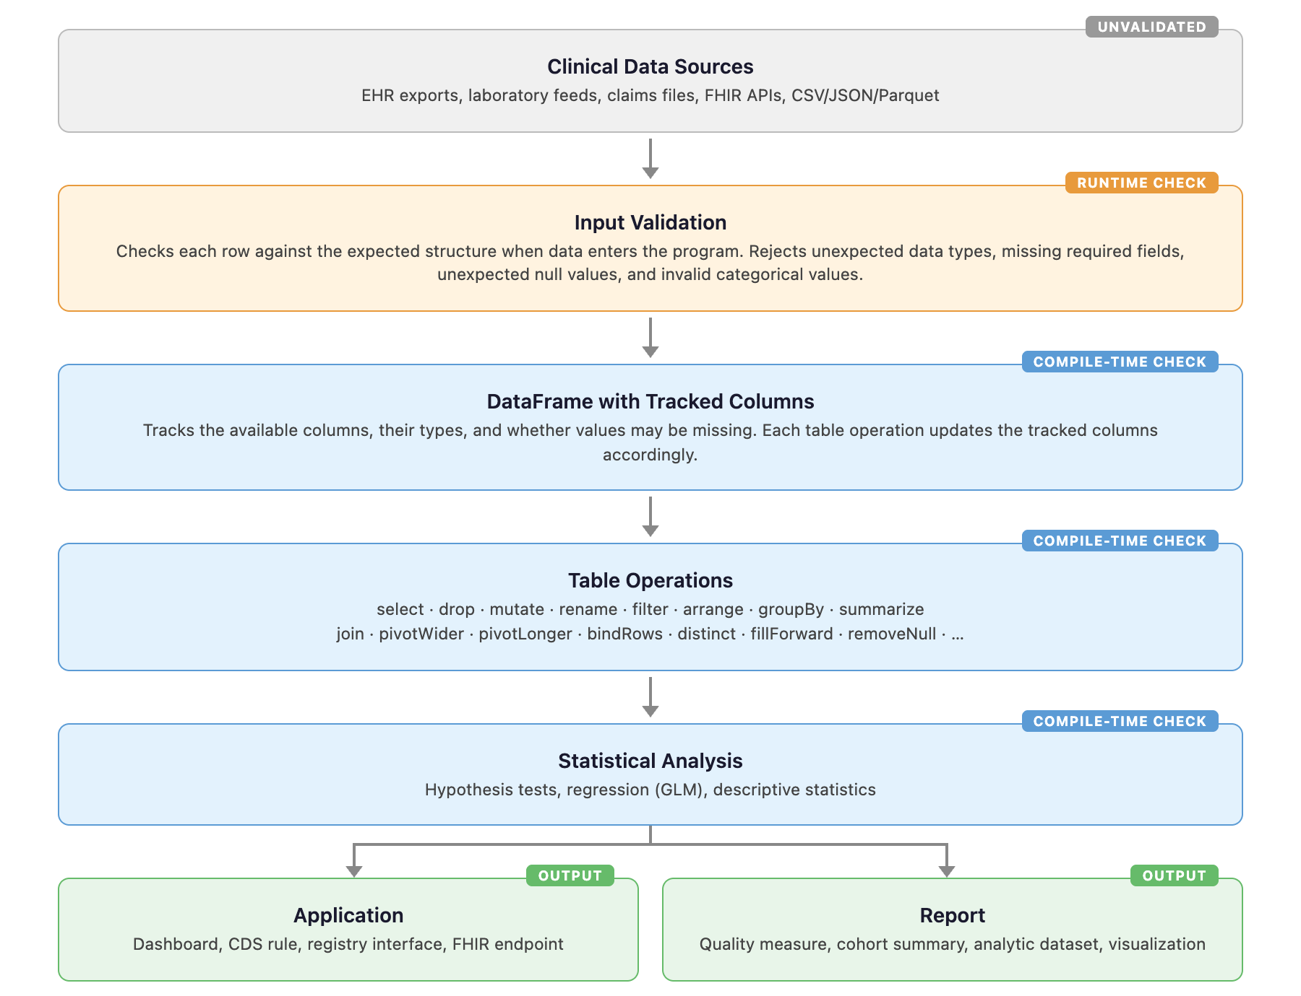

Figure 2. Detection Rates by Error Category and Language

Each cell shows how many intentional errors were detected (compile-time error, runtime error, or warning) before producing incorrect output. Green = all detected. Yellow = some detected. Red = most went undetected.

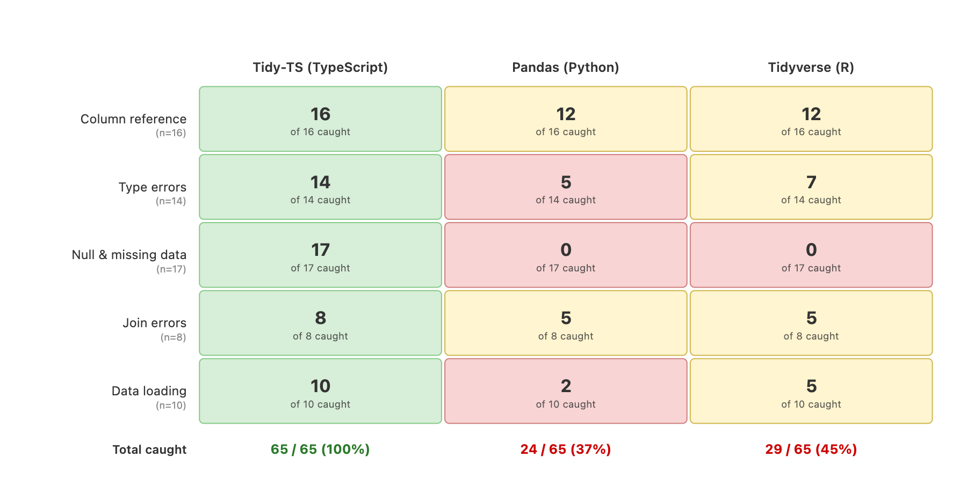

Figure 3. Arithmetic on a laboratory value stored as text.

Laboratory data sometimes contains text values such as "MISSING" or "pending" where a number is expected. Each panel multiplies this column by 2. Tidy-TS (TypeScript) catches the error before the code runs. Pandas (Python) continues silently and produces "MISSINGMISSING." Tidyverse (R) stops with an error when the code runs.

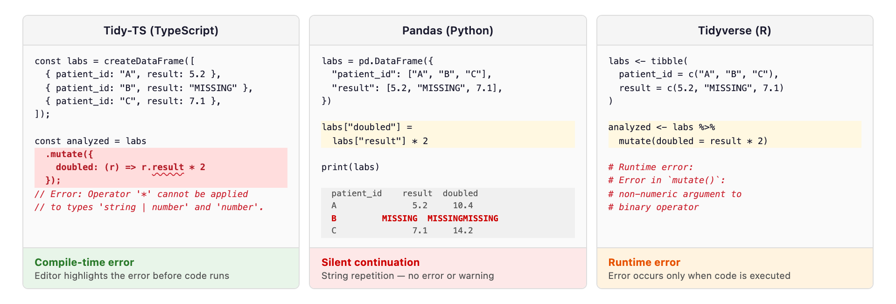

Table 1: Error Outcome Definitions

Outcome | Meaning
Compile-time error | The compiler identifies the error before the code runs
Runtime error | Program runs and stops with an error message
Runtime warning | Program prints a warning but continues and may produce an incorrect result
Silent continuation | Program continues without error or warning and produces incorrect output

Table 2. Detection Outcomes by Error Category
Detection outcomes for 65 tests across five error categories and three languages. For Tidy-TS, 'compile' shows errors caught before the code runs. 'Runtime' shows errors that would also produce an error or stop the program when the code runs, including validation of external data.
 |  |  | Tidy-TS (TypeScript) |  | Pandas (Python) |  |  | Tidyverse (R)
 |  |  | compile | runtime | runtime |  |  | runtime
Category | Example error | n | error | error | error | warn | silent | error | warn | silent
Column reference | Use ‘patientId’ instead of ‘patient_id’ | 16 | 16 | 16 | 14 | 0 | 2 | 14 | 0 | 2
Value type errors | Lab result imported as text instead of number, then used in arithmetic | 14 | 13 | 3 | 5 | 0 | 9 | 4 | 3 | 7
Missing value errors | Divide by a reference range value that may be missing | 17 | 17 | 3 | 0 | 0 | 17 | 2 | 0 | 15
Join errors | Use a department column that may be missing after joining patients to encounters | 8 | 8 | 6 | 5 | 0 | 3 | 5 | 0 | 3
Data loading | Load lab results where a numeric column contains text like "pending" | 10 | 8 | 8 | 2 | 0 | 8 | 4 | 1 | 5
Total |  | 65 | 62 | 36 | 26 | 0 | 39 | 29 | 4 | 32

Supplemental Table 1. Python Static Type Checker Coverage and Polars Runtime.
Detection outcomes for pyright (1.1.400) and mypy (1.16.0) running in strict mode on the same 65 error scenarios, with pandas-stubs (2.2.3.241126) installed. Polars (1.30.0) runtime results are included for comparison.
 |  | Tidy-TS |  | pyright | mypy | Polars | pandas | tidyverse
Category | n | compile | runtime | compile | compile | runtime | runtime | runtime
Column reference | 16 | 16 (100%) | 16 (100%) | 0 (0%) | 0 (0%) | 14 (88%) | 14 (88%) | 14 (88%)
Value type | 14 | 13 (93%) | 3 (21%) | 0 (0%) | 1 (7%) | 6 (43%) | 5 (36%) | 4 (29%)
Missing value | 17 | 17 (100%) | 3 (18%) | 0 (0%) | 0 (0%) | 0 (0%) | 0 (0%) | 2 (12%)
Join errors | 8 | 8 (100%) | 6 (75%) | 0 (0%) | 0 (0%) | 3 (38%) | 5 (63%) | 5 (63%)
Data loading | 10 | 8 (80%) | 8 (80%) | 0 (0%) | 0 (0%) | 5 (50%) | 2 (20%) | 5 (50%)
Total | 65 | 62 (95%) | 36 (55%) | 0 (0%) | 1 (2%) | 28 (43%) | 26 (40%) | 29 (45%)

References
- Why Are Data Missing in Clinical Data Warehouses? A Simulation Study of How Data Are Processed (And Can Be Lost). Priou S, Lame G, Jankovic M, et al. Studies in Health Technology and Informatics. 2023;302:202-206. doi:10.3233/SHTI230103.
- Unintended Adverse Consequences of a Clinical Decision Support System: Two Cases. Stone EG. Journal of the American Medical Informatics Association : JAMIA. 2018;25(5):564-567. doi:10.1093/jamia/ocx096.
- Targeted Data Quality Analysis for a Clinical Decision Support System for SIRS Detection in Critically Ill Pediatric Patients. Tute E, Mast M, Wulff A. Methods of Information in Medicine. 2023;62(S 01):e1-e9. doi:10.1055/s-0042-1760238.
- Beyond Missingness: Systematizing Methods for Comprehensive Data Fitness Assessment in Clinical Research. Razzaghi H, Wieand K, Dickinson KL, et al. Journal of Medical Internet Research. 2026;28:e76398. doi:10.2196/76398.
- Automated Testing to Improve Data Quality in Clinical Study Databases. Hussein E, Dugas M, Ganzinger M, et al. Studies in Health Technology and Informatics. 2025;329:1718-1719. doi:10.3233/SHTI251180.
- Implications of Data Extraction and Processing of Electronic Health Records for Epidemiological Research: Observational Study. van Essen MHJ, Twickler R, Weesie YM, et al. Journal of Medical Internet Research. 2025;27:e64628. doi:10.2196/64628.
- “Goldmine” or “Big Mess”? An Interview Study on the Challenges of Designing, Operating, and Ensuring the Durability of Clinical Data Warehouses in France and Belgium. Priou S, Kempf E, Jankovic M, Lamé G. Journal of the American Medical Informatics Association : JAMIA. 2024;31(11):2699-2707. doi:10.1093/jamia/ocae244.
- The METRIC-framework for Assessing Data Quality for Trustworthy AI in Medicine: A Systematic Review. Schwabe D, Becker K, Seyferth M, Klaß A, Schaeffter T. NPJ Digital Medicine. 2024;7(1):203. doi:10.1038/s41746-024-01196-4.
- Detecting and Remediating Harmful Data Shifts for the Responsible Deployment of Clinical AI Models. Subasri V, Krishnan A, Kore A, et al. JAMA Network Open. 2025;8(6):e2513685. doi:10.1001/jamanetworkopen.2025.13685.
- Opportunities, Pitfalls, and Alternatives in Adapting Electronic Health Records for Health Services Research. Taksler GB, Dalton JE, Perzynski AT, et al. Medical Decision Making : An International Journal of the Society for Medical Decision Making. 2021;41(2):133-142. doi:10.1177/0272989X20954403.
- Validating the Extract, Transform, Load Process Used to Populate a Large Clinical Research Database. Denney MJ, Long DM, Armistead MG, Anderson JL, Conway BN. International Journal of Medical Informatics. 2016;94:271-4. doi:10.1016/j.ijmedinf.2016.07.009.
- Tracking Provenance in Clinical Data Warehouses for Quality Management. Johns M, Baum L, Prasser F. International Journal of Medical Informatics. 2025;193:105690. doi:10.1016/j.ijmedinf.2024.105690.
- Methods and Dimensions of Electronic Health Record Data Quality Assessment: Enabling Reuse for Clinical Research. Weiskopf NG, Weng C. Journal of the American Medical Informatics Association : JAMIA. 2013;20(1):144-51. doi:10.1136/amiajnl-2011-000681.
- Challenges for Data Quality in the Clinical Data Life Cycle: Systematic Review. An D, Lim M, Lee S. Journal of Medical Internet Research. 2025;27:e60709. doi:10.2196/60709.
- Analysis of Clinical Decision Support System Malfunctions: A Case Series and Survey. Wright A, Hickman TT, McEvoy D, et al. Journal of the American Medical Informatics Association : JAMIA. 2016;23(6):1068-1076. doi:10.1093/jamia/ocw005.
- The Impact of Data Quality Defects on Clinical Decision-Making in the Intensive Care Unit. Kramer O, Even A, Matot I, Steinberg Y, Bitan Y. Computer Methods and Programs in Biomedicine. 2021;209:106359. doi:10.1016/j.cmpb.2021.106359.
- Increasing Trust in Real-World Evidence Through Evaluation of Observational Data Quality. Blacketer C, Defalco FJ, Ryan PB, Rijnbeek PR. Journal of the American Medical Informatics Association : JAMIA. 2021;28(10):2251-2257. doi:10.1093/jamia/ocab132.
- A Harmonized Data Quality Assessment Terminology and Framework for the Secondary Use of Electronic Health Record Data. Kahn MG, Callahan TJ, Barnard J, et al. EGEMS (Washington, DC). 2016;4(1):1244. doi:10.13063/2327-9214.1244.
Baldridge AS, Bellinger GC, Fleming OM, Rasmussen LV, Whitley EW, Welty LJ. The epidemiology of errors in data capture, management, and analysis: A scoping review of retracted articles and retraction notices in clinical and translational research. Journal of Clinical and Translational Science. 2024;8(1):e174. doi:10.1017/cts.2024.533.
Ziemann M, Eren Y, El-Osta A. Gene name errors are widespread in the scientific literature. Genome Biology. 2016;17(1):177. doi:10.1186/s13059-016-1044-7.

