Detecting Clinical Data Errors Before the Code Runs: Design and Evaluation of a TypeScript Data Analysis Framework

Abstract

Objective
Clinical data analyses often require many processing steps, including selecting columns from a dataset, joining patient and encounter records, reorganizing laboratory and vital sign data, converting strings to numbers or dates, and handling missing values. Mistakes in these steps can produce incorrect results, especially when errors are not detected until late in the workflow or the program continues without warning and produces incorrect output.

Materials and Methods
We developed Tidy-TS, a TypeScript framework for clinical data analysis that provides structured datasets with processing operations and statistical functions. Tidy-TS tracks the available columns and their types as data moves through each processing step, so that errors such as referencing a missing column, using a value that might be missing, or treating text as a number are caught before the code runs. We evaluated the framework with a comparison suite of 65 intentional error scenarios using sample clinical datasets representing patients, encounters, laboratory results, medications, and vital signs. Equivalent tests were implemented in Tidy-TS, Python (using pandas), and R (using tidyverse). Each outcome was classified as caught before the code ran (compile-time error), caught when the code ran (runtime error), flagged as a warning (runtime warning), or missed entirely (silent continuation). Tests were also classified by severity.

Results
The comparison suite included 65 error scenarios across five error categories. Tidy-TS caught 62 of 65 errors before the code ran and caught the remaining 3 when the data was first loaded. Pandas caught 24 at runtime and missed 41. Tidyverse caught 25 at runtime, warned on 4, and missed 36. The gap was largest for the most consequential errors, those that produce plausible but incorrect output. All 30 of these continued silently in pandas, and 27 of 30 in tidyverse. None continued silently in Tidy-TS. Missing value errors accounted for 12 of the 30 most consequential errors, and all 12 continued silently in both pandas and tidyverse.

Discussion
The detection gap is concentrated in errors that produce plausible but incorrect output, particularly missing values carried through calculations or introduced by joins. These are the errors most likely to affect clinical results without being noticed.

Conclusion
Tidy-TS demonstrates that many common clinical data errors can be caught before the code runs by tracking column names, types, and missing values through each processing step. Tidy-TS catches errors that continue silently in Python and R, particularly in the most consequential categories.

Background and Significance

Clinical Data Processing Errors Are Common, Consequential, and Often Invisible
Clinical data work involves many processing steps. Patient demographics, encounters, diagnoses, medications, laboratory results, vital signs, and claims must be selected, joined, converted, grouped, and summarized before they can be analyzed. A typical workflow may read data from files or databases, select a subset of columns, join records from different sources, convert strings into numbers or dates, reorganize data from long to wide form, group records by patient or encounter, summarize measurements, and then pass the result into a statistical model or dashboard.
These steps are routine, but they are also a well-documented source of error. And the consequences of such errors can be large enough to change study conclusions.[4][6][7] A column may be misspelled. A column that existed early in a workflow may no longer exist. Missing values can be introduced after joining two datasets with incomplete data. Numeric laboratory results might have a string of text where a number was expected. A missing dose quantity might lead a medication prescription to be misinterpreted, converted, or silently excluded depending on the programming language being used.
Most clinical data analysis is performed in Python or R, programming languages that check for errors only when the code runs (called runtime checking). Some errors are clear because the program stops immediately after the error occurs. Others are harder to detect because the program continues without any signal that something went wrong. When this happens, an incorrect result may be used in later steps for cohort definition, quality measurement, modeling, or clinical decision support.
One analysis found that 25 to 58% of eligible patients were silently dropped from a breast cancer cohort before any researcher touched the data.[11] In a survey across 14 US sites, nearly all Chief Medical Information Officers reported at least one alert malfunction caused by data changes that silently broke clinical decision support rules.[10]
In contrast to Python and R, some programming languages include a program called a compiler that checks for certain categories of errors before the code runs, using what is called a static type system. This is called compile-time checking, and its theoretical foundation is well established.[18][19]
Two independent studies found that static type checking could detect approximately 15% of real-world bugs in programming languages that check for errors only when the code runs, with missing-value errors, references to things that no longer exist, and treating text as a number among the most common preventable categories.[20][21] These are the same kinds of errors that arise in clinical data processing.
TypeScript is a programming language with a static type system that is increasingly used in clinical informatics for health data standards, web dashboards, and data services.[26][27][28]
Despite this widespread use, TypeScript has not traditionally been used as a primary language for data analysis. Clinical applications that receive, process, and display patient data using TypeScript typically export that data to Python or R for analysis, then re-import results. This boundary crossing introduces its own opportunities for error. As regulators begin to require data quality evaluation for clinical software,[29][30] the cost of undetected processing errors increases.
This study evaluates whether a data analysis framework built in TypeScript can detect common clinical data processing errors compared to conventional Python and R workflows, and characterizes the practical limits of this approach.

Objective
We developed Tidy-TS, a framework for clinical data analysis in TypeScript that represents data as structured datasets. The evaluation addressed three questions.
- Can TypeScript's type system track column names, types, and whether values may be missing through clinical data processing steps, and catch errors before the code runs?
- How are equivalent clinical data errors detected in Tidy-TS compared to Python (using pandas) and R (using tidyverse)?
- Where does compile-time checking end and runtime checking remain necessary?

Materials and Methods

System Design
Tidy-TS is a TypeScript framework for working with datasets. It represents data as a collection of rows, where each row has named columns with specific value types. Each dataset tracks which columns are available and what type of value each column contains.
For example, a dataset with patient identifier, name, and age tracks those three columns and their types. When a processing step changes the dataset, the tracked columns change as well. Selecting specific columns removes the other columns from the tracked set, while adding or editing an existing column updates the tracked columns. Joining two datasets combines the columns from both and marks values in those columns as possibly missing when the join can introduce missing values.
Each operation follows a defined type rule that determines how the tracked columns change. For example, selecting columns keeps only those columns. Joining two datasets combines their columns and marks values as possibly missing when the join can introduce missing values. Summarizing replaces the original columns with only the summary columns plus any group keys. Removing missing values from a column narrows that column's type so that subsequent operations can use it without handling the missing case. The full set of type rules covering all operations is provided in Supplementary Table 2.
The framework includes common dataset operations such as filtering, selecting, joining, grouping, summarizing, adding or modifying columns, and filling missing values. It also includes statistical functions and hypothesis tests. Statistical functions are validated against R, with test statistics and p-values required to agree within 1e-6. The validation suite covers hypothesis tests, distributions, and regression models, and includes tests adapted from R's own test suite.

Compile-Time Checking
The core mechanism of Tidy-TS is that TypeScript's compiler reviews each processing step before the code runs. If a program refers to a column that does not exist, uses a value that might be missing without handling it first, or treats text as a number, the compiler rejects the code and shows exactly where the problem is.
The framework's test suite includes approximately 1,700 tests covering dataset operations, statistical functions, and input handling, including tests that verify column tracking works correctly through each processing step. For this evaluation, we also created a focused test file containing a series of intentional errors alongside valid operations (Supplementary A). The compiler checks this file without running it, confirming that valid operations produce the expected column types and that invalid operations are rejected. For example, it verifies that selecting columns returns only the selected columns, that joining two datasets marks values as possibly missing when the join can introduce missing values, and that removing missing values from a column allows arithmetic on that column afterward.

Runtime Checking and Validation
Compile-time checking can only work after the program knows the expected structure of the data. For data coming from files, databases, or other external sources, Tidy-TS confirms that each row matches the expected structure when the data is first loaded, a process called validation. If the data matches, the column types are set automatically. If there is an unexpected value, for example a text value when only numbers are expected, Tidy-TS reports an error and stops. After validation, the compiler checks each subsequent processing step against the known columns and types.

Language Comparison Suite
To compare error detection across Tidy-TS, Python, and R, we created a comparison suite using sample clinical datasets representing patients, encounters, laboratory results, medications, and vital signs. The test cases were derived from error patterns described in published clinical data quality literature[4][6][7][11][14] and from errors encountered during the framework's deployment at the University of Utah. Tests were organized by the type of mistake involved, including misspelled or missing columns, using the wrong type of value, arithmetic on values that might be missing, errors introduced by joining datasets, and problems when loading data from files. Each test represents a specific clinical data processing error, such as a misspelled patient identifier, a column that no longer exists after summarization, arithmetic on a laboratory value that might be missing, a join that introduces missing data, or an invalid categorical value.
We implemented equivalent tests using pandas (3.0.3) with Python 3.14.5 and tidyverse (2.0.0) with R 4.6.0. Tidy-TS tests were run with TypeScript 5.9.2 on Deno 2.7.14, a runtime environment for TypeScript. Each outcome was classified into four categories (Table 1).
The tests cover five error categories, including column reference errors, value type errors, missing value errors, join errors, and data loading errors.
The error categories in the comparison suite map primarily to the Conformance and Completeness dimensions of the Kahn et al. harmonized data quality framework.[Kahn 2016] Column reference and value type errors correspond to relational and value conformance. Missing value errors correspond to completeness. Join errors span both conformance and completeness. Plausibility, which requires inspecting actual data values against domain knowledge or external benchmarks, is outside the scope of compile-time checking.

Error Severity Classification
Each test was also classified by how consequential the error would be if it went undetected. Severity was determined independently of whether the error was caught. This follows established approaches in quality assurance, including Failure Modes and Effects Analysis (FMEA)[45][46] and the O'Kane system for grading laboratory errors,[47][48] both of which score severity by consequence rather than likelihood of detection.
Severity was assigned to each test in two tiers.
High - All three of the following were required.
- The error would change a numeric result, cohort membership, or clinical decision.
- The error is systematic, affecting every patient or row that meets a certain condition in the same way, rather than introducing random noise. Based on findings that systematic data errors bias effect size estimates even at low prevalence.[17]
- The incorrect output looks plausible and would not be caught by routine inspection.
Low - The error did not meet all three High criteria, Any one of the following was also sufficient.
- The error produces obviously wrong output that an analyst would likely identify and fix (zero rows, an entirely missing column, a negative count)
- The error affects only cosmetic properties such as display formatting or column ordering.
- The error is overwritten or discarded by a later step.
Every error in the comparison suite was classified into one of the two tiers.
Detection outcomes were recorded for each language separately from severity.

Results

Language Comparison Suite
The comparison suite included 65 tests across five error categories, including column reference errors (16, 25%), value type errors (14, 22%), missing value errors (17, 26%), join errors (8, 12%), and data loading errors (10, 15%). Of these, 30 (46%) were classified as High severity and 35 (54%) as Low. Each test was run in Tidy-TS, pandas, and tidyverse.
Tidy-TS caught 62 of 65 errors (95%) before the code ran and caught the remaining 3 (5%) through validation when the data was first loaded. Pandas caught 24 (37%) at runtime and missed 41 (63%). Tidyverse caught 25 (38%) at runtime, warned on 4 (6%), and missed 36 (55%) (Table 2).
We also tested Python's compile-time checking tools mypy and pyright with pandas-stubs installed. Neither tool caught any of the 65 errors at compile time (Supplemental Table 1).
Tidy-TS also caught 35 of 65 errors (54%) at runtime, providing a second layer of detection for errors the compiler had already identified.
The largest detection gap was in the missing value category. All 17 tests continued silently in both pandas and tidyverse. Common examples included missing values carried through calculations, comparisons that silently excluded rows with missing values, and missing values introduced by joins that were used in later operations without being handled. Tidy-TS caught all 17 before the code ran.
Column reference errors showed the smallest detection gap because these errors tend to stop the program immediately. Pandas and tidyverse caught 12 of 16 (75%) at runtime, typically stopping when a misspelled or nonexistent column was used. The 4 that continued silently involved columns that a processing step was expected to remove but did not, such as keeping extra columns when removing duplicate rows.
Value type errors and join errors fell between these extremes. In both categories, pandas and tidyverse caught errors involving obviously invalid operations (such as misspelled join keys) but allowed errors with plausible output to continue silently. Figure 3 illustrates this with a laboratory result column that contains the text value "MISSING" alongside numbers. Multiplying the column by 2 produces "MISSINGMISSING" in pandas without any error or warning.

Detection by Severity
The detection gap between Tidy-TS and the other languages was largest for the most consequential errors, those classified as High severity (Table 3). Of the 30 High-severity tests, none continued silently in Tidy-TS. In pandas, all 30 (100%) continued silently. In tidyverse, 27 of 30 (90%) continued silently.
Twelve of the 30 High-severity tests involved missing values. These errors are particularly consequential because a missing laboratory value carried through a calculation, or a missing value introduced by a join and then used in a comparison, produces output that looks correct but is systematically wrong. All 12 continued silently in both pandas and tidyverse.
At Low severity, the gap narrowed. Pandas caught 24 of 35 (69%) at runtime and tidyverse caught 24 of 35 (69%), with 2 additional warnings (6%). Low-severity errors are more likely to stop the program immediately or produce visibly wrong output, such as using a column name that does not exist. Tidy-TS caught all 35 at compile time.

Discussion
Clinical data analysis requires many processing steps, and each step can introduce errors. Columns are misspelled or removed by earlier steps, joins change which patients have complete data, and missing values enter calculations. When these errors stop the program, the analyst can find and fix them. When they do not, incorrect results enter downstream analysis without any signal that something went wrong.
Tidy-TS caught all 30 high-severity errors before the code ran. All 30 continued silently in pandas, and 27 of 30 in tidyverse. The gap is concentrated in errors that produce plausible but systematically wrong output, particularly missing values carried through calculations or introduced by joins. Systematic data errors of this kind have been shown to bias treatment-effect estimates even when the errors affect a small fraction of records.[17] The consistency of this finding across all 30 high-severity scenarios suggests that the problem is structural rather than a matter of analyst skill or diligence.
Python and R detect errors only when the code runs. Python's optional static analysis tools (mypy, pyright) caught none of the 65 errors, even with the most thorough settings enabled. These tools can describe the types of individual values but cannot track how a dataset's columns and types change as data moves through processing steps. That tracking is the specific capability that allows Tidy-TS to catch errors before the code runs.
Compile-time checking is sometimes perceived as adding friction. In practice, Tidy-TS surfaces errors in the editor as the analyst writes, with a message identifying the exact problem. Handling a missing value after a join is work the analyst would need to do regardless to get a correct result. The difference is whether that requirement is made visible before the code runs or allowed to silently produce incorrect output.
This work addresses a gap between data quality checks on stored datasets and the errors that arise during analysis. At the data repository level, tools like the OHDSI Data Quality Dashboard run thousands of checks against stored datasets to assess conformance, completeness, and plausibility.[Blacketer 2021] At the study level, recent work has argued that even comprehensive repository checks do not fully address what each individual analysis needs from the data.[Razzaghi 2026] Both of these approaches evaluate data before or outside the analysis code. The errors Tidy-TS catches occur within the analysis workflow itself, after data has already passed quality checks. Data handling and transformation during analysis have been identified as distinct error sources that these checks do not address.[Sauer 2022][Kohane 2021]
Runtime validation libraries in Python and R (such as pandera and pointblank) also target the analysis workflow, but they require the analyst to anticipate each check and write it manually. Tidy-TS enforces these checks structurally through the compiler whether or not the analyst adds them. This distinction is largest for errors that are difficult to anticipate, which in this evaluation were also the most consequential.
LLM-generated analysis code is susceptible to the same error patterns. Large language models are increasingly used to generate data analysis code in biomedical research, but benchmarking across hundreds of biomedical data analysis tasks has found overall accuracy below 40%, with errors that often produce plausible but incorrect output rather than obvious failures.[Wang 2026] LLM-generated code is susceptible to the error patterns this evaluation identified as high-severity. An LLM generating a join will not track whether the join introduced missing values, and an LLM referencing a column after a summarization step will not verify that the column still exists. Compile-time checking provides a safeguard that operates independently of whether the code was written by a human or generated by a model.[Trisovic 2022][Song 2026]
The framework is deployed at the University of Utah, where it maps hospital data into structured datasets for quality improvement and research. In practice, the most common benefit has been explicit handling of missing values after joins, consistent with the finding that missing value errors are the category most likely to continue silently in pandas and tidyverse.
Compile-time checking does not eliminate the need for runtime validation when external data enters the program, which is why 3 of the 65 errors were caught at that boundary. TypeScript also has practical limits. Programmers can bypass the compiler, and workflows with many steps in sequence can exceed compiler capacity, requiring them to be broken into smaller parts.
Limitations
The comparison suite uses sample clinical datasets rather than production workflows and does not measure how often these errors occur in routine work. The evaluation measures error detection, not downstream patient outcomes, analyst productivity, or false-positive rates. Severity was assigned by the study team rather than independent raters, though criteria are defined explicitly to support reproducibility. Compile-time checking cannot verify that a cohort definition is appropriate, that a statistical test is justified, or that clinical concepts are correctly specified. Runtime validation remains necessary for external data, and designing the expected data structure remains the developer's responsibility.

Conclusion
Tidy-TS is a data analysis framework supporting clinical data analysis in TypeScript. It tracks the available columns, their types, and whether values may be missing as data moves through each processing step, and catches errors before the code runs. External data is validated when it enters the program. Tidy-TS catches errors that continue silently in Python and R, particularly in the most consequential categories. The approach does not replace clinical review or statistical validation, but it addresses a class of errors that Python and R do not detect.

Acknowledgements
AI-assisted tools (Anthropic Claude, OpenAI ChatGPT) were used throughout the project for code development, data processing, and manuscript drafting. All scientific content, study design, analysis decisions, and interpretations were made by the authors, who take full responsibility for the work.
Tidy-TS builds on ideas and infrastructure from several open-source projects, including R, Python, pandas, Polars, tidyverse, Arquero, and Zod. The authors are grateful to these communities for their work.
Data Availability
The Tidy-TS framework, the full comparison suite of 65 error scenarios with equivalent implementations in Tidy-TS, pandas, tidyverse, and Polars, the sample clinical datasets, and the framework's test suite are publicly available at https://github.com/jtmenchaca/tidy-ts (release 2.0.0). All outcomes reported in this paper can be reproduced from the published source code.

Figure 1. Tidy-TS Clinical Data Workflow

In a Tidy-TS workflow, external data is validated against an expected structure when first loaded, processed through a series of steps checked by the compiler before the code runs, and then used in later outputs.

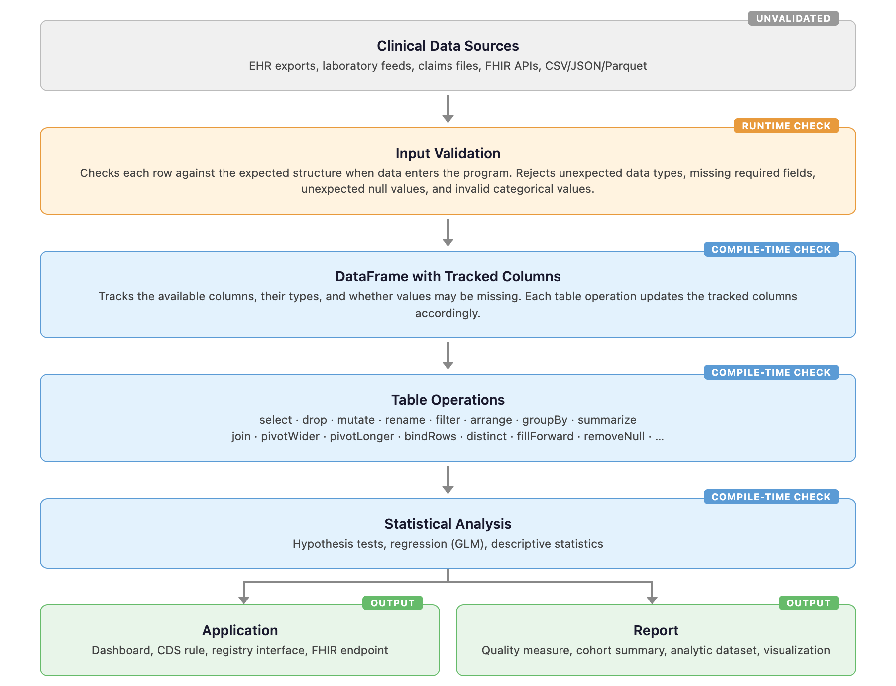

Figure 2. Detection Rates by Error Category and Language

Each cell shows how many intentional errors were detected (compile-time error, runtime error, or warning) before producing incorrect output. Green = all detected. Yellow = some detected. Red = most went undetected.

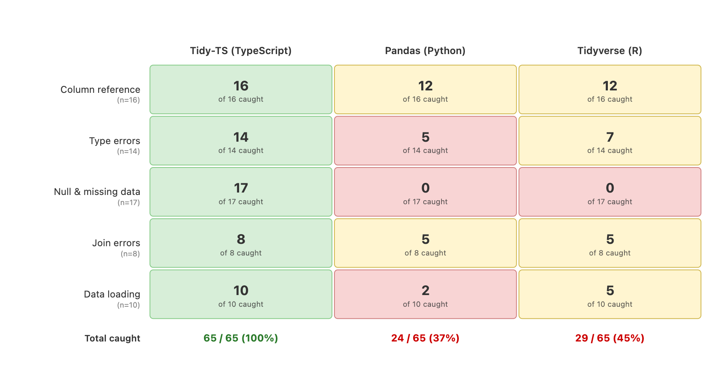

Figure 3. Arithmetic on a laboratory value stored as text.

Laboratory data sometimes contains text values such as "MISSING" or "pending" where a number is expected. Each panel multiplies this column by 2. Tidy-TS (TypeScript) catches the error before the code runs. Pandas (Python) continues silently and produces "MISSINGMISSING." Tidyverse (R) stops with an error when the code runs.

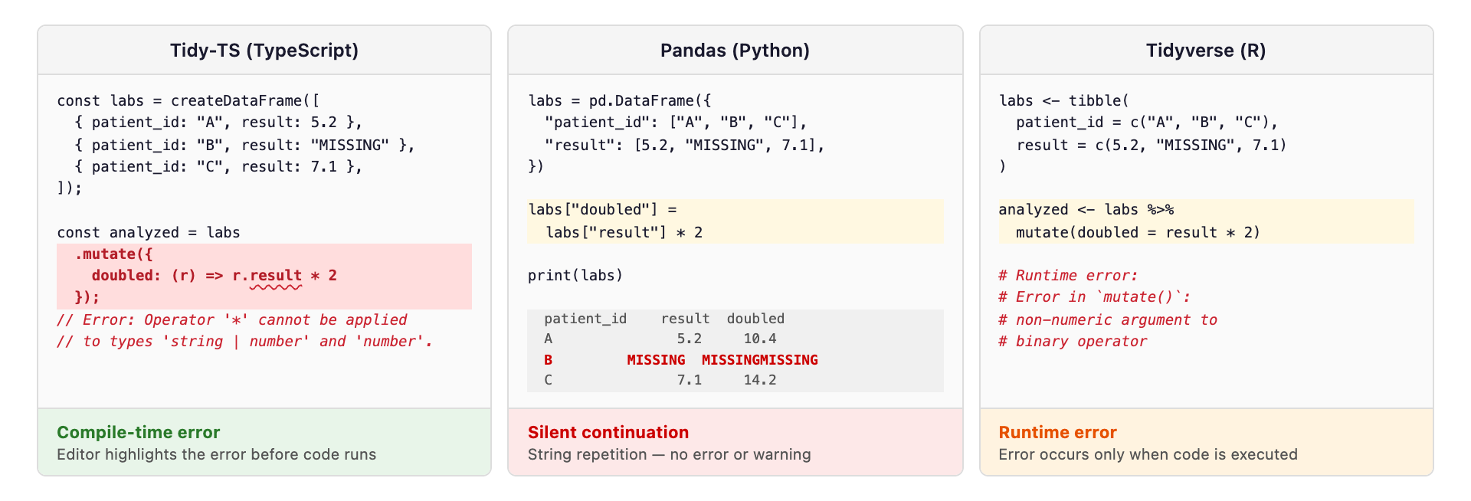

Table 1: Error Outcome Definitions

Outcome | Meaning
Compile-time error | The compiler identifies the mistake before the code runs
Runtime error | Program runs and stops with an error message
Runtime warning | Program prints a warning but continues and may produce an incorrect result
Silent continuation | Program continues without error or warning and produces incorrect output

Table 2. Detection Outcomes by Error Category
Detection outcomes for 65 tests across five error categories and three languages. For Tidy-TS, 'compile' shows errors caught before the code runs. 'Runtime' shows errors that would also produce an error or stop the program when the code runs, including validation of external data.
 |  |  | Tidy-TS (TypeScript) |  | Pandas (Python) |  |  | Tidyverse (R)
 |  |  | compile | runtime | runtime |  |  | runtime
Category | Example error | n | error | error | error | warn | silent | error | warn | silent
Column reference | Use ‘patientId’ instead of ‘patient_id’ | 16 | 16 | 16 | 12 | 0 | 4 | 12 | 0 | 4
Value type errors | Lab result imported as text instead of number, then used in arithmetic | 14 | 13 | 3 | 5 | 0 | 9 | 4 | 3 | 7
Missing value errors | Divide by a reference range value that may be missing | 17 | 17 | 3 | 0 | 0 | 17 | 0 | 0 | 17
Join errors | Use a department column that may be missing after joining patients to encounters | 8 | 8 | 6 | 5 | 0 | 3 | 5 | 0 | 3
Data loading | Load lab results where a numeric column contains text like "pending" | 10 | 8 | 7 | 2 | 0 | 8 | 4 | 1 | 5
Total |  | 65 | 62 | 35 | 24 | 0 | 41 | 25 | 4 | 36

Table 3. Detection Results by Severity
Number of tests at each severity level, showing whether each language caught or missed the error. Severity was assigned independently of whether the error was caught, as described in Methods.
 |  | Tidy-TS (TypeScript) |  |  | Pandas (Python) |  | Tidyverse ®
Potential severity | n | compile | runtime | silent | error | silent | error | warn | silent
High | 30 | 28 (93%) | 2 (7%) | 0 (0%) | 0 (0%) | 30 (100%) | 1 (3%) | 2 (7%) | 27 (90%)
Low | 35 | 34 (97%) | 1 (3%) | 0 (0%) | 24 (69%) | 11 (31%) | 24 (69%) | 2 (6%) | 9 (26%)
Total | 65 | 62 (95%) | 3 (5%) | 0 (0%) | 24 (37%) | 41 (63%) | 25 (38%) | 4 (6%) | 36 (55%)

Supplemental Table 1. Python Static Type Checker Coverage and Polars Runtime.
Detection outcomes for pyright (1.1.400) and mypy (1.16.0) running in strict mode on the same 65 error scenarios, with pandas-stubs (2.2.3.241126) installed. Polars (1.30.0) runtime results are included for comparison.
 |  | Tidy-TS |  | pyright | mypy | Polars | pandas | tidyverse
Category | n | compile | runtime | compile | compile | runtime | runtime | runtime
Column reference | 16 | 16 (100%) | 16 (100%) | 0 (0%) | 0 (0%) | 13 (81%) | 12 (75%) | 12 (75%)
Value type | 14 | 13 (93%) | 3 (21%) | 0 (0%) | 0 (0%) | 7 (50%) | 5 (36%) | 7 (50%)
Missing value | 17 | 17 (100%) | 3 (18%) | 0 (0%) | 0 (0%) | 0 (0%) | 0 (0%) | 0 (0%)
Join errors | 8 | 8 (100%) | 6 (75%) | 0 (0%) | 0 (0%) | 3 (38%) | 5 (63%) | 5 (63%)
Data loading | 10 | 8 (80%) | 7 (70%) | 0 (0%) | 0 (0%) | 5 (50%) | 2 (20%) | 5 (50%)
Total | 65 | 62 (95%) | 35 (54%) | 0 (0%) | 0 (0%) | 28 (43%) | 24 (37%) | 25 (38%)

References
- Why Are Data Missing in Clinical Data Warehouses? A Simulation Study of How Data Are Processed (And Can Be Lost). Priou S, Lame G, Jankovic M, et al. Studies in Health Technology and Informatics. 2023;302:202-206. doi:10.3233/SHTI230103.
- Unintended Adverse Consequences of a Clinical Decision Support System: Two Cases. Stone EG. Journal of the American Medical Informatics Association : JAMIA. 2018;25(5):564-567. doi:10.1093/jamia/ocx096.
- Targeted Data Quality Analysis for a Clinical Decision Support System for SIRS Detection in Critically Ill Pediatric Patients. Tute E, Mast M, Wulff A. Methods of Information in Medicine. 2023;62(S 01):e1-e9. doi:10.1055/s-0042-1760238.
- Beyond Missingness: Systematizing Methods for Comprehensive Data Fitness Assessment in Clinical Research. Razzaghi H, Wieand K, Dickinson KL, et al. Journal of Medical Internet Research. 2026;28:e76398. doi:10.2196/76398.
- Automated Testing to Improve Data Quality in Clinical Study Databases. Hussein E, Dugas M, Ganzinger M, et al. Studies in Health Technology and Informatics. 2025;329:1718-1719. doi:10.3233/SHTI251180.
- Implications of Data Extraction and Processing of Electronic Health Records for Epidemiological Research: Observational Study. van Essen MHJ, Twickler R, Weesie YM, et al. Journal of Medical Internet Research. 2025;27:e64628. doi:10.2196/64628.
- “Goldmine” or “Big Mess”? An Interview Study on the Challenges of Designing, Operating, and Ensuring the Durability of Clinical Data Warehouses in France and Belgium. Priou S, Kempf E, Jankovic M, Lamé G. Journal of the American Medical Informatics Association : JAMIA. 2024;31(11):2699-2707. doi:10.1093/jamia/ocae244.
- The METRIC-framework for Assessing Data Quality for Trustworthy AI in Medicine: A Systematic Review. Schwabe D, Becker K, Seyferth M, Klaß A, Schaeffter T. NPJ Digital Medicine. 2024;7(1):203. doi:10.1038/s41746-024-01196-4.
- Detecting and Remediating Harmful Data Shifts for the Responsible Deployment of Clinical AI Models. Subasri V, Krishnan A, Kore A, et al. JAMA Network Open. 2025;8(6):e2513685. doi:10.1001/jamanetworkopen.2025.13685.
- Opportunities, Pitfalls, and Alternatives in Adapting Electronic Health Records for Health Services Research. Taksler GB, Dalton JE, Perzynski AT, et al. Medical Decision Making : An International Journal of the Society for Medical Decision Making. 2021;41(2):133-142. doi:10.1177/0272989X20954403.
- Validating the Extract, Transform, Load Process Used to Populate a Large Clinical Research Database. Denney MJ, Long DM, Armistead MG, Anderson JL, Conway BN. International Journal of Medical Informatics. 2016;94:271-4. doi:10.1016/j.ijmedinf.2016.07.009.
- Tracking Provenance in Clinical Data Warehouses for Quality Management. Johns M, Baum L, Prasser F. International Journal of Medical Informatics. 2025;193:105690. doi:10.1016/j.ijmedinf.2024.105690.
- Methods and Dimensions of Electronic Health Record Data Quality Assessment: Enabling Reuse for Clinical Research. Weiskopf NG, Weng C. Journal of the American Medical Informatics Association : JAMIA. 2013;20(1):144-51. doi:10.1136/amiajnl-2011-000681.
- Challenges for Data Quality in the Clinical Data Life Cycle: Systematic Review. An D, Lim M, Lee S. Journal of Medical Internet Research. 2025;27:e60709. doi:10.2196/60709.
- Analysis of Clinical Decision Support System Malfunctions: A Case Series and Survey. Wright A, Hickman TT, McEvoy D, et al. Journal of the American Medical Informatics Association : JAMIA. 2016;23(6):1068-1076. doi:10.1093/jamia/ocw005.
- The Impact of Data Quality Defects on Clinical Decision-Making in the Intensive Care Unit. Kramer O, Even A, Matot I, Steinberg Y, Bitan Y. Computer Methods and Programs in Biomedicine. 2021;209:106359. doi:10.1016/j.cmpb.2021.106359.
- Increasing Trust in Real-World Evidence Through Evaluation of Observational Data Quality. Blacketer C, Defalco FJ, Ryan PB, Rijnbeek PR. Journal of the American Medical Informatics Association : JAMIA. 2021;28(10):2251-2257. doi:10.1093/jamia/ocab132.
- A Harmonized Data Quality Assessment Terminology and Framework for the Secondary Use of Electronic Health Record Data. Kahn MG, Callahan TJ, Barnard J, et al. EGEMS (Washington, DC). 2016;4(1):1244. doi:10.13063/2327-9214.1244.

