Dear Recruiter,
I am excited to apply for the [POSITION] at [COMPANY] for Summer 2026 I am pursuing a B.S.E. in Computer Science and Engineering with a minor in Mathematics at the University of Iowa (anticipated May 2027), and my coursework and professional experience have given me a strong foundation in software development, testing, and problem solving.
This past summer, I worked with Fractality LLC, where I designed and tested AWS pipelines for image processing and QR code generation, built Docker images to run tasks on EC2, and automated infrastructure setup with Python scripts. This gave me hands-on experience with cloud infrastructure and modern software workflows. I also serve as a Teaching Assistant for introductory and intermediate C++ courses at the University of Iowa, where I help students with object-oriented design, debugging, and problem-solving strategies. This role has strengthened both my technical expertise and my ability to explain complex concepts clearly.
Beyond the classroom, I have built personal projects including a C++ digital cookbook that organizes recipes with custom data structures and implementations of linked lists, stacks, and queues. These projects highlight my ability to design and test object-oriented programs. I also bring leadership and teamwork experience as the Vice President of the University of Iowa Cycling Club, where I coordinate events, manage logistics, and foster collaboration. These skills translate directly into working effectively in team-based engineering environments like [COMPANY]’s.
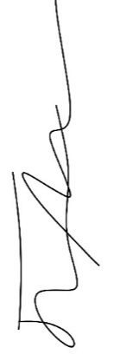
Thank you for considering my application. I am eagar about the opportunity to contribute to various projects and am excited to discuss how my skills align with the company’s goals. I look forward to the possibility of being part of [COMPANY]’s mission to tackle challenging problems and make a positive impact through technology.
Sincerely,

Jordan Miller

