Wireframe Examination
Joseph Noble
012440352
C971

Term Page
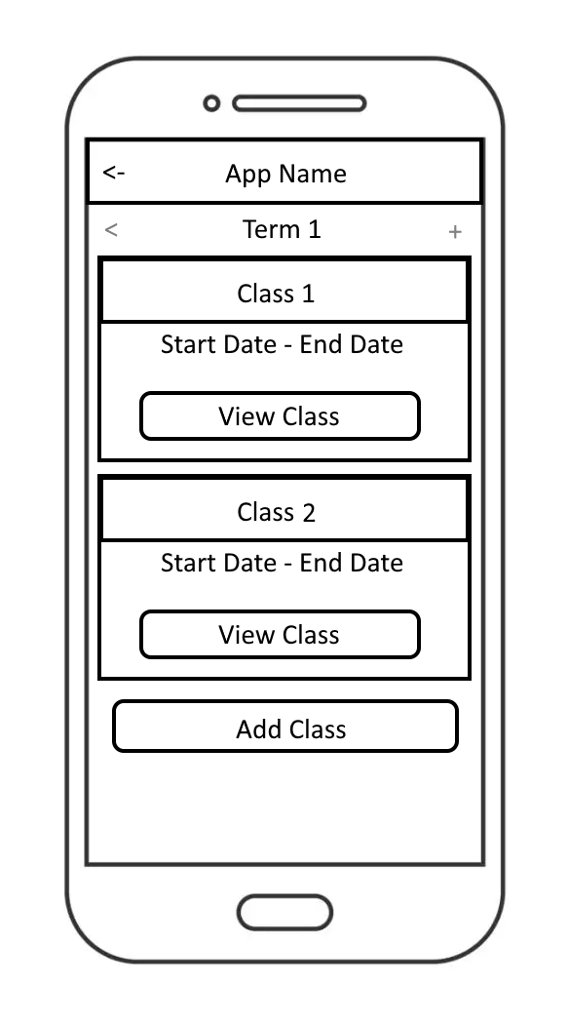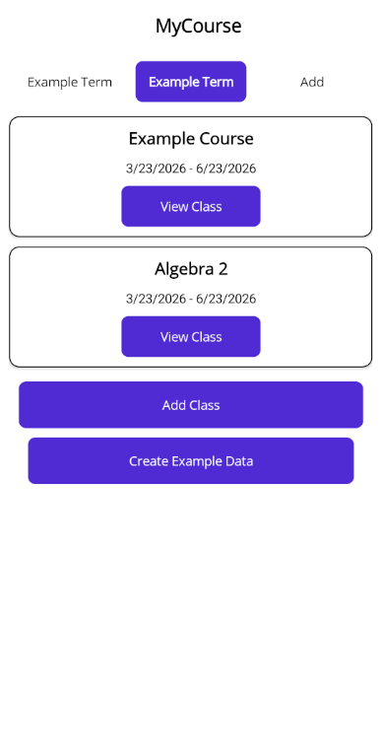

Before and after pages are very similar here. A back button was never required since this was the home menu. Likewise, using Back and + buttons didn’t work best for navigating between terms, so I instead opted for just keeping the term names on each side, and using the word “Add” instead. The “Create Example Data” button is a new addition; however, this is only held for debugging and wouldn’t end up in the full production release.

Add Term Page
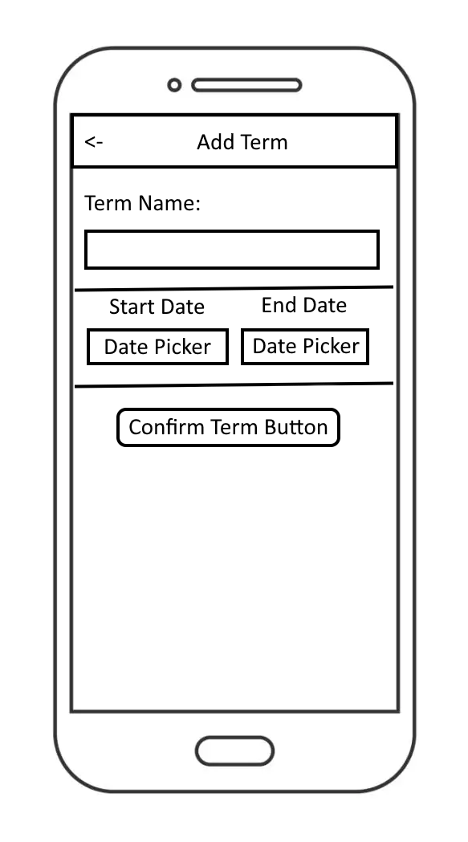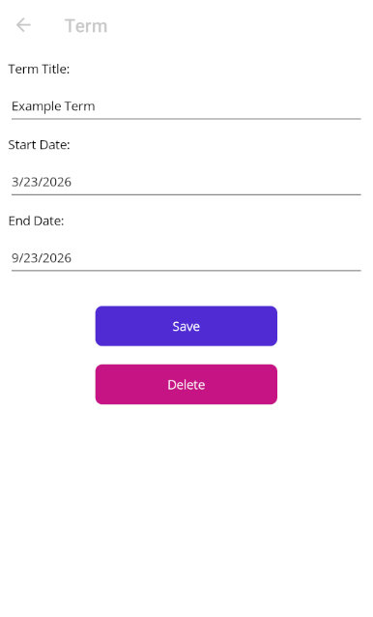

The term page ended up very similar, but instead of putting the start and end dates beside each other, I instead opted for a vertical layout because there was so much extra space. The delete button exists here now as well (it is automatically hidden on creation, but on edit it exists).

View/Edit/Delete Term Page
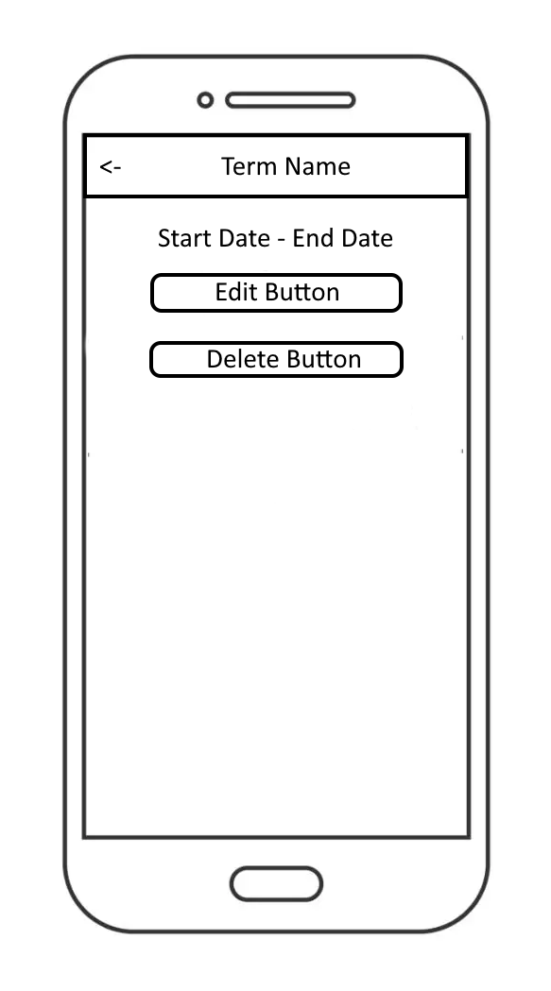
The view/edit/delete term page ended up completely different in the end, mostly because I opted to reuse the “Add term” page for this instead. It didn’t feel super intuitive to click the term name, and then click another edit button afterwards, so I opted for a single page for both.

Create Course Screen
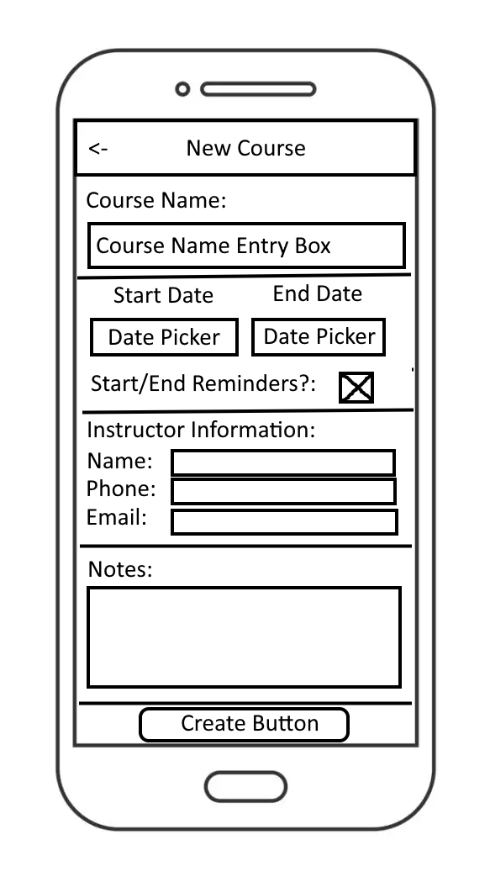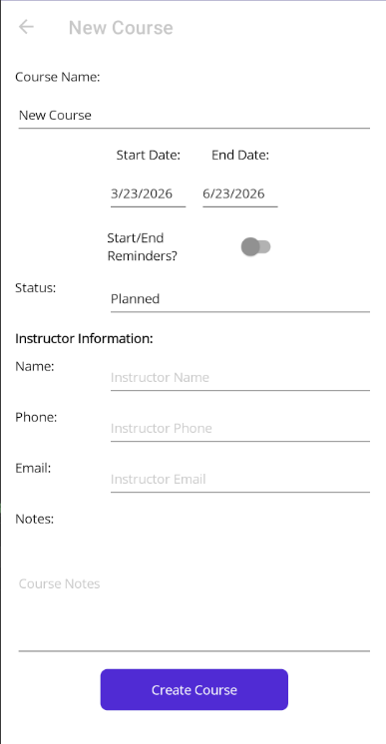

The “Create Course” screen ended up mostly the same, with the main difference being to opt for a sliding selector instead of a checkbox for reminders.

Course Screen
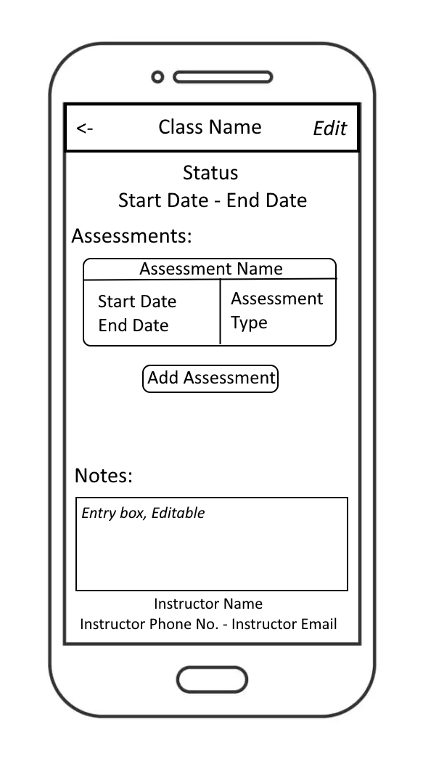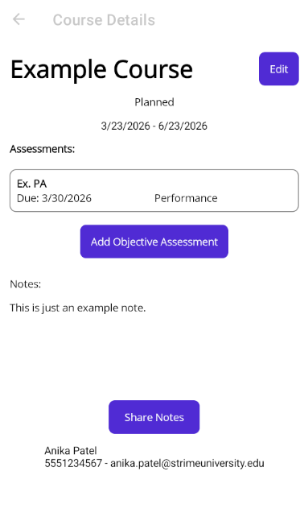

Some more noticeable changes are found here. I opted for using .NET MAUI’s built in back buttons and titles for some of the sub-screens, keeping the “Course Details” at the top. The course name is instead left-aligned, and there is an edit button on the right. Assessments were originally planned to allow users to add multiple of any assessment, but now instead only allows for two assessments, one of each type: performance and objective. Assessments also no longer have a start date, instead just having a due date, and the layout is modified. The notes are no longer editable outside of the edit panel, as this caused some performance issues with needing to save after every input.

Edit Course Page
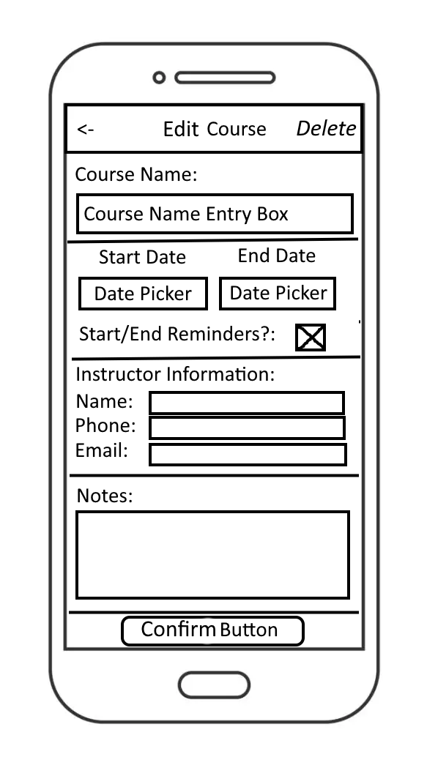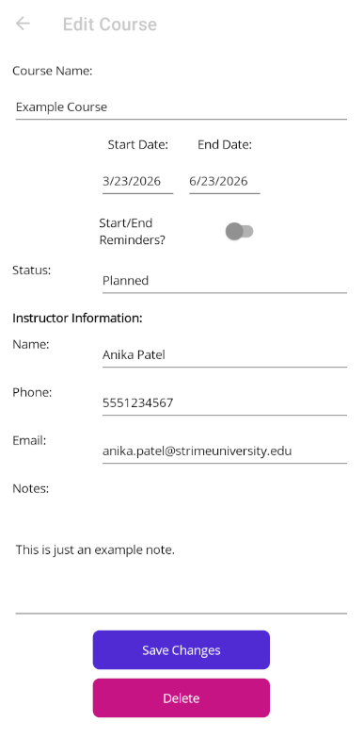

The “Edit Course” page faces some quite large changes. Firstly, the delete button is moved to the bottom. Next, the start/end notifications were swapped to a switcher from a checkbox. Lastly, the original wireframe lacked a course status, so this was added above “Instructor Information”

Create Assessment Page
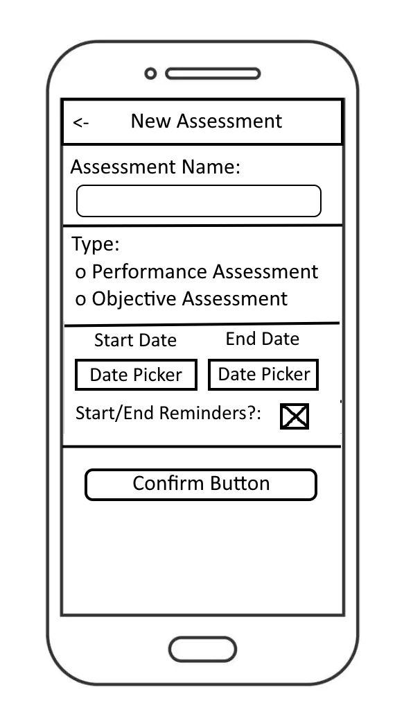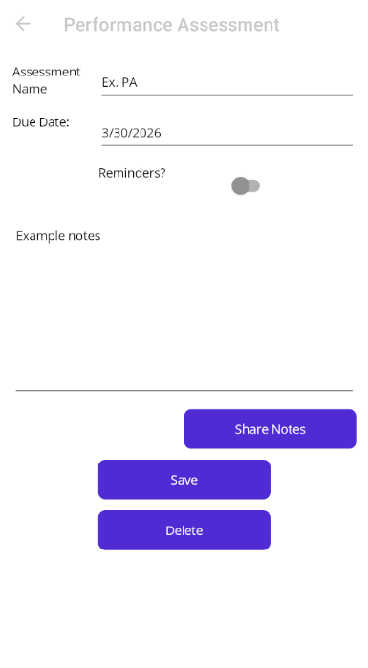
The “Create Assessment” page has likely the largest change from the original wireframe to the finished product. The assessment name placement is much the same, but instead of the entry box being below the heading, it is now beside it. There is no longer a start/end date, but instead just a due date. Reminders are a switcher instead of a checkbox. The type of assessment is chosen before getting to this screen, where you specifically click “Add Performance/Objective Assessment”, so the “type” radio buttons were not necessary. Confirm and delete buttons are mostly in the same spot, but a “Share Notes” button was not originally considered and has since been added. Lastly, there were originally a separate add and edit screen for assessments, but this was combined into one screen.

