Unit 1 | Assignment - Kickstart My Chart

Jose Tomines

# Background[1]

Over two billion dollars have been raised using the massively successful crowdfunding service, Kickstarter, but not every project has found success. Of the over 300,000 projects launched on Kickstarter, only a third have made it through the funding process with a positive outcome.

Since getting funded on Kickstarter requires meeting or exceeding the project's initial goal, many organizations spend months looking through past projects in an attempt to discover some trick to finding success.

The following is an analysis of a database of four thousand past projects to uncover hidden trends.

# Methodology

Using the assignment instructions and the provided spreadsheet, three pivot tables and their associated graphs were created to provide some insight to the Kickstarter data:

* The counts of project outcomes organized by parent category and filterable by country.
* The counts of project outcomes organized by sub-category and filterable by both country and parent category.
* The counts of project outcomes organized by date project was created, and filterable by both parent category and the year created. Trendlines were also added.

In addition, a table was created showing the counts of project outcomes organized by the project goal size.

The excel file, JTomines_StarterBook.xlsx, where all the pivot tables and graphs were created, can be accessed in the Reference Documents subsection. Included in this section is the README.md that provided all the instructions for this assignment.

# Observations

The following observations are organized by pivot tables and associated graphs created.

## **Pivot Table 1: Count of Outcomes per Parent Category**

The following graph was created from the pivot table displaying the count of outcomes based on the Parent Category:

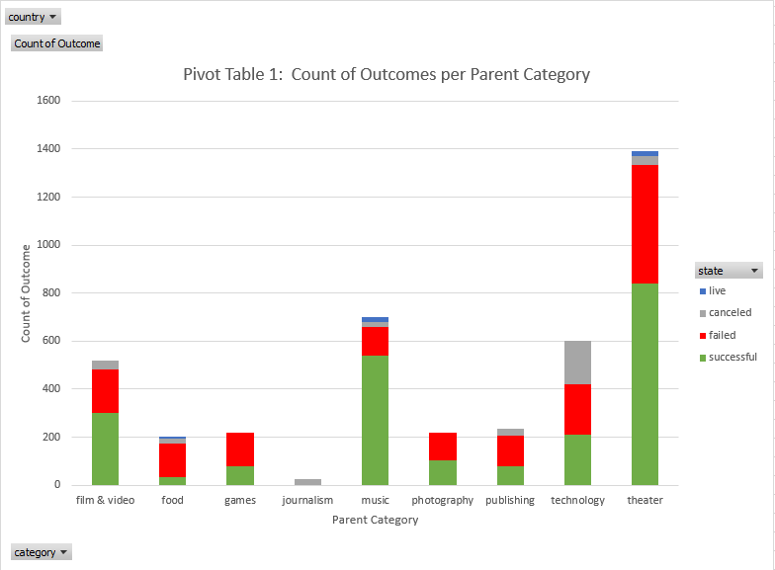

From this graph, the following was observed:

* The most successful Parent Category is the music category, with an overall success percentage of 77% (540 successful / 700 total projects).
* The least successful Parent Category is the journalism category, with an overall success percentage of 0% (0 successful / 24 total projects).
* The most projects were found in the theater category, with 1393 projects, which is almost double the next largest category of music, and with a better than average success rate of 60% (839 successful / 1393 total projects).
* The overall success rate of the projects listed in the initial spreadsheet is 53% (2185 successful / 4114 projects).

This indicates that entertainment projects such as those categorized as theatre, music, and even film and video, dominate projects in Kickstarter. The relative success rates show that the community of both artists and backers are eager to use Kickstarter to support these types of projects.

## **Pivot Table 2: Count of Outcomes per Sub-Category**

The following graph was created from the pivot table displaying the count of outcomes based on the Sub-Category:

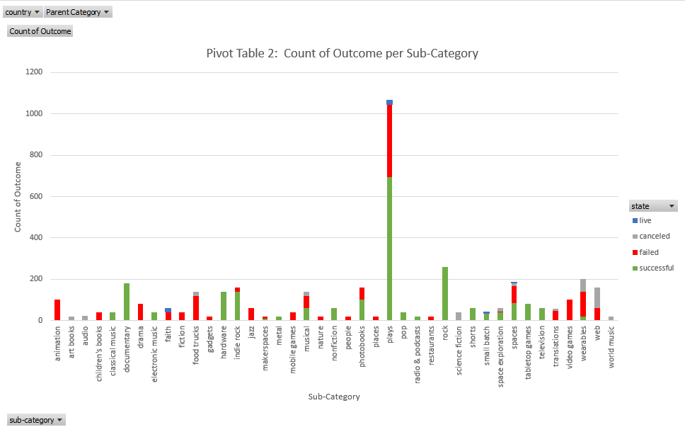

From this graph, the following was observed:

* The Sub-Category with the greatest number of projects was plays, with a total of 1066 projects, which is more than four times the next largest Sub-Category with 260 projects, and with a better than average success percentage of 65%
* The most successful Sub-Categories, with 100% success rate, are classical music, documentary, electronic music, hardware, nonfiction, pop, radio & podcasts, rock, shorts, tabletop games, and television.
* The least successful Sub-Categories, with 0% success rate, are animation, art books, audio, children’s books, drama, faith, fiction, food trucks, gadgets, jazz, mobile games, nature, people, places, restaurants, science fiction, translations, video games, web, and world music.

Notice that many of the successful sub-categories are part of the successful Parent Category of music, indicating that backers have more appetite to support music projects. This is especially true for the modern music projects of pop, electronic music, and rock.

## **Pivot Table 3: Count of Outcomes per Month Created**

The following graph was created from the pivot table displaying the count of outcomes based on the calendar month the project was created:

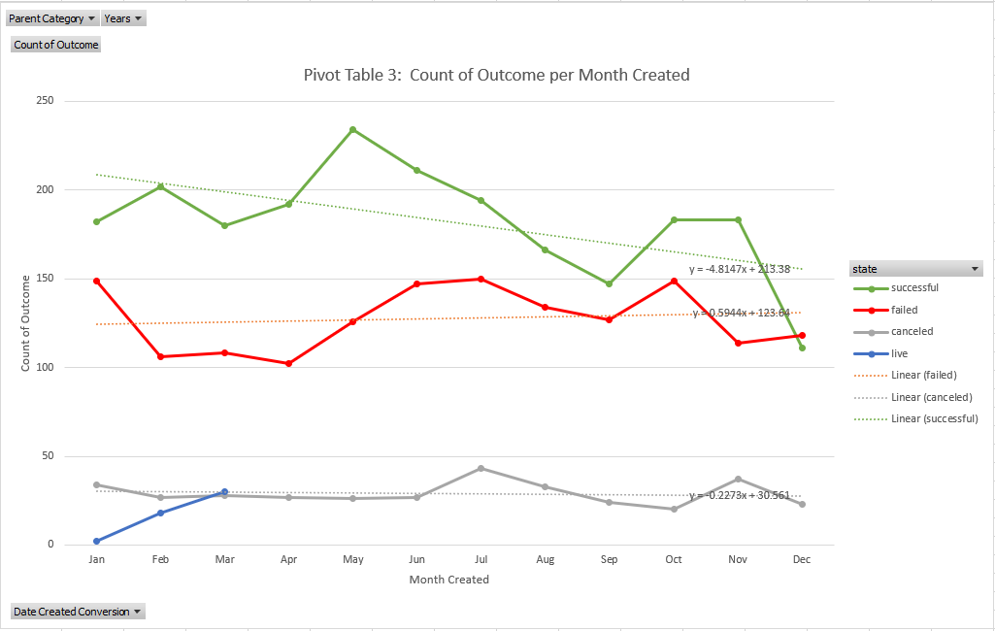

Trendlines were added to provide clarity to the graph.

From this graph, the following was observed:

* The number of successful projects is observed to decline as the month created falls further back in the calendar year.
* As expected, the number of failed and cancelled projects do rise, but at a slower rate, based on the created month in the calendar year.
* Live projects are only observed for months created of January, February, and March.
* The highest number of successful projects were created in the month of May, and the lowest number were created in the month of December
* The highest number of failed projects were created in the month of July, with January, October, and June, following closely behind. The lowest number of failed projects were created in the month of April.
* The highest number of canceled projects were created in the month of July, with the lowest number in the month of October.

This definitely shows that the closer to the end of the year that the project is created, the less likelihood that of reaching its funding goal.

## **Bonus Graph: Outcomes Based on Goal**

The following graph was created from the pivot table displaying the count of outcomes based on the Goal set for the project:

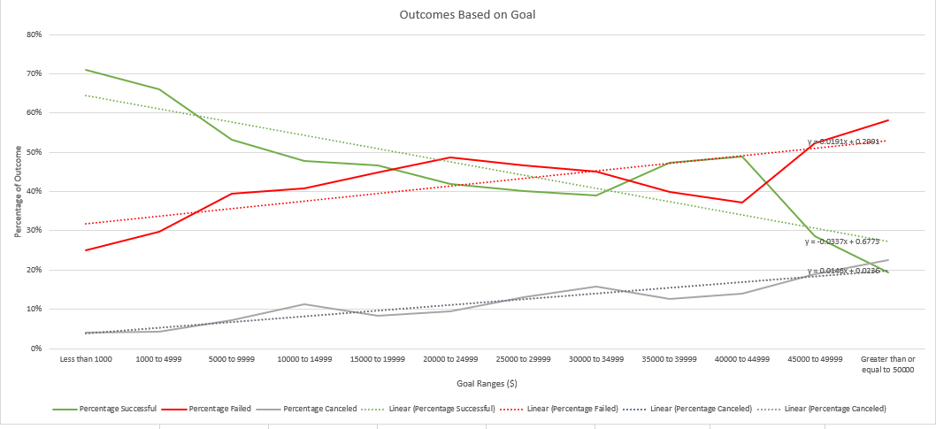

Trendlines were added to provide clarity to the graph.

From this graph, the following was observed:

* Based on the trendline calculated by excel, projects with higher goal amounts had experienced lower success rate.
* Correspondingly, projects with higher goals, also experienced higher rate of Failed or Canceled status.
* Around the $45,000 to $49,999 range, there is a sharp decrease in success.

As expected, projects with higher goals do not as easily reach their goals.

# Limitations

The largest limitation of the data provided is the number of projects in the initial spreadsheet in comparison with the overall number of projects that have been found in Kickstarter. With a sample size of 1.33% of the overall number of projects, and correlating many different factors (goal amount, months created, categories), confidence level in the conclusions of trends begins to decrease.

The randomness of the data provided is crucial to seeing overall trends, but data of a small sample size specific to a time range would only provide insight to that time.

There may be other factors, not included in this spreadsheet, that can provide better insight to the trends that is observed from this data. For example, overall economic factors of the time and of the country would play a role for projects’ overall success, and we could possibly make conclusions on what those factors are based on the data provided, but this lack of understanding is a limitation to determining future behaviour.

One data that would have been useful is the cancellation date for those projects that were canceled. This could give insight to how long a project was waiting for backers before the decision was made to cancel the project. This information, when assessed beside End Date for failed projects, could help determine the appetite of backers as well as the fortitude of project owners during different months of the year.

The following graphs would have been useful to forecast ideal project conditions:

* Count of Outcome per Country
* Count of Outcome per Project Duration (Days between Date Created and Date Ended)
* Count of Outcome based on Average Donation
* Average Donation based on Category / Sub-Category

# Conclusions

Disregarding the limitations of the data, the following conclusions can be reached:

The entertainment projects such as those categorized as theatre, music, and film and video, dominate projects in Kickstarter. The relative success rates show that the community of both artists and backers are eager to use Kickstarter to support these types of projects.

Many of the successful sub-categories are part of the successful Parent Category of music, indicating that backers have more appetite to support music projects. This is especially true for the modern music projects of pop, electronic music, and rock. This may indicate young people’s appetite to use alternative and technological based funding of Kickstarter.

Several sub-categories, such as plays, classical music, documentary, and television, may reflect a more affluent target audience that may be able to provide greater support for their passions.

Generally, more projects found success when started in April, but the rate of success dramatically fell during the months of August/September and December. During those poor months, backers are usually focused on either their summer holidays, or Christmas shopping, to give discretionary funds. The April spike could be due to tax returns, or upswing of business after the holidays, that allows backers to fund these projects.

It would be logical to assume that projects that have higher funding targets would be also have a higher failure rate to reach those targets. It is easy for projects with goals of less than a thousand dollars to find the required number of backers to support their project. The low goal also allows the backer to assume less risk, and an easier reward. It might be easy to assume that higher goals may also turn backers away, and $45,000 projects may be psychologically unattractive.

Therefore, the keys to success in Kickstarter can be summarized as:

* Ensure your project fits a category that is appetizing to Kickstarter backers such as entertainment categories of Theatre and Music
* Ensure that you post your project during April when backers may have access and appetite to give more money
* Don’t be overambitious in setting high funding goals; ensure that the overall goal is reasonably low enough to get the funds you require to start the project.

# Reference Documents

The following embedded document is the instructions for this assignment:



The following embedded document is the entire analysis spreadsheet for this assignment:



1. Taken from README.md assignment instructions file