BDMI_mapping

2022-08-25

## region A

Read in vcf files (mapped to N17 and W303) - remove one comment line first so get header.

##   
## Attaching package: 'dplyr'

## The following objects are masked from 'package:stats':  
##   
## filter, lag

## The following objects are masked from 'package:base':  
##   
## intersect, setdiff, setequal, union

Check that it worked

head(AN)

## V1 V2 V3 V4 V5 V6 V7  
## 1 N_17.chr09 5283 . G A 1557.10 PASS  
## 2 N_17.chr09 5286 . T G 6432.63 PASS  
## 3 N_17.chr09 5292 . A G 6512.63 PASS  
## 4 N_17.chr09 5304 . T C 6737.63 PASS  
## 5 N_17.chr09 5316 . A G 6692.63 PASS  
## 6 N_17.chr09 5322 . C A 6647.63 PASS  
## V8  
## 1 AC=1;AF=0.167;AN=6;BaseQRankSum=0.688;DP=525;FS=0;MLEAC=1;MLEAF=0.167;MQ=45.09;MQRankSum=-1.578;QD=11.12;ReadPosRankSum=-0.65;SOR=0.703  
## 2 AC=3;AF=0.5;AN=6;DP=526;FS=0;MLEAC=4;MLEAF=0.667;MQ=45.01;QD=33.76;SOR=1.006  
## 3 AC=3;AF=0.5;AN=6;DP=534;FS=0;MLEAC=4;MLEAF=0.667;MQ=45.04;QD=31.63;SOR=0.987  
## 4 AC=3;AF=0.5;AN=6;DP=549;FS=0;MLEAC=4;MLEAF=0.667;MQ=44.82;QD=35.64;SOR=0.927  
## 5 AC=3;AF=0.5;AN=6;DP=576;FS=0;MLEAC=4;MLEAF=0.667;MQ=44.66;QD=28.73;SOR=0.881  
## 6 AC=3;AF=0.5;AN=6;DP=570;FS=0;MLEAC=4;MLEAF=0.667;MQ=44.52;QD=31.75;SOR=0.806  
## V9 V10 V11  
## 1 GT:AD:DP:GQ:PL 0/0/0:316,0:316:0:0,0,0,6232 0/0/1:77,63:140:41:1562,0,41,2020  
## 2 GT:AD:DP:GQ:PL 0/0/0:318,0:318:0:0,0,0,1653 1/1/1:0,144:144:99:6445,686,253,0  
## 3 GT:AD:DP:GQ:PL 0/0/0:325,0:325:0:0,0,0,1595 1/1/1:0,145:145:99:6525,692,255,0  
## 4 GT:AD:DP:GQ:PL 0/0/0:335,0:335:0:0,0,0,2034 1/1/1:0,150:150:99:6750,716,264,0  
## 5 GT:AD:DP:GQ:PL 0/0/0:363,0:363:0:0,0,0,1892 1/1/1:0,149:149:99:6705,711,262,0  
## 6 GT:AD:DP:GQ:PL 0/0/0:358,0:358:0:0,0,0,3525 1/1/1:0,148:148:99:6660,706,261,0

head(AW)

## V1 V2 V3 V4 V5 V6 V7  
## 1 W303.chr09 1729 . C T 15104.7 PASS  
## 2 W303.chr09 1734 . T C 13187.7 PASS  
## 3 W303.chr09 1738 . C T 13019.7 PASS  
## 4 W303.chr09 1792 . A G 33180.7 PASS  
## 5 W303.chr09 1810 . G A 33672.7 PASS  
## 6 W303.chr09 1830 . T A 31901.7 PASS  
## V8  
## 1 AC=2;AF=0.333;AN=6;BaseQRankSum=-0.707;DP=2299;FS=0;MLEAC=2;MLEAF=0.333;MQ=58.76;MQRankSum=-6.455;QD=7.17;ReadPosRankSum=0.458;SOR=0.663  
## 2 AC=2;AF=0.333;AN=6;BaseQRankSum=-0.548;DP=2253;FS=0.682;MLEAC=2;MLEAF=0.333;MQ=58.78;MQRankSum=-0.557;QD=6.28;ReadPosRankSum=2.21;SOR=0.613  
## 3 AC=2;AF=0.333;AN=6;BaseQRankSum=1.61;DP=2273;FS=0.69;MLEAC=2;MLEAF=0.333;MQ=58.77;MQRankSum=-0.442;QD=6.14;ReadPosRankSum=2.8;SOR=0.571  
## 4 AC=2;AF=0.333;AN=6;BaseQRankSum=0.206;DP=2192;FS=2.477;MLEAC=2;MLEAF=0.333;MQ=59.52;MQRankSum=-5.104;QD=15.58;ReadPosRankSum=-0.879;SOR=0.712  
## 5 AC=2;AF=0.333;AN=6;BaseQRankSum=4.41;DP=2114;FS=1.113;MLEAC=2;MLEAF=0.333;MQ=59.59;MQRankSum=-5.116;QD=16.07;ReadPosRankSum=-0.255;SOR=0.791  
## 6 AC=2;AF=0.333;AN=6;BaseQRankSum=0.083;DP=2032;FS=0.53;MLEAC=2;MLEAF=0.333;MQ=59.52;MQRankSum=-5.461;QD=15.94;ReadPosRankSum=0.019;SOR=0.735  
## V9 V10  
## 1 GT:AD:DP:GQ:PL 0/0/1:840,265:1105:99:9093,0,1731,34715  
## 2 GT:AD:DP:GQ:PL 0/0/1:860,245:1105:99:8274,0,1851,35840  
## 3 GT:AD:DP:GQ:PL 0/0/1:875,243:1118:99:8157,0,1902,36322  
## 4 GT:AD:DP:GQ:PL 0/0/1:588,539:1127:99:19887,0,147,22080  
## 5 GT:AD:DP:GQ:PL 0/0/1:581,529:1110:99:20221,0,156,22468  
## 6 GT:AD:DP:GQ:PL 0/0/1:554,520:1074:99:19371,0,102,21001  
## V11  
## 1 0/0/1:813,188:1001:99:6019,0,1882,33976  
## 2 0/0/1:834,160:994:99:4921,0,2029,35122  
## 3 0/0/1:843,160:1003:99:4870,0,2056,35360  
## 4 0/0/1:633,370:1003:99:13301,0,791,24863  
## 5 0/0/1:622,363:985:99:13459,0,779,25066  
## 6 0/0/1:580,347:927:99:12538,0,703,23001

Rename the columns.  
Cut down to the range for A:  
range for A - YIL166C to YIL156W is region, did transformations YIL151C to YIL169C  
For N17 - (??) end to 41322  
For W303 - 24534 to 62140  
Go a bit outside (1kb on either end).

Only keep the columns I want.  
Information wanted: chr(omosome), pos(ition), ref (allele), alt(ernate allele), qual(ity), a1 (sample), a2 (sample)

In last two columns, the format is GT:AD:DP:GQ:PL  
FORMAT=<ID=GT,Number=1,Type=String,Description=“Genotype”>  
FORMAT=<ID=AD,Number=R,Type=Integer,Description=“Allelic depths for the ref and alt alleles in the order listed”>  
FORMAT=<ID=DP,Number=1,Type=Integer,Description=“Approximate read depth (reads with MQ=255 or with bad mates are filtered)”>  
FORMAT=<ID=GQ,Number=1,Type=Integer,Description=“Genotype Quality”>  
FORMAT=<ID=PL,Number=G,Type=Integer,Description=“Normalized, Phred-scaled likelihoods for genotypes as defined in the VCF specification”>

Split the last column and make new columns out of the “AD” section.  
FORMAT=<ID=AD,Number=R,Type=Integer,Description=“Allelic depths (high-quality bases)”> - ref, alt  
Save as a1nref, a1nalt, a2nref, a2nalt.

Then calculate the frequencies of paradoxus alleles. For AN (mapped to paradoxus), it’s nref/total. For AW (mapped to cerevsiae), it’s nalt/total. Saved as a1reff, a2reff, a1altf, a2altf.  
  
Also found coverage of each SNP as nref+nalt. Saved as a1cov, a2cov.

Plot outcome of frequencies. Mapped to paradoxus, with a1reff in black, a2reff in blue. 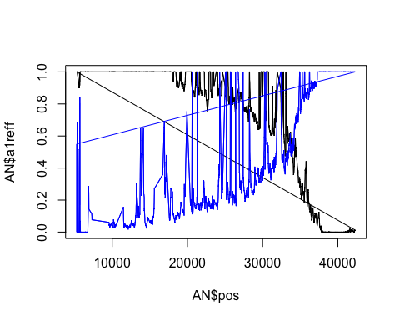

Plot mapped to cerevisiae. a1altf in black, a2altf in blue. 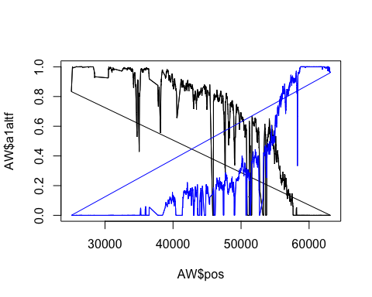

According to Eyal’s paper, “SNPs with excessive depth were removed because they are suspected as repetitive sequences, using a threshold of 450X total depth across all samples” (which was two standard deviations above the mean depth)  
  
Find the mean coverage in the region and the SD and make the cutoff 2 SD above the mean.

mean(AN$a1cov)

## [1] 294.1557

sd(AN$a1cov)

## [1] 75.40178

cutAN1 <- mean(AN$a1cov)+2*sd(AN$a1cov)  
  
mean(AN$a2cov)

## [1] 198.1067

sd(AN$a2cov)

## [1] 74.56178

cutAN2 <- mean(AN$a2cov)+2*sd(AN$a2cov)  
  
mean(AW$a1cov)

## [1] 261.0112

sd(AW$a1cov)

## [1] 100.5098

cutAW1 <- mean(AW$a1cov)+2*sd(AW$a1cov)  
  
mean(AW$a2cov)

## [1] 226.4242

sd(AW$a2cov)

## [1] 58.0252

cutAW2 <- mean(AW$a2cov)+2*sd(AW$a2cov)

Now remove outliers in coverage that are higher that 2 SDs above mean. These may be repetitive sequences. Save as AN/AWcut.

Plot the coverage of the original and versions with cutoff (cutoff in red and purple).  
Also add the cutoffs as lines.  
Also add the frequencies (*400 to fit on plot).

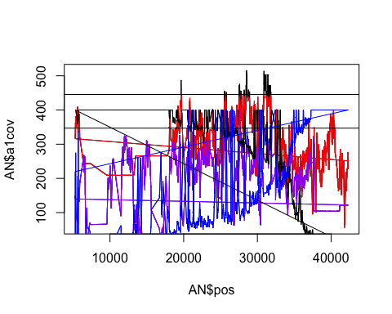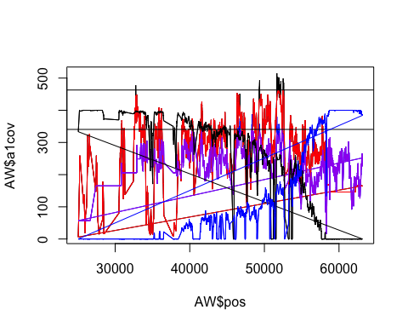 Still not good. Also, large region with very few SNPs in a1.  
  
Try cutting off the bottom ones as well as they don’t have consistent coverage.  
Cutoff is 2 SD below mean.  
Save as AN/Wcut2.  
Plot these in green and orange.

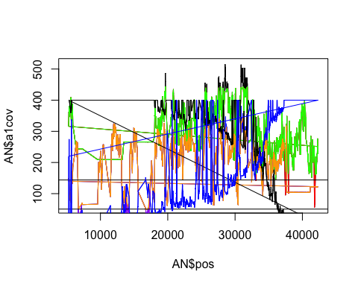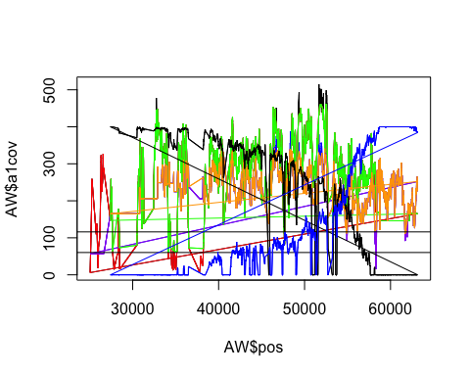 Got rid of some crazy peaks and smoothed it out a bit.  
  
Now try requiring that called variants are variable in both samples (within mapping to a single species).  
This will cut off the ends, but we’re not really interested in those.  
Then plot again with original (lightest), cut2 (darker) and cut3 (darkest).

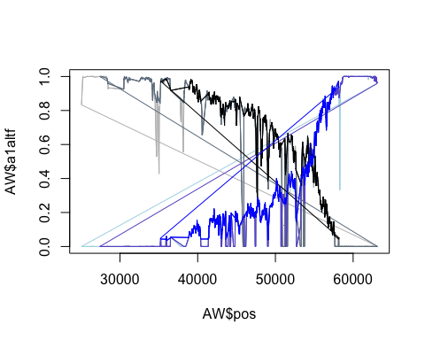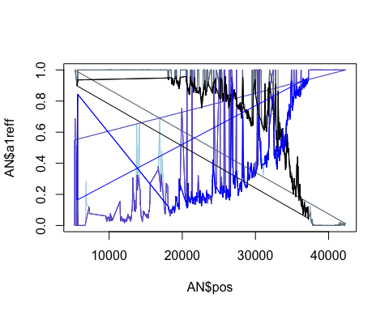 Improved again.  
Tried requiring certain minimal minor allele frequency but doesn’t seem helpful, almost none with low cutoff.  
  
Now will trim SNPs that are quite different from the median around them. First, need to find out how big the region is.

min(ANcut3$pos)

## [1] 5601

max(ANcut3$pos)

## [1] 37264

min(AWcut3$pos)

## [1] 35236

max(AWcut3$pos)

## [1] 58160

Based on this, the region in paradoxus (N) is:  
37273-5601=31672bp long  
We expect the frequency to go from 0 to 1 in this region so, if went up consistently, would change by 0.1 within:  
31672/10=3167.2  
so should be reasonable to expect that every SNP should be within 0.1 of the median within ~1584bp.  
  
For cerevisiae (W): 57641-35236= 22405bc long  
22405/10 = 2240.5  
So will use 1120bp.  
  
Also, do regions every 100bp. Plots the old frequencies from SNPs in lighter colours and post-cut in darker colours. First, need to rename columns.

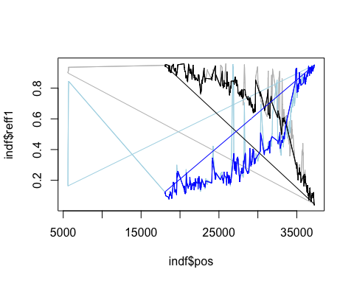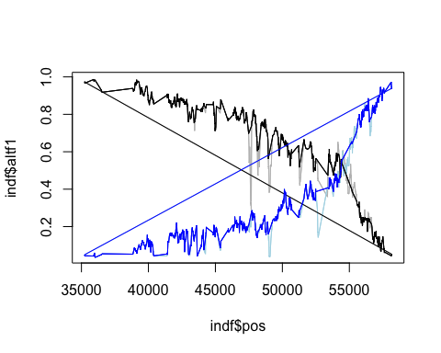

Find out how many cut:

length(ANcut3$chr)

## [1] 2258

length(ANcut4$chr)

## [1] 1628

length(AWcut3$chr)

## [1] 2514

length(AWcut4$chr)

## [1] 2112

Now plot with loess smoothing. Loess with span=0.25. Do for those mapped to paradoxus first. 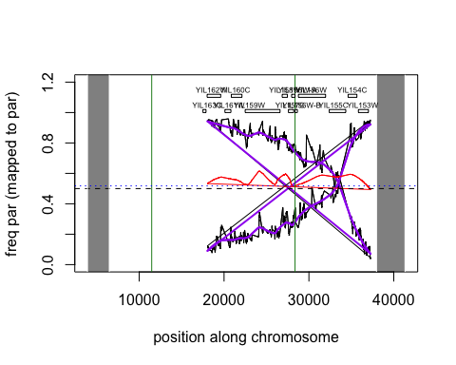 Plot for those mapped to paradoxus (N17) with loess smoothing.  
Borders of original region in forestgreen. Rectangles where did transformations.  
Bottom 5% of sum of fits in dotted blue line.  
  
Now plot with loess smoothing. Loess with span=0.25. Do for those mapped to cerevisiae. 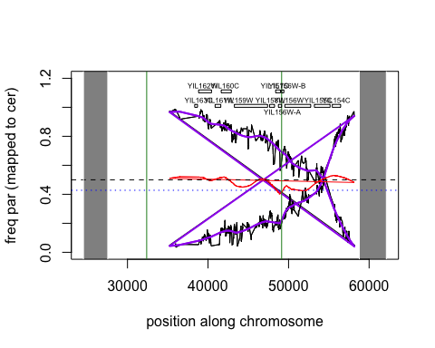 Plot for those mapped to cerevisiae (W303).  
Borders of original region in forestgreen. Rectangles where did transformations.  
Bottom 5% of sum of fits in dotted blue line.  
  
Next idea was to try and match up SNPs between the two mappings to only keep those that correspond. This is not trivial, however, and I haven’t done that yet.

## region C

Do same as for region A. Only noted when something specific to region C. Read in vcf files (mapped to N17 and W303).

Check that it worked.

head(CN)

## V1 V2 V3 V4 V5 V6 V7  
## 1 N_17.chr10 1516 . T C 20955.7 PASS  
## 2 N_17.chr10 1528 . C A 22579.7 PASS  
## 3 N_17.chr10 1543 . A G 20911.7 PASS  
## 4 N_17.chr10 1546 . C T 20957.7 PASS  
## 5 N_17.chr10 1550 . T G 20689.7 PASS  
## 6 N_17.chr10 1552 . C A 20495.7 PASS  
## V8  
## 1 AC=4;AF=0.667;AN=6;BaseQRankSum=-5.983;DP=1127;FS=48.749;MLEAC=4;MLEAF=0.667;MQ=41.33;MQRankSum=-12.33;QD=18.71;ReadPosRankSum=4.68;SOR=0.146  
## 2 AC=4;AF=0.667;AN=6;BaseQRankSum=-6.502;DP=1258;FS=34.647;MLEAC=4;MLEAF=0.667;MQ=41.47;MQRankSum=-12.19;QD=19.07;ReadPosRankSum=5.89;SOR=0.105  
## 3 AC=4;AF=0.667;AN=6;BaseQRankSum=-6.797;DP=1190;FS=26.007;MLEAC=4;MLEAF=0.667;MQ=41.53;MQRankSum=-11.98;QD=17.62;ReadPosRankSum=8.24;SOR=0.148  
## 4 AC=4;AF=0.667;AN=6;BaseQRankSum=-9.015;DP=1195;FS=26.007;MLEAC=4;MLEAF=0.667;MQ=41.54;MQRankSum=-12.05;QD=17.54;ReadPosRankSum=7.58;SOR=0.152  
## 5 AC=4;AF=0.667;AN=6;BaseQRankSum=-6.711;DP=1167;FS=23.99;MLEAC=4;MLEAF=0.667;MQ=41.53;MQRankSum=-11.79;QD=17.73;ReadPosRankSum=7.51;SOR=0.154  
## 6 AC=4;AF=0.667;AN=6;BaseQRankSum=-4.065;DP=1158;FS=23.83;MLEAC=4;MLEAF=0.667;MQ=41.52;MQRankSum=-11.74;QD=17.7;ReadPosRankSum=6.7;SOR=0.158  
## V9 V10  
## 1 GT:AD:DP:GQ:PL 0/0/1:608,191:799:99:6525,0,1239,17909  
## 2 GT:AD:DP:GQ:PL 0/0/1:637,180:817:99:6079,0,1365,19341  
## 3 GT:AD:DP:GQ:PL 0/0/1:680,145:825:99:4636,0,1610,28609  
## 4 GT:AD:DP:GQ:PL 0/0/1:686,145:831:99:4625,0,1628,28868  
## 5 GT:AD:DP:GQ:PL 0/0/1:666,140:806:99:4459,0,1583,28103  
## 6 GT:AD:DP:GQ:PL 0/0/1:662,135:797:99:4265,0,1586,27947  
## V11  
## 1 1/1/1:0,321:321:99:14445,1531,565,0  
## 2 1/1/1:0,367:367:99:16515,1751,646,0  
## 3 1/1/1:0,362:362:99:16290,1727,637,0  
## 4 1/1/1:0,364:364:99:16347,1736,641,0  
## 5 1/1/1:0,361:361:99:16245,1722,636,0  
## 6 1/1/1:0,361:361:99:16245,1722,636,0

head(CW)

## V1 V2 V3 V4 V5 V6 V7  
## 1 W303.chr10 2884 . T C 347.26 PASS  
## 2 W303.chr10 2912 . G A 347.26 PASS  
## 3 W303.chr10 2920 . C T 347.26 PASS  
## 4 W303.chr10 2925 . C T 347.26 PASS  
## 5 W303.chr10 18799 . C G 28940.70 PASS  
## 6 W303.chr10 18804 . G A 29161.70 PASS  
## V8  
## 1 AC=3;AF=1;AN=3;DP=29;FS=0;MLEAC=3;MLEAF=1;MQ=46.45;QD=25.36;SOR=1.863  
## 2 AC=3;AF=1;AN=3;DP=22;FS=0;MLEAC=3;MLEAF=1;MQ=55.34;QD=28.73;SOR=1.863  
## 3 AC=3;AF=1;AN=3;DP=22;FS=0;MLEAC=3;MLEAF=1;MQ=55.34;QD=30.97;SOR=1.863  
## 4 AC=3;AF=1;AN=3;DP=22;FS=0;MLEAC=3;MLEAF=1;MQ=55.34;QD=27.24;SOR=1.863  
## 5 AC=2;AF=0.333;AN=6;BaseQRankSum=0.286;DP=3962;FS=0.651;MLEAC=2;MLEAF=0.333;MQ=59.66;MQRankSum=-5.382;QD=9.09;ReadPosRankSum=1.88;SOR=0.599  
## 6 AC=2;AF=0.333;AN=6;BaseQRankSum=1.97;DP=3874;FS=1.375;MLEAC=2;MLEAF=0.333;MQ=59.73;MQRankSum=-5.758;QD=9.03;ReadPosRankSum=1.58;SOR=0.575  
## V9 V10  
## 1 GT:AD:DP:GQ:PL 1/1/1:0,8:8:14:360,38,14,0  
## 2 GT:AD:DP:GQ:PL 1/1/1:0,8:8:14:360,38,14,0  
## 3 GT:AD:DP:GQ:PL 1/1/1:0,8:8:14:360,38,14,0  
## 4 GT:AD:DP:GQ:PL 1/1/1:0,8:8:14:360,38,14,0  
## 5 GT:AD:DP:GQ:PL 0/0/1:967,477:1445:99:17254,0,1467,38381  
## 6 GT:AD:DP:GQ:PL 0/0/1:992,489:1481:99:17408,0,1515,39908  
## V11  
## 1 ././.:14,0:14:.:0,0,0,0  
## 2 ././.:14,0:14:.:0,0,0,0  
## 3 ././.:14,0:14:.:0,0,0,0  
## 4 ././.:14,0:14:.:0,0,0,0  
## 5 0/0/1:1383,358:1741:99:11694,0,3083,57044  
## 6 0/0/1:1387,363:1750:99:11761,0,3082,57240

Rename the columns.  
Cut down to the range for C:  
range for C - YJL218W to YJL165C is region, did transformations YJL164C to YJL219W  
for N17 - 1422 to 102835  
for W303 - 23187 to 114847  
Go a bit outside (1kb on either end).

Only keep the columns I want.

Plot outcome. Mapped to paradoxus, with c1reff in black, c2reff in blue. 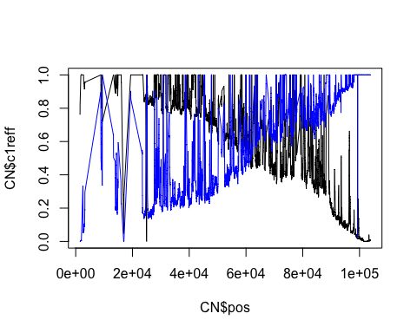

Plot mapped to cerevisiae. c1altf in black, c2altf in blue. 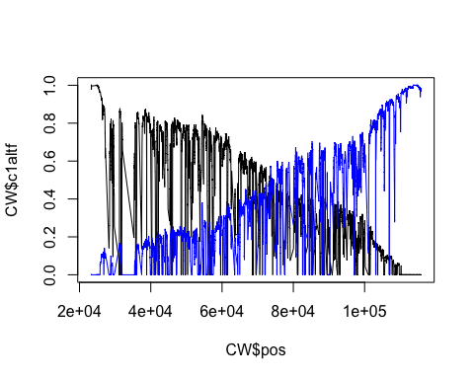

Cut SNPs with coverage 2 SD above mean.

mean(CN$c1cov)

## [1] 929.1932

sd(CN$c1cov)

## [1] 242.5692

cutCN1 <- mean(CN$c1cov)+2*sd(CN$c1cov)  
  
mean(CN$c2cov)

## [1] 838.3074

sd(CN$c2cov)

## [1] 199.0349

cutCN2 <- mean(CN$c2cov)+2*sd(CN$c2cov)  
  
mean(CW$c1cov)

## [1] 884.4712

sd(CW$c1cov)

## [1] 230.6425

cutCW1 <- mean(CW$c1cov)+2*sd(CW$c1cov)  
  
mean(CW$c2cov)

## [1] 863.27

sd(CW$c2cov)

## [1] 244.4764

cutCW2 <- mean(CW$c2cov)+2*sd(CW$c2cov)  
  
CNcut <- CN[-which(CN$c1cov > cutCN1 | CN$c2cov > cutCN2),]  
CWcut <- CW[!(CW$c1cov > cutCW1 | CW$c2cov > cutCW2),]

Plot the coverage of the original and versions with cutoff (cutoff in red and purple).  
Also add the cutoffs as lines.  
Also add the frequencies (*1250 to fit on plot).

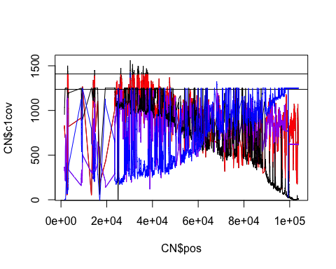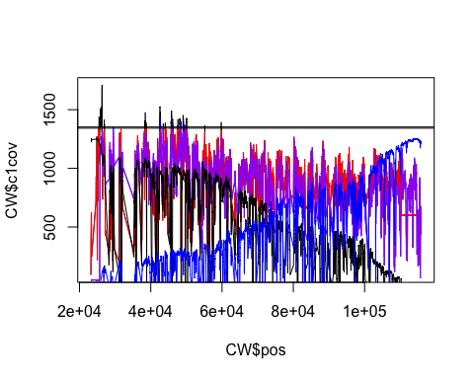 Still not good. Also, largish region with very few SNPs in paradoxus mapping (and cer a bit).  
  
Cut off bottom as well  
Plot these in green and orange.

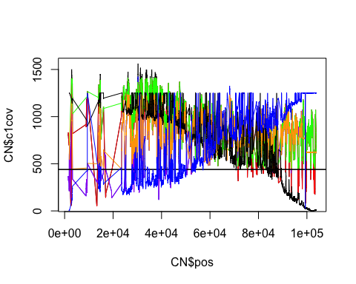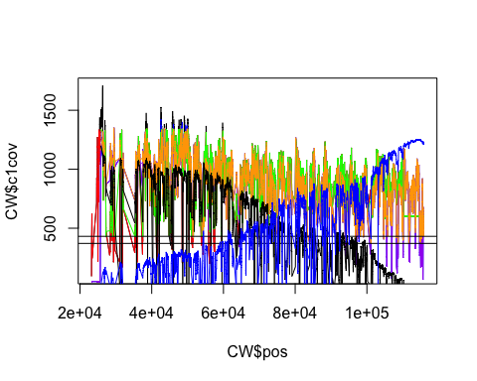 Got rid of some crazy peaks and smoothed it out a bit.  
  
Now try requiring that called variants are variable in both samples (within mapping to a single species).  
This will cut off the ends, but we’re not really interested in those.  
Then plot again with original (lightest), cut2 (darker) and cut3 (darkest).

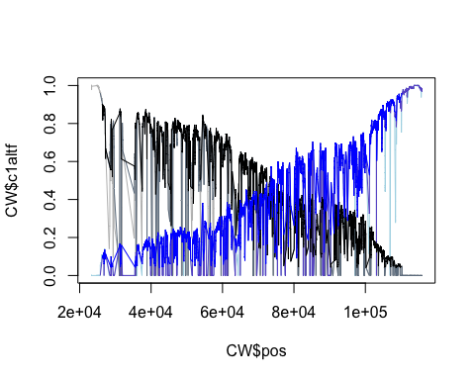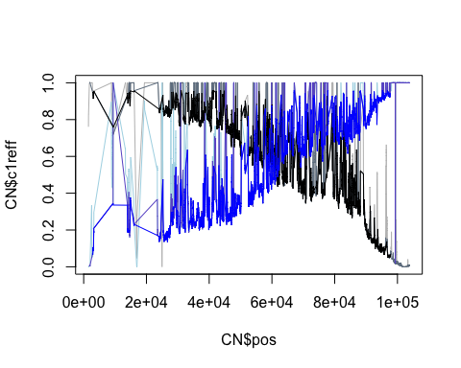 Still pretty crazy.  
Tried requiring certain minimal minor allele frequency but doesn’t seem helpful, almost none with low cutoff.  
  
Now will trim SNPs that are quite different from the median around them. First, need to find out how big the region is.

## [1] 2837

## [1] 97702

## [1] 26354

## [1] 110226

Based on this, the region in paradoxus (N) is:  
97702-2837=94865bp long  
We expect the frequency to go from 0 to 1 in this region so, if went up consistently, would change by 0.1 within:  
94865/10=9486.5  
so should be reasonable to expect that every SNP should be within 0.1 of the median within ~4743bp.  
  
For cerevisiae (W): 110253-25752= 84501bp long  
84501/10 = 8450.1  
So will use 4225bp.  
  
Also, do regions every 100bp. Plots the old frequencies from SNPs in lighter colours and post-cut in darker colours. First, need to rename columns.

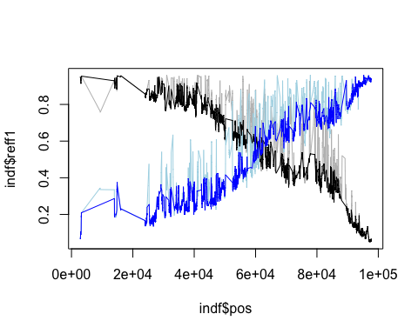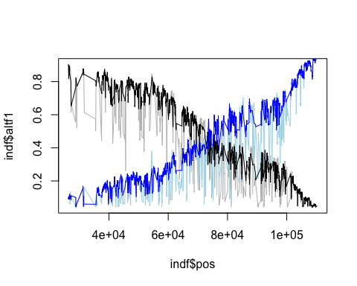 Find out how many cut:

length(CNcut3$chr)

## [1] 4670

length(CNcut4$chr)

## [1] 3324

length(CWcut3$chr)

## [1] 4713

length(CWcut4$chr)

## [1] 3281

Now plot with loess smoothing. Loess with span=0.25. Do for those mapped to paradoxus first. 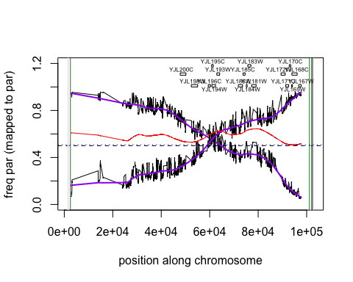 Plot for those mapped to paradoxus (N17) with loess smoothing.  
Borders of original region in forestgreen. Rectangles where did transformations.  
Bottom 5% of sum of fits in dotted blue line.  
  
Now plot with loess smoothing. Loess with span=0.25. Do for those mapped to cerevisiae.

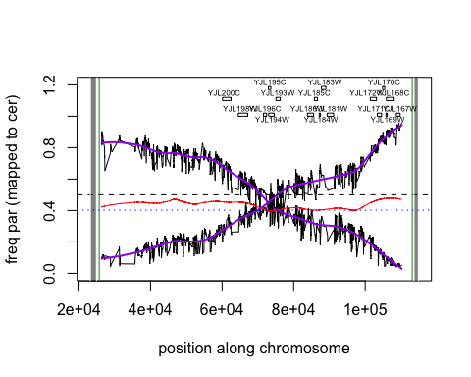 Plot for those mapped to cerevisiae (W303).  
Borders of original region in forestgreen. Rectangles where did transformations.  
Bottom 5% of sum of fits in dotted blue line.  
  
Maybe could try taking an average of the two mappings??? But this would also involve knowing which SNPs correspond.

## region F

Do same as for region A and C. Only noted when something specific to region F. Read in vcf files (mapped to N17 and W303).

Check that it worked.

head(FN)

## V1 V2 V3 V4 V5 V6 V7  
## 1 N_17.chr15 473 . A C 9754.48 PASS  
## 2 N_17.chr15 474 . C A 1821.05 PASS  
## 3 N_17.chr15 488 . A C 2851.05 PASS  
## 4 N_17.chr15 854 . T A 14780.50 PASS  
## 5 N_17.chr15 862 . A T 16120.50 PASS  
## 6 N_17.chr15 899 . G A 23453.50 PASS  
## V8  
## 1 AC=3;AF=0.5;AN=6;BaseQRankSum=-3.2;DP=1039;FS=30.675;MLEAC=3;MLEAF=0.5;MQ=55.53;MQRankSum=1.8;QD=10.5;ReadPosRankSum=-4.019;SOR=0.079  
## 2 AC=1;AF=0.167;AN=6;BaseQRankSum=0.635;DP=867;FS=18.713;MLEAC=1;MLEAF=0.167;MQ=50.1;MQRankSum=-9.369;QD=6.13;ReadPosRankSum=4.74;SOR=1.781  
## 3 AC=1;AF=0.167;AN=6;BaseQRankSum=4.28;DP=804;FS=43.456;MLEAC=1;MLEAF=0.167;MQ=50.43;MQRankSum=-10.95;QD=10.92;ReadPosRankSum=-0.03;SOR=1.826  
## 4 AC=3;AF=0.5;AN=6;BaseQRankSum=0.326;DP=2238;FS=12.83;MLEAC=3;MLEAF=0.5;MQ=58.48;MQRankSum=-8.245;QD=6.93;ReadPosRankSum=-1.59;SOR=1.013  
## 5 AC=3;AF=0.5;AN=6;BaseQRankSum=-1.97;DP=2338;FS=10.742;MLEAC=3;MLEAF=0.5;MQ=58.3;MQRankSum=-8.842;QD=7.37;ReadPosRankSum=-2.342;SOR=0.937  
## 6 AC=3;AF=0.5;AN=6;BaseQRankSum=-2.068;DP=2592;FS=5.925;MLEAC=3;MLEAF=0.5;MQ=57.86;MQRankSum=-11.36;QD=9.42;ReadPosRankSum=3.02;SOR=0.442  
## V9 V10  
## 1 GT:AD:DP:GQ:PL 0/1/1:95,184:279:99:6859,264,0,3425  
## 2 GT:AD:DP:GQ:PL 0/0/1:241,56:297:99:1828,0,557,10153  
## 3 GT:AD:DP:GQ:PL 0/0/1:182,79:261:99:2858,0,310,7493  
## 4 GT:AD:DP:GQ:PL 0/1/1:128,302:430:99:12184,525,0,4445  
## 5 GT:AD:DP:GQ:PL 0/1/1:130,332:462:99:13157,608,0,4454  
## 6 GT:AD:DP:GQ:PL 0/1/1:151,425:576:99:17503,825,0,5170  
## V11  
## 1 0/0/1:545,105:650:99:2905,0,1322,22394  
## 2 0/0/0:507,0:507:70:0,70,191,1800  
## 3 0/0/0:507,0:507:70:0,70,191,1800  
## 4 0/0/1:1566,138:1704:99:2606,0,4297,65260  
## 5 0/0/1:1575,151:1726:99:2973,0,4282,65287  
## 6 0/0/1:1691,224:1915:99:5960,0,4409,70421

head(FW)

## V1 V2 V3 V4 V5 V6 V7  
## 1 W303.chr15 17358 . T G 20422.3 PASS  
## 2 W303.chr15 17384 . T C 31737.9 PASS  
## 3 W303.chr15 17429 . A G 49415.5 PASS  
## 4 W303.chr15 17448 . C T 49686.5 PASS  
## 5 W303.chr15 17451 . T A 49790.5 PASS  
## 6 W303.chr15 17472 . A G 50051.5 PASS  
## V8  
## 1 AC=2;AF=0.333;AN=6;BaseQRankSum=-0.303;DP=2632;FS=16.717;MLEAC=2;MLEAF=0.333;MQ=60;MQRankSum=0;QD=28.36;ReadPosRankSum=-3.092;SOR=1.43  
## 2 AC=2;AF=0.333;AN=6;BaseQRankSum=0.117;DP=2261;FS=16.873;MLEAC=2;MLEAF=0.333;MQ=60;MQRankSum=0;QD=28.73;ReadPosRankSum=0.389;SOR=0.941  
## 3 AC=3;AF=0.5;AN=6;BaseQRankSum=1.09;DP=2897;FS=11.208;MLEAC=3;MLEAF=0.5;MQ=60;MQRankSum=0;QD=17.1;ReadPosRankSum=3.67;SOR=1.394  
## 4 AC=3;AF=0.5;AN=6;BaseQRankSum=0.917;DP=2919;FS=5.331;MLEAC=3;MLEAF=0.5;MQ=60;MQRankSum=0;QD=17.02;ReadPosRankSum=4.01;SOR=1.076  
## 5 AC=3;AF=0.5;AN=6;BaseQRankSum=5.22;DP=2936;FS=3.466;MLEAC=3;MLEAF=0.5;MQ=60;MQRankSum=0;QD=16.96;ReadPosRankSum=5.47;SOR=0.99  
## 6 AC=3;AF=0.5;AN=6;BaseQRankSum=2.03;DP=3086;FS=6.236;MLEAC=3;MLEAF=0.5;MQ=60;MQRankSum=0;QD=16.22;ReadPosRankSum=1.72;SOR=1.086  
## V9 V10  
## 1 GT:AD:DP:GQ:PL 0/0/0:1901,0:1901:0:0,0,3663,61661  
## 2 GT:AD:DP:GQ:PL 0/0/0:1410,0:1410:70:0,70,191,1800  
## 3 GT:AD:DP:GQ:PL 0/0/1:1582,82:1664:99:504,0,4514,67794  
## 4 GT:AD:DP:GQ:PL 0/0/1:1586,84:1670:99:587,0,4521,68177  
## 5 GT:AD:DP:GQ:PL 0/0/1:1601,85:1686:99:600,0,4563,68820  
## 6 GT:AD:DP:GQ:PL 0/0/1:1732,83:1815:99:289,0,4964,74494  
## V11  
## 1 0/1/1:108,612:720:99:20431,1511,0,2245  
## 2 0/1/1:92,755:847:99:31750,1996,0,2218  
## 3 0/1/1:83,1142:1225:99:48921,3187,0,1320  
## 4 0/1/1:102,1147:1249:99:49109,3146,0,2084  
## 5 0/1/1:101,1149:1250:99:49200,3155,0,2040  
## 6 0/1/1:108,1163:1271:99:49772,3176,0,2297

Rename the columns.  
Cut down to the range for F:  
range for F - YOL138C to YOL024W is region, did transformations YOL020W to YOL141W for N17 - 272160 273938 to 46776 48863 for W303 - 288189 289967 to 58476 60563 Go a bit outside (1kb on either end).

Only keep the columns I want.

Plot outcome. Mapped to paradoxus, with f1reff in black, f2reff in blue. 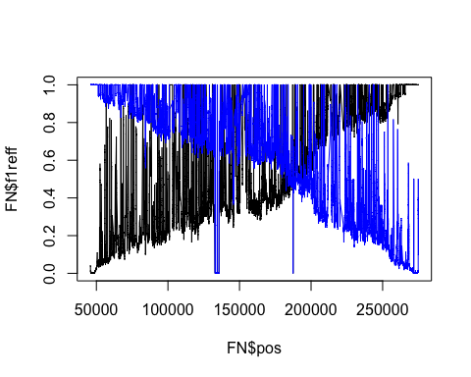

Plot mapped to cerevisiae. f1altf in black, f2altf in blue. 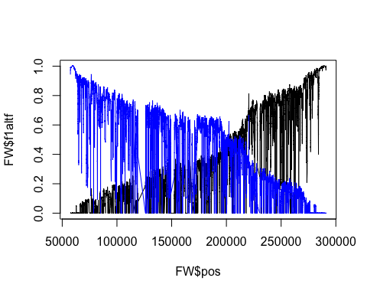

Cut SNPs with coverage 2 SD above mean.

mean(FN$f1cov)

## [1] 754.733

sd(FN$f1cov)

## [1] 212.1618

cutFN1 <- mean(FN$f1cov)+2*sd(FN$f1cov)  
  
mean(FN$f2cov)

## [1] 719.8816

sd(FN$f2cov)

## [1] 255.309

cutFN2 <- mean(FN$f2cov)+2*sd(FN$f2cov)  
  
mean(FW$f1cov)

## [1] 805.2579

sd(FW$f1cov)

## [1] 254.9876

cutFW1 <- mean(FW$f1cov)+2*sd(FW$f1cov)  
  
mean(FW$f2cov)

## [1] 693.7501

sd(FW$f2cov)

## [1] 204.9185

cutFW2 <- mean(FW$f2cov)+2*sd(FW$f2cov)  
  
FNcut <- FN[-which(FN$f1cov > cutFN1 | FN$f2cov > cutFN2),]  
FWcut <- FW[!(FW$f1cov > cutFW1 | FW$f2cov > cutFW2),]

Plot the coverage of the original and versions with cutoff (cutoff in red and purple).  
Also add the cutoffs as lines.  
Also add the frequencies (*1250 to fit on plot).

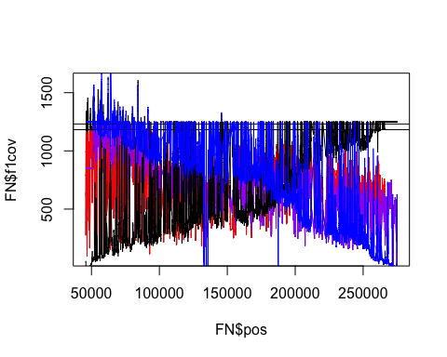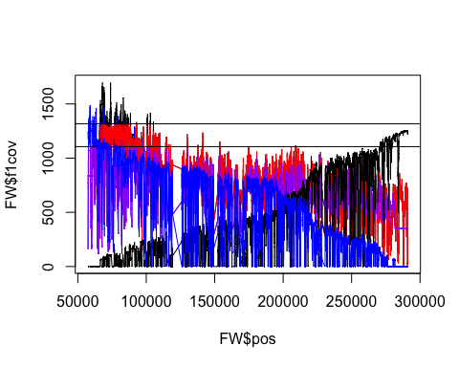 Still not good. Also, medium region with very few SNPs in cerevisiae mapping.  
  
Cut off bottom as well  
Plot these in green and orange. 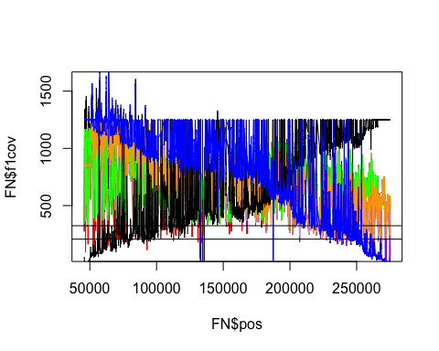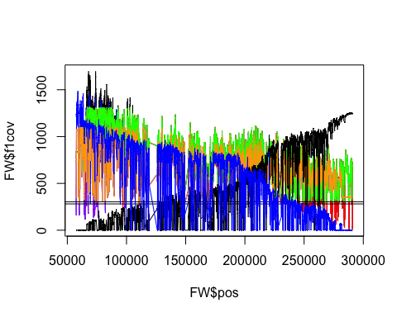 Got rid of some crazy peaks and smoothed it out a bit?  
  
Now try requiring that called variants are variable in both samples (within mapping to a single species).  
This will cut off the ends, but we’re not really interested in those.  
Then plot again with original (lightest), cut2 (darker) and cut3 (darkest).

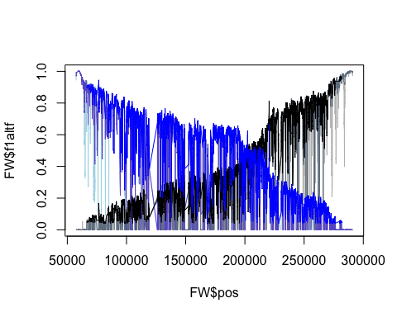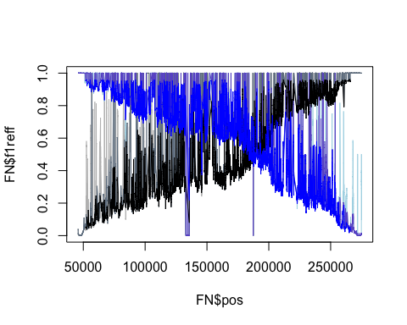 Still pretty crazy.  
Now will trim SNPs that are quite different from the median around them. First, need to find out how big the region is.

min(FNcut3$pos)

## [1] 51917

max(FNcut3$pos)

## [1] 265747

min(FWcut3$pos)

## [1] 66392

max(FWcut3$pos)

## [1] 281704

Based on this, the region in paradoxus (N) is:  
265747-51917=213830bp long  
We expect the frequency to go from 0 to 1 in this region so, if went up consistently, would change by 0.1 within:  
213830/10=21383  
so should be reasonable to expect that every SNP should be within 0.1 of the median within ~10691bp.  
  
For cerevisiae (W): 281704-66392= 215312bp long  
215312/10 = 21531.2  
So will use 10765bp.  
  
Also, do regions every 100bp. Plots the old frequencies from SNPs in lighter colours and post-cut in darker colours. First, need to rename columns.

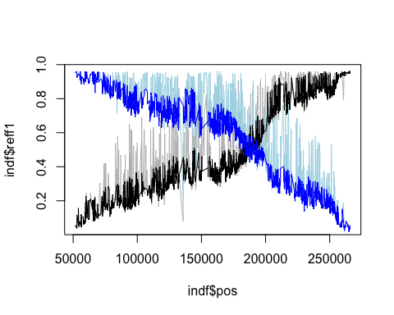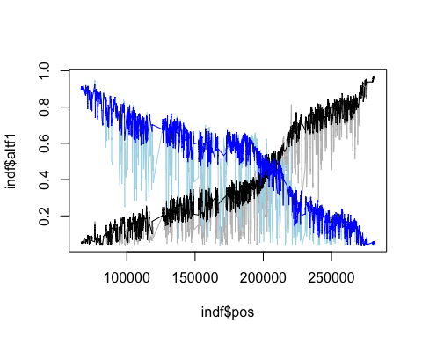

Find out how many cut:

length(FNcut3$chr)

## [1] 10588

length(FNcut4$chr)

## [1] 7834

length(FWcut3$chr)

## [1] 10534

length(FWcut4$chr)

## [1] 7761

Now plot with loess smoothing. Loess with span=0.25. Do for those mapped to paradoxus first. 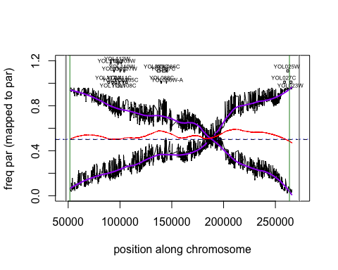

Plot for those mapped to paradoxus (N17) with loess smoothing.  
Borders of original region in forestgreen. Rectangles where did transformations.  
Bottom 5% of sum of fits in dotted blue line.  
  
Now plot with loess smoothing. Loess with span=0.25. Do for those mapped to cerevisiae.

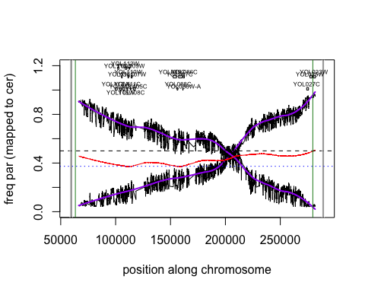 Plot for those mapped to cerevisiae (W303).  
Borders of original region in forestgreen. Rectangles where did transformations.  
Bottom 5% of sum of fits in dotted blue line.  
  
Next idea was to try and match up SNPs between the two mappings to only keep those that correspond. This is not trivial, however, and I haven’t done that yet.

## region E - try2

Do same. Read in vcf files (mapped to N17 and W303).

Check that it worked.

head(E2N)

## V1 V2 V3 V4 V5 V6 V7  
## 1 N_17.chr15 473 . A C 5078.55 PASS  
## 2 N_17.chr15 589 . T C 1050.10 PASS  
## 3 N_17.chr15 607 . C A 696.05 PASS  
## 4 N_17.chr15 621 . T G 476.05 PASS  
## 5 N_17.chr15 854 . T A 10945.50 PASS  
## 6 N_17.chr15 862 . A T 11244.50 PASS  
## V8  
## 1 AC=3;AF=0.5;AN=6;BaseQRankSum=-2.779;DP=486;FS=19.281;MLEAC=3;MLEAF=0.5;MQ=55.98;MQRankSum=-5.233;QD=11.87;ReadPosRankSum=-3.689;SOR=0.168  
## 2 AC=1;AF=0.167;AN=6;BaseQRankSum=-0.219;DP=599;FS=6.278;MLEAC=1;MLEAF=0.167;MQ=52.76;MQRankSum=-6.611;QD=6.4;ReadPosRankSum=-1.859;SOR=0.782  
## 3 AC=1;AF=0.167;AN=6;BaseQRankSum=0.003;DP=517;FS=1.867;MLEAC=1;MLEAF=0.167;MQ=52.37;MQRankSum=-6.171;QD=4.67;ReadPosRankSum=-3.407;SOR=0.621  
## 4 AC=1;AF=0.167;AN=6;BaseQRankSum=0.392;DP=479;FS=0;MLEAC=1;MLEAF=0.167;MQ=52.36;MQRankSum=-5.439;QD=3.63;ReadPosRankSum=-4.578;SOR=0.661  
## 5 AC=3;AF=0.5;AN=6;BaseQRankSum=-3.001;DP=931;FS=25.681;MLEAC=3;MLEAF=0.5;MQ=57.59;MQRankSum=-8.876;QD=12.18;ReadPosRankSum=-1.463;SOR=1.539  
## 6 AC=3;AF=0.5;AN=6;BaseQRankSum=-0.526;DP=960;FS=23.877;MLEAC=3;MLEAF=0.5;MQ=57.37;MQRankSum=-9.178;QD=12.25;ReadPosRankSum=-0.53;SOR=1.408  
## V9 V10  
## 1 GT:AD:DP:GQ:PL 0/1/1:65,68:133:8:2400,8,0,2399  
## 2 GT:AD:DP:GQ:PL 0/0/1:132,32:164:99:1055,0,301,5555  
## 3 GT:AD:DP:GQ:PL 0/0/1:126,23:149:99:703,0,310,5338  
## 4 GT:AD:DP:GQ:PL 0/0/1:114,17:131:99:483,0,292,4848  
## 5 GT:AD:DP:GQ:PL 0/1/1:128,150:278:66:5815,66,0,4703  
## 6 GT:AD:DP:GQ:PL 0/1/1:132,154:286:66:5906,66,0,4796  
## V11  
## 1 0/0/1:212,83:295:99:2688,0,390,8651  
## 2 0/0/0:379,0:379:0:0,0,0,6477  
## 3 0/0/0:324,0:324:70:0,70,191,1800  
## 4 0/0/0:328,0:328:70:0,70,191,1800  
## 5 0/0/1:469,152:621:99:5140,0,952,19000  
## 6 0/0/1:472,160:632:99:5348,0,936,19050

head(E2W)

## V1 V2 V3 V4 V5 V6 V7  
## 1 W303.chr15 340 . G C 35.06 PASS  
## 2 W303.chr15 380 . C T 152.13 PASS  
## 3 W303.chr15 13264 . A T 52.06 PASS  
## 4 W303.chr15 14308 . G A 52.05 PASS  
## 5 W303.chr15 14310 . A T 52.05 PASS  
## 6 W303.chr15 14314 . A G 56.06 PASS  
## V8  
## 1 AC=1;AF=0.167;AN=6;BaseQRankSum=-0.431;DP=79;FS=0;MLEAC=1;MLEAF=0.167;MQ=58.36;MQRankSum=-2.287;QD=3.51;ReadPosRankSum=-2.287;SOR=0.169  
## 2 AC=1;AF=0.167;AN=6;BaseQRankSum=-2.996;DP=91;FS=1.719;MLEAC=1;MLEAF=0.167;MQ=54.95;MQRankSum=-4.218;QD=7.24;ReadPosRankSum=-0.818;SOR=0.368  
## 3 AC=1;AF=0.167;AN=6;BaseQRankSum=0.826;DP=64;FS=2.881;MLEAC=1;MLEAF=0.167;MQ=42.96;MQRankSum=-1.025;QD=4.34;ReadPosRankSum=0.215;SOR=1.721  
## 4 AC=1;AF=0.167;AN=6;DP=71;FS=5.611;MLEAC=1;MLEAF=0.167;MQ=60;MQRankSum=0;QD=3.72;SOR=0.027  
## 5 AC=1;AF=0.167;AN=6;BaseQRankSum=-2.211;DP=71;FS=5.611;MLEAC=1;MLEAF=0.167;MQ=60;MQRankSum=0;QD=3.72;ReadPosRankSum=0.183;SOR=0.027  
## 6 AC=1;AF=0.167;AN=6;BaseQRankSum=-1.801;DP=69;FS=4.973;MLEAC=1;MLEAF=0.167;MQ=60;MQRankSum=0;QD=4.67;ReadPosRankSum=0.43;SOR=0.039  
## V9 V10 V11  
## 1 GT:AD:DP:GQ:PL 0/0/0:67,0:67:70:0,70,191,1800 0/0/1:8,2:10:18:42,0,18,266  
## 2 GT:AD:DP:GQ:PL 0/0/0:67,0:67:70:0,70,191,1800 0/0/1:12,9:21:9:159,0,9,361  
## 3 GT:AD:DP:GQ:PL 0/0/0:52,0:52:70:0,70,191,1800 0/0/1:10,2:12:24:59,0,24,357  
## 4 GT:AD:DP:GQ:PL 0/0/0:52,0:52:70:0,70,191,1800 0/0/1:12,2:14:30:59,0,30,509  
## 5 GT:AD:DP:GQ:PL 0/0/0:52,0:52:70:0,70,191,1800 0/0/1:12,2:14:30:59,0,30,509  
## 6 GT:AD:DP:GQ:PL 0/0/0:52,0:52:70:0,70,191,1800 0/0/1:10,2:12:24:63,0,24,423

Rename the columns.  
Cut down to the range for E:  
range for E rep2 - YOL160W to YOL157C is region, did transformations pau20 (YOL161C) to zps1 (YOL154W)  
for N17 - 1590 2276 to 24900 25649  
for W303 - 13641 14003 to 36750 37499  
Go a bit outside (1kb on either end).

Only keep the columns I want.

Plot outcome. Mapped to paradoxus, with e21reff in black, e22reff in blue. 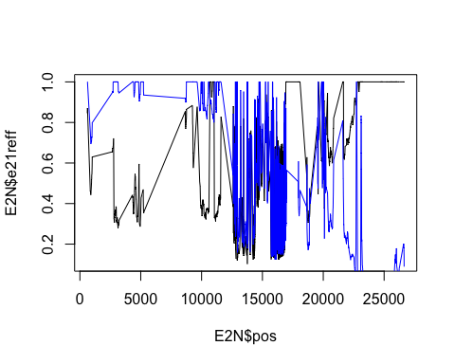 Doesn’t look great.

Plot mapped to cerevisiae. e21altf in black, e22altf in blue. 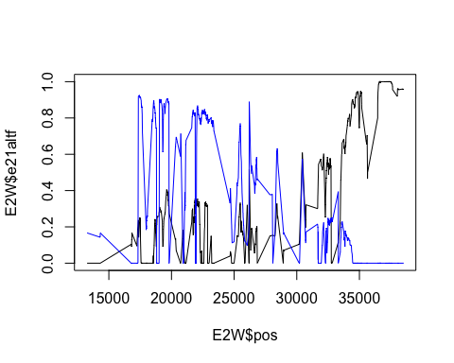 better???

Cut SNPs with coverage 2 SD above mean.

mean(E2N$e21cov)

## [1] 728.2364

sd(E2N$e21cov)

## [1] 399.622

cutE2N1 <- mean(E2N$e21cov)+2*sd(E2N$e21cov)  
  
mean(E2N$e22cov)

## [1] 721.6316

sd(E2N$e22cov)

## [1] 476.4803

cutE2N2 <- mean(E2N$e22cov)+2*sd(E2N$e22cov)  
  
mean(E2W$e21cov)

## [1] 525.7803

sd(E2W$e21cov)

## [1] 202.9725

cutE2W1 <- mean(E2W$e21cov)+2*sd(E2W$e21cov)  
  
mean(E2W$e22cov)

## [1] 509.1424

sd(E2W$e22cov)

## [1] 189.4075

cutE2W2 <- mean(E2W$e22cov)+2*sd(E2W$e22cov)  
  
E2Ncut <- E2N[-which(E2N$e21cov > cutE2N1 | E2N$e22cov > cutE2N2),]  
E2Wcut <- E2W[!(E2W$e21cov > cutE2W1 | E2W$e22cov > cutE2W2),]

Plot the coverage of the original and versions with cutoff (cutoff in red and purple).  
Also add the cutoffs as lines.  
Also add the frequencies (*1250 to fit on plot).

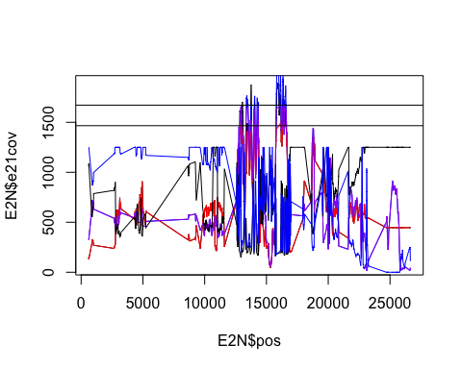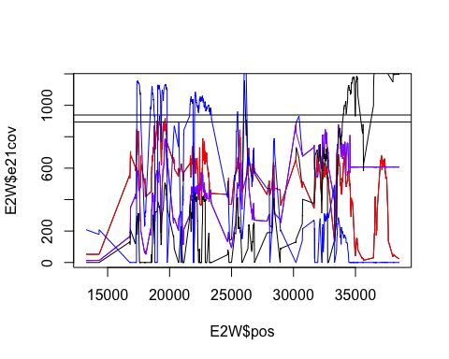 Still not good.  
  
Cut off bottom as well  
Plot these in green and orange. 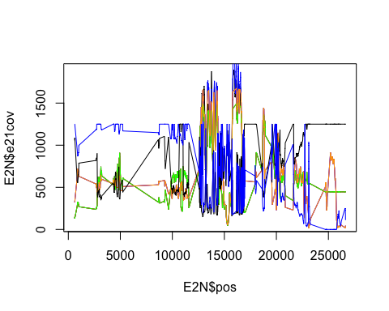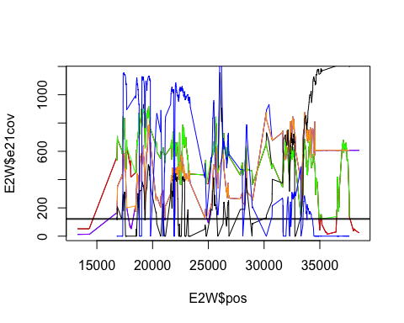 Now try requiring that called variants are variable in both samples (within mapping to a single species).  
This will cut off the ends, but we’re not really interested in those.  
Then plot again with original (lightest), cut2 (darker) and cut3 (darkest).

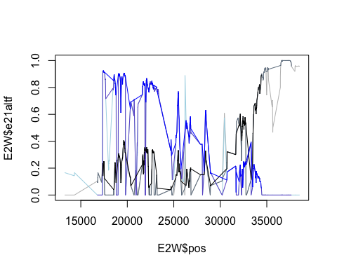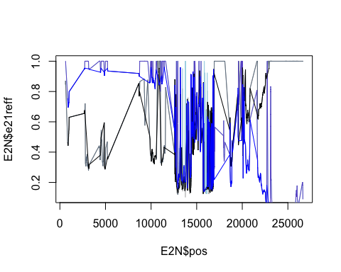 Still pretty crazy.  
Now will trim SNPs that are quite different from the median around them. First, need to find out how big the region is.

min(E2Ncut3$pos)

## [1] 854

max(E2Ncut3$pos)

## [1] 22937

min(E2Wcut3$pos)

## [1] 17358

max(E2Wcut3$pos)

## [1] 34422

Based on this, the region in paradoxus (N) is:  
22937-854=22083bp long  
We expect the frequency to go from 0 to 1 in this region so, if went up consistently, would change by 0.1 within:  
22083/10=2208.3  
so should be reasonable to expect that every SNP should be within 0.1 of the median within ~1104bp.  
  
For cerevisiae (W): 34422-17358= 17064bp long  
17064/10 = 1706.4  
So will use 853bp.  
  
Also, do regions every 100bp. Plots the old frequencies from SNPs in lighter colours and post-cut in darker colours. First, need to rename columns.

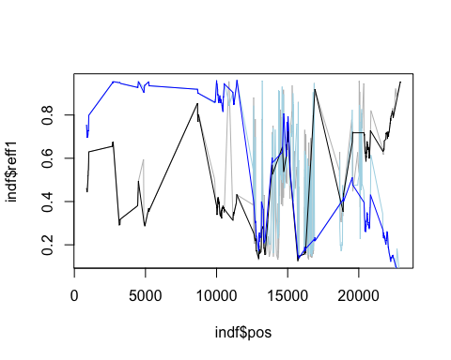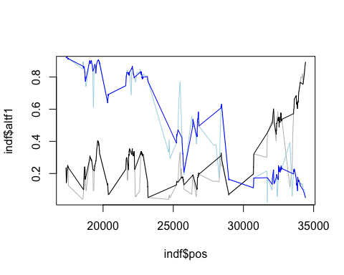 Find out how many cut:

length(E2Ncut3$chr)

## [1] 609

length(E2Ncut4$chr)

## [1] 329

length(E2Wcut3$chr)

## [1] 442

length(E2Wcut4$chr)

## [1] 303

Now plot with loess smoothing. Loess with span=0.25. Do for those mapped to paradoxus first. ####add genes#### 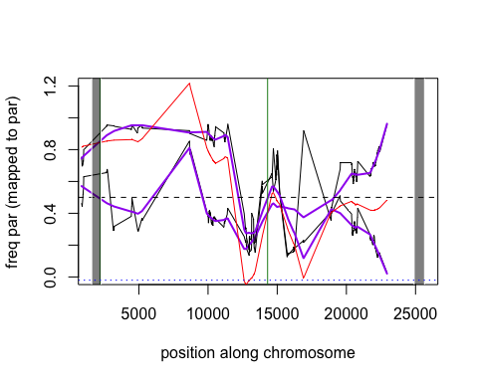 Not great but at least they cross?  
Plot for those mapped to paradoxus (N17) with loess smoothing.  
Borders of original region in forestgreen. Rectangles where did transformations.  
Bottom 5% of sum of fits in dotted blue line.  
  
Now plot with loess smoothing. Loess with span=0.25. Do for those mapped to cerevisiae. ###add genes#### 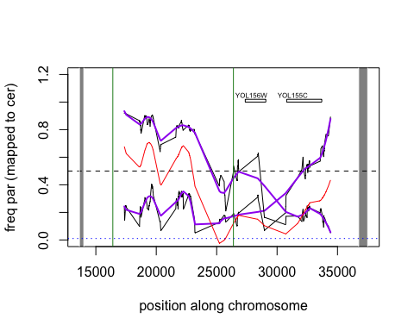 Plot for those mapped to cerevisiae (W303).  
Better? They cross….  
Borders of original region in forestgreen. Rectangles where did transformations.  
Bottom 5% of sum of fits in dotted blue line.  
  
Next idea was to try and match up SNPs between the two mappings to only keep those that correspond. This is not trivial, however, and I haven’t done that yet.