ECE 3710 Microcontrollers

Dr. Ryan Gerdes

TA: Samuel Tanner

by:

Jonathan Tousley

**Lab0**

**About the M4C123GH6PM Microcontroller:**

1.

a) Section 2.3.3 describes the M4's memory map

b) Table 2-2 gives the memory map of the M4's processor

2.

GPIO_A has base memory address 0x4000.4000

3.

a) Section 10.4 describes the GPIO register map

b) Table 10-6 gives the GPIO register map

4.

Register 2 corresponds to the direction of GPIO ports.

It's memory offset is 0x400, so for GPIO port A's direction register the memory address is 0x4000.4400.

5.

a) Binary value of 1 corresponds to output.

b) 7:0 = 1001 0001

c) 7:0 = 0x6E

6.

Timer 2 is located at memory address 0x4003.2000.

7.

Register 26 (GPTMTBPV) is located at offset 0x068. This register shows the current free running value of the Timer B prescaler.

8.

Pins in group 3,12,27,39,55 and 25,56 and 2,11,26,42,54 and 34,35 are wired together.

**Introduction to the MDO3014 Mixed Domain Oscilloscope:**

1. Potential uses of a logic analyzer:

- Debugging a microprocessor

- Monitor digital circuits

- View logic states

2.

a) Push the `trigger menu` button -> select Type:`edge`, and slope:`falling`.

b) Push the `trigger menu` button -> select Type:`edge`, and slope:`rising`.

3.

Adjust the sample rate by turning the horizontal scale knob.

A simple program to turn an LED light on was loaded onto the microcontroller, and the light output was directed to the oscilloscope input. Setting the view window at 40ms and configuring the trigger to capture upon a falling edge, the light was turned off and the oscilloscope displayed this output:

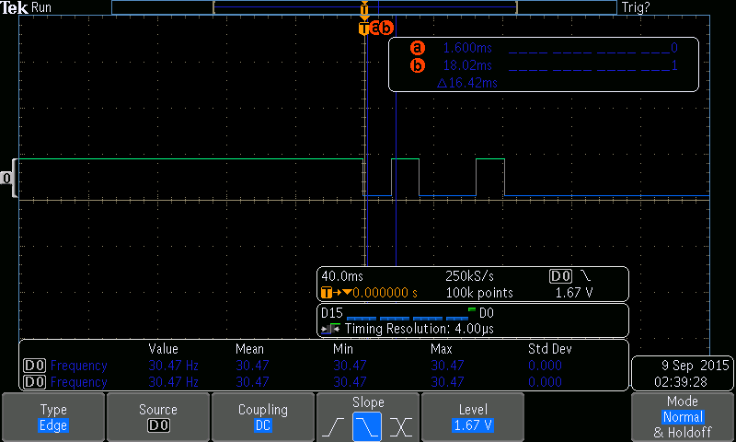

The graph depicts a frequency of 30.47Hz and 5ms of clock cycles after the falling edge. Instead of just turning off as might be expected, the light flickered off at a set frequency, which was captured by the oscilloscope. Manually measuring the waveform gave 16.42*2 = 32.84ms. 1/T = f = 30.45Hz which is 0.02 lower than the oscilloscope itself measured. Good accuracy!

Using the rising edge as a trigger and turning the light on gave:

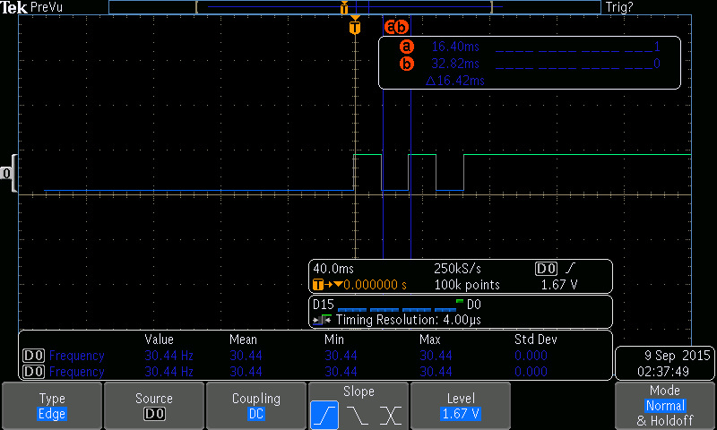

The graph depicts a frequency of 30.44Hz and 5ms of clock cycles after the rising edge.

**Using the Analog Comparator of the TM4C123GH6PM Microcontroller:**

2.

Comparator (Vin) -> PC4

Light -> PF1

3.

The ACREFCTL register stores internal reference information.

4.

The ACREFCTL register has a VREF value stored as an 8 bit value, and single bits RNG and EN.

5.

RNG = 1;

VREF = 0x07;

The light will be on between .971 and 1.118 V (.971, 1.118).

A simple program to turn an LED light on when an input voltage is within a specific boundary was loaded onto the microcontroller. The system was simulated and then tested with an input voltage source, and the results were as expected.