LAB 2

ECE 3710

Dr. Ryan Gerdes

By: Jonathan Tousley

**Goal:**

Design a system such that a 10 pin LED light will count in binary beginning at 0. Count to the max value and loop. Do nothing until start is pressed, and then begin counting. Design an interrupt stop that will pause the counter and a reset interrupt that will return the counter to 0 and wait for start. The rate of increase should be 2 counts per second, plus or minus 5%.

**Solution:**

Connect the 10 pins to the LED to the microcontroller in Pull-Down configuration so the microcontroller does not need to supply the power. Connect the third switch to the microcontroller in Pull-Down configuration and add some resistance to reduce current sink. Because of the active-low position configuration of the LEDs, set the counter to start from the max value and count down to zero. The pin configuration was as follows:

LED[0:5] = PA[2:7] (lower six values of the LED reflecting lower binary values. OUTPUT)

LED[6:9] = PB[0:3] (higher four values of the LED. OUTPUT)

SW3 = PB4 (switch 3, configured to be RESET. INPUT)

SW2 = PF0 (switch 2, configured to be STOP. INPUT)

SW1 = PF4 (switch 1, configured to be START. INPUT)

Schematics drawn in other PDF file.

Verification of timing to be 500ms +- 25ms:

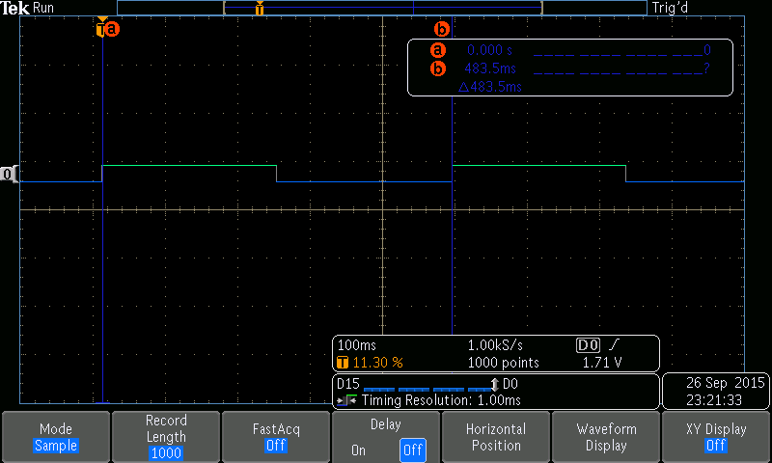

Code for microcontroller:

PA EQU 0x40004000

PB EQU 0x40005000

PF EQU 0x40025000

RCGC2 EQU 0x400FE608

Start

; ***************CONFIGURATION / SETUP ***********************

; 1. activate clock

LDR R1,=RCGC2 ;clock enable register

MOV R0,#0x23 ; enable PA and PB and PF

STR R0,[R1]

NOP ;system clock takes a while...

NOP ;to get going...

; 2. disable alt. function

LDR R1,=PA

MOV R0,#0x0

STR R0,[R1,#0x420]

LDR R1, =PB

STR R0, [R1, #0x420]

LDR R1, =PF

STR R0, [R1, #0x420]

MOV32 R0, #0x4C4F434B ; GPIO Unlock code.

STR R0, [R1,#0x520] ; unlock GPIOF_LOCK

; 3. set port pins as OUTPUT

LDR R1, =PA

MOV R0,#0xFF ; PA[0:7] output

STR R0,[R1,#0x400] ;

LDR R1, =PB

MOV R0, #0x0F ; PB[0:3] output, [4:7] INPUT

STR R0, [R1, #0x400] ;

LDR R1, =PF

MOV R0, #0x00 ; set PF as input

STR R0, [R1, #0x400]

; 4. additional settings

LDR R1, =PA

MOV R0, #0x0 ;disable GPIOPCTL PA

STR R0, [R1, #0x52C]

LDR R1, =PB

STR R0, [R1, #0x52C] ;disable GPIOPCTL PB

MOV R0, #0x10 ; set pull down for PB4

STR R0, [R1, #0x514]

LDR R1, =PF

MOV R0, #0x01

STR R0, [R1,#0x524] ; GPIOCR unlock pin PF0

; MOV32 R0, #0x4C4F434B ; GPIO Unlock code. Unlock GPIOF_LOCK after write to GPIOCR (pg681)

; STR R0, [R1,#0x520] ;

MOV R0, #0x11 ; set pull up for PF0 and PF4

STR R0, [R1, #0x510]

; 5. enable port

LDR R1, =PA

MOV R0,#0xFF

STR R0,[R1,#0x51C] ; enable 8 pins on PA

LDR R1, =PB

STR R0, [R1, #0x51C] ;enable 8 pins on PB

MOV R0, #0x1F ; enable PF4 (sw1) and PF0 (sw2)

LDR R1, =PF

STR R0, [R1, #0x51C]

;********************* CONFIGURATION END ***************************

begin

MOV R0, #0xFF ; initialize zero

LDR R1, =PA

LDR R3, =PB

LDR R5, =PF

STR R0, [R1, #0x3FC]

STR R0, [R3, #0x3FC]

MOV R12, #0x3FF ; value to count

MOV R10, #0x0 ; value to compare

stop

ADDS R0, R12, #0xFFFFFFFF ; set carry bit

LDR R0, [R5, #0x3FC] ; PF DATA

LSR R0, R0, #4 ; take 2nd bit

AND R0, #0x1 ; mask

CMP R10, R0 ; check if 0

BEQ count

LDR R0, [R3, #0x3FC]

LSR R0, #4

AND R0, #0x1

CMP R10, R0

BNE begin

B stop

count

SUBS R12, #0x1 ;count--

MOV32 R8, #0x562AD ; delay counter

LSR R0, R12, #6 ; take 4 MShB of count

STR R0, [R3, #0x3FC] ; write to PB[0:3]

LSL R0, R12, #2 ; take 6 LShB of count

STR R0, [R1, #0x3FC] ; write to PA[2:7]

delay

; stop counting

LDR R0, [R5, #0x3FC]

AND R0, #0x01

CMP R10, R0

BEQ stop

; reset

LDR R0, [R3, #0x3FC]

LSR R0, #4

AND R0, #0x1

CMP R10, R0

BNE begin

SUBS R8, #0x1

BNE delay

;keep counting!

B count