Umar Dastgir

Nathan Tipton

Jonathan Tousley

Vending Machine Proposal

**Introduction:** The IEEE club has a vending machine that has been out of operation for a considerable amount of team. This group proposes to restore the vending machine to working conditions, and add sufficient aesthetic modifications to make the machine appear trustworthy.

**Solution:** To achieve the desired results, this team will replace the mechanical coin system with an electronically operated system to dispense the sodas. The system will be interfaced via a touchscreen that will display the available products, the internal temperature, and allow the user to select their preference freely. In addition, the system will notify the IEEE club when the quantity becomes low.

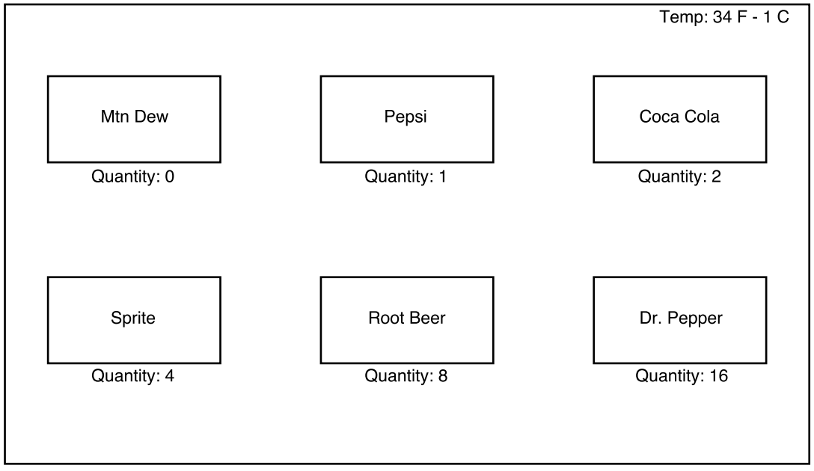

Figure 1: Example

|  |  |  |
| --- | --- | --- |
| Item | Cost | Total Cost |
| Ultrasonic proximity sensors | $10.99 |  |
| 7” touchscreen | $70.92 |  |
| Raspberry Pi 3 B | $39.99 |  |
| Thermometer sensor | $12.99 |  |
| Cleaning/aesthetic supplies | $10 - $20 |  |
|  |  | $154.99 |