Readme

# iPhone App

You can change the values shown on the General > About page via the iPhone App. When the Watch app is running, press “Save and send update” to store the values on the iPhone, and send them to the Watch. The Watch will store these and remember it after restart.

You can use the “Reset to defaults” button to restore the iPhone values to the hard-coded values, and store these on the iPhone. To send these over to the Watch, use the “Save and send update” button again.

The hardcoded values can be changed in the source code.

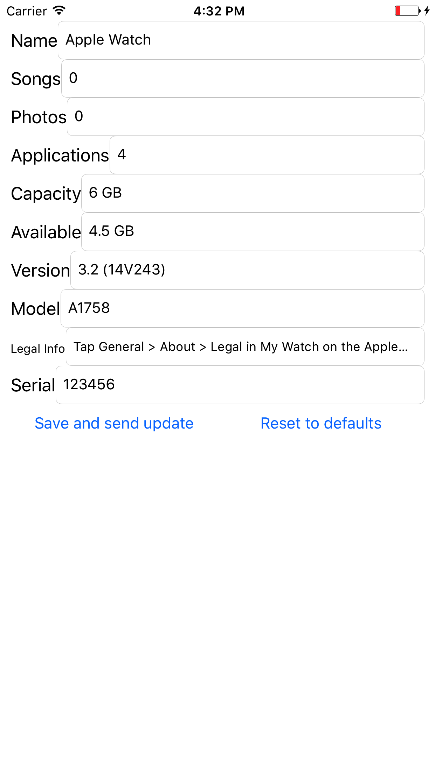

# Apple Watch app

The app starts with the settings menu’s content, and you can dig down in the menu tree to most pages available in the original settings app. Functionalities not available from the WatchKit SDK (e.g. changing brightness level, setting fonts bold system-wide, etc.) are not supported in the app.

# Source code structure

The core of the app is the GenericTableInterfaceController. This is a huge page with a tableview, containing all possible cells in the app.

The navigation tree is defined in the RootPageSource class, so it can be extended easily. The app starts with the a GenericTableInterfaceController having the context of the root menu node.

Each subpage (in the subpages array) are rendered as table cells. If you click these, a new GenericTableInterfaceController is pushed and it gets the context of the sub-node.

The different cell types and some related conversion functions are in the WatchSettingsPage class.

The about page is special: it is built up from KeyedLeafButton cells, which have an extra textKey property to define, which custom text from the UserDefaults needs to be displayed. This way new rows can be added easily.