**Winter 2022 – Shopify Developer Intern**

**Challenge Question Testing**

**Author: Jeanne Payoyo**

1. Here is the main form.

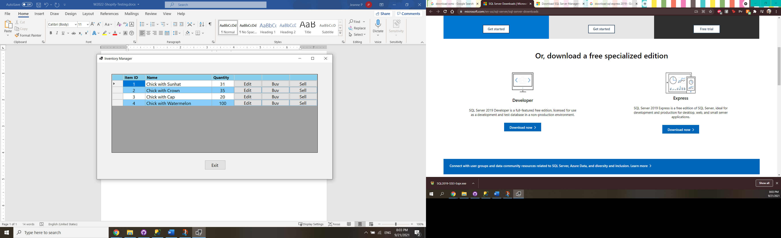

1. Let’s edit the first item.

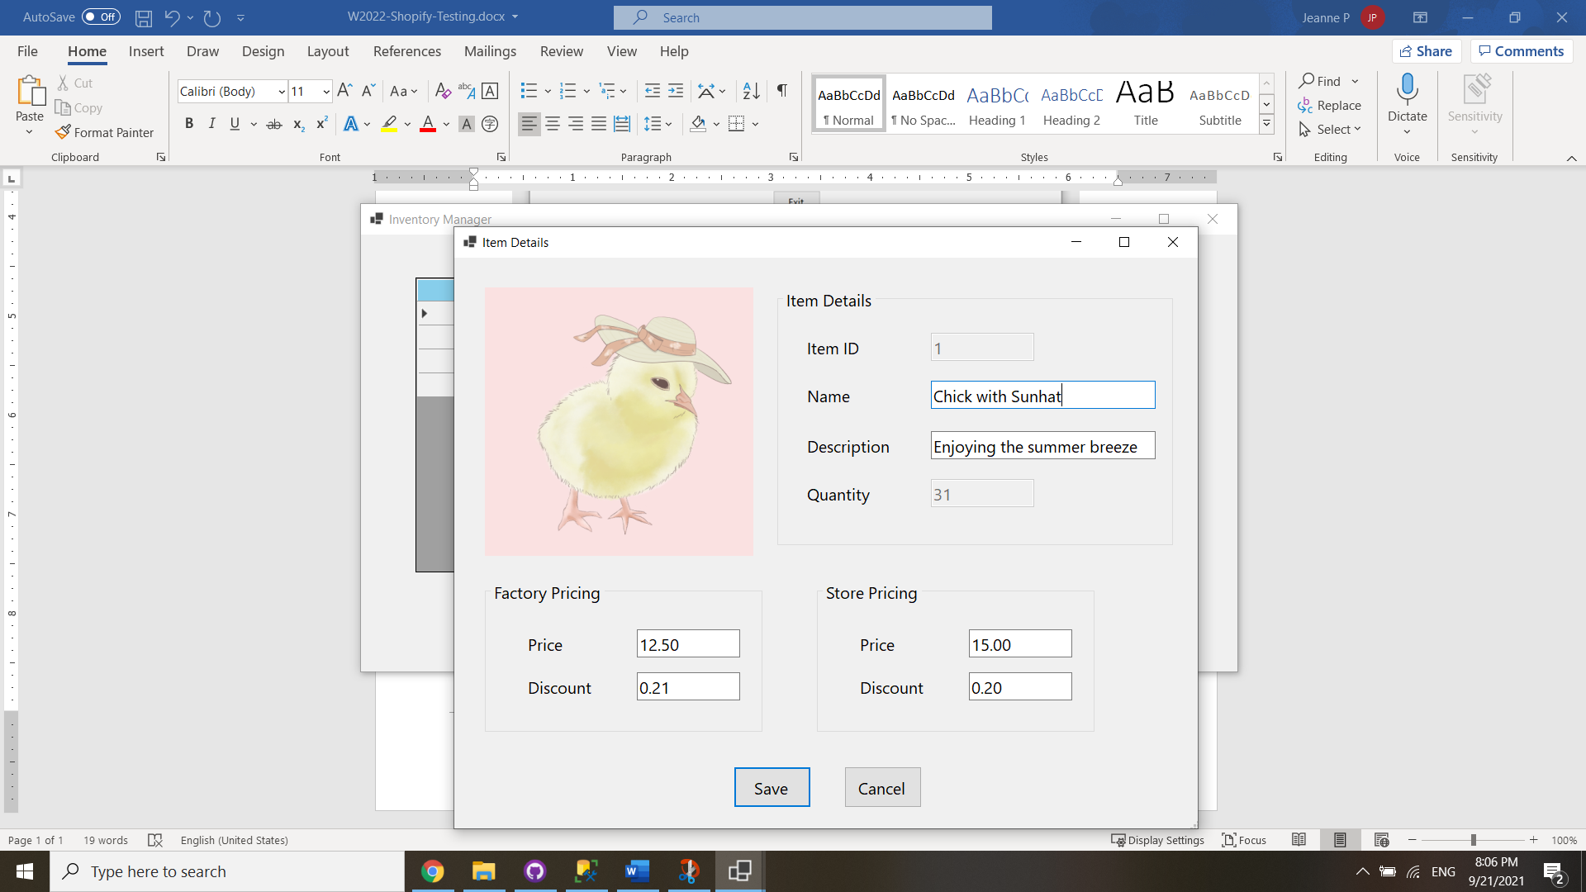

1. If I try to save with an empty field, an error will appear.

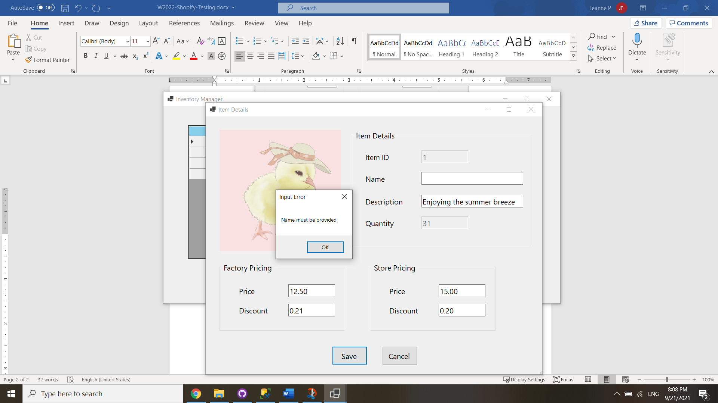

1. If factory/store price is negative or non-numeric, an error will appear.

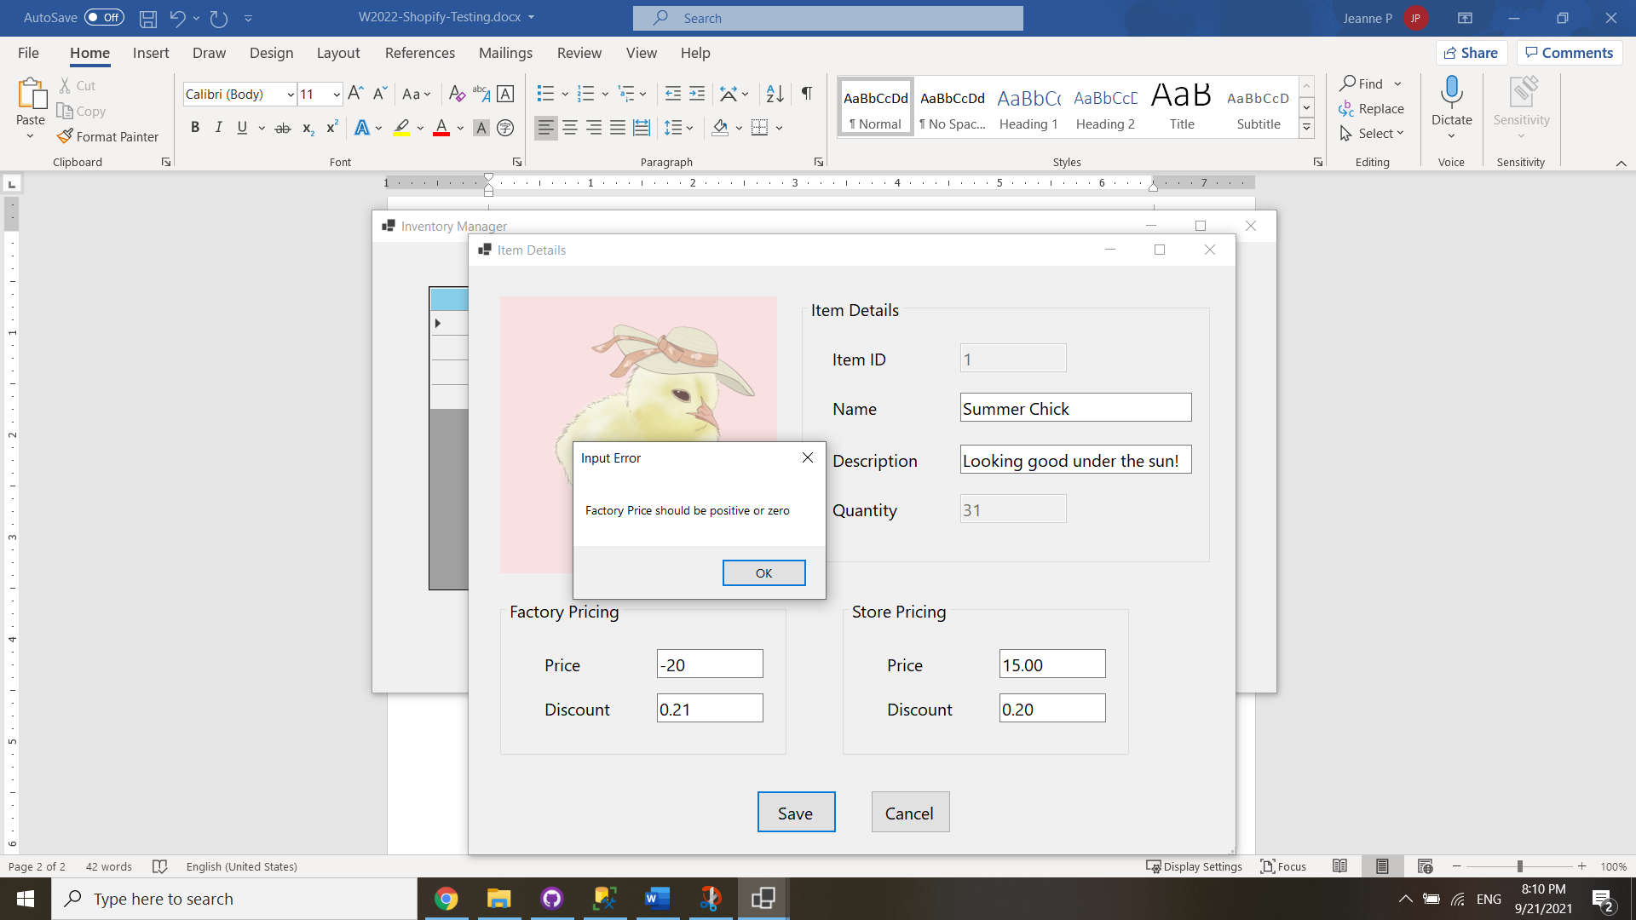

1. The factory/store discounts must be between 0 and 1. A factory discount of 0.1 is acceptable.

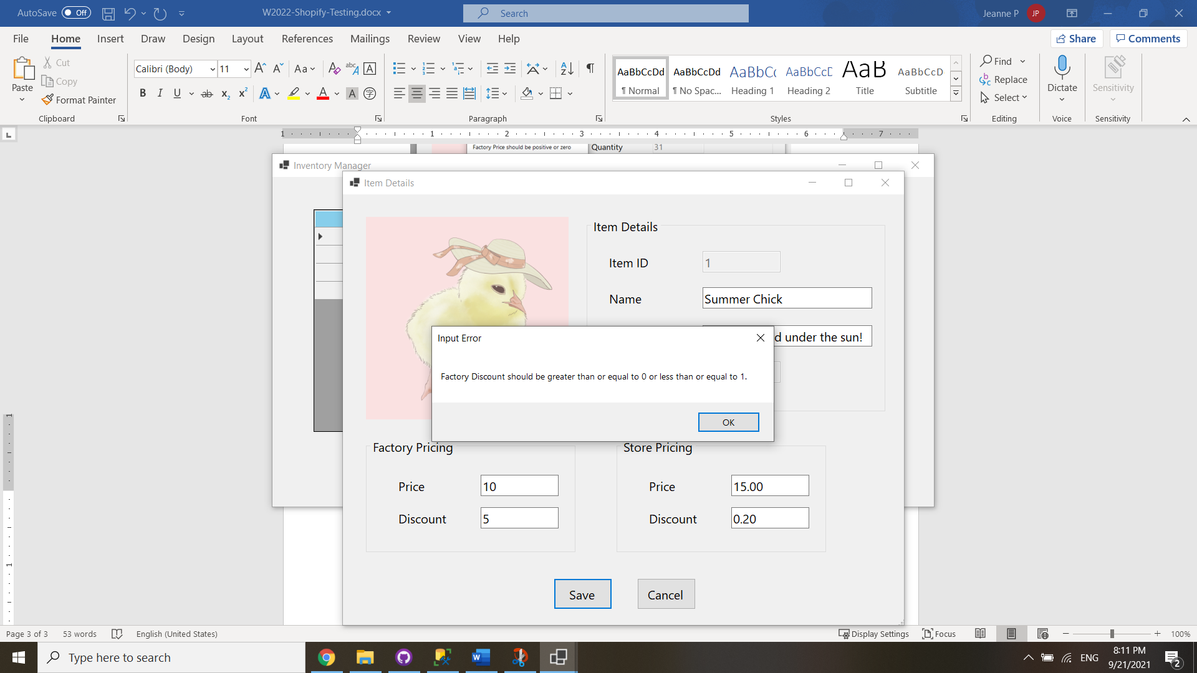

1. The name has changed successfully from “Chick With Sunhat” to “Summer Chick”.

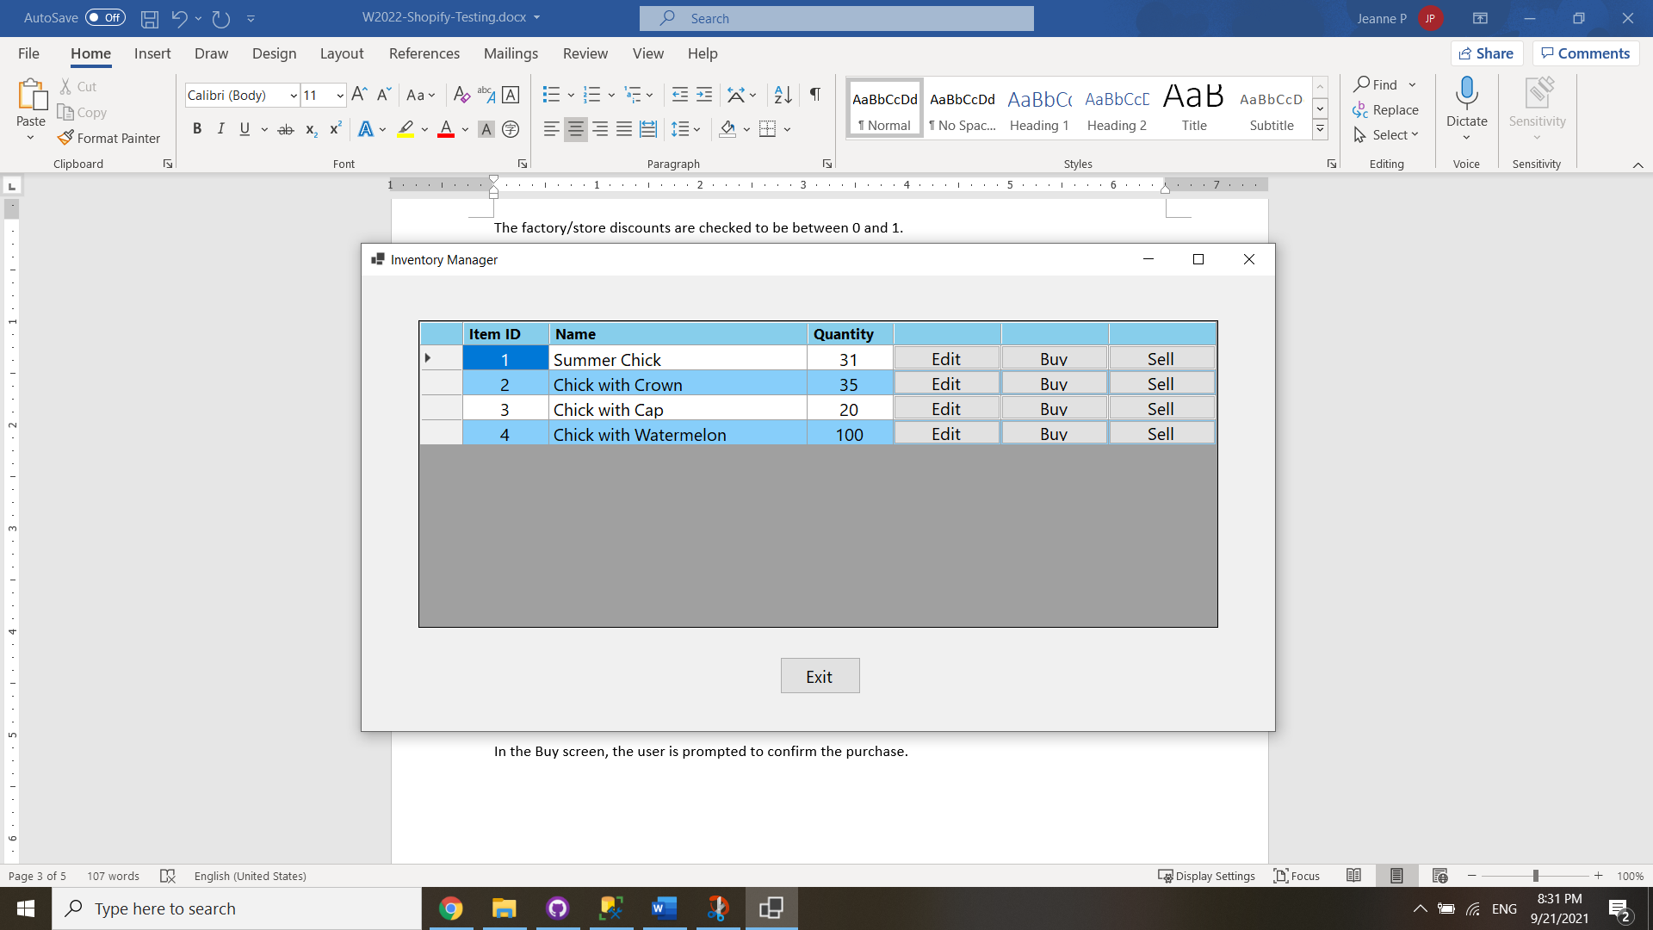

1. In the Buy screen, the user is prompted to confirm the purchase. For 9 items at a factory price of $10 each at a 10% discount, the total cost displays correctly at $81.

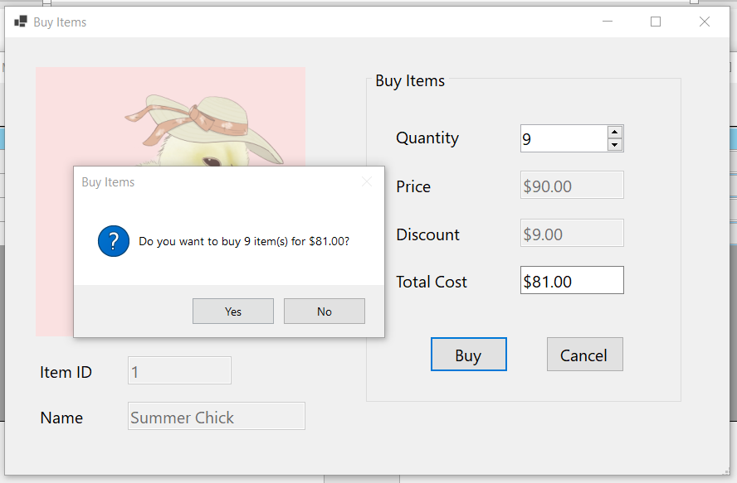

1. The updated quantity for Item 1 is 40.

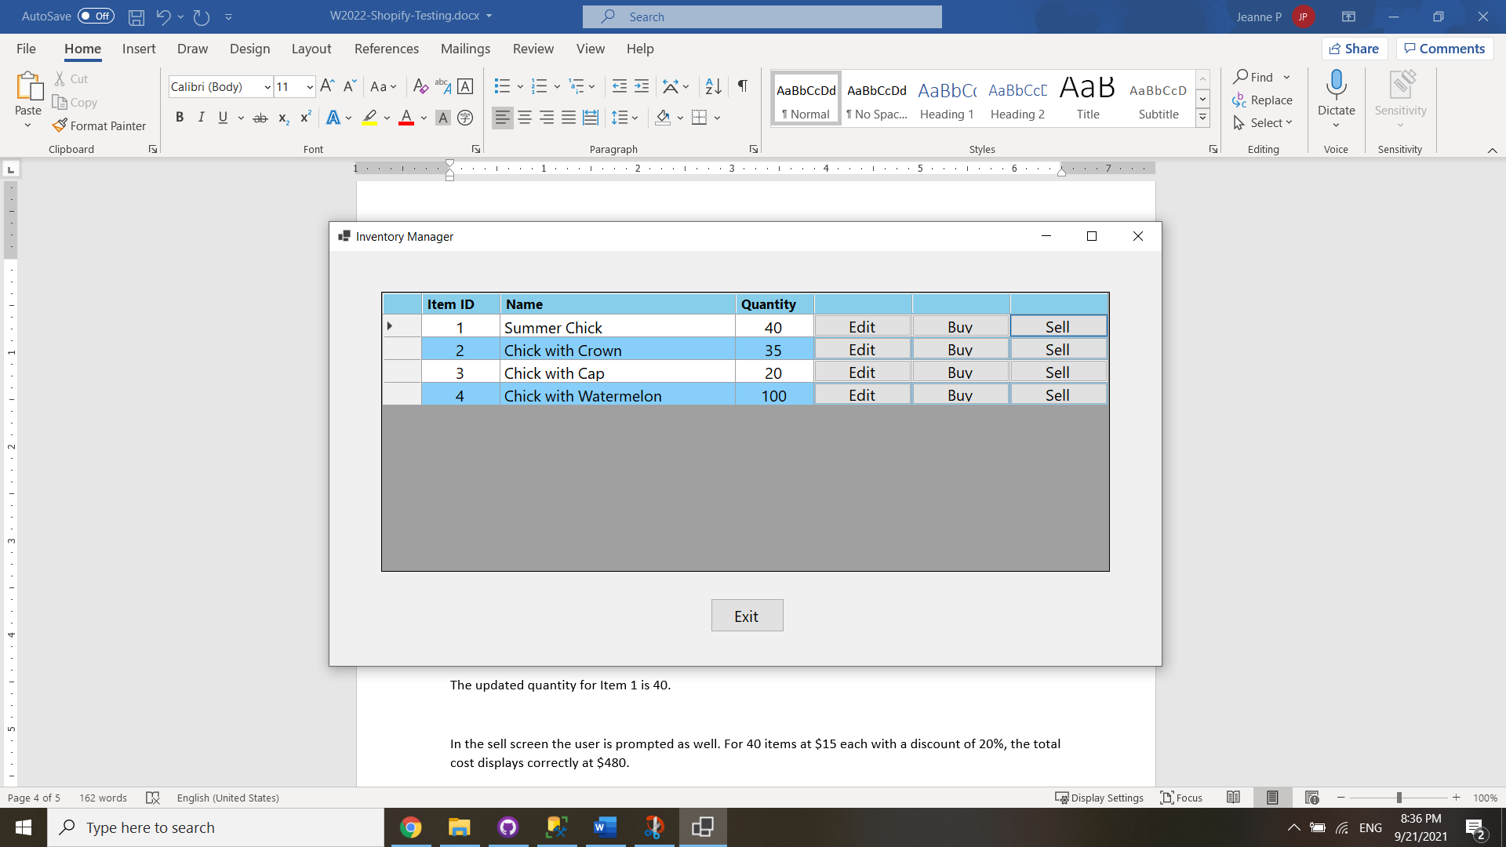

1. The user is also prompted for confirmation in the sell screen. For 40 items at $15 each with a discount of 20%, the total cost displays correctly at $480.

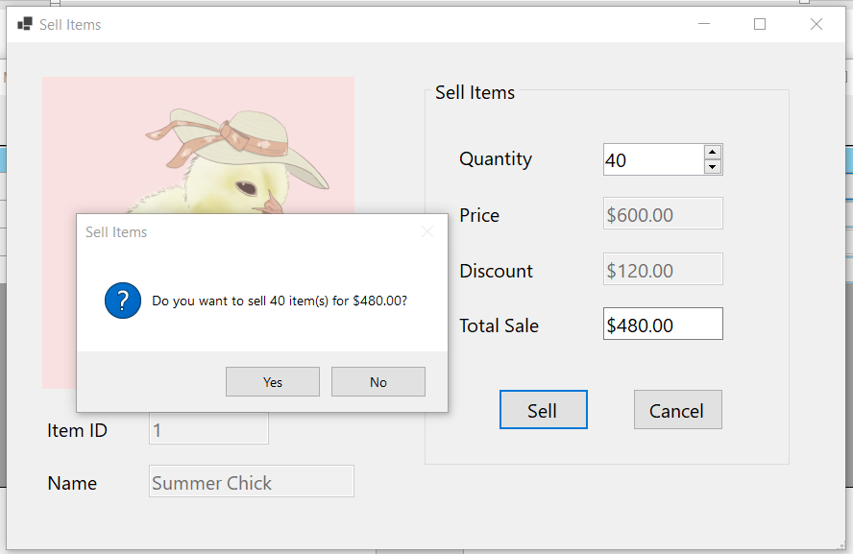

1. The user is warned if they try to sell an out-of-stock item and may not enter the sell screen.

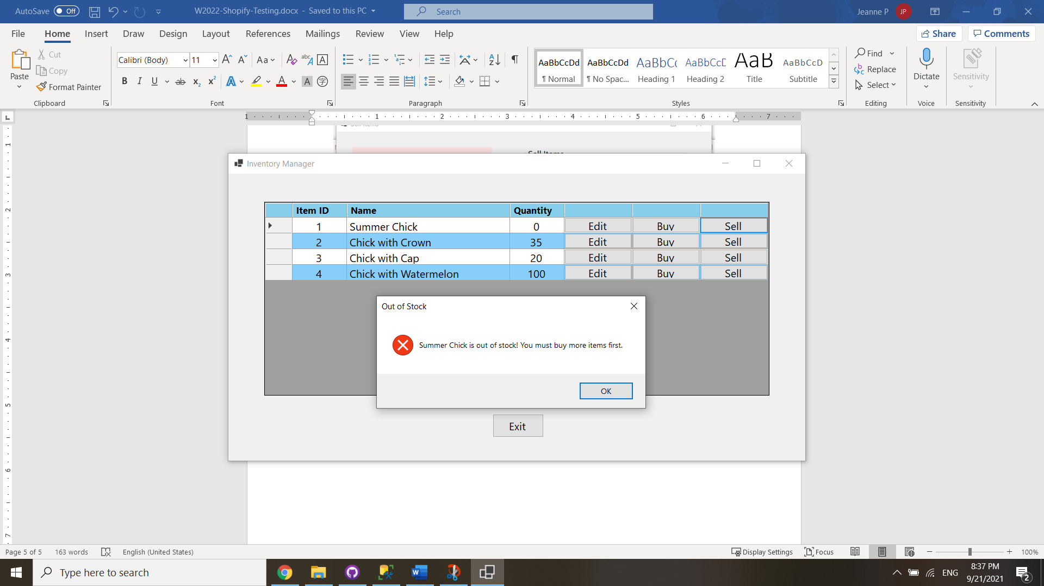

1. The changes are reflected in the database. The following screenshot is from SSMS.

