Linear Regression

<http://www.analyzemath.com/statistics/linear_regression.html>

y = ax + b

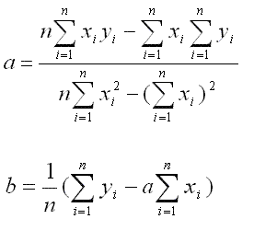

# Base Equation

$$y=ax+b$$

# Slope

$$a= \frac{n\sum_{i=1}^{n}{x_{i}y_{i}}- \sum_{i=1}^{n}{x_{i}}\sum_{i=1}^{n}{y_{i}}}{\sum_{i=1}^{n}{x_{i}^{2}}-{\left(\sum_{i=1}^{n}{x_{i}}\right)}^{2}}$$

# Y-Intercept

$$b= \frac{1}{n} \left(\sum_{i=1}^{n}{y_{i}}-a\sum_{i=1}^{n}{x_{i}}\right)$$

# Alternate forms

$$a= \frac{\overline{xy}-\left(\overline{x}\right)\left( \overline{y}\right)}{\overline{x^{2}}-{\overline{x}}^{2}}$$

$$b= \frac{\overline{y}\overline{x^{2}}-\overline{x} \overline{xy}}{\overline{x^{2}}-{\overline{x}}^{2}}$$

# Alternate forms 2

Used in the lazyprogrammer programming exercise.

$$a= \frac{\sum_{i=1}^{n}{x_{i}y_{i}}- \overline{y}\sum_{i=1}^{n}{x_{i}}}{\sum_{i=1}^{n}{x_{i}^{2}}-\overline{x}\sum_{i=1}^{n}{x_{i}}}$$

$$b= \frac{\overline{y}\sum_{i=1}^{n}{x_{i}^{2}}- \overline{x}\sum_{i=1}^{n}{x_{i}y_{i}}}{\sum_{i=1}^{n}{x_{i}^{2}}-\overline{x}\sum_{i=1}^{n}{x_{i}}}$$

# Error

E = Error

y^ = prediction

y^ = (ax + b)

yi = collected data points.

xi = collected data points.

$$E= \sum_{i=1}^{n}{{\left(y_{i}- {\hat{y}}_{i}\right)}^{2}}$$

$$E= \sum_{i=1}^{n}{{\left(y_{i}-(ax_{i}+b)\right)}^{2}}$$