CB 7 Collision Report

Joyce Robbins

October 28, 2015

## Data Source

<https://data.cityofnewyork.us/NYC-BigApps/CB7-10023-10024-10025-10069-/3deq-ujhm>

## Number of Persons Injured

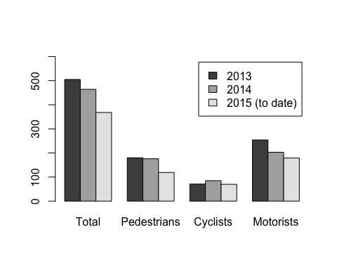 The number of injuries went down from 2013 to 2014...

## Number of Persons Killed

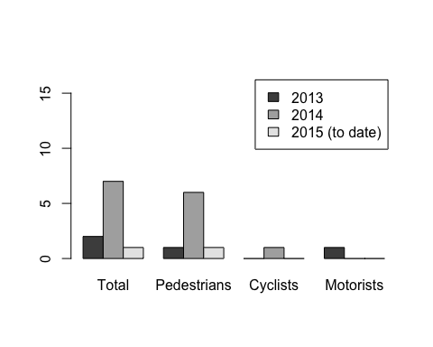

... but the number killed went up from 2 to 7 from 2013 to 2014.

## Monthly Pattern of Injuries/Deaths

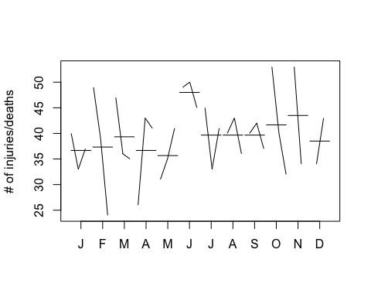

## Observations

June is consistently high:

## June 2013 -- 49 injured/killed  
## June 2014 -- 50 injured/killed  
## June 2015 -- 45 injured/killed

Otherwise, no clear pattern emerges. There are no repeated months in either the top five or bottom five for injured/killed, and 2 months appear in both lists: Oct, Feb.

Top five:

## Oct 2013 (53)  
## Nov 2013 (53)  
## Jun 2014 (50)  
## Feb 2013 (49)  
## Jun 2013 (49)

Bottom five:

## Jul 2014 (33)  
## Oct 2015 (32)  
## May 2013 (31)  
## Apr 2013 (26)  
## Feb 2015 (24)

## Location

Plotting (longitude, latitude) shows that injured/killed are distributed throughout the community board district:

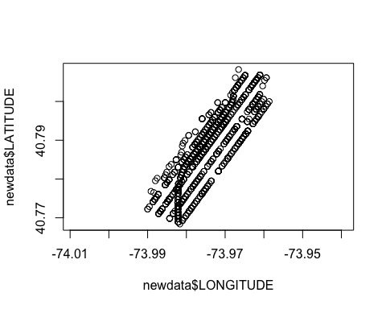

## Intersection with the highest # of injured/killed

Intersection: BROADWAY and WEST 96 STREET  
Collisions by month:

## Source: local data frame [16 x 3]  
## Groups: year  
##   
## year month n  
## 1 2013 Jan 2  
## 2 2013 Feb 1  
## 3 2013 May 2  
## 4 2013 Sep 2  
## 5 2013 Nov 1  
## 6 2013 Dec 1  
## 7 2014 Jan 2  
## 8 2014 Feb 1  
## 9 2014 Mar 1  
## 10 2014 Apr 1  
## 11 2014 Jul 1  
## 12 2014 Aug 1  
## 13 2014 Oct 1  
## 14 2014 Nov 1  
## 15 2015 Jan 1  
## 16 2015 Feb 1