Jackson Rapp Dec. 13, 2025

Analysis Report

Study Overview / Introduction

Background / Study Population
Gene editing not only raises scientific questions but also stirs moral dilemmas. Gene editing involves altering a living creature’s genetic material to control a characteristic or prevent a genetic disorder. However, applying gene editing to humans could require testing on human embryos. This study aims to capture a snapshot of the public perception surrounding embryonic testing for gene editing. Firstly, we aim to understand if a gender divide exists on the morality of embryonic testing, and then we examine how religious commitment impacts these beliefs. For this study, data from the 2018 American Trends Panel 34 from the Pew Research Center were used. This data set was composed of 2,537 adults living in the United States who were surveyed via the web and mail. This study is intended to shed light on the intersection of biotechnology and morality as well as how American belief systems impact public perception.

Study Aims / Objectives
Aim 1: To determine if there is a statistical association between sex (Male vs. Female) and the opinion that gene editing of human embryos is "taking medical technology too far" versus an "appropriate use."

Aim 2: To evaluate whether this association is confounded or impacted by the respondent's level of religious commitment (High, Medium, Low).

Statistical Methods

Study Variables
Our study was centered around three key variables: sex (male or female), religious commitment (high, medium, or low), and whether embryonic testing was “an appropriate use of medical technology” or “taking medical technology too far.” Sex will be acting as our binary predictor in this study for a respondent’s opinion on embryonic testing. To assess potential confounding or interaction, religious commitment was included as a stratifying variable. High, medium, and low commitment were based on a respondent’s self-reported frequency of prayer, attendance at religious services, and importance of religion.

Descriptive Statistics
The above variables were summarized via descriptive statistics in the Table One found in the results section below. The table includes counts and percentages of men and women stratified by religious commitment. Additionally, the table includes a section on men and women stratified by their opinion on gene editing. Standardized mean differences are calculated for each section to assess the balance of covariates between male and female respondents. Additionally, a stacked bar chart is included as a visual to better assess the dataset. The chart assesses respondents’ views on gene editing, stratified by sex, and faceted by religious commitment.

Analysis Plan for Aim 1
To determine if there is a statistical association between respondent sex and their corresponding opinion on the morality of gene editing, a chi-squared test of independence was used. This test determines if we reject our null hypothesis that sex and opinion on gene editing are independent of each other. The alternative hypothesis is that there is an association between sex and the morality of gene editing.

If an association exists, then a logistic regression will be used to determine the magnitude and direction of the association. This will be calculated using sex as a binary predictor for the log-odds of gene editing appropriateness. The resulting unit of measurement will be the odds ratio. An odds ratio greater than one indicates females have higher odds of approving of embryonic testing than men, while an odds ratio less than one indicates the opposite.

Analysis Plan for Aim 2
If an association is found in our first aim, then the data set will be stratified based on religious commitment to evaluate whether this association is confounded by or interacts with the stratifying variable. Following stratification, a Breslow-Day test will be utilized to assess the homogeneity of odds ratios across the three religious strata. The goal of this test is to determine if religious commitment interacts with sex to determine a respondent's beliefs on embryonic testing.

The interpretation of this test depends on the corresponding p-value. A p-value less than 0.05 will indicate that a statistically significant interaction exists between religious commitment and sex. As a result, reporting common odds ratios would be inappropriate. In this case, distinct odds ratios will be reported by religious subgroups. A p-value larger than 0.05 will indicate that interaction does not exist, and a common odds ratio is safe to report.

If homogeneity is determined, the common odds ratio will be determined by a Cochran-Mantel-Haenszel (CMH) Test. This test yields a common odds ratio, which quantifies the association between sex and opinion adjusted for religious commitment. After computing a common odds ratio, we will compare it to the unadjusted odds ratio calculated by our logistic regression to assess if religious commitment is a confounder in our data set. If the values are dramatically different, we have evidence of confounding. If they are similar, then religious commitment will not be considered a confounder in our dataset.

Note that for all the above tests, a p-value of 0.05 will be used to determine significance.

Assumptions
Both aims rely on two primary assumptions: independence and sample size. For independence, the study will trust the Pew Research Center's exhaustive methodology to ensure independence in the data set. For the sample size, both aims require an asymptotic chi-squared distribution such that all expected cell counts in our contingency table are greater than five. If this assumption was not met, a Fisher’s exact test would have been used instead of the chi-square and CMH tests. Fortunately, our sample size was sufficiently large to ensure this. The second aim has an assumption of homogeneity. To use a common odds ratio, we require any association to be uniform across strata. If homogeneity is not ensured, we will not use a common odds ratio, and we will use distinct odds ratios instead.

Missing data
Missing data is a combination of non-response bias and the occasional refusal to answer questions related to sex or faith. In our data set, “don’t know” responses were coded as 9 or 99. While missingness may be informative (individuals with strong religious views might be more likely to refuse), it was assumed for this analysis that data are missing completely at random. Missing data, refusals to answer, and “don’t know” responses will be eliminated from the data set.

Results

Table 1: Descriptive Statistics of the Sample
Characteristic | Overall N = 2,264¹ | Male N = 1,153¹ | Female N = 1,111¹ | SMD²
Religious Commitment |  |  |  | 0.35
High | 434.0 (19.2%) | 169.0 (14.7%) | 265.0 (23.9%) .
Medium | 1,266.0 (55.9%) | 620.0 (53.8%) | 646.0 (58.1%) .
Low | 564.0 (24.9%) | 364.0 (31.6%) | 200.0 (18.0%) .
Opinion on Gene Editing |  |  |  | 0.36
Appropriate | 794.0 (35.1%) | 500.0 (43.4%) | 294.0 (26.5%) .
Too Far | 1,470.0 (64.9%) | 653.0 (56.6%) | 817.0 (73.5%) .
¹n (%)
²Standardized Mean Difference
Abbreviation: CI = Confidence Interval

The above table provides descriptive statistics for the 2,264 respondents who remained in the dataset after participants with missing data or refusals to answer were removed. From the remaining pool, gender was roughly balanced, with 1,153 males (50.9%) and 1,111 females (49.1%). In the above table, respondents are first stratified by religious commitment and are then stratified by their opinion on gene editing. The standardized mean differences (SMD) were 0.35 for religious commitment and 0.36 for opinion on gene editing. As a result, there is reason to believe our groups are not balanced on these variables. Therefore, religion and sex may be correlated, as well as opinions on gene editing and sex. Our following tests will hopefully shed some light on these SMD values.

The majority of the population had a religious commitment level of 55.9%. The rest of the population was roughly split between high and low religious commitment, with a slightly larger (5.7%) portion identified as having a low level. By gender, women were more likely to be identified as having a high religious commitment (23.9%) than their male counterparts (14.7%). Likewise, a large portion of men (31.6%) were identified as having a low level of religious commitment. Comparatively, only 18% of women had a low level of religious commitment.

Moving to the respondents’ opinion on gene editing, we observe that roughly two-thirds (64.9%) of respondents believe that testing on human embryos would be taking gene editing research too far. Once again, we observe a gender divide. 73.5% of women oppose embryonic testing, while only 56.6% of men oppose it.

Figure 1
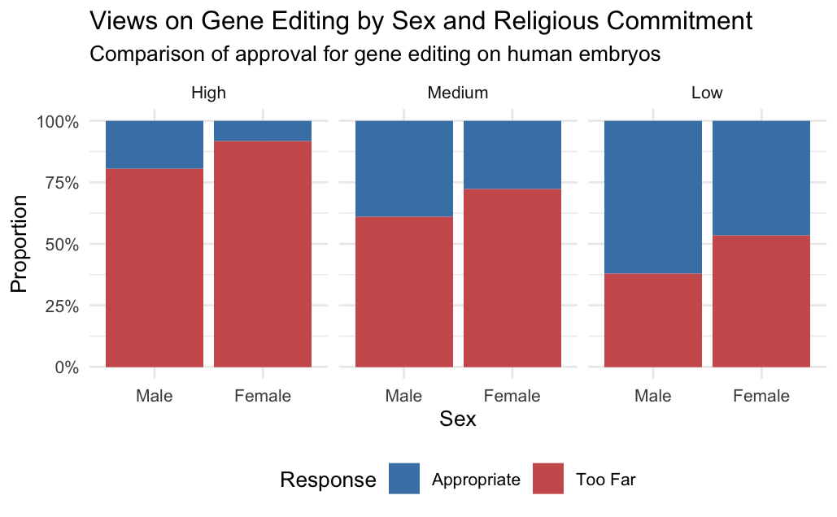

The above figure illustrates the trends previously identified in our Table One. We observe across strata that a higher percentage of women are opposed to embryonic testing compared to men. Additionally, as religious commitment decreases, approval for embryonic testing increases for both sexes. Taken together, these observations highlight that religious commitment is unlikely to fully explain the gender divide on this moral issue.

Results From the Chi-Square Test
From our Chi-squared test, we observed a χ² value of 70.247 with one degree of freedom. This resulted in a p-value less than 0.001 (roughly 2.2x10⁻¹⁶). As a result, we reject the null hypothesis that sex and opinion on gene editing are independent of each other. Instead, we have significant statistical reasoning to believe that an association between gender and a respondent's opinion on embryonic testing exists. This result is consistent with the gender divide we observed in our Table One and our previous figure. As a result, we will continue with a logistic regression to quantify the magnitude and the direction of the association.

Results From the Logistic Regression
Using sex as a binary predictor and opinion on embryonic testing as a binary outcome, we fitted a logistic regression to determine an unadjusted odds ratio. Our odds ratio for females was 0.47 with a 95% confidence interval of 0.39 to 0.56. Therefore, women were found to have 53% lower odds of finding embryonic testing appropriate than their male counterparts when not adjusting for religious commitment. This difference was statistically significant with a p value less than 0.001 (roughly 6.23x10⁻¹⁷). Once again, this result is consistent with what we observed in our Table One and Figure One. Together, these two tests address our first aim and indicate that an association exists between gender and a respondent’s opinion on embryonic testing, such that women are less likely to approve.

Results From the Breslow-Day Test
Using a Breslow-Day test, we tested whether the previously observed associations were impacted by religious commitment. Specifically, we were testing whether religious commitment interacted with sex. The Breslow-Day test had a χ² value of 2.35 with two degrees of freedom. This resulted in a p-value of 0.308. As a result, we failed to reject the null hypothesis that interaction does not exist between sex and religious commitment. As a result, we can assume homogeneity in our data set. In other words, the difference in sex and opinion is consistent across religious commitment.

Results from the CMH Test
Since we can safely assume homogeneity, we can proceed with a CMH test to report an adjusted common odds ratio. This test resulted in a χ² of 39 with one degree of freedom, resulting in a p-value less than 0.001 (roughly 4.27x10⁻¹⁰). As a result, we reject the null hypothesis that the true common odds ratio is equal to one in favor of the alternative hypothesis that the true common odds ratio is not equal to one. Our test’s common odds ratio was 0.55 with a confidence interval of 0.46 to 0.67. The adjusted odds ratio of 0.55 is close to our unadjusted odds ratio from our logistic regression of 0.47. Thus, religious commitment is likely only a minor confounder in the data set. As a result, religious commitment can only explain a marginal portion of the gender divide on embryonic testing. Our common odds ratio indicates that after adjusting for religious commitment, women are only 45% less likely to approve of embryonic testing. Together, tests address our second aim by showing that the association discovered between sex and opinion is only marginally, if at all, confounded by religious commitment.

Discussion

Main Takeaways
The primary aim of our study was to determine if a statistical association exists between gender and one’s opinion on embryonic testing for gene editing research. Through a Chi-squared test and a logistic regression, we found statistically significant evidence that a gender gap does, in fact, exist concerning one’s opinion on this topic. We showed that women were 53% less likely to approve of gene editing than their male counterparts when not adjusting for religious commitment

Our second aim was to determine if religious commitment would play a role in this gender divide. In our study, we did not find statistically significant evidence that religious commitment interacted with sex in our Breslow-Day test. Additionally, the CMH test did not suggest that religious commitment acted as a confounder in the data set. As a result, the observed gender divide persists across all levels of religious commitment. However, religious commitment does impact our odds ratio. Our adjusted odds ratio showed that after adjusting for religious commitment, women were only 45% less likely to approve of embryonic testing. Therefore, differences in religious commitment between sexes narrow the gender divide, but it does not fully close it. These results suggest that the gender divide is not just a result of women generally having higher religious commitments than their male counterparts. Instead, another factor must be at play that warrants further investigation.

Limitations
The decision to remove missing data and “don’t know” responses could skew the data and thus was a limitation on our results. By removing the “don’t know” responses, we are missing the portion of the population that is undecided on this issue. As a result, the data could be more polarized than reality. Additionally, our specific model did not control for confounders, such as education level or political affiliation. These potentially confounding variables could narrow or widen the gender gap we observed in this study.

Future Research Directions
While we observed a gender gap in the ethics of embryonic testing, we did not successfully answer why it exists since stratifying by religious commitment did not confound or interact with gender. Further studies ought to explore why this gender divide exists. Adjusting for confounders we did not explore, such as education level or political affiliation, may shed light on this gendered divide. Additionally, we did not explore respondents’ knowledge of what embryonic testing entails, nor their knowledge of the benefits of gene editing. Controlling for these factors may also reveal why such a divide exists. Future studies should consider a multivariable regression that can properly account for these potential confounders.

References and AI Disclosure Statement
Pew Research Center. (2018, July 26). Public views of gene editing for babies depend on how it would be used. https://www.pewresearch.org/science/2018/07/26/public-views-of-gene-editing-for-babies-depend-on-how-it-would-be-used-2/.

Gemini (Large Language Model) was used in this project to generate the R code necessary to run this project, including statistical tests, table generation, and plot generation.

