Miniconda installation under windows

Download miniconda at https://docs.conda.io/en/latest/miniconda.html
Choose the installer (python 2 or 3) corresponding to your plateform (probably windows 64 bit version for recent windows)
Development was done using 2.7 python but scripts should be compatible with python 3 anytime soon.

Run miniconda installer :
- Click Next
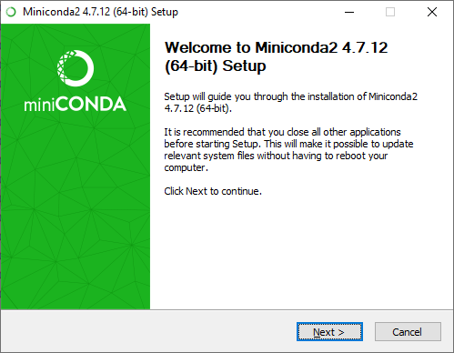
- Accept the licence
- Install for "Just me"
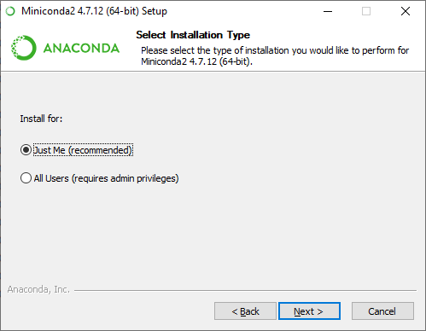
- Select the default installation directory : C:\Users\<username>\Miniconda2
note the installation directory for later reference and click Next.
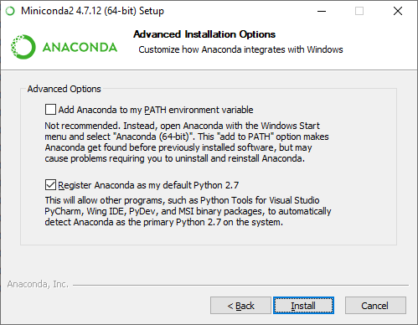
- Advanced options : click Install
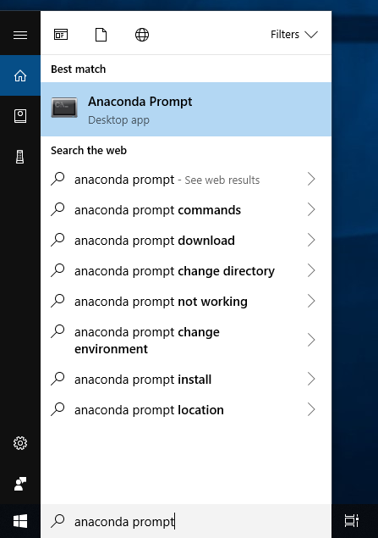
- Installation complete : click Next

From Windows menu run : "anaconda prompt"

In the cmd terminal run the command :
conda create -n JTutils_env numpy
proceed ? Y

run the command :
conda activate Jtutils_env

run the command
echo%PATH %
The printed text in the terminal contains the required path list to executable for miniconda python.
The list elements are separated by semicolon (;)

