Jeff Reimschussel

Project 3—Network Routing

**Code implementation**

# Define abstract methods priority queues must implement

class PriorityQueue(abc.ABC):

def __init__(self):

self.list = []

self.list_idx = {}

@abc.abstractmethod

def makeQueue(self, nodes):

pass

@abc.abstractmethod

def insert(self, entry):

pass

@abc.abstractmethod

def deleteMin(self):

pass

@abc.abstractmethod

def decreaseKey(self, changed):

pass

def empty(self):

return 0 == len(self.list)

# Priority queues contain this data holder object

class PriorityQueueEntry:

def __init__(self, id, dist, prev):

self.id = id

self.prev = prev

self.dist = dist

def __str__(self):

return '(id:%s prev:%s dist:%s)' % (self.id, self.prev, self.dist)

class UnsortedListPriorityQueue(PriorityQueue):

def __init__(self):

self.list = {}

def makeQueue(self, nodes):

# Returns the initial list of vertices entered into the queue

queue = []

for node in nodes:

self.insert(PriorityQueueEntry(node.node_id, float('inf'), None))

queue.append(self.list[node.node_id])

return queue

def insert(self, entry):

self.list[entry.id] = entry

def deleteMin(self):

# Search for the minimum value still in the queue

min = next(iter(self.list))

min_entry = self.list[min]

for k in self.list.keys():

entry = self.list[k]

if min_entry.dist > entry.dist:

min = k

min_entry = entry

del self.list[min]

return min_entry

def decreaseKey(self, changed):

# Nothing to update except the node value

self.list[changed.id].dist = changed.dist

self.list[changed.id].prev = changed.prev

class BinaryMinHeapPriorityQueue(PriorityQueue):

def makeQueue(self, nodes):

# Returns the initial list of vertices entered into the queue

queue = []

for node in nodes:

self.insert(PriorityQueueEntry(node.node_id, float('inf'), None))

queue.append(self.list[node.node_id])

return queue

def insert(self, entry):

idx = len(self.list)

self.list.append(entry)

# Update map to enable constant lookup

self.list_idx[entry.id] = idx

self.bubbleUp(idx)

def deleteMin(self):

min = PriorityQueueEntry(self.list[0].id,

self.list[0].dist,

self.list[0].prev)

# Swap minimum with leaf in heap, bubble down to right priority

back = len(self.list) - 1

self.swap(0, back)

del self.list[back]

self.bubbleDown(0)

return min

def decreaseKey(self, changed):

idx = self.list_idx.get(changed.id)

self.list[idx] = changed

self.bubbleUp(idx)

def swap(self, parent, child):

# Swaps two nodes

temp = self.list[parent]

parent_id = temp.id

child_id = self.list[child].id

self.list[parent] = self.list[child]

self.list[child] = temp

# Update map to enable constant lookup

self.list_idx[parent_id] = child

self.list_idx[child_id] = parent

def bubbleUp(self, child):

# The parent of any child (assuming starting at index 1) is child // 2

parent = (child + 1)//2 – 1

if parent >= 0 and self.list[parent].dist > self.list[child].dist:

self.swap(parent, child)

# Check for continuing to bubble up

self.bubbleUp(parent)

def bubbleDown(self, parent):

# The child of any node (assuming starting at index 1) is parent * 2

child = parent * 2 + 1

# Get smaller of two children

if (len(self.list) > (child + 1) and

self.list[child + 1].dist < self.list[child].dist):

child += 1

if (len(self.list) > child and

self.list[parent].dist > self.list[child].dist):

self.swap(parent, child)

# Check for continuing to bubble down

self.bubbleDown(child)

def dijkstra(self, use_heap):

shortest_paths = {}

queue = UnsortedListPriorityQueue()

if use_heap:

queue = BinaryMinHeapPriorityQueue()

shortest_paths = queue.makeQueue(self.network.nodes)

start = PriorityQueueEntry(self.source, 0, self.source)

queue.decreaseKey(start)

while not queue.empty():

next = queue.deleteMin()

shortest_paths[next.id] = next

for edge in self.network.nodes[next.id].neighbors:

id = edge.dest.node_id

if next.dist + edge.length < shortest_paths[id].dist:

shortest_paths[id].dist = next.dist + edge.length

shortest_paths[id].prev = next.id

queue.decreaseKey(shortest_paths[id])

return shortest_paths

**Time and Space Complexity Analysis**

In each of the operations, this is assuming that the queue entries are only storing information for each vertex in the graph, not all of the edges. This is why |V| is used to represent the number of entries in the queues; it is the same as the number of vertices in a graph.

**insert**

The unsorted array has a time complexity of O(1) for insert; the function simply inserts a new entry into the queue at the entry’s id.

The space complexity is also 1-to-1 for each entry in the queue; there’s no new space required when inserting multiple entries beyond a constant space. Therefore the space complexity is only dependent on the number of entries into the queue, or O(|V|).

In order to ensure a O(1) for lookup in the binary minimum heap priority queue, the function inserts both an entry into the main list, and the entry’s index in the main list into a map. After appending to the end of the main list, however, the priority queue may need to “bubble up” the entry if it’s found to have a higher priority than the entry’s parent. The binary minimum heap maintains a structure of every parent entry having at most 2 children. This means that the number of possible swaps an entry could make when swapping a parent with a child is always cut in half after each swap. Therefore the time complexity for completing the bubbling up portion of inserting a new entry is O(log|V|). Because this is the most expensive aspect of inserting new entries, the overall time complexity for insert in the binary minimum heap priority queue is at worst O(log|V|).

This space complexity is also dependent on the number of entries in this implementation. Each entry requires space in the list, and a map entry to be able to locate that entry. Therefore the space complexity can be reduced to O(|V|).

**deleteMin**

The unsorted array does not have a good way to locate the entry within the queue with the highest priority. In order to find the highest priority to remove, a search of all entries still in the queue has to be made. After locating the highest priority entry, deleting it takes O(1) time, because there is no reordering of the queue after deleting an entry. This makes searching the queue the most expensive aspect of deleteMin, meaning deleteMin has a time complexity of O(|V|).

There’s no new space needed at a call of deleteMin, so the space complexity is O(1).

Because the entry with the highest priority is always the root of the heap, locating the entry to delete is straightforward. In order to maintain the heap priority structure, a leaf node in the heap is swapped with the root and the original root entry is removed. Next, the leaf node in the root index must be “bubbled down” the heap to the right place to maintain the binary minimum heap structure. Bubbling down is very similar to bubbling up; a parent node is compared with the higher priority of its two children, swapped if the child has a higher priority, and then the original parent is again compared with the new children. Entries compared are only between parent and one of its two children, meaning the most possible swaps and rechecks that can take place is O(log|V|). Because bubbling down is the most expensive part of deleteMin, the time complexity is O(log|V|).

Still no new space stored in this implementation. O(1).

**decreaseKey**

Because the unsorted list has O(1) lookup time, and because there’s no restructuring for adjusting entry priorities within the queue, decreaseKey has a time complexity of O(1)—the entry to change is directly changed.

There is no new space stored in this implementation for decreaseKey. O(1).

The heap implementation does have O(1) lookup time, but it does need to restructure to maintain the binary minimum heap structure. After adjusting an entry priority directly, the heap must check if that value now needs to bubble up. There’s no need to check if it must bubble down because the only adjustments to entries within a queue are to improve an entry’s priority, never to lower it. Because bubbling up is also the most expensive part to decreaseKey, the time complexity is also O(log|V|).

Still no new space stored for decreaseKey. O(1).

After looking through each of the operations in both priority queue implementations, it is apparent that the overall time complexity is dependent primarily on the number of entries. The worst case for the unsorted array comes from its deleteMin, with a O(|V|). The worst case for the binary minimum heap comes from bubbling up or down entries, which is used in its insert, deleteMin, and decreaseKey. Therefore the time complexity is O(log|V|).

**Screenshots**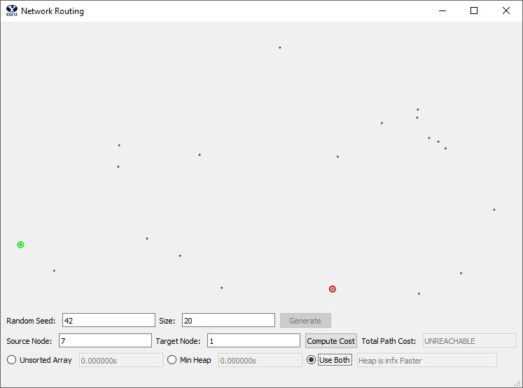

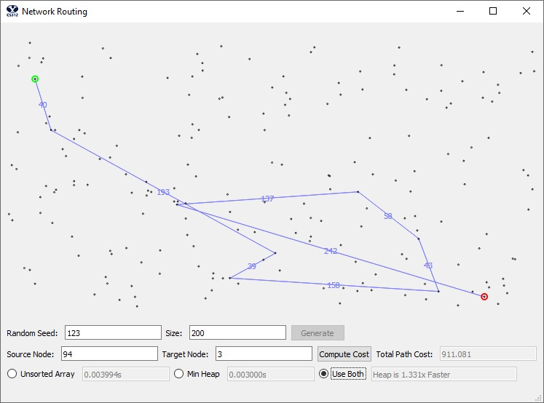

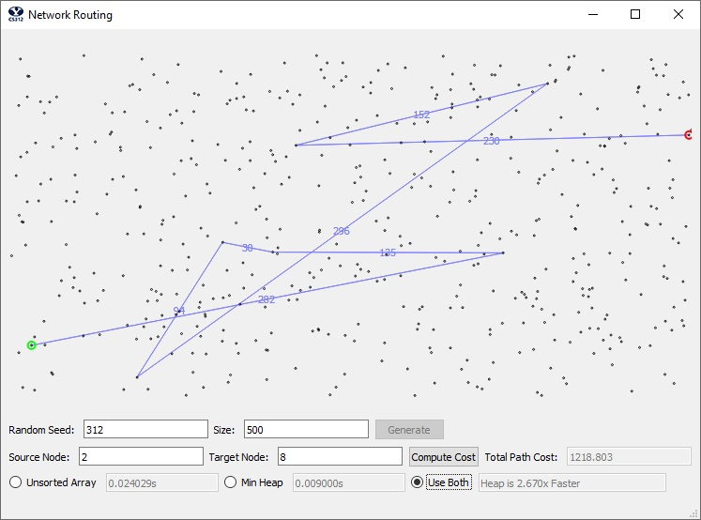

**Time complexity tests**

Unsorted List

|  |  |  |  |  |  |  |
| --- | --- | --- | --- | --- | --- | --- |
| Node count | Test run | | | | | |
|  | 1 | 2 | 3 | 4 | 5 | Average |
| 100 | 0.002013 | 0.001983 | 0.000993 | 0.000998 | 0.001028 | 0.001403 |
| 1000 | 0.086020 | 0.087991 | 0.089026 | 0.089013 | 0.086017 | .0876134 |
| 10000 | 8.248960 | 8.276991 | 8.283018 | 8.317017 | 8.199953 | 8.2651878 |
| 100000 | 886.789167 | 890.266031 | 920.024997 | 961.650983 | 915.116964 | 915.7696284 |

When projecting out an expected run time for computing Dijkstra’s on 1,000,000 nodes using an unsorted list, this graph suggests a runtime of around 10,000 seconds. Every time the amount of points is multiplied by 10, the runtime is also multiplied by roughly 10, suggesting a linear time complexity. This is exactly what was expected when computing the biggest time complexity of this priority queue; that is, that it runs in O(|V|).

Binary Min. Heap

|  |  |  |  |  |  |  |
| --- | --- | --- | --- | --- | --- | --- |
| Node count | Test run (in seconds) | | | | | |
|  | 1 | 2 | 3 | 4 | 5 | Average |
| 100 | 0.000999 | 0.001002 | 0.000998 | 0.001996 | 0.000997 | 0.0011984 |
| 1000 | 0.018996 | 0.017994 | 0.017997 | 0.018022 | 0.019000 | 0.0184018 |
| 10000 | 0.269024 | 0.254000 | 0.252000 | 0.253008 | 0.259011 | 0.2574086 |
| 100000 | 3.837003 | 3.786991 | 3.841024 | 4.075006 | 3.784002 | 3.8648052 |
| 1000000 | 50.436939 | 50.338431 | 52.849001 | 55.172690 | 52.939029 | 52.3456226 |

As expected, the runtime for the binary minimum heap implantation was not a linear relationship with the number of vertices in the graph. As the number of vertices increased by a factor of ten, the factor by which runtime also increased was decreasing. This suggests a logarithmic relationship rather than a linear one, which is to be expected from the code analysis.