Jennifer Reinke

LiDAR Exercise (Advanced)

The primary objective of this exercise is to explore a few of the uses for high resolution LIDAR derived DEM rasters and how to create those rasters using Esri’s ArcMap and ArcScene software. This exercise will demonstrate how to derive tree canopy height, how to do hydro flattening, and some groundwater mapping with the ArcHydro tool set.

Analysis

1. Determine canopy height
2. Land cover classification

**Part 1: Canopy height**

Step1. Launch ArcScene, using the catalog pane, navigate to your working directory and right click on it. Create a new LAS dataset in that folder.

Step 2. Then run Add "Files to LAS Dataset" to add the .las files into the new dataset file.

In the LAS Dataset toolbar use the Filters pulldown, select ground, then run the LAS Dataset to TIN tool to create the ground TIN.

Step 3. Then select the first return and run LAS Dataset to TIN tool again to get the tree top elevations, as well as other high points.

You must increase the maximum nodes count. Changing it from 5,000,000 to 500,000,000 will do for this .las dataset.

**Question - A:** What is lost in the translation of LAS to TIN? And how might that data be useful for classification or analysis?

**Answer:** (The intensity data and RBG values are lost. They might be useful for determining different types of land cover.)

Step 4. Repeat this process with a different filter, selecting ground this time.

Now there are two TINS corresponding to the first and last returns.

Step 5. Convert each to a Raster with the TIN to Raster (3D Analyst) tool.

**Question - B:** What assumptions might someone make from a DEM that would be less obvious for a TIN? And how might that data be useful for classification or analysis?

**Answer:** (The gaps between data points are more obvious on a TIN and it may be assumed that data is continuous between change on the Raster, when in reality there was simply no LAS point in between that could show a lower or higher change in elevation.)

Step 6. Then run the Raster Calculator tool on the two that are created. ( first return minus ground )

The numbers roughly correlate to the volume of ‘stuff’ mostly trees and shrubs, a few buildings, from the ground.

The negative values can be attributed to sensor errors and artifacts from the TIN conversion.

**Part 2: Hydro Flattening**

Step1. Install the ArcHydro ArcMap extension

Step 2. Open ArcMap and import the ground Raster DEM created in Part 1 of this exercise, and the water polygon layer.

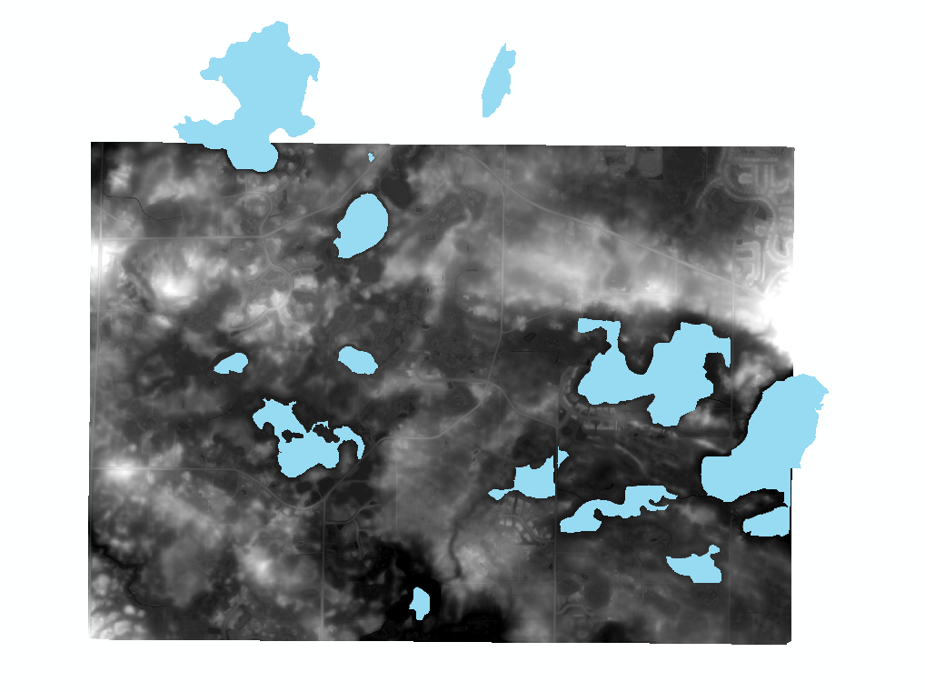

Step 3. Use the Extract By Mask Tool (Spatial Analyst) to create a raster of the lake features from the Ground Raster. Name the output Raster “Extracted_Lakes”.

Step 4. Find the mean value for the Extracted_Lakes raster.

Properties > Symbology > Histogram > Mean = ______________

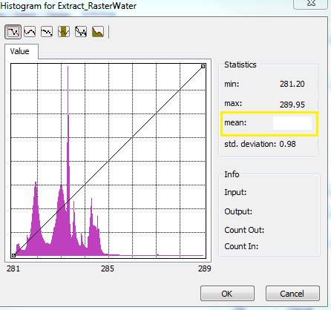

Step 5. Create a DEM of the Ground Raster with hydro flattening using the Raster Calculator (Spatial Analyst). Use the following equation within the Raster Calculator:

Con(IsNull("Extracted_Lakes" ), "rasterGround", Enter Your Mean Value Here)

Name the output raster “Hydro_Flattened_Raster”

Set the extend in the environment variables to match the ground raster so that the flattened raster will have the extent of the full ground raster and not just the overlap between the water clipped regions and the ground raster.

Without Hydro Flattening:

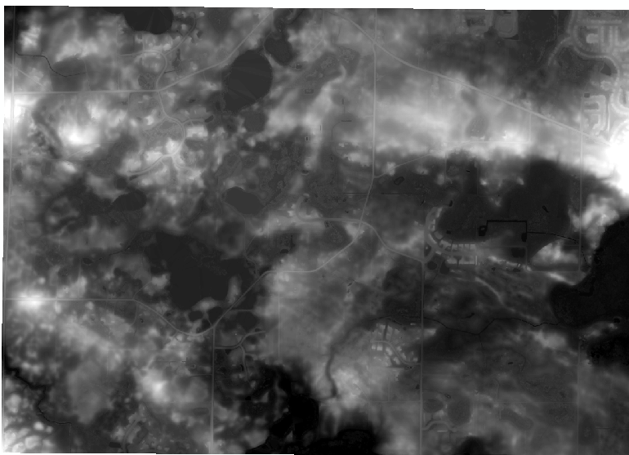

With Hydro Flattening:

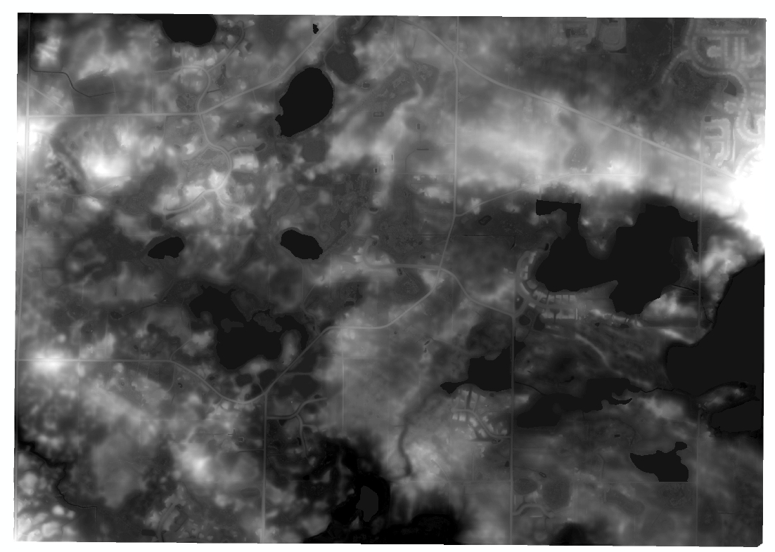

**Question - C:** In which circumstance would hyrdo flattening be most useful? Stagnant Lake or Turbulent Ocean?

**Answer:** (Ocean, Turbulence produces more variant returns)

**Part 3: Arc Hydro - Stream Mapping**

Step 1. Install the relevant version of ArcHydro Tools on your machine if not already installed.

Step 2. Create a new folder for all files needed for this part of the lab. Into that folder import the ground return DEM created from part one, and the water bodies polygons and hydro flattened DEM from part two.

Step 3.

Run Sink Prescreening with the hydro flattened DEM and the minimum drainage area set to 30 pixels. Leave other fields.

There are a lot of sinks, it will look like this:

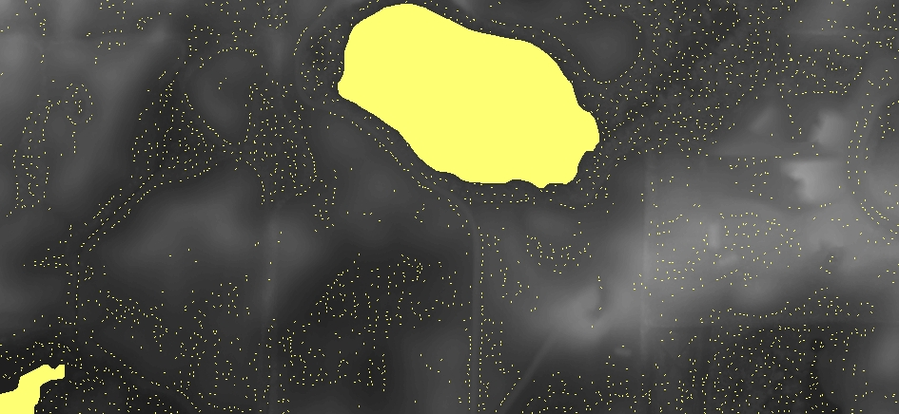

But will also produced a DEM of those sinks filled which will make the next steps possible.

Step 4. Raster Calculator:

Con("rasterGround",1)

to create a solid raster, then use that raster to in the raster to polygon tool to make a polygon for the boundary of the area, which is used in the next step.

Step 5. Run Flow Direction with the filled DEM and the outline polygon as the outline polygon.

Step 6. Fun Flow Accumulation with the flow direction layer that was created, fdr.

Which should create a raster like this:

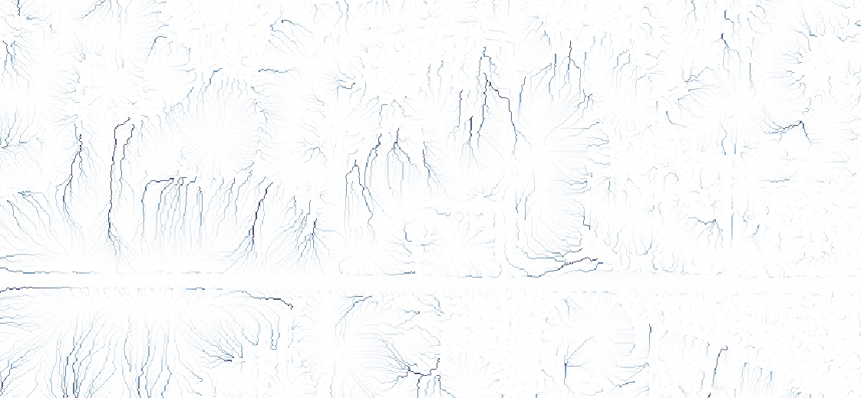

Step 7. Run Stream Definition a number of times with pixel values of 200, 500, 1000, 2000 and 3000. Label the outputs respectively to be able to identify them later.

**Question - D:** What pixel number is best for this DEM? When might a higher or lower number be more appropriate?

**Answer:** (Anywhere between 200 and 1000, since the higher numbers loses almost all the details and only a few lines remain) (Higher numbers would be more appropriate for smaller scale maps that cover bigger areas, and vice versa is also true.)