**Lab 7: Terrain**

**Jennifer Reinke**

**4.2.2015**

**Objective:** The purpose of this task is to learn about the similarities and differences between Triangular Irregular Networks (TIN) and Terrain Formats.

A TIN divides a geographical surface into adjoining, non-overlapping triangles. The nodes of the triangles are the elevation points used for sample data, represented by x,y, and z-values. Terrain is similar, but is driven by a geodataset in a geodatabase that also uses multiresolution TIN-based measurements, and creates pyramids. The Terrain datasets often originate from lidar, sonar, and photogrammetric data. The subject area used for this exercise is the country of Afghanistan that has a wide elevation range.

**Procedure:**

The first step executed was to convert the E00 files into a feature layer after I confirmed that the Interoperability and 3D Analyst extensions were checked. To do this, I selected the PONET, HYNET, HYPOINT, and DNNET E00 files as indicated by the instructions required to complete the procedure. I used the Import from E00 tool in the Conversion Toolbox under To Coverage. Once I converted the files into coverages, I selected the Feature Class to Feature Class tool in the Conversion Toolbox. The output location was the EX07DEM geodatabase created.

It was then time to assign the correct projection to the feature class layers. I racked my brain trying to remember how to modify the projection information manually, but instead I decided to use the DEM as the source layer for the projection tool. This is because the DEM has the exact projection parameters stated in the instructions. To complete this portion, I selected the Project Tool in the Data Management Toolbox and add the desired feature layer and renamed the output layer with more information so I would not have to keep referencing the instructions (i.e. DNNET = DNNET_Edges). For the output coordinate system, I went to the upper-righthand corner and selected the globe and went to import, then browsed to the DEM. I repeated these steps for all four layers. Image on the left is Terrain format and right image is of a TIN.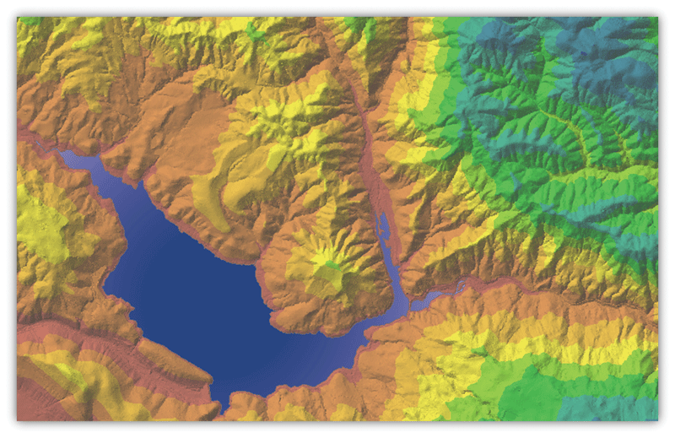

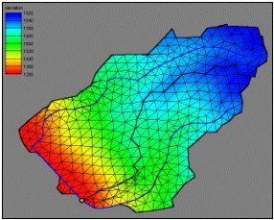

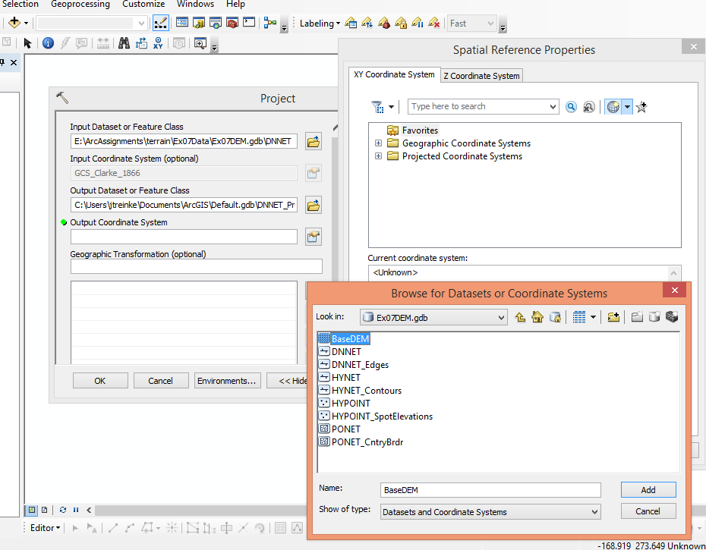

It was time to review the attribute tables to see what I was working with. The HYPOINT layer had the HYPVAL which represents the elevation. I was confused by the range of numbers 0 - 9999s. I realized that the zeros indicated the boundary area and the 9999s were no data values. The numbers were still not matching up. I then proceeded to find an elevation map of Afghanistan and saw the elevation range in meters and realized the HYPVAL values were in feet. I figured it best to convert the feet to meters because the DEM is in meters and is easier for my brain to process the information. I also completed this process with the contour layer named HYNET. I added a field with the same naming convention, but added _meters for a float type. I then used the field calculator for basic arithmetic of converting the feet to meters (as seen in the image below). Once the values were populated, I referenced my elevation map to confirm that the ranges fell within its natural range. This was successful.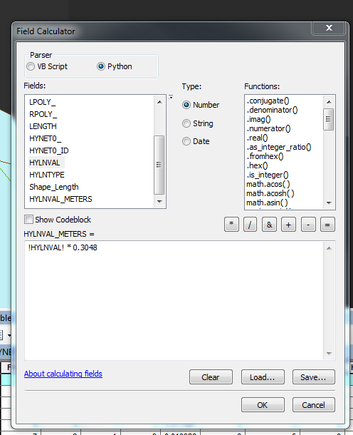

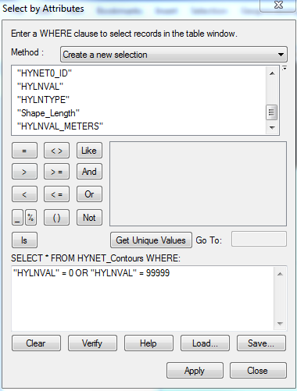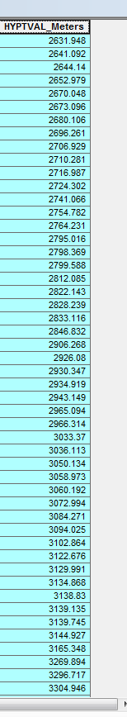

As seen in the images above, I then generalized the data marginally. I decided to remove unnecessary values from the contour and spot elevations. I chose Select By Attributes and selected the ‘0’ and ‘99999’ values and removed them by selecting them, activating an Edit Session from the Editing Toolbar, and deleting the records, and saving my editing session.

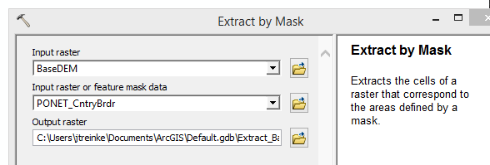

I then clipped the DEM to the country boundary polygon layer. I employed the Extract by Mask Tool in the Spatial Analyst Toolbox because it “Extracts the cells of a raster that correspond to the areas defined by a mask,” which seems to be more accurate than a clip. Plus, the instructions indicate mask. The images below show the extraction.

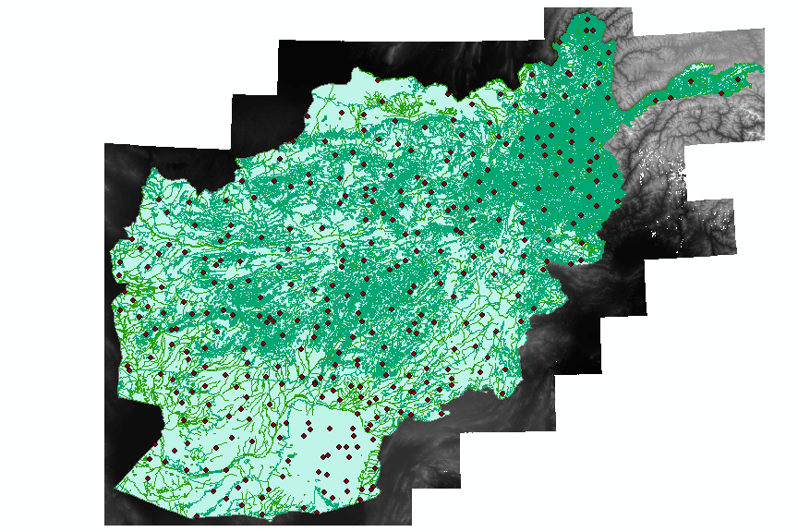

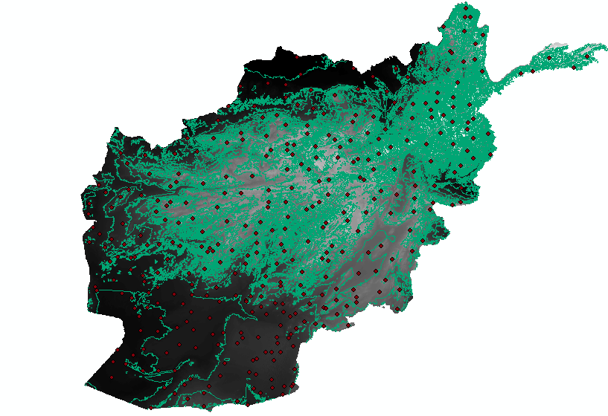

The next step of the procedure is to create a TIN using the Create a TIN from the TIN toolset in the 3D analyst toolbox. I used the clipped DEM as my base and added all feature layers as input features. The default SF Types were

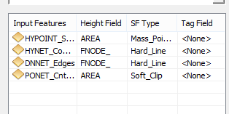

which was close to what I wanted. The spot elevation makes sense to have as mass points because they are points. I wanted to change HYNET_contours to Soft_Line because contours would not have discontinuity. I would keep edges as hard line and the boundary area as soft_clip because fill and replace did not seem to make sense. After some trial and error, I realized I also had to think about the height Field or z-value. I also played around with the Delaunay constraint, which is a generalized form of the Delaunay triangulation. This means that some edges that do not fit the “"Delaunay condition", i.e., the requirement that the circumcircles of all triangles have empty interiors.” In all honesty, I do not understand this fully. When I compared creating a TIN with and without the constraint, I still could not observe a difference. So I decided, to use the constraint hoping it might provide more information.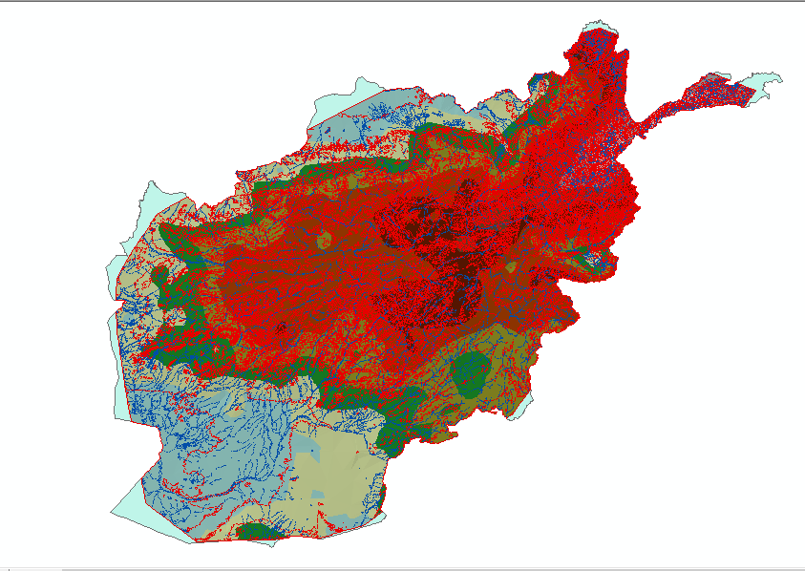

Then I compared having the default height field values ( except for changing the the height field to HYPTVAL_meters and contours to soft lines) to HYPTVAL_meters for the spot elevations and left the remaining height fields as none. On the left is the default parameters and the latter on the right. As one can see, the one on the right is more generalized, but seems to offer enough information.

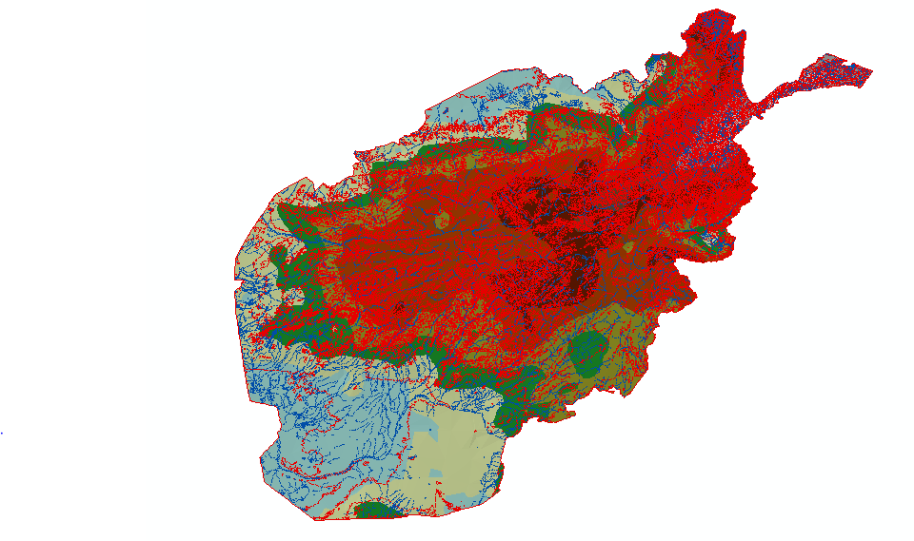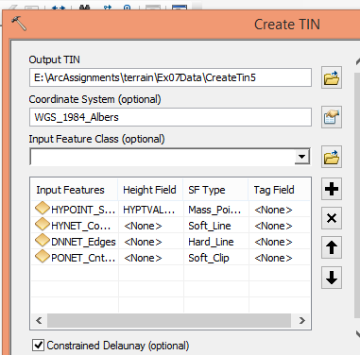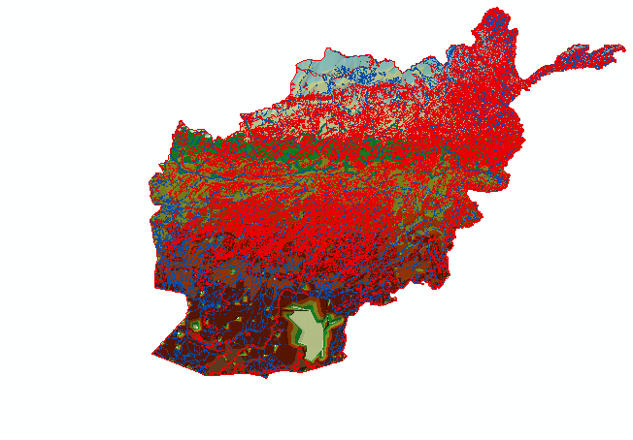

Therefore, I chose the one on the right with the final parameters stated in the image on the right.

Afterwards, I created a Terrain using the Create Terrain Tool in the 3D Analyst Toolbox. It is interesting to see the contrast between the two immediately. The Terrain Tool requires a feature dataset and not just a feature layer to execute. Therefore, I created a new geodatabase called Terrain and set that as my default geodatabase. I then used the Create a Feature Dataset Tool in the Data Management Toolbox. I created a feature dataset named _Terrain and imported all four feature layers from the TIN geodatabase. In addition, I added the custom coordinate system I created earlier so that everything would match correctly.

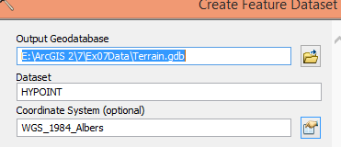

To create the terrain, I right- clicked on the _Terrain feature dataset and selected new > terrain. Then I had to select each layer that was going to be be used to build the terrain such as the SF Type, point spacing, and Z-Tolerances for the pyramids.

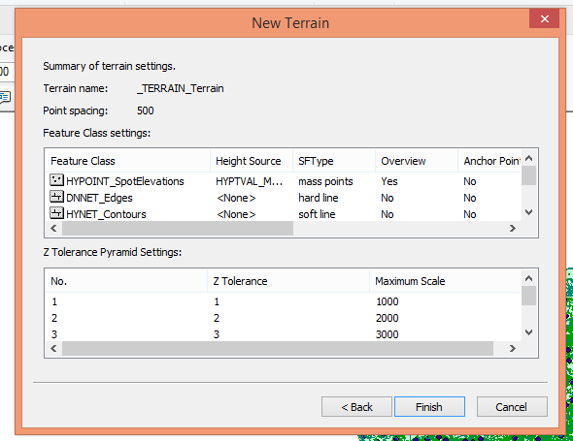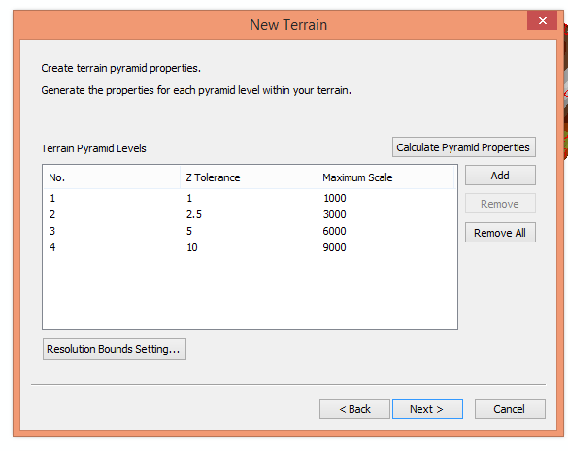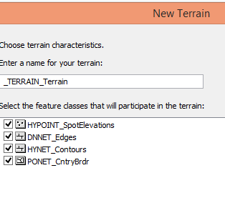

This portion took many attempts to get a feel for creating terrain. I selected the same SF values for the terrain as I did the TIN because I wanted to keep them as controls in hopes of seeing the difference between the two surface models. I tried several point spacing values. I kept everything in meters because I knew that the z-values needed to be in the same units. I then tried several versions of pyramids for a z-tolerance. I tried the automatic calculations and my own. I know in lecture it was stated that the z-tolerance should be half the contour intervals so I tried that as well. I even attempted to create a terrain without the polygon boundary to see what would happen. I was surprised to see that the area went well over the boundary because I assumed it would be short of the country border. There were small differences I could see with different point spacing values, but not much was seen with varying pyramid value.. The image on the left is a terrain built without the polygon layer and on the right is my final output. The final parameters chosen were: select all four feature layers, point spacing of 150 meters, same SF types as TIN, and Z-tolerance by 1000 meters.

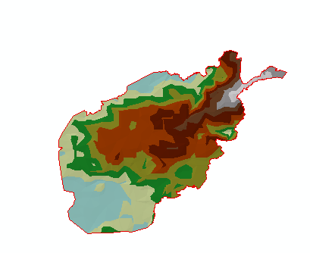

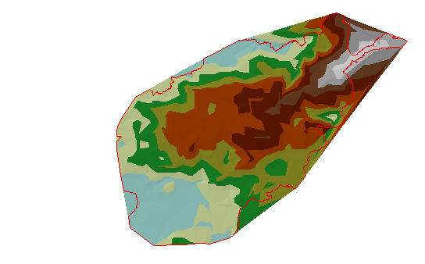

Afterwards, I had to create floating-point rasters for the TIN and the terrain. I used the Tin to Raster Tool and the Terrain to Raster Tool in the 3D Analyst toolbox. I added the final input and set the processing environment to the TIN and terrain I was using because the coordinate system and the area was clipped to the correct parameters. I made sure the the Data type was a float and left the rest of the parameters to the defaults.

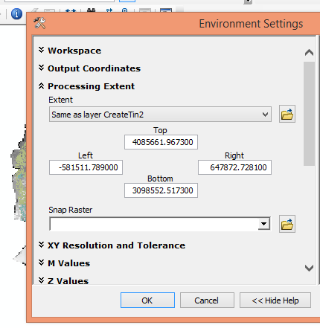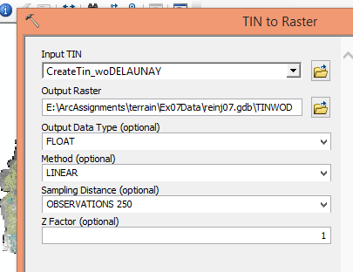

Below is the image of my generalized TIN

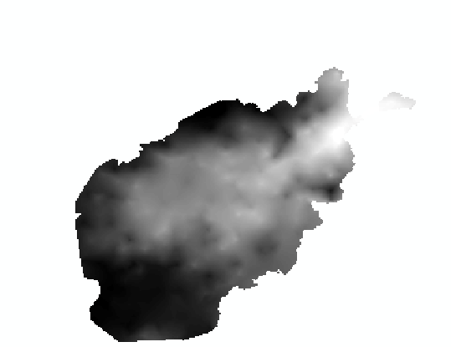

I tried converting the more detailed TIN into a raster to see if my choice was correct or not. The image is below.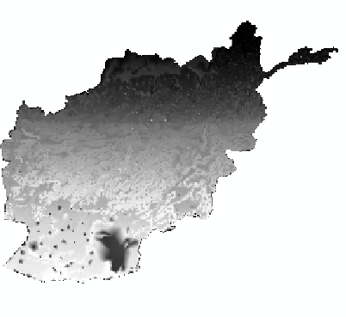

I repeated these steps to convert the terrain into a raster and the results look like the image below. The range images vary slightly, and the ranges, but are roughly the same. Terrain ~332-6842 meters. TIN ~334-6853 meters.

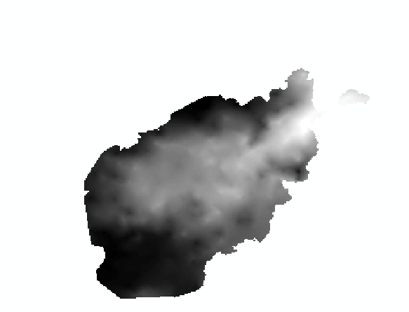

Integer Raster was the next raster created, which subtracted the TIN raster values from the terrain raster values showing the difference between them. In order to do this, I used the Raster Calculator in the Spatial Analyst Toolbox.

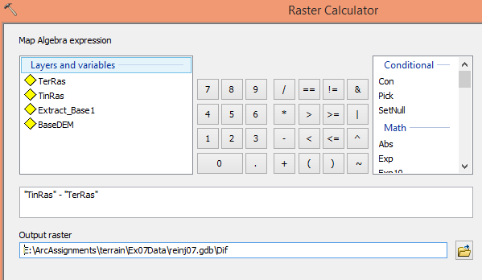

The output is seen in the image below.

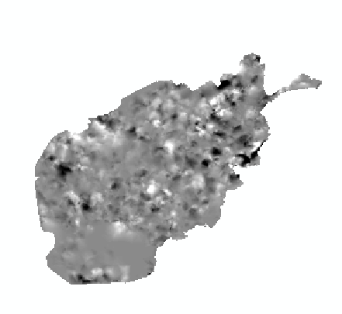

The last raster that needed to be created was the TinErr which displays the difference between the Tin raster and the BaseDEM. Once again, I used the raster calculator to complete this section.

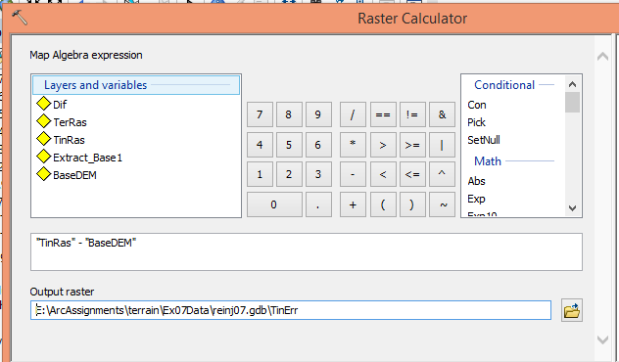

The output is the image below:

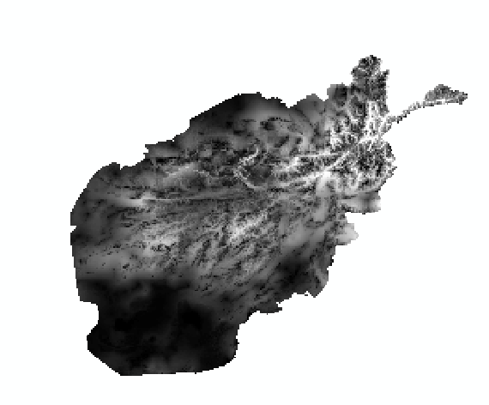

Lastly, I needed to convert the Dif and TinErr, which are floating-point rasters, to integer rasters. In order to do this, I found the Int Tool in the Spatial Analyst Toolbox that “Converts each cell value of a raster to an integer by truncation.”

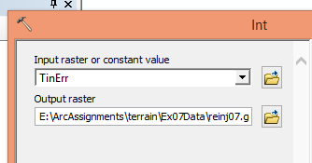

**Comparison:** Both TINs and terrains are vector surface models. TINs can be stored individually and store points, edges, and topology. TINS seem to be the quick and dirty way of calculating elevations. Terrains use TINS as part of their calculations, but is stored in a geodatabase and in a geodataset. Terrains are better for massive datasets like that of LIDAR or SONAR. Terrains are also nice because they allow one to make pyramids so one can use them at different scales.

**TinErr Results:** The output of the TinErr indicates that the TIN and the original DEM contrast. I think that the TIN did a pretty good job or representing the surface especially since I generalized the data. It seems that even if the TIN was not generalized, it still would not reflect the elevation perfectly. I believe part of that has to do with the higher resolution of the DEM compared to the TIN. I also believe that in order to reduce the error, the dataset would need to be larger with more elevation spots and contours, which could be advantageous or disadvantageous due to large file sizes and the slowing of processing the data.

**Problems:**  At one point, I only had spatial analyst checked in my extensions and not 3D analyst, when I specifically looked for 3D Analyst. I kept receiving a licensing error when I clicked on certain tools. First, I assumed it was the machine voodoo, but I was in luck! Furthermore, it took a lot of fiddling around to see how parameters affected the output, but there were no serious problems that I am aware of.

**Conclusion & Time Estimate:**

In conclusion, it is easy to see the benefits of using TINS and terrains, but they are not perfect in surface model representation. I believe that creating the TINS and terrains are “simple” to use, as in, I believe my workflow is accurate. It is difficult to completely understand all the small details that affect the output. I think with more practice it would become easier to choose the various parameters (SF, z-tolerance, point spacing). This exercise took me roughly ten hours to complete the exercise and the write-up.