**Graduate Admission Analysis**

**Juan Trejo**

**May 9, 2018**

**SDS358**



**Introduction**

**Objectives:**

1. Investigate how GRE, GPA, Applicant Status, Degree Sought and School Ranking effect the likelihood of an applicant being accepted to her graduate school of interest.
2. Predict and compare my probability of being admitted into graduate school vs the average applicant’s

**Hypotheses:** I expect that GPA, GRE Math score, and School Ranking will be the main drivers of the outcome. In addition, I speculate that the Applicant’s Status will have an effect on admission probability.

**Methods**

**Sample:** The sample subjects are 500 prospective students applying to computer science graduate programs in the US between 2012 and 2018. Data was scraped from thegradcafe.com, which contains thousands admission records from students around the world. These records include data on GRE and GPA scores, applicant status and degree sought. The model also took into account the school ranking. These values were obtained from US News. Initial investigations showed 1 applicant with a Cook’s Distance 3 times the cutoff. This record was removed.

**Analysis Method:** Logistic regression with a dichotomous outcome and both quantitative and categorical independent variables

**Descriptives**

**Response Variable: Admission**

|  |  |
| --- | --- |
| **Rejected** | **Accepted** |
| 231 | 269 |

|  |  |
| --- | --- |
| **Masters** | **PhD** |
| 279 | 221 |

**Explanatory Variables:**

|  |  |  |
| --- | --- | --- |
| **Name** | **Mean** | **SD** |
| **GPA** | 3.65 | 0.28 |
| **GRE Verbal** | 158.23 | 6.47 |
| **GRE Math** | 164.86 | 5.06 |
| **GRE Written** | 3.99 | 0.70 |
| **Ranking** | 3.94 | 0.72 |

|  |  |  |
| --- | --- | --- |
| **American** | **Int, US Degree** | **International** |
| 139 | 49 | 312 |

**Results**

**Regression table & Odds Ratios:**

|  |  |  |  |  |  |  |
| --- | --- | --- | --- | --- | --- | --- |
| **Variable** | **Coefficients** | **CI 2.5%** | **CI 97.5%** | **S.E.** | **z-test** | **Pr(>|z|)** |
| **GPA** | 1.49 | 0.70 | 2.28 | 0.402 | 3.71 | < 0.001 * |
| **GREV** | 0.08 | 0.04 | 0.12 | 0.019 | 4.18 | < 0.001 * |
| **GREM** | 0.05 | 0.01 | 0.09 | 0.022 | 2.32 | 0.02 * |
| **GREW** | -0.22 | -0.59 | 0.14 | 0.186 | -1.18 | 0.24 |
| **StatusU** | 0.34 | -0.44 | 1.12 | 0.399 | 0.85 | 0.40 |
| **StatusI** | -0.26 | -0.78 | 0.26 | 0.265 | -0.99 | 0.32 |
| **PhD** | -0.47 | -0.87 | -0.06 | 0.206 | -2.27 | 0.02 * |
| **Ranking** | -1.43 | -1.77 | -1.09 | 0.174 | -8.23 | < 0.001 * |

**Overall Model Fit:** LR chi2(8) = 99.36, p < 0.05; Pseudo R2 (Nagelkerke) = 24.1%

|  |  |  |  |  |
| --- | --- | --- | --- | --- |
| **Variable** | **Odds Ratio** | **CI 2.5%** | **CI 97.5%** | **Increment** |
| **GPA** | 2.11 | 1.43 | 3.15 | 0.5 |
| **GREV** | 1.5 | 1.24 | 1.81 | 5 |
| **GREM** | 1.29 | 1.05 | 1.59 | 5 |
| **PhD** | 0.63 | 0.42 | 0.94 | NA |
| **Ranking** | 0.49 | 0.41 | 0.58 | 0.5 |

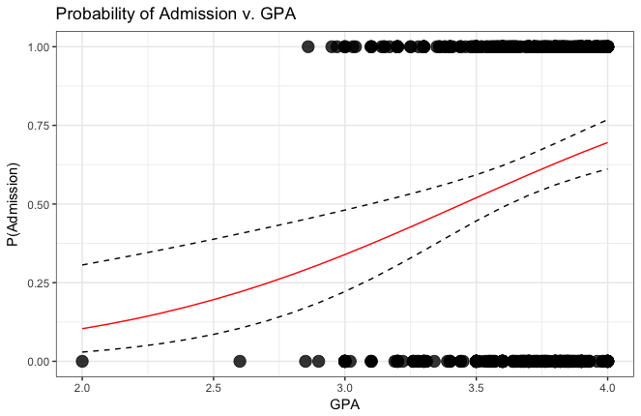

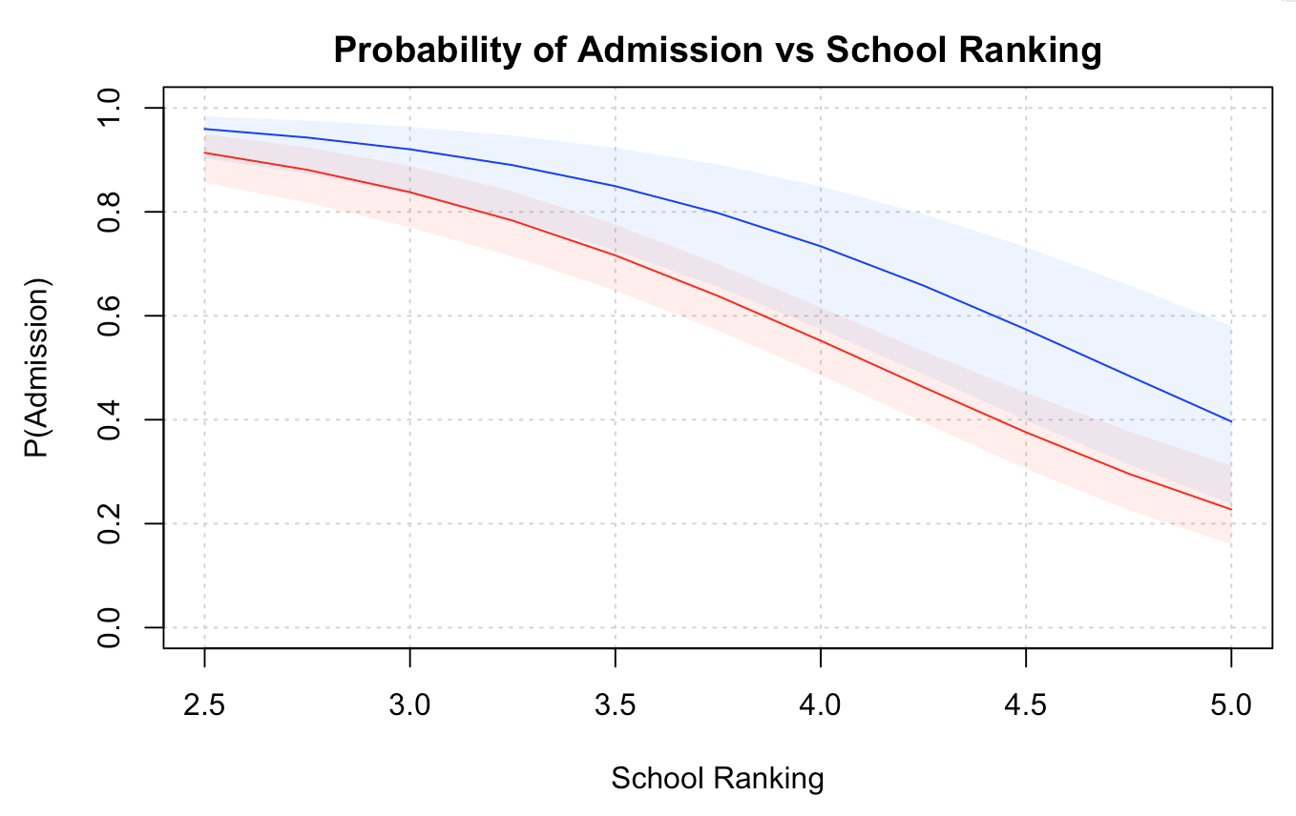

Carnegie Mellon

MIT

Stanford

UT Austin

Cornell

Georgia Tech

Univ. Florida

WashU

Boston U

Oregon State

Syracuse

Colorado State

UCSD

Univ. Minnesota

**GPA:** 3.65, 3.83

**GRE V:** 158.23, 160

**GRE M:** 164.9, 164

**GRE W:** 3.99, 4.5

**Status:** A, U

**Degree:** Masters

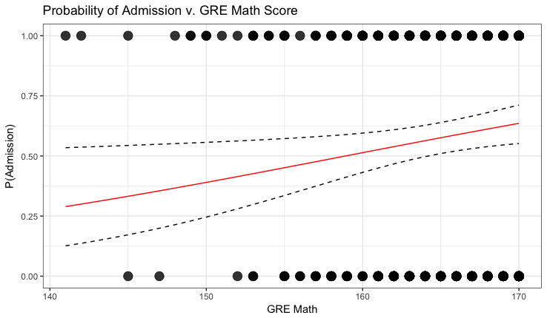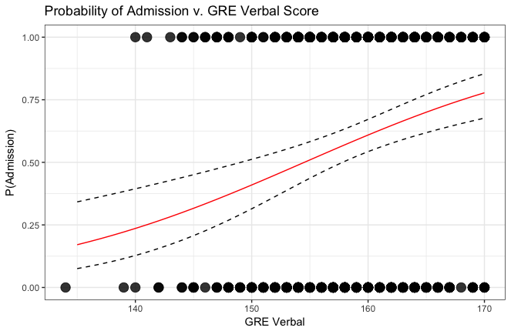

**Assumptions**

**Assumptions:** Examined Cook’s Distance plot to look for outliers. Verified that multicollinearity was acceptable.

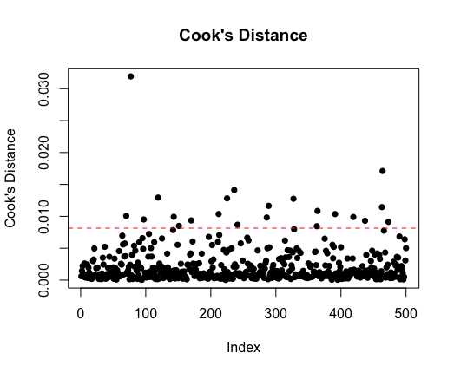

|  |  |
| --- | --- |
| **Variable** | **VIF** |
| **GPA** | 1.22 |
| **GREV** | 1.58 |
| **GREM** | 1.18 |
| **GREW** | 1.70 |
| **StatusU** | 1.34 |
| **StatusI** | 1.64 |
| **PhD** | 1.05 |
| **Ranking** | 1.43 |

**Discussion**

**Interpretation:** The model was observed to be significant, with an overall chi-square value (LR chi2(8) = 99.36, p < 0.05) and pseudoR^2 = 24.1%. Analysis showed five out of the eight predictors, GPA, GRE V, GRE M, Degree, and Ranking, to be significant. A closer look at the odds ratios revealed that an increase in GPA by 0.5 points doubles one’s chances of admission. In addition, OR surprisingly reveal that a 5-point increase in GRE V score increase odds of admission by 50% while an equal increase in GRE M score improves one’s outcome by only 29%. Finally, OR reveal, intuitively, that one’s odds of admission decrease with increasing Ranking and Degree Level. Specifically, admission is 2.04 times less likely when Ranking increases by 0.5 points. Similarly, if an applicant decides to apply to a PhD program instead of Masters, her chances decrease by nearly 60%.

**Limitations:** The model did not take into account factors that we know from intuition will impact a student’s chances of being admitted. These factors are: Undergraduate Institution, Undergraduate Program, Research Experience, Professional Experience, and Demographics

**Implications:** Old GRE scores (200-800 range), as well as international grading scales, were ignored for simplicity purposes. To generalize this model even further, standardization of GRE and GPA data would be required.

**References**: The primary source of data for this project is a website called thegradcafe.com. This site was published circa 2006 and contains over 500,000 admission results from prospective graduate students around the world. The second source of data was usnews.com, which is known for ranking colleges and programs around the country.