Seifenkiste
The goal of this project is to place an Arduino between the remote control and the ESC of a RC car. In its standard configuration, the RC car is difficult to handle in tight spaces and because of its fast acceleration it is difficult to avoid accidents and drive smoothly.
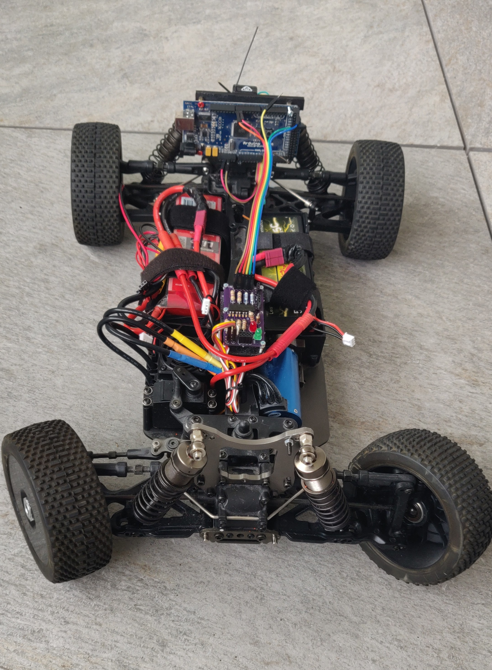
With additional hardware such a distance sensor it will be possible to detect and avoid obstacles because the Arduino will adjust the control signals to the ESC accordingly.
The combination of hardware and software, and some 3D design and printing promises to be a lot of fun. Care has to be taken with respect to power supply. The LiPo batteries need proper and careful handling or they can become a real danger. For piercing them, or depleting them below the minimum voltage, or shortcuircuiting them can result in a fire danger.

Table of Contents
The Basher Sabertooth 2
Power Supply 2
Car Modifications 2
Controller Hardware 3
Arduino Mega 3
Remote Control Transmitter and Receiver 3
1 Battery replacements 3
2 Emergency Button 4
3 Throttle and Steering 4
Controller Hardware Circuit 5
Electronic Speed Controller – ESC 5
Controller Software 5
Reading Antenna Receiver Signals 6
The Emergency Button 6
Generating ESC PWM signals 6
Controller Status 6
ESC programming protocol 7
ESC calibration protocol 7

The Basher Sabertooth
A vehicle designed with a robotic application in mind can be very expensive. They are engineered for robustness and hardware can often easily be fixed to the vehicle base. Furthermore they usually have wheel configurations which allow the implementation of well known odometry and motion models such as 3 wheel differential drives.
As vehicle for this project I chose the Basher Sabretooth, an 1:8 size RC car. While not cheap, it is an affordable base with enough space to install hardware. It is a powerful vehicle designed for heavy duty RC car racing. Because of its shock absorbers and suspension mechanism the car tilts forward and backwards when accelerating or decelerating. This is going to impact the sensor data evaluation, for example a distance sensor such as a Ultrasound device may give different results depending on the tilt of the car.

Power Supply
The Basher runs with 2 Lipo Batteries type 2s, 5000mAH, 20C. The Arduino Mega requires between 7-12V for its regulator to work. A Lipo Battery type 2s 5400mAH with 7.4V is closer to the lower bound of the required range will keep the conversion low.

Car Modifications
The best way to fix additional hardware to the car is to design 3D footings with shapes and screwholes which fit exactly to the measures of the car and the hardware. After removing the car’s body a number of options become visible. The OpenSCAD models for 3d printed parts can be found in the project folders.
The image of the rear shock tower shows the 6 screw holes in the center arranged in T shape. The upper left, upper right, and bottom middle will be used to fix the H shape base to the car with M3 screws. The remaining 3 holes will fit the noses on the base for additional stability. The screw holes in the H fit the Ardiuno screw hole locations and M3 standoffs will hold the device.
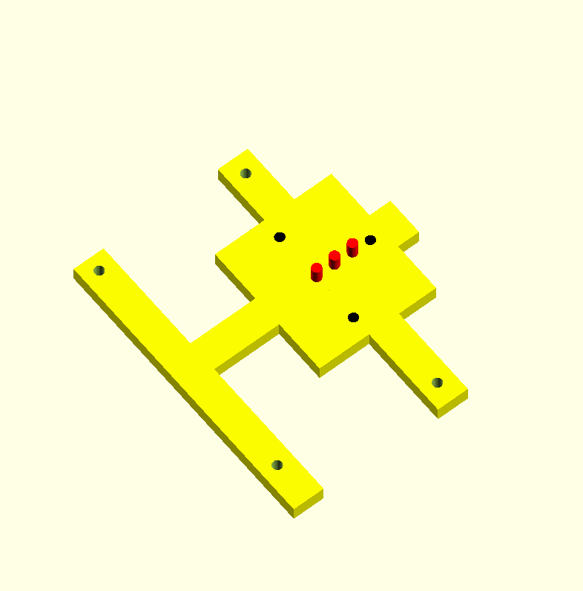Figure 2: OpenSCAD - Arduino H
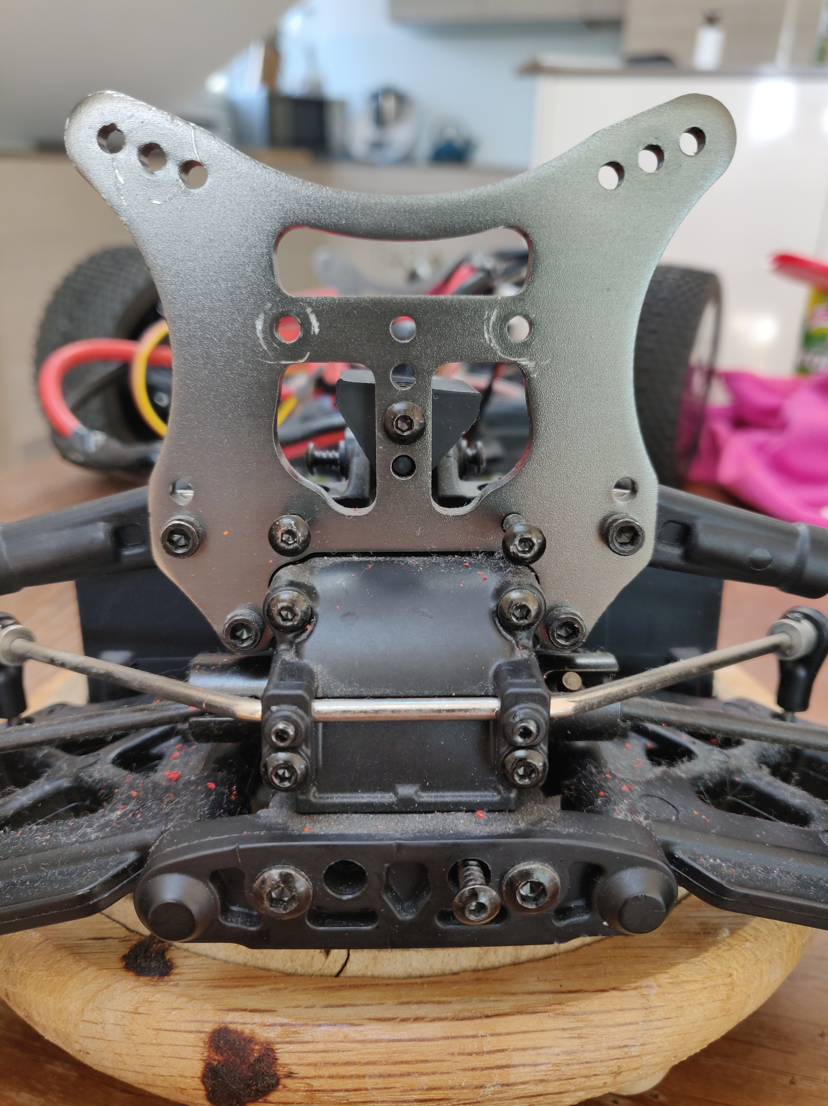Figure 1: Rear Shock Tower

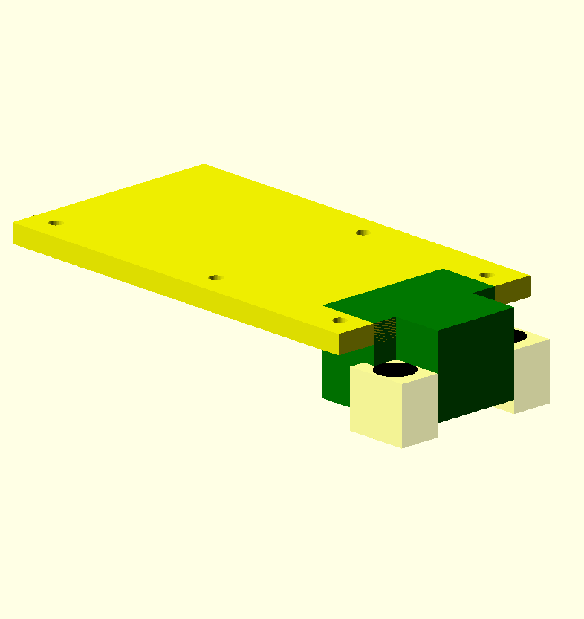Figure 2: OpenSCAD - Controller Bed
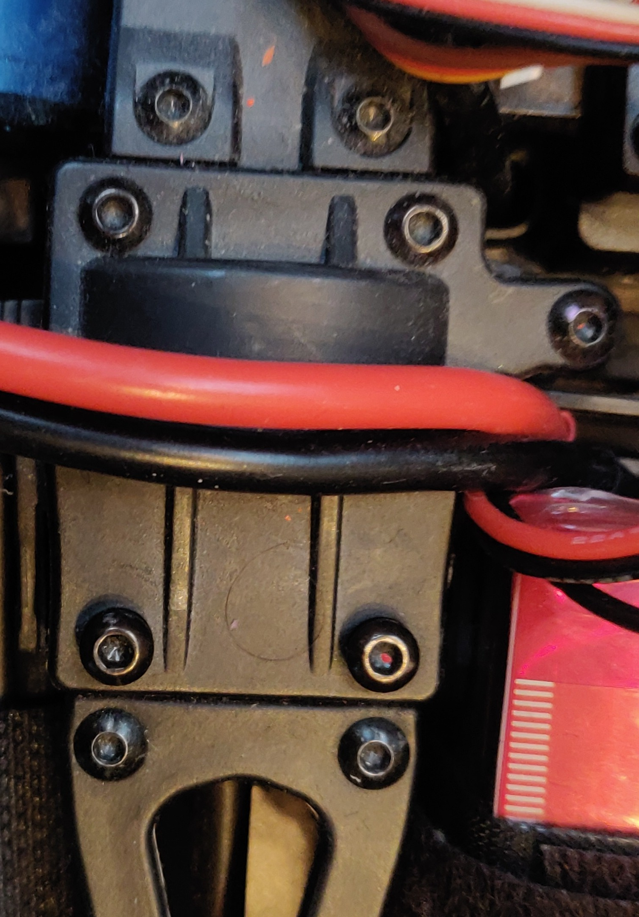Figure 1: Differential Gear Box
The controller PCB is held by a bed type footing which is fixed to the differential gearbox in the center of the car. For that the bottom 2 screws in the image are removed so that the can be bed inserted and be fixes with the screws.
The screw hole locations of the controller bed are usable, however they need slight positional adjustments to exactly match the holes of the PCB. Mistakenly, the holes in the PCB are 0.3 mm instead of 3mm. Re-drilling them as M3 was not possible because of the proximity to the electronic parts. As a result the holes are currently M2 and to correct the situation, the PCB and controller bed screw holes will be adjusted to M3 which allows for standofs to be used instead of M2 screws.

Motor Control Hardware

Remote Control Transmitter and Receiver
The basher comes with a standard remote control, consisting of a transmitter and an antenna receiver.
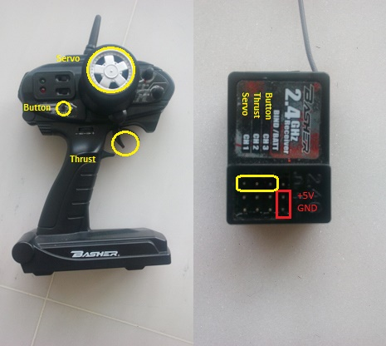Illustration 1: RC Functions and Antenna Receiver pins
The transmitter produces a pulsed radio signal from a servo input for steering the wheels, a thrust for controlling the motor speed, as well as a start button.
On the car the receiver transforms the radio signal into an electrical signal. Originally those signals feed directly into the ESC. Here the Arduino captures and processes the signals and then creates the appropriate outputs for the ESC.
On the remote control are adjustment and reversal buttons for the 2 signals and one start push button.

Battery replacements

The remote controls runs on 12V. Eight AA batteries can power the remote control for about 30 minutes.
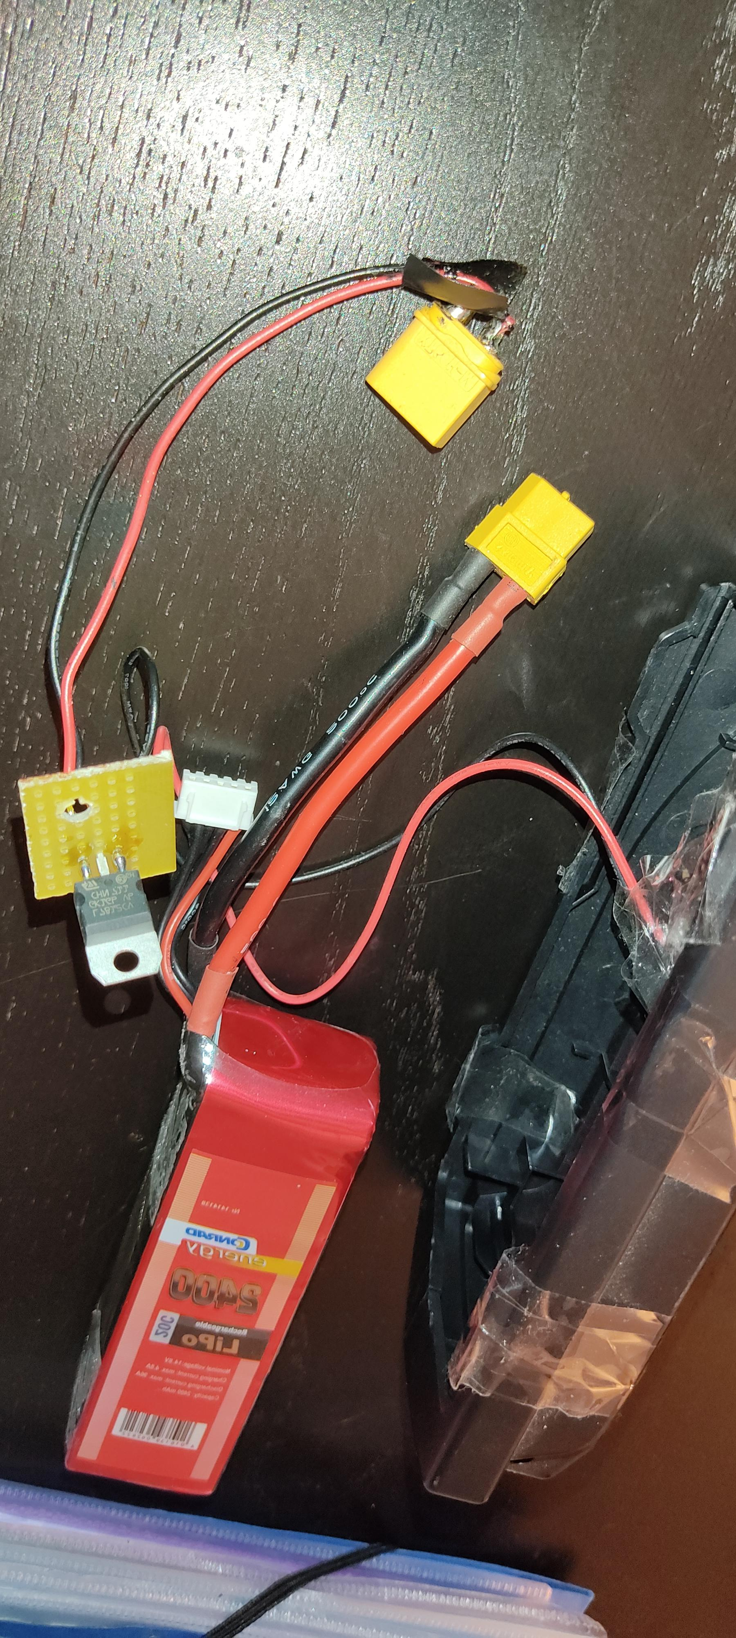Illustration 2: 14.8V Lipo RC Pilot
It is a good idea to use rechargeable batteries, however once empty those batteries take about 8 hours to charge which doesn’t help with continuous operation.
Hence the decision to replace the batteries with a 14.8V Lipo and a L7812CV Voltage controller chip. It holds much longer and is much faster to charge. It is more important now to remember to disconnect the battery to avoid a Lipo battery discharge below acceptable levels.

Emergency Button
The start button will provide the emergency function. It is connected to the arduino port with the highest interrupt priority so that in case of emergency the motor can be stopped by pressing the button.

Throttle and Steering
Both steering and throttle are PWM signals of about 18.5ms duration with a neutral signal of 1.5ms.
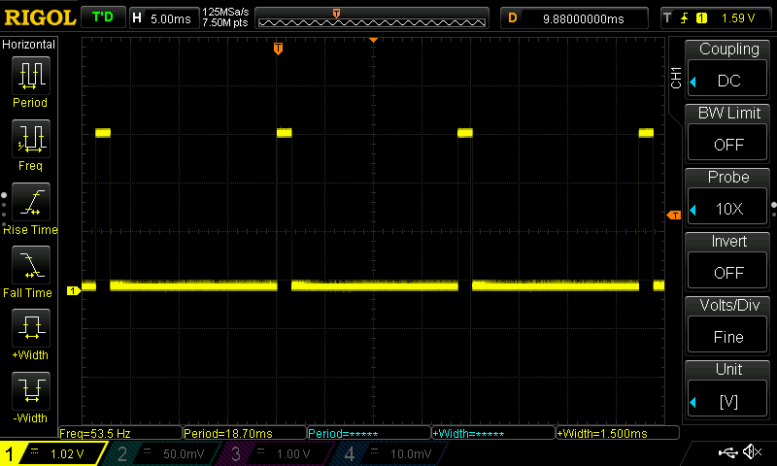Illustration 3: Base signal duration 18.5ms, neutral setting 1.5ms
The min and max PWM signals correspond to approx. 1.2ms and 1.8ms respectively. The 2 trim buttons allow the center signal to be calibrated for the throttle and steering to rest in neutral position when the remote control is sending neutral signals. Furthermore there are 2 reverse buttons for the 2 signals.
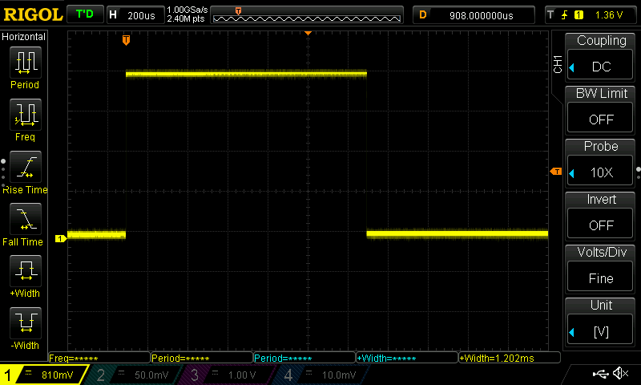Illustration 4: Min signal duration 1.2 ms
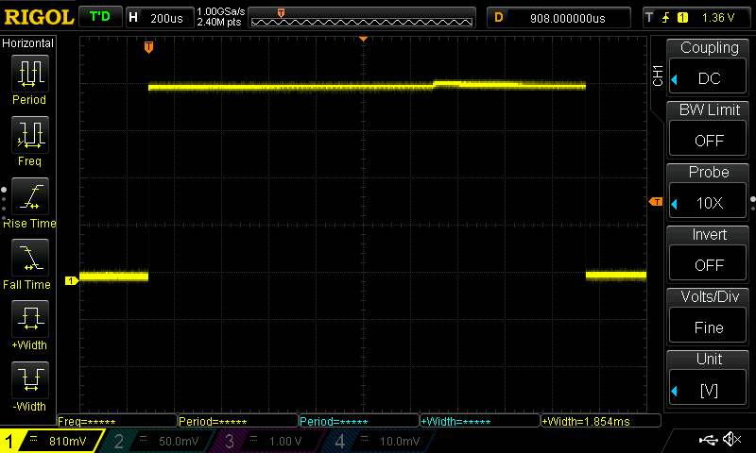Illustration 5: Max signal duration 1.8 ms

Electronic Speed Controller – ESC
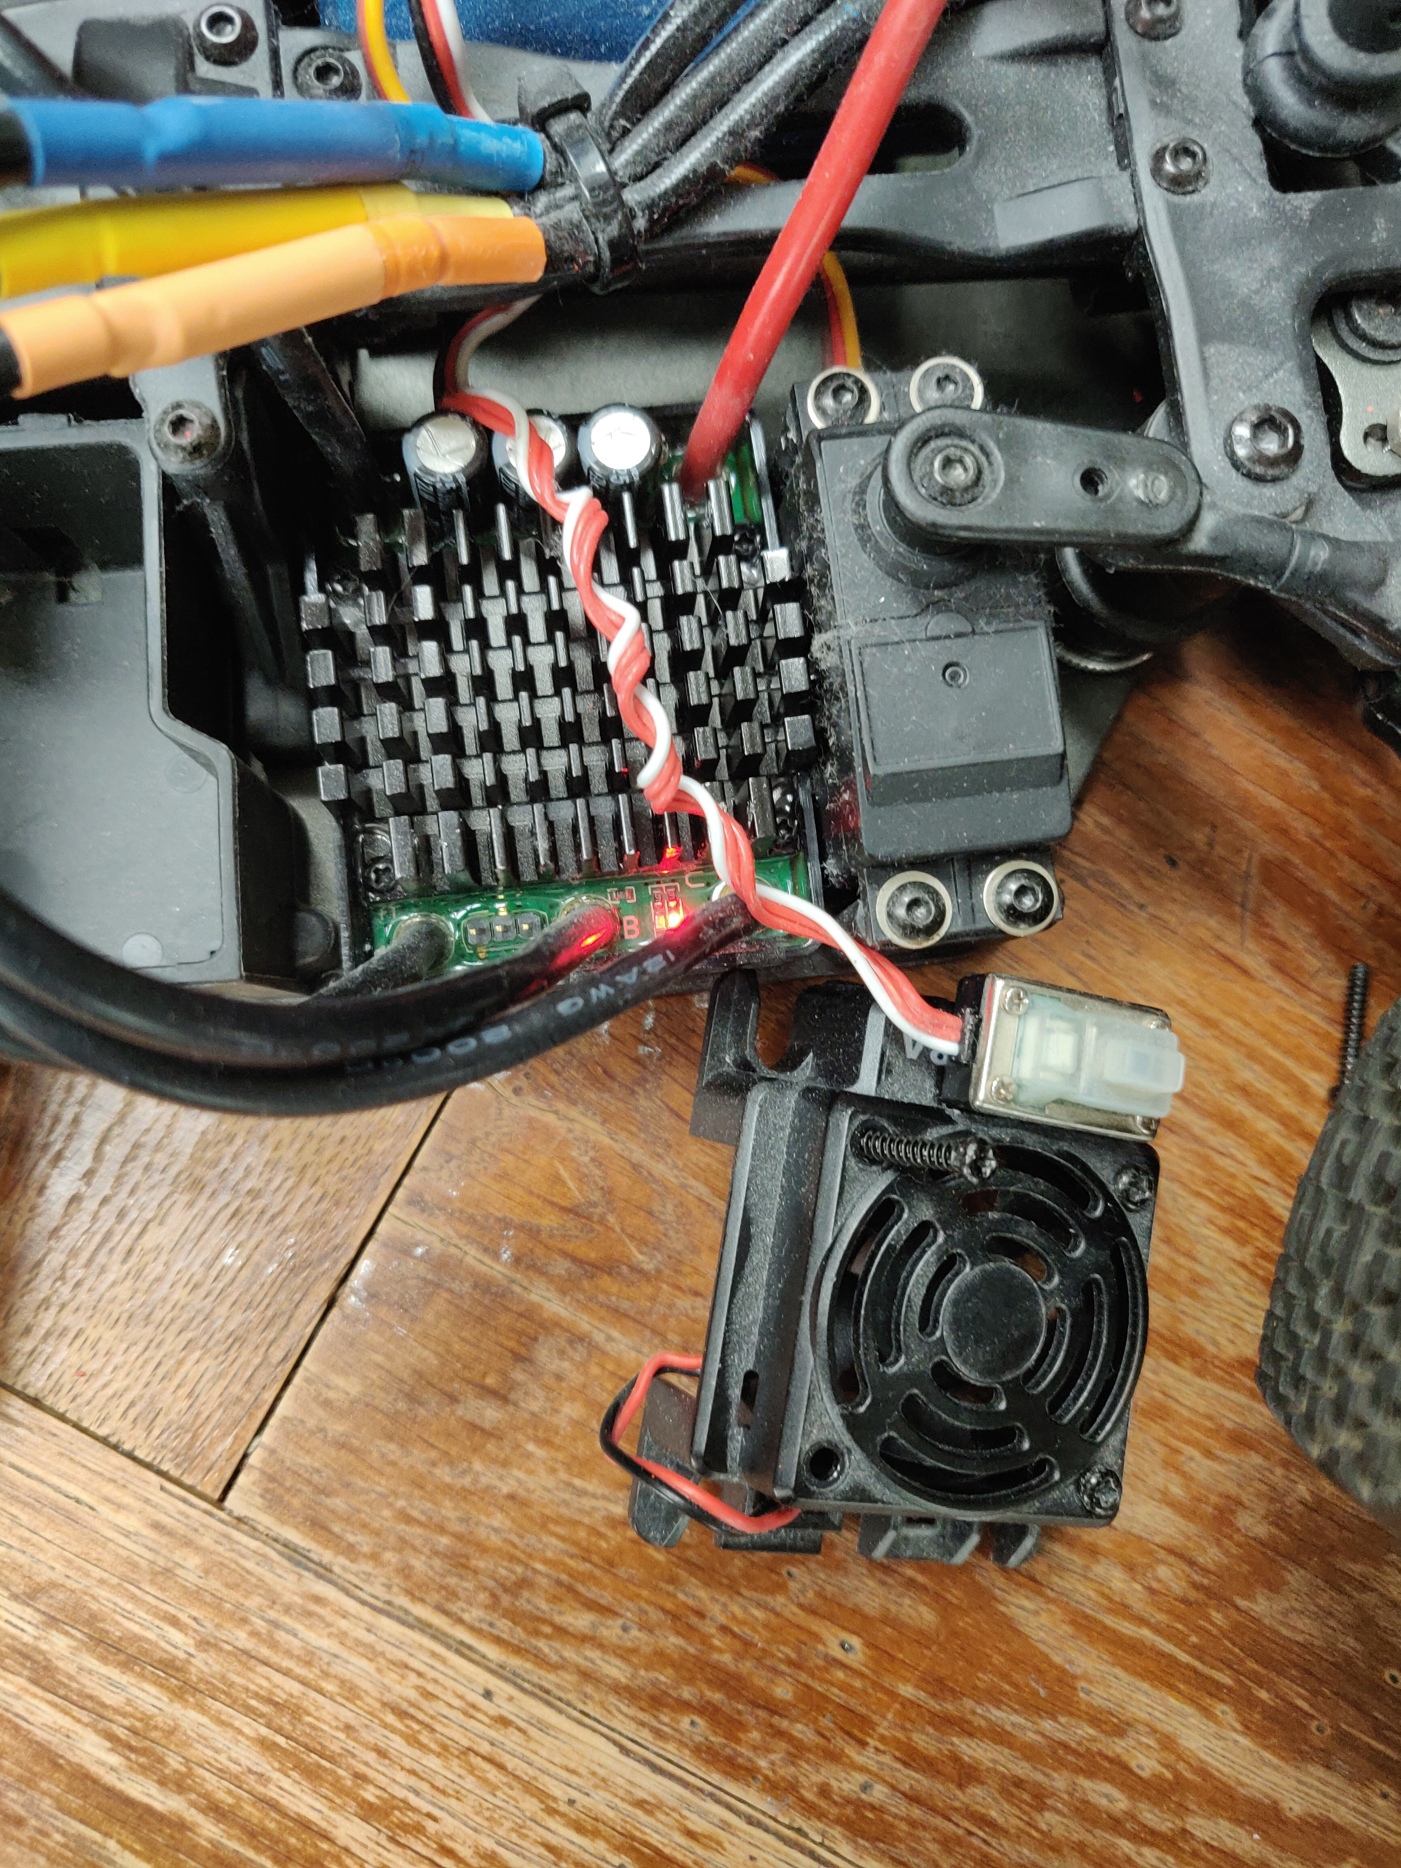
In normal operation, the antenna receiver will feed the control signals directly into the ESC. The ESC converts the PWM duty signals into a 3-phase electronic power signal to the brushless motor. The 3 power cables can be seen in the top left of the image. It shows the ESC with the fan removed. The power button and the SET key are under the white plastic. Visible is the large cooler surface under which the electronic control circuit is located.
Five ESC parameters can be programmed. Details of the programming procedure are described in the manual and in the appendix of this document. All settings have been chosen to be defensive, for example choosing break forces so that the forces applied to the motor are minimized.
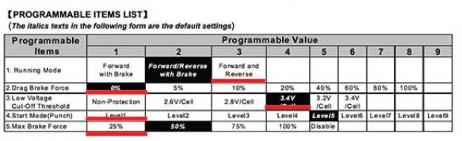
The ESC needs to be calibrated before the first use. It needs to learn the duty range of the pwm input signals for the throttle. Using the SET button the neutral, minimum and maximum settings are exposed to the ESC using the protocol at the end of the document.

Motion Control Concept
To control the car’s motion it is necessary to control the PWM signals going to the ESC. In a first step this means intercepting the remote control signals coming from the antenna receiver and translating them into the corresponding PWM signals for the ESC. As a precaution the throttle signal will be filtered so that the car moves at a limited speed. A next step could be to filter the RC signals to avoid jerky motion and create output signals which ideally make the car move smoothly.
This control process is implemented on an Arduino Mega.

Arduino Mega
The Arduino is a powerful 16MHZ microcomputer board which in addition to timer and communication functionality offers a large number of input output ports. It is well equipped to implement the control regime described above. Specifically the external interrupts to read the RC signals from the Antenna and several timers to create the PWM signals for the ESC will be key to controlling the car.

Controller Hardware Circuit
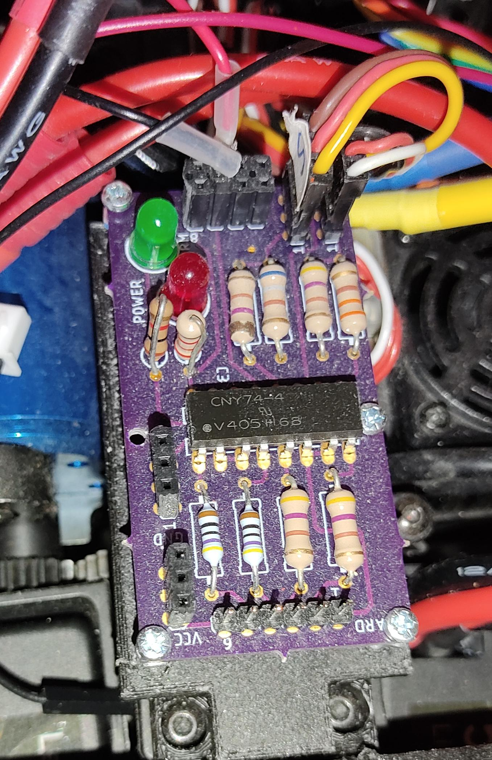
The Basher motor can draw significant power with temporarily very high currents. Hence it is advisable to separate the power supply of the ESC and the motors from the power supply for the Arduino and the RC receiver. The opto coupled controller board will separate the 2 power circuits so that the PWM signal on the Arduino output can be decoupled from the PWM signal on the ESC input so that the 2 circuits don’t need to share common ground to establish signal levels.
The the optocoupler CNY74-4 provides 4 otpo-coupled channels. Hence, inn addition to the 2 PWM channels for steering and throttle the board can control 2 outputs on the motor power supply side. These channels can drive visual or audio signals or other devices such as the green and red led and the buzzer.

Controller Software
General Overview

Reading Antenna Receiver Signals
Description

The Emergency Button
Descrip

Generating ESC PWM signals
Descrip

Controller Status
Descrip

Appendix

ESC programming protocol
To program the ESC : see manual page 7-9:
In general:
The green LED signals the item number, ie. if it flashes once this is the “running mode” entry.
The red LED signals the current items value, ie. if it flashes once this is “Forward with break”
Settings can be selected by releasing and pressing the SET button as described below

- turn off ESC
- turn on transmitter
- hold set key and keep it pressed
- switch on ESC

Keep holding down the SET button!

The Red LED flashes 8 or 9 times and the ESC enters the programmable mode.

Next the green LED flashes once.
This indicates that currently item number 1 “running mode” is selected.
To program item 1 release the SET key.
To program one of the next items keep the SET button pressed until the ESC has increased the item number and the green LED has flashed the corresponding number of times.

Once the item number is selected by releasing the SET button, the red LED indicates the items’s current value by flashing the corresponding number of times.
With short breaks the ESC will continue to indicate the currently selected items value.
To keep the current value switch off the ESC.
To increase the item’s value give the SET button a short push.
The ESC will now indicate the new value by flashing accordingly.
End the programming by switching off the ESC.

ESC calibration protocol
To calibrate the ESC with the RC signal range : see manual page 6:

- turn off ESC
- turn on RC with throttle in REV
- press the SET key and turn on the ESC
- as soon as the red light flashes release the SET key, the red light keeps flashing
- the RC should be on neutral, i.e. the controller software should output 1.5ms
- then press the SET key, there is one green light signal
- the RC should now output the max forward signal, I.e the controller output needs to be 2ms.
- Then press the SET key again, there are 2 green light signals
- the RC should now output the max backward signal, I.e the controller output should be 1ms
- press the SET key one last time, there are 3 green light signals.
- Then turn of the ESC and wait 3s before turning on
The ESC is now calibrated to the range of the RC, or here to the range of the controller between 1ms and 2ms

