三层状态机课程设计报告

朱鹏飞

16040310083

三层状态机课程设计报告

各个状态函数描述：

Idle→movingup/movingdown

if (floor > 0 && up)→SetMotorPower(1);→movingup

if (floor > 0 && !up)→SetMotorPower(0);→movingdown

idle→dooropen

if (GetOpen/callDoorLight())→SetDoor(floor,true)→dooropen

movingup→dooropen

if (fabs(GetFloor() - floor) < Lib_FloorTolerance)

{

SetMotorPower(0);

SetDoor(GetNearestFloor(), true);

}

→dooropen

Movingdown→dooropen:

if (fabs(GetFloor() - floor) < Lib_FloorTolerance)

{

SetMotorPower(0); //电梯停止

SetDoor(GetNearestFloor(), true); //开门

}

→dooropen

Dooropen→doorclosing：

if (GetCloseDoorLight())

{

SetDoor(GetNearestFloor(), false);//关门

SetCloseDoorLight(false);//消费门内关门灯

}

else if (GetCloseDoorLight())

{

SetDoor(GetNearestFloor(), false);//关门

SetCloseDoorLight(false);//消费门内关门灯

}

Doorclosing→dooropen：

if (GetOpenDoorLight())→SetDoor(GetNearestFloor(),false);orif (IsBeamBroken())→SetDoor(GetNearestFloor(), true);

→dooropen

doorclosing→idle:

if (IsDoorClosed(GetNearestFloor()))

测试结果：

经测试

运行正常

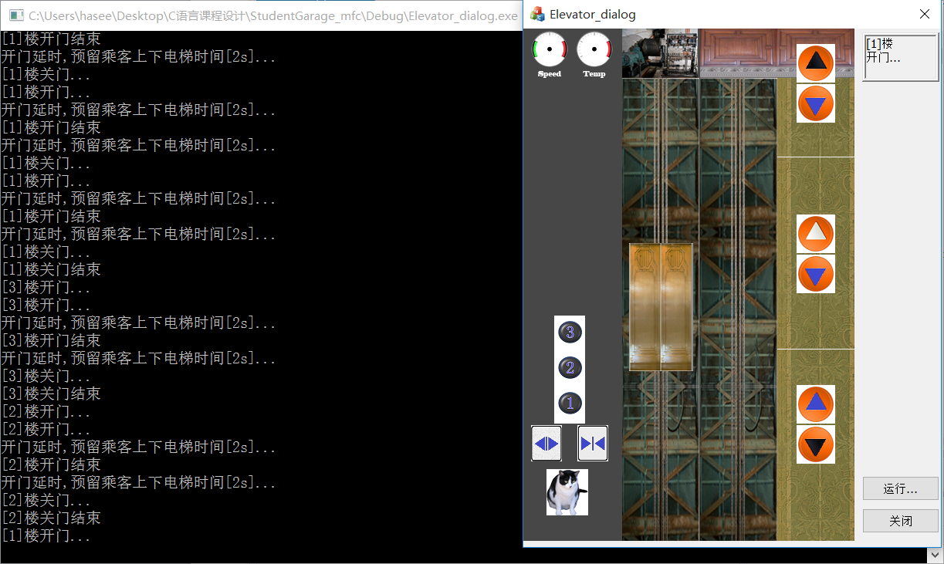

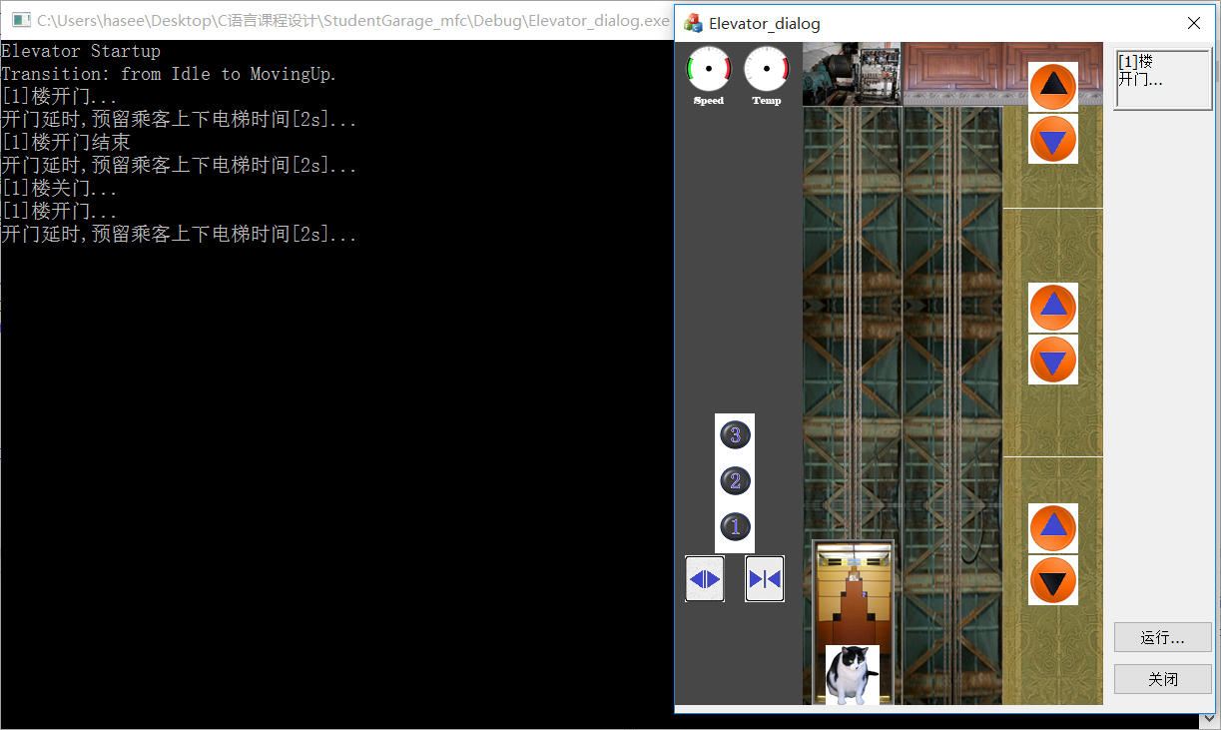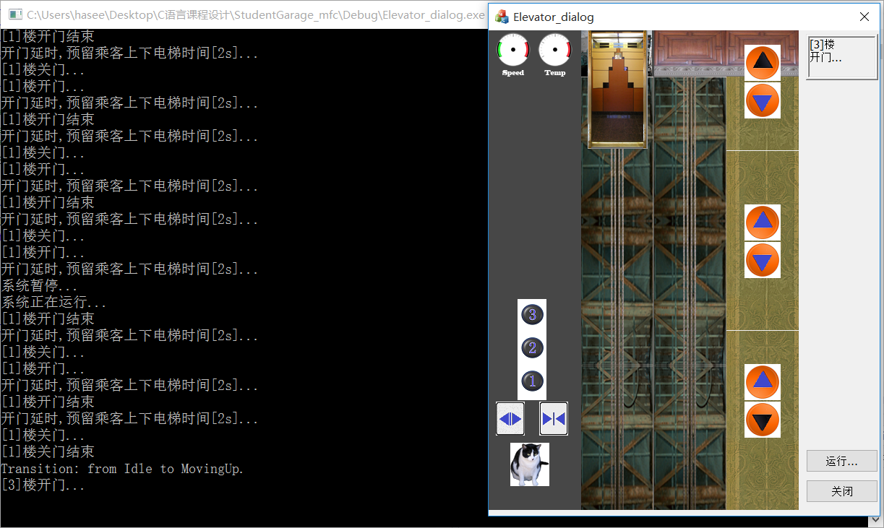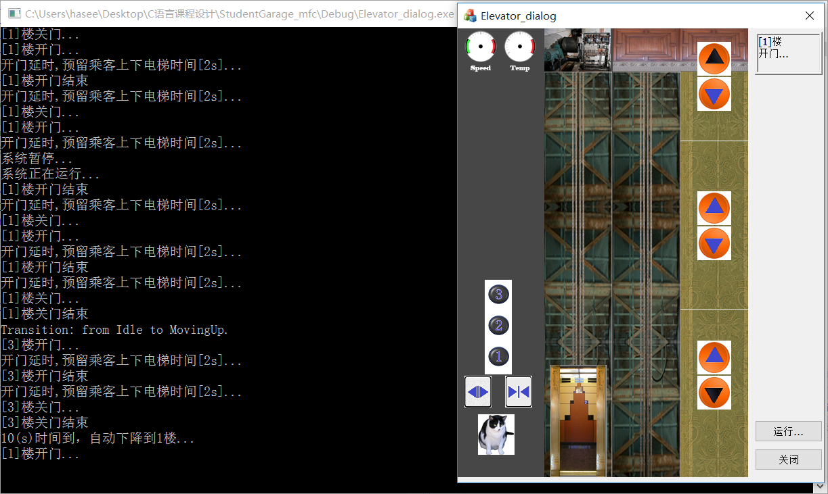

三层状态机图

ifIsDoorClosed(GetNearestFloor()))

if(GetOpenDoorLight());(IsBeamBroken())

Doorclosing

if(GetCloseDoorLight())if(IsDoorOpen(GetNearestFloor()))

if(fabs(GetFloor() -floor)<Lib_FloorTolerance)

SetMotorPower(0);

SetDoor(GetNearestFloor(), true);

if(fabs(GetFloor() -floor)<Lib_FloorTolerance)

SetMotorPower(0);

SetDoor(GetNearestFloor(), true);

if(GetCallLight(floor,true))

if (floor > 0 && !up)

if (floor > 0 && up) && up)

Dooropen

Movingdown

Idle

Movingup