**CPSC 4420/6420: ARTIFICIAL INTELLIGENCE** ASSIGNMENT 1- DUE: SEP 16, 2022 @11:59 PM NAME:

Uses “Pycharm CE” to code / run my program

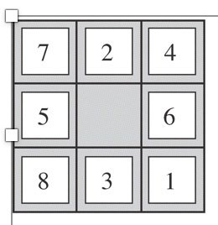Can change “goal state” manually

Program either gives a random “Type 4” or a user given “Type 3” initial state

For the above puzzle shown here, develop a Python program that

1. [10 pts] Lists all states [No need to submit the output (the list of states) for this part, and just submit the code and the first [or randomly selected] 10 states, since the list will be very long !!!]

Type “1” in my Program

1. [10 pts] Gets the current state and the action (moving up:1, down:2, left:3, right:4) as input, and returns the resulting state. Represent the blank spot with “0” and use one of the following naming formats for states
   * Represent each state with a sequence of numbers from left to right and top to bottom. Ex. Use 7-2-4-5-0-6-8-3-1 for the state shown above
   * Represent each state by a 9-digit integer number. Like show the above state by 724506831

Ex: Input (Current state: 724506831, Action: 3) should give output state: 724056831

Type “2” in my Program

1. 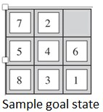[10 pts] Suppose that the goal is to arrange the numbers so that the resulting 3-digit numbers created by each row are divisible by 3. For instance, 7-2-0-5-4-6-8-3-1 is a goal state because 720, 546, and 831 are divisible by 3. Write a program that prompts the user to receive an arbitrary initial state, and then performs random actions to reach the goal state. Show the sequence of actions and the sequence of states.

Type “4” in my Program. Can use UCS, BFS or DFS

1. [20 pts] Suppose that the goal is arranging the blocks in numerical order as shown below. Develop a Breadth First Search (BFS) algorithm and show the results. Present the sequence of states and moves, starting from the initial state. How many moves (actions) did it take to reach the goal state?

Type “3” or “4”. And then pick option “2” for Breadth First Search.

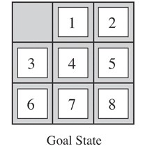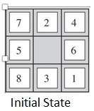

1. [10 pts] Repeat part (D) using a Depth-First Search (DFS). How many moves (actions) did it take to reach the goal state?

Which algorithm found the solution with fewer moves? Explain your observation.

Type “3” or “4”. And then pick option “3” for Depth-First Search.

Breadth-First Search: 163,375 Iterations

Depth-First Search: 159,711 Iterations

Depth-First Search reached it in lesser iterations. The target node is closer to the leaf rather than being closer to the root.

1. [10 pts] Repeat Part (D), if the goal is ordering the numbers clockwise around the blank space, with the given initial state, as shown below.

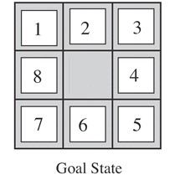

The puzzle was unsolvable

1. Implement a Uniform Cost Search (UCS), if the goal is achieving the final state in part F from an arbitrary initial state, if we have the following costs for different moves

Type “3” or “4”. And then pick option “1” for Uniform-Cost Search

[15 pts] G1) All moves have a unit cost - Yes

[15 pts] G2) Up (Cost=1), Down (Cost=1) Left (Cost=2) Right (Cost=0.5) Present the sequences of moves and states for each option. How many actions are used to achieve the solution for each option? Explain your observation. - Yes