For Lab 6 Collage of PPM
Due: Monday, February 28, 2022

You may work with one partner on this lab. You both must be registered in the same lab section. Working with a partner is not required.

Assignment Overview:

Using a ppm image of your choice, you are going to create a collage. Below are several example outputs from a class I taught 5 years ago.

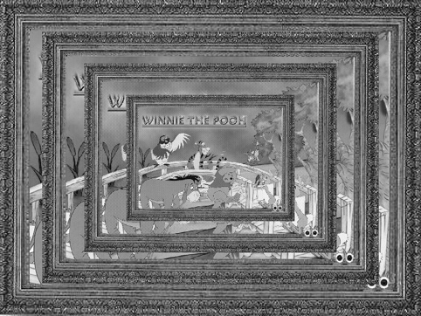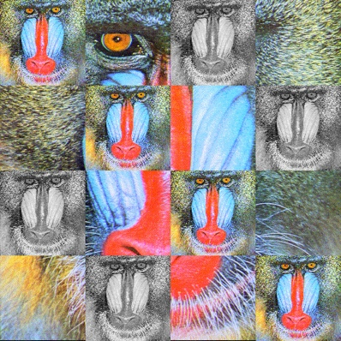

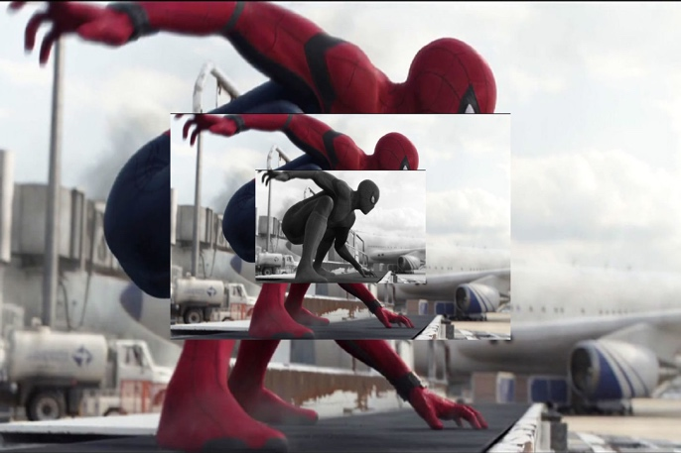

Notice each of these images have various sizes of the same image in the collage. For this lab you are going to create a collage using at least one resized image in your collage. You are also required to flip or gray scale at least one of the images in the collage. Be creative. If you wrote functions in another class to mirror, rotate, etc. feel free to use these image manipulations in your final output image as well. However, you must meet the basic requirements of this lab. (A flipped or gray scaled image and a resized image.)

Requirements:

Using code, create a collage. You must write a function that will resize an image then write that image in your ppm collage. As stated above, at least one of the images in the collage must be either flipped or gray scaled. It must be clear when looking at your collage that you have a resized image in the collage.

Below is a description of a resize function. While there are many sophisticated algorithms that provide smoother resized images than the algorithm below, this one works just fine for this project. If you are mathematically inclined and wish to create your own algorithm, feel free to do so. DO NOT COPY ONE FROM THE INTERNET.

void imageResize(pixel_t** original, pixel_t** newImage);
The two pixel_t’s represent the original image and the new resized image.
The basic algorithm I used is as follows: (The algorithm was a written by a previous student, and TA, Alex Meyers.)
- Calculate the relative width by dividing the original image width by the desired width. Do the same for the height. These will be doubles.
- For each pixel, find the relative pixel location in the old image that will be used set to the pixel in the new image. This can be done by multiplying the col * the relative width calculated in ‘a’ above. You will need to do this for height as well.
- Set the new resized image [row][col] equal to the old image [value calculated for height in ‘b’ above][value calculated for width in ‘b’ above]. Remember the row and columns are the height and width of the image.

You will also need to create a function that will create the collage. This function should call all necessary functions needed to create the collage.

Your function prototypes should be added to the ppm.h file from Lab 5. The implementation of the resize function should be in the ppm.c file created in Lab 5. (feel free to make copies of these files to use for this lab) You can use the driver (main) file from Lab 5 to add the needed code for this lab or create a new driver (main). Remember, the driver (main) file should have minimal code in it. It should only contain calls to functions, needed variables, and code to clean up (give back memory, close files, etc.)

Formatting:
You will need to add a header to each of your files similar to the following:
/*************************
*Your name
*CPSC 2311 your lab section
*Spring 22
*Your email
*************************/

Your program should compile with no warnings and no errors. There will be a deduction up to 50 points if your program does not compile. If your program compiles but has warnings, there will be a deduction up to 20 points.

- Your code should be well documented. (comments)
- There should be no lines of code longer than 80 characters.
- You must use proper and consistent indention.
- Variable names should be meaningful.

There will be a minimal of a 5 point deduction per infraction for failing to comply with the above formatting rules.

Handin:
Use handin.cs.clemson.edu to submit your files to the Lab6 bucket
Things to do prior to handing in your files:
- Test your program on cerf15 on the SoC servers. I will not accept the excuse “It compiled on my computer.” I test programming assignments on cerf15 of the SoC servers.
- Tar zip your files naming the tarred file Lab6_<username>.tar.gz Do not place your files in a folder and then tar the folder. This will break the grading script I plan to give the TA’s. When your files are untarred all your files must be visible to the TA. The TA should not see a folder with your files. This will require a step that will not be in the grading script.

GRADING:
The grading rubric is attached:
Note to grader: If the files did not compile, look at the code; if a substantial effort was made to complete the assignment give a grade of 30 and move on. If a substantial effort was not made give a 0 and move on.

Rubric:

Student: ____________________ Section: _______ Grade:_______
Did the program compile with no errors? _______ -50 if no
Did the program compile with no warnings? _______ -20 if no

Did the program use file pointer? _______ -5 if no
Did the program close the file pointer? _______ -5 if no
Did the program use command line arguments? _______ -5 if no
Did the program use a 2D array and dynamically allocate the memory?_______ -10 if no
Did the program free dynamically allocated memory? _______ -5 if no

Were the appropriate typedef structs used. (2) _______ -5 for each no
Did the student implement the functions required? Resize & Collage _______ -5 if no
Were header guards used in ppm.h _______ -10 if no

Formatting:
Was code well documented (comments) _______ -5 if no
Were headers in the files? _______ -5 if no
Were there any lines over 80 characters? _______ -5 if yes
Proper and consistent indention _______ -5 if no
Meaning variable names. _______ -5 if no

Notes:

