 | 
  Lab 9–Filter
  CPSC 2311- Spring 2022

Introduction
This is a programming lab. You will write a program in C. You are not allowed to use any other programming language for this lab.

Due: April 4, 2022, Midnight
You may choose to work with one classmate from your lab section on this assignment.

Lab Instructions
You are going to use a filter kernel of size 3x3 or 5x5 to change the values of a 2D array of integers. This is a concept often used to sharpen, blur, remove noise, etc. on images. The two filters you will use are designed to sharpen an image. I mentioned in class, we may use this concept to apply a filter to an image to sharpen the image.

Below are definitions for two filters used to sharpen an image. The first produces a mild sharpened image. While the second filter produces a more pronounced sharpened image.
Matrix Filter::K3 =
{{ 0,-1, 0},
{-1, 5,-1},
{ 0,-1, 0}};

Matrix Filter::K5 =
{{ 0, 0, -1, 0, 0},
{ 0, 0, -1, 0, 0},
{-1, -1, 9, -1, -1},
{ 0, 0, -1, 0, 0},
{ 0, 0, -1, 0, 0}};

s

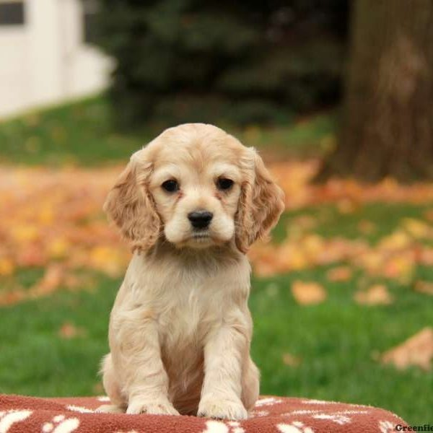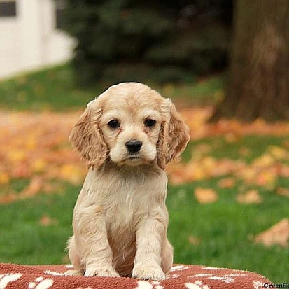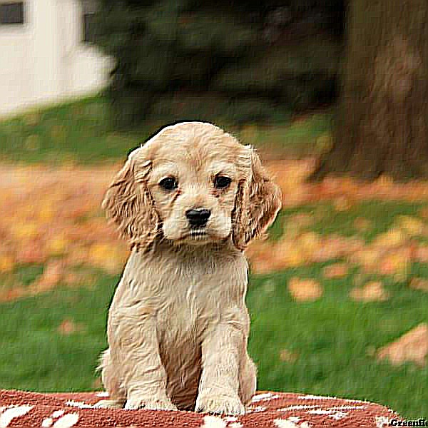
Original image After 3X3 filter After 5X5 filter

REQUIREMENTS:
Please read the entire document. The requirements will be discussed throughout the document not just in one place.
You will provide a functions.h file for the prototypes and implement the functions in functions.c. You must also provide a driver.c file that will contain your main and all code needed to demonstrate your functions work.

There are many ways to solve this assignment. I have written various versions of this assignment, each using, different algorithms. However, you must use good programming practices when developing your code. This means you must create functions that are small and do specific task.

I am now going to discuss conceptually how to apply a filter to a set of data. Consider the matrix below. The orange “E” is the current element of a 2D array. We are going to recalculate the values of Array[5][5] for the output array. You are NOT to change the value of the input data; you are basically creating a new set of data storing it in a new array.
Columns (x)
R
o
w
s

3X3 FILTER
 |  |  |  | A | B | C
 |  |  |  | D | E | F
 |  |  |  | G | H | I
0 | -1 | 0
-1 | 5 | -1
0 | -1 | 0
Imagine the 3X3 filter to the right is the filter represented in matrix on the left, A-I.
To calculate the value of “E”, for the output array, do the following:

E(the calculated value for the output 2D array) =
(A(input value)*0) + (B(input value)*-1) + (C(input value)*0) + (D(input value)*-1) + (E(input value)*5) + (F(input value)*-1) + (G(input value) *0) + (H(input value)*-1) + (I(input value)*0). Notice the filter values are the values being used in the above calculation.

After you have calculated the value for E you need to make sure the newly calculated value is between 0 and 255. You should write a function to check this. If the calculated value is less that 0 set the output value to 0. If the calculated value is greater than 255 then you should set the output value to 255.

The above calculation will be repeated for each element in the 2D array except for the elements on the edges.

Let’s discuss why we would not calculate the values for the elements on the edge?
Consider the following:
3 X 3 filter
6 X 6 array
A | B | C
D | E | F
G | H | I

As demonstrated in the above illustration, when the current element is on any edge of the array and you are using a 3X3 filter, there could be up to 6 elements of the filter that are outside of the border of the array. Therefore, simply do not change the value of the edge of the array (the elements in blue). In an image, not calculating the values on the edge will not noticeably effect the output image.

FOOD FOR THOUGHT: Since we are going to be working with 5X5 filters as well as 3X3, how do the above concepts translate to a 5X5 filter? Basically, any filter that is square you can divide the size of the rows (or columns) of the filter by two. This will give you the number of rows and columns on the edge that you will not apply the filter on.

Other requirements:

You are required to create each of your 2D arrays as int**. This will require you to dynamically allocate memory for each 2D array. (ex: data set, filters). In class we discussed the use of typedef and that you can use it to create an alias or synonym for an existing type. You are required to use typedef to create an alias for an “int**”. I called mine MATRIX. You can call yours whatever you wish. You will need a function that basically allocates memory for a 2D array. We have covered several methods for dynamically allocating memory for a 2D arrary. You must use one of the methods that stores all memory on the heap not on the stack.

You will need a function that prints the output data in the following format:

1 1 2 1 2 1
0 2 0 3 4 5
5 9 0 4 5 6
0 0 0 0 9 0

You are to create an input file similar to the following.
5 7
1 2 3 4 5 6 7
1 2 9 3 1 3 0
8 1 3 2 5 6 0
8 4 3 5 9 0 2
1 2 2 2 2 2 2
As you can tell the first number is the number of rows and the second is the number of columns. The remaining data will be read in and stored in the 2D array you dynamically allocated.

Below are short descriptions some of the functions I wrote.

A function to read in the data. This function creates a file pointer for the input and output. DO NOT DO THIS IN MAIN. Be sure to check that the files opened successfully. You can create a function for this or use assert. The input and output file names MUST be given through the command line. You must use fscanf to read the data. Make sure to close the file pointer after the file has been read.

I created a function that allocates the memory for the 2D arrays, as well as a separate function that gives the memory back to the operating system. You must call this function once you are finished with the dynamically allocated memory.

A function to make sure the output data is within the range of 0 and 255.

You will also need one or more functions to calculate and store the new data. I used two functions for this. One to determine the element that is going to be changed and then call another function to do the calculation. Again these are only suggested functions. You can choose to create whatever function you will need for your program, but if your functions are to large or do multiple task, points will deducted. Functions that do specific task are preferred.

Code requirements:
- Your programs must compile on one of the “cerf” SoC servers.
- You must add a header to each of your files like the following:
/*************************
*Your names
*CPSC 2311 Sp22 Section 00?
*Your email
*************************/
- Your code should be well documented. (comments)
- There should be no lines of code longer than 80 characters. This will be strictly monitored.
- You should use proper and consistent indention.
- You must use header guards in your functions.h file.
- YOU SHOULD NEVER #include a “.c” file; only #inclue “.h” files.
- You should test your program on several sets of data of various sizes.

Violating any of the above will cost a minimal of 5 points each. A higher number of offenses will increase the amount of point reduction.

Here are some guidelines for documenting code.
Before each function you should have a detailed description of what the overall function does. To borrow from another student’s code, here is an example of overall function description. Your description should be more than just a word or two.
/* Parameters: img - image_t pointer array holding the image data for
* each of the input files
* Return: output - image_t struct containing output image data
* This function averages every pixels rbg values from each of the
* input images and puts those averages into a single output image …
*/

Also, if you include comments in the body of the function (and you should) they should be placed above the line of code not beside the code.
Example:

Good
//This is a comment
if(something)
{
do something;
}
Bad
if(something) //This is a comment
{
do something;
}

Handin:
You will use the School of Computing handin system to submit your program files.
You are required to tar zip your files calling the tarred file: <username>_lab9.tar.gz, where <username> is replaced with your Clemson username. As an example, my tarred file would be called: yfeaste_lab9.tar.gz. Be sure to check your submission by downloading your tarred file after submitting it to handin, untar the file, and examine the files to determine there were no files corrupt during the tarring process.

