**Software Engineering For Database Warehouse**

**Ahsen Ershad**

**Erik Malone**

**Andrew Woodruff**

**Evan Jarvis**

**Software Requirements Specification** **Documentation**

**Version: (1.0)** **Date: (09/07/2017)**

**Table of Contents**

**1. Introduction**

*1.1 Purpose*

*1.2 Scope*

*1.3 References*

*1.5 Overview*

**2. The Overall Description**

*2.1 Product Perspective*

*2.2 Product Functions*

*2.3 User Characteristics*

*2.4 Constraints*

*2.5 Assumptions and Dependencies*

**3. Specific Requirements**

*3.1 General Requirements*

*3.2 User Requirements*

*3.3 Network Requirements*

*3.4 Error Handling Requirements*

*3.5 Security Requirements*

*3.6 Input Requirements*

*3.7 Output Requirements*

*3.8 Additional Comments*

**4. Appendices**

*4.1 Definitions. Acronyms, Abbreviations*

*4.2 Contributions*

# **1. Introduction**

This section gives a scope description and overview of everything included in this SRS document. Also, the purpose for this document is described and a list of abbreviations and definitions is provided.

## **1.1 Purpose**

The purpose of this document is to give a detailed description of the requirements of the ”Warehouse Database” software. It will illustrate the purpose and complete declaration for the development of system. It will also explain system constraints, interface and interactions with other external applications. This document is primarily intended to be proposed to a customer for its approval and a reference for developing the first version of the system for the development team.

## **1.2 Scope**

The “Warehouse Database” is a cloud-driven, browser based, warehouse inventory database system which helps warehouse administrators, warehouse managers, sales associates, and customers maintain, keep track of, and sell inventory. The application should accessible via web browser.

Warehouse administrators are users who are given all permission for managing and controlling the system; for instance, creating a new warehouse manager account.

Warehouse managers are users who are given more specific permissions for managing; for instance, adding/ordering new products to inventory and creating sales associate accounts.

Sales associates are users who given minor permissions to handle sales; for instance, purchase inventory from main warehouse and create sales invoices.

Customers are users who are given minimum permissions to inventory; for instance, view products, orders, and view invoices.

Furthermore, the software needs a database engine, cloud provider, and a browser user interface connection to maintain and display results. All system information is maintained in a database, which is located on a cloud server. By using the database, users can view add, remove, and alter, along with different roles that come with different permissions. The browser user interface also represents detailed information about the products, such as name, ID number, cost, quantity, description.

## **1.**3 **References**

IEEE Software Engineering Standards Committee, “IEEE Std 830-1998, IEEE Recommended Practice for Software Requirements Specifications”, October 20, 1998.

## **1.**4 **Overview**

The remainder of this document includes two chapters and appendices.

The second chapter provides an overview of the system functionality and system interaction with all and other users. Furthermore, the chapter also mentions the system constraints and assumptions about the product.

The third chapter provides the requirements specification in detailed terms and a description of the different system interfaces. Different specification techniques are used in order to specify the requirements more precisely for different audiences.

# **2. The Overall Description**

This section will give an overview of the whole system. The system will be explained in its context to show how the system interacts with other systems and introduce the basic functionality of the system. It will also describe what type of stakeholders that will use the system and what functionality is available for each type. Finally, the constraints and assumptions for the system will be presented.

## 2.1 Product Perspectives

This system will consist of just one part: a web portal. The browser based application will be used to manage and maintain inventory, along with the assignment of products and user capabilities.

The web-based application will need to communicate to a database engine within the cloud, which in turn communicates with the browser application to display pertinent data as it relates to operation of the warehouse. Since this is a data-centric product, it will need somewhere to store the data. Toward that end, a database will be used.

The web portal will communicate with the database to retrieve customer information in addition to a listing of products near a customer’s location, depending on the current user’s role. The browser-based application will communicate with the database to retrieve a listing of warehouses (both physical and mobile) and their associated products, as well as assigning products to warehouses, and working with customer data to prepare invoices and review orders, depending on the user’s role.

## **2.**2 **Product** Functions

With the browser application, the users will be able to search for products, assign and alter products, create and receive invoices, track employees and commission, and update orders from a text file. The result will be based on the criteria the user inputs. There are several search criteria and it will be possible for the administrator of the system to manage the options for those criteria that have that capability.

The result of the search will be viewed in a listview. The list view will have one list item for each result matching the search criteria and show a small part of the result information so the user can identify the product or order.

With the browser application, users will be able to add products to the database, both in terms of totally new additions to the inventory, as well as adding more of existing stock.

Through the browser application, users will be able to remove products from warehouses, both in terms of totally removing items from a warehouse and decreasing quantity of existing stock.

The system will deliver invoices to to customers when they place orders for items, including individual items ordered, the quantities of items ordered, and the price per unit of each, as well as a total for the entire order. These invoices will also be stored in the database for retrieval by both customers and administrators. The invoices will be saved as text files which can be emailed to the customer.

Sales associates will be able to take product from the main warehouse, adding them to their mobile warehouses, as well as creating sales invoices for customers when they buy items from the associate.

Administrators will be able to track product by their relationship with the sales associates’ mobile warehouses.

The database will include details regarding the four levels of users, including administrators, sales associates, managers, and customers. Such details include permissions, commission percentage, contact information, address, etc.

## **2.**4 **User Characteristics**

There are four types of users that interact with the system: administrators, customers, manager, and sales associates. Each of these types of users has different use of the system so each of them has their own requirements.

The customers will be able to view and receive invoices and search for products by location, as well as order product.

The sales associates will have all of the above capabilities, in addition to being able to view inventory, create, view, and send invoices, move product from primary warehouse to mobile warehouse, add and alter customer information, receive commission, and transfer product between mobile warehouses.

The managers will have all of the above permissions, as well as being able to hire and fire sales associates, manage commission rates, alter products, and order product from central warehouse and add to main inventory.

The administrators will have all of the above abilities, being master users, and in addition, they will be able to remove and hire managers, and alter manager roles.

## **2.**5 **Constraints**

The system will be constrained by the limitations of the user’s browser. Depending on certain, specific implementation details, the system may have further constraints outside the scope of this document.

## **2.**6 **Assumptions and Dependencies**

The primary assumption is that there will be extra steps required to account for the various differences between Internet Explorer and other browsers.

# **3. Specific Requirements**

This section contains all of the functional and quality requirements of the system. It gives a detailed description of the system and all its features.

## **3.1** General Requirements

REQ 3.1.1: The application must have a search feature for products.

DESC: A user must be able to search for items by name or id and location via City, State/Province, or Postal Code.

REQ 3.1.2: The system must be able to add entries to the database.

DESC: The system must have the ability to add stock to current inventories and add new items to the inventory database.

REQ 3.1.3: The system must be able to remove entries from the database.

DESC: The system must have the ability to decrement stock of current inventories and remove items for the inventory entirely.

REQ 3.1.4: The system must have functionality for selling products.

DESC: Remove entries from database and create invoice/record of the sell.

REQ 3.1.5: The system must have functionality for ordering products.

DESC: Remove entries from database and create invoice/record the purchase.

REQ 3.1.6: The system must be able to read text files for input of data.

## **3.**2User **Requirements**

REQ 3.2.1: Customer User

* Must be able to search for products
* Must be able to view products
* Must be able to order products
* Must be able to view invoices
* Must be able to receive invoices

REQ 3.2.2: Sales Associate Users

* Must be able to do all customer capabilities
* Must be able to create invoice
* Must be able to move products from main warehouse to mobile warehouses
* Must be able to alter customer information
* Must be able to receive commision

REQ 3.2.3: Manager Users

* Must be able to do all sales associate capabilities.
* Must be able to manage sales associates
  + Track and manage commission and commission rates
  + create and remove sales associates accounts
* Must be able to alter products
  + Add or edit a field of a product
* Must be able to add to main warehouse
  + Order products from manufacture warehouse in Kansas

REQ 3.2.4: Administrator Users

* Must be able to do all manager capabilities
* Must be able to manage managers
  + create or remove manager accounts
* Must be able to Master User

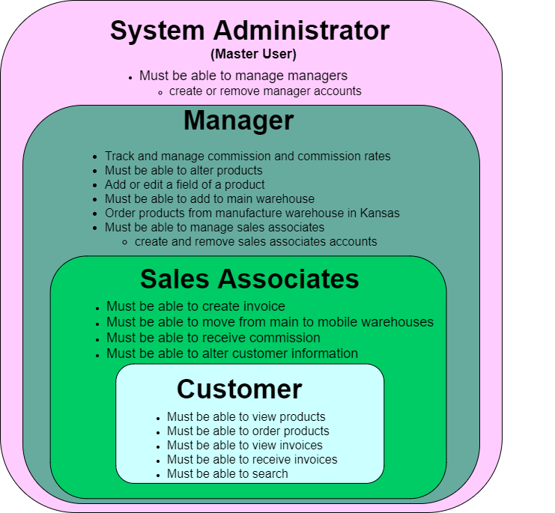

## **3.**3 Network **Requirements**

REQ 3.3.1: The application must be hosted on a cloud service.

DESC: Specific cloud provider does not matter.

REQ 3.3.2: The application must be a web application.

REQ 3.3.3: The application must utilize a database.

DESC: Specific database engine does not matter.

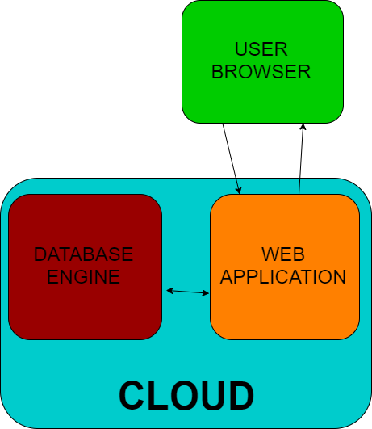

## **3.**4Error Handling Requirements

REQ 3.4.1: The system must handle invalid database inputs without crashing the system.

DESC: For example: Cost of item cannot be letters

REQ 3.4.2: The System must handle invalid text file inputs without crashing the system.

DESC: For example: improperly formatted text files should return a proper error when a user attempts to enter it.

## **3.**5Security Requirements

REQ 3.5.1: The system must have user authentication.

DESC: Such as password protected accounts

## **3.**6Input **Requirements**

REQ 3.6.1: The system must allow input through brower interaction.

REQ 3.6.2: The system must allow input of a text file

## **3.**7 Output Requirements

REQ 3.7.1: The system must allow output of a text file

REQ 3.7.2: The system must allow email of a text file

# 4. Appendices

## 4.1 Definitions, Acronyms, and Abbreviations

|  |  |
| --- | --- |
| **Term** | **Definition** |
| cloud computing | The use of remote, rather than local servers to store and manage data. This application can be installed on a remote server and accessed by any user with an internet connection. |
| frontend | Pieces of software concerning the presentation directly accessed by the user |
| backend | The piece of software running on the server that communicates database information to the browser |
| database | A structured and accessible data set stored on the server. The database contains information about users and their roles, and also inventory status. |
| invoice | A human-readable statement itemizing goods sold, the amount due, the customer and the sales associate making the sale. |
| client-server model | An application structure that partitions tasks between the provider of a resource (server) and the requester (client). |
| commission | A percentage of sales paid to the salesman as compensation |
| system administrator | A user with privileges that include the creation and modification of other user accounts. He will be the master user. |
| user role | A set of access restrictions that vary by the type of user. |
| unique ID | A unique computer generated number used for indexing. Inventory items and transactions are both identified with unique ID numbers. |
| user interface | The presentation that users access and directly interact with |
| web-based | Software used over the internet with a web browser |
| warehouse | A collection of inventory items. This includes inventory groups not necessarily in a physical warehouse, such as items in a salesman’s van. |
| data fields | A place for storing data; commonly a column in a database or an entry field in a data entry form |
| stakeholder | The client requesting the product, and additional investors |
| master user | Will have all permissions granted to interact directly with the database. |
| REQ | Short term for requirement |
| DESC | Short for description |

## 4.2 Contributions

Contributions were done collaboratively by all members having input of all aspects of the documentation.