Samantha Miller  
25 October 2017  
CPSC-430

Usability Study

**Section 1: Example Users**

The paragraphs below details three example users for the system.

Javier, a Latino man in his 40s, works at the warehouse in Ashland as a salesman. He transports products from the main warehouse and sells them to local garages in his district in Caroline county. He moved to America when he was a child, so he speaks with a small with a slight accent, but he reads and writes both English and Spanish well. A man who works with his hands, he used computers a bit in school, and later to do his job, using Microsoft Word and Excel upon occasion, and the Internet for browsing, he doesn’t have a lot of technical experience using complex programs. He can take a part your car blindfolded, but if something doesn’t make sense on the site, he’s easily frustrated, especially if he’s in front of customers. He’ll enjoy having an easily accessible listing of inventory in his mobile warehouse, and easy invoice generation to be confident selling merchandise with charm to satisfy his customers.

Tasha, a black woman in her late 50s, is the warehouse manager and one of the stakeholders of the company. She receives the main warehouse inventory and its flow and sale via the mobile warehouses. She likes the numbers, being efficient at her job, and ensuring that all inventory numbers and sales match up. She’s become pretty tech-savvy, working administrative and budgeting jobs most of her life, but she doesn’t want to receive training to figure out how to use a tool. She just wants simplicity: add and update inventory, list available inventory, create invoices as needed, and track her company’s success through reporting metrics. Updating employees and vans would be helpful as well, to keep the system current with personnel and resource changes.

Joanne, a white woman in her mid-sixties, is the company’s technology administrator. She runs a one-woman consulting shop that contracts technology support to local small businesses. Since she’s only contracted part-time, she’d like a software application that provides administrative support for the warehouse that is stable and doesn’t break easily, because it will cost her customer more to fix it and take time from her other contracts. She needs to oversee all user functionalities, like invoices, product search, and product imports, to ensure all are working in good order without taking the time to train and provide support to the warehouse employees.

**Section 2: User Model**

**a. System Overview.** The application provides inventory management and sales support to a BG sales group in the greater Richmond area. The client has a main warehouse in Ashland, Virginia and approximately seven “mobile warehouses” that visit local auto shops to sell BG automotive fluids and accessories. The application should allow for company employees to import warehouse inventory to the main warehouse as well as transfer product among warehouses. Employees should be able to search for the products the company has in stock as well as create sales invoices (like a sales record) when a sale is made. Managers also want to manage employee and warehouse accounts and create reports based on the sales per each employee for a given time period.

**b. Selected Feature and Focus Group 1.** This usability study has selected the Product Search functionality for feedback.

Paul: The search should have text boxes with key descriptors with a range of possibilities to search, like name and serial number, with a submit button to search the inventory. Returned list should have the number in stock and location as a list below the search parameters. No restrictions.

Chris: Track where the products are across the system. Have a keyword search like google, and item codes and names for lookup. Returned list of items with detailed information showing narrow, common keywords, product number, description/name, location, and number of units. Offer to request if the search is not found. No restrictions.

Jeff: It should have a listing by different types of product: different additives, antifreeze, power steering fluid, etc. The inventory search should list the product information and the warehouses found. No restrictions. No restrictions.

Julie: There should be more than one way to search, not necessarily by product number. Keyword search returns all related items and narrow by categories using selections. Warehouses could be selectable in a drop-down menu. Searching for types of products would list all information for that type. All results would should have availability in quantity and location, price. Buttons to request an order, price, add to cart and check out for invoice generation would be helpful. Even nicer would be color-coded availability by warehouse which updated as products were moved. No restrictions.

**c. User Model.** This user model shall demonstrate the “best case” scenario, if funding, time, and resources were available to implement it. Based on focus group feedback, the user model for Search should be simple and easily to use. Users feel more confident and empowered to use the tool successfully when there are just enough options to find what they need. The Search page should provide product number and keyword search fields and potentially filter options for product types. The page should update with the results of the search, listing complete product information, locations and quantities. Additionally, displaying related search terms, and options to add item to cart and generate the items as an invoice, and requesting new product would be “nice-to-haves” for ease of use. Additional color-coding features for identifying warehouses would be helpful. No one in the focus group had any thoughts to limitations on the search because accessibility helps the employees use the tool successfully.

**Section 3: Prototype**

Based on the feedback for the first focus group, I created the mockup below. Figure 1 represents the best-case scenario for the model. Figure 2 represents the current implementation.

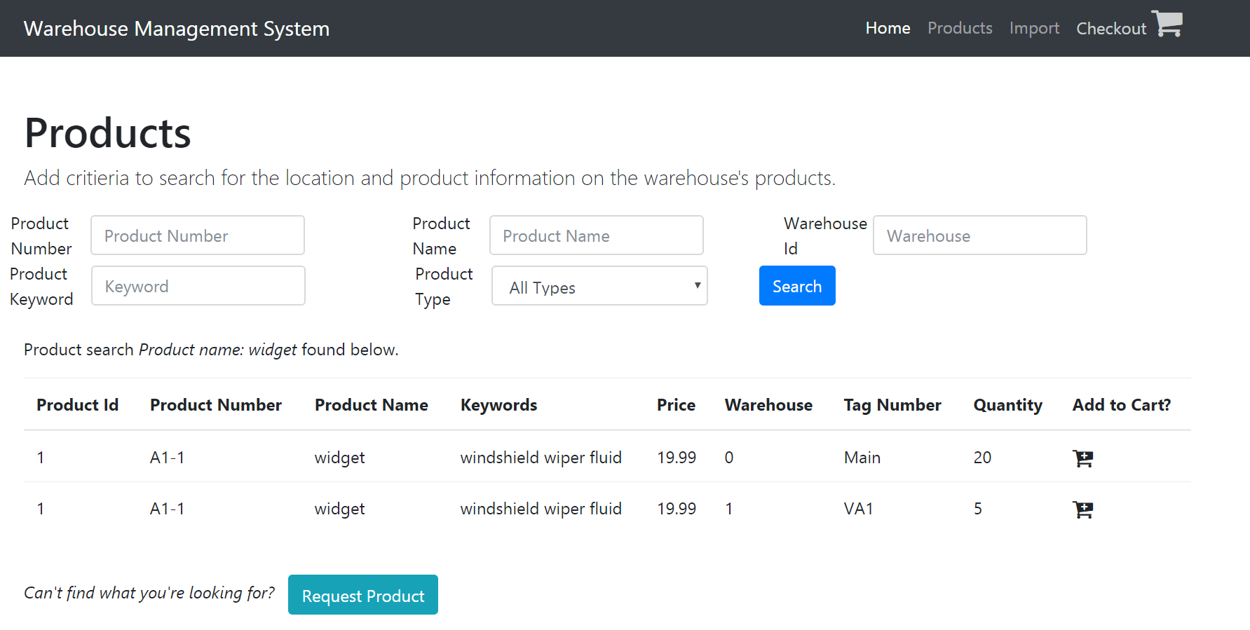

Figure 1. Best-Case Scenario

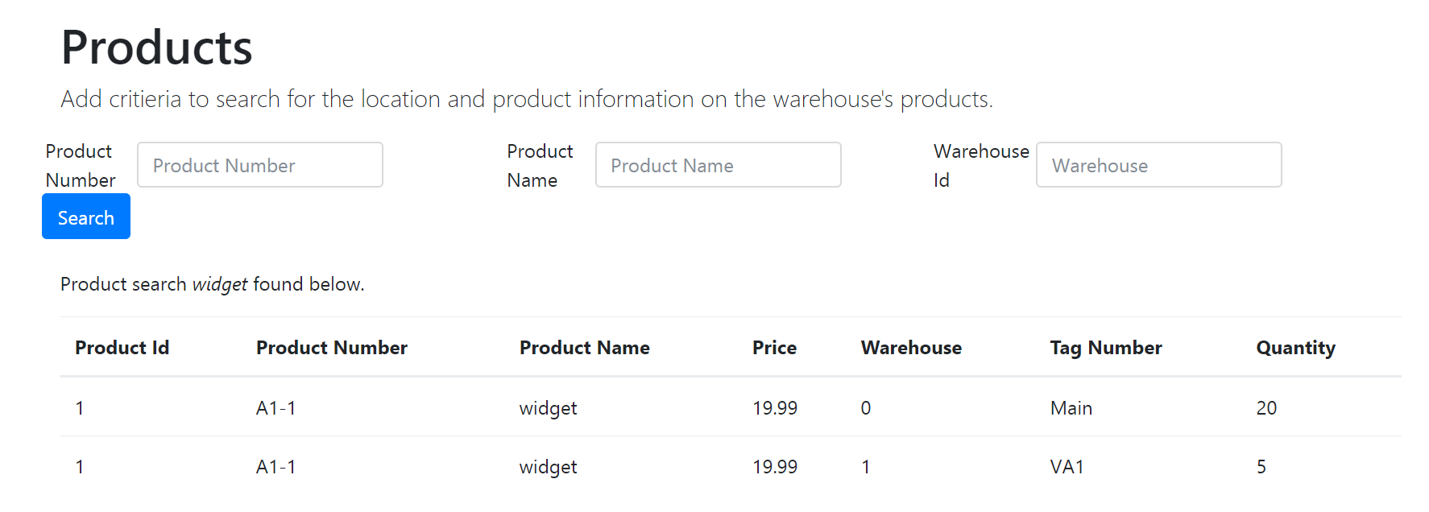

Figure 2. Current Implementation

**Section 4: Focus Group 2 Feedback**

**a. Prototype comments.** Each focus group member was shown the first figure, asked what they thought, if they could successfully use it, and provide any additional feedback on it.

Paul: The “Add to Cart” feature is very intuitive. I could easily fill this search out, know what to add in, and search. “Warehouse 0” is weird, normal people don’t start counting at 0. Otherwise, the tool is intuitive and familiar. “Request Product” feature is helpful. Creating an invoice via the cart is intuitive. The second figure has less options, but has the same intuitive interface to search and list products.

Chris: Figure 1 makes sense. I could add to the cart and check out items. It might be helpful to simplify the product fields to one field and search but more/less fields could be argued either way. No training required and the drop-down is a nice touch. Extra fields could be inhibiting, but easily adaptable. Figure 2 is still easy to use. An employee would know the names and numbers. Simple version still makes sense.

Brad: Could definitely figure both our and use them. They both do what needs to be done. Sorting each column would be nice.

Julie: Figure 1 is basic, not too many bells and whistles. Liked the Request Product feature and the form has everything expected. Misses the keywords in Figure 2, which is still functional but clunkier by missing the other features. Cart and Request Product functionality is missed, it would be a quick form and done.

**b. Reflection.** All the feedback is quality. It felt good that my mockups were not far from the mark expected from my focus groups. I really like the ideas expanded in the first mockup, especially the cart and checkout features added by the first focus group. The focus group members related strongly to the salesmen using the tool and wanted to make it as easy to use as possible, from every level. I think they all enjoyed the high-level (numbers and names) and low-level (keywords and types) searches, refinements, ability to request product and cart functionality. However, I think the customer expects a level of familiarity with the product that this focus group does not have with BG automotive fluids to know what to look for in the search. I think the mockups were successful since all focus group members found them accessible and easy-to-use. Unfortunately, we do not have enough time to implement these ideas, but I definitely enjoyed the feedback.

**Section 5: Changes**

I added the sorted options to the interface so that it’s sorted by product number and organization. Due to the time constraint, since the page is functional, I will not implement any other changes at this time.