CIS581 Project 3
Joseph Trovato

My implementation of project 3 includes several features that grader and users should be aware of. My implementation is different from the specifications in that it allows the user to specify a reference image in which it will match each other image to this image and when stitching the reference image remain untransformed. This allows the user to produce a panorama around a point of interest. To run this implementation run the proj3_ref_img.m script which calls the mymosaic.m function. The flaw of this implementation is that is cannot handle long strings of images; it requires a central image that all other images can be amtched to. I also implemented the in-order matching and stiching procedure, which was outlined in the project guidelines. I found this gave me worse results as the reference image was usually the end image and caused the panorama to be disproportionate. To run this implementation run proj3_ordered.m which calls mymosaic_ordered.m.

My results for the reference image implementation are below. I used some pictures from a trip I took this summer. Because I was not concerned about taking pictures with either translation or rotation of the camera and not both, I could only get two images to match. If you would like to see it on more, see the extra images provided or run the script on the test images.

Original Images:

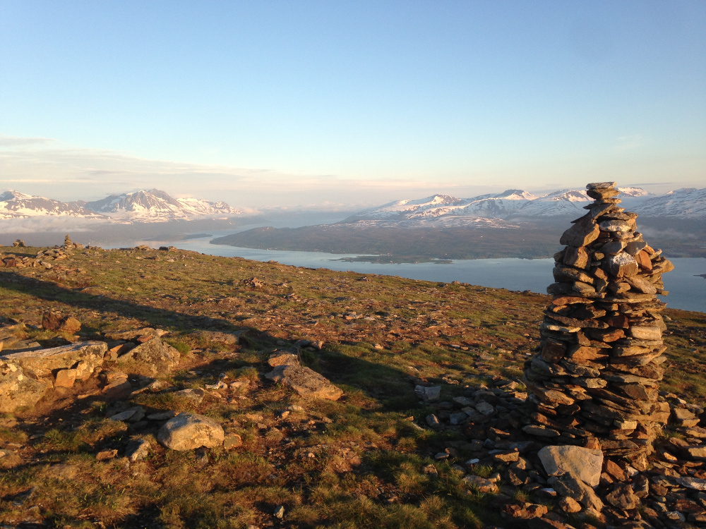
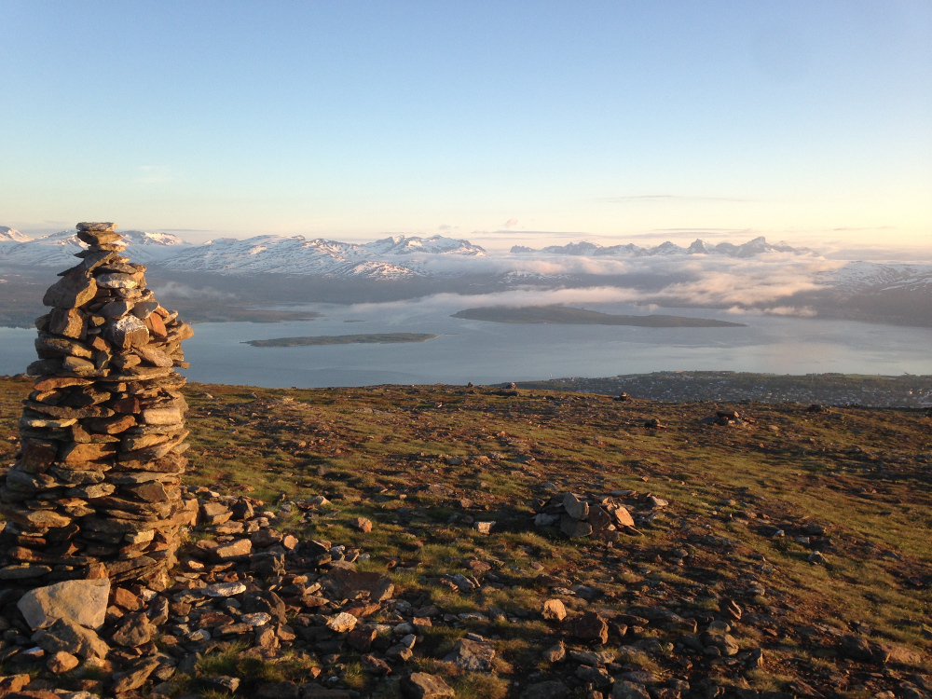

Corner Detection and Adaptive Non-Maximum Supression:

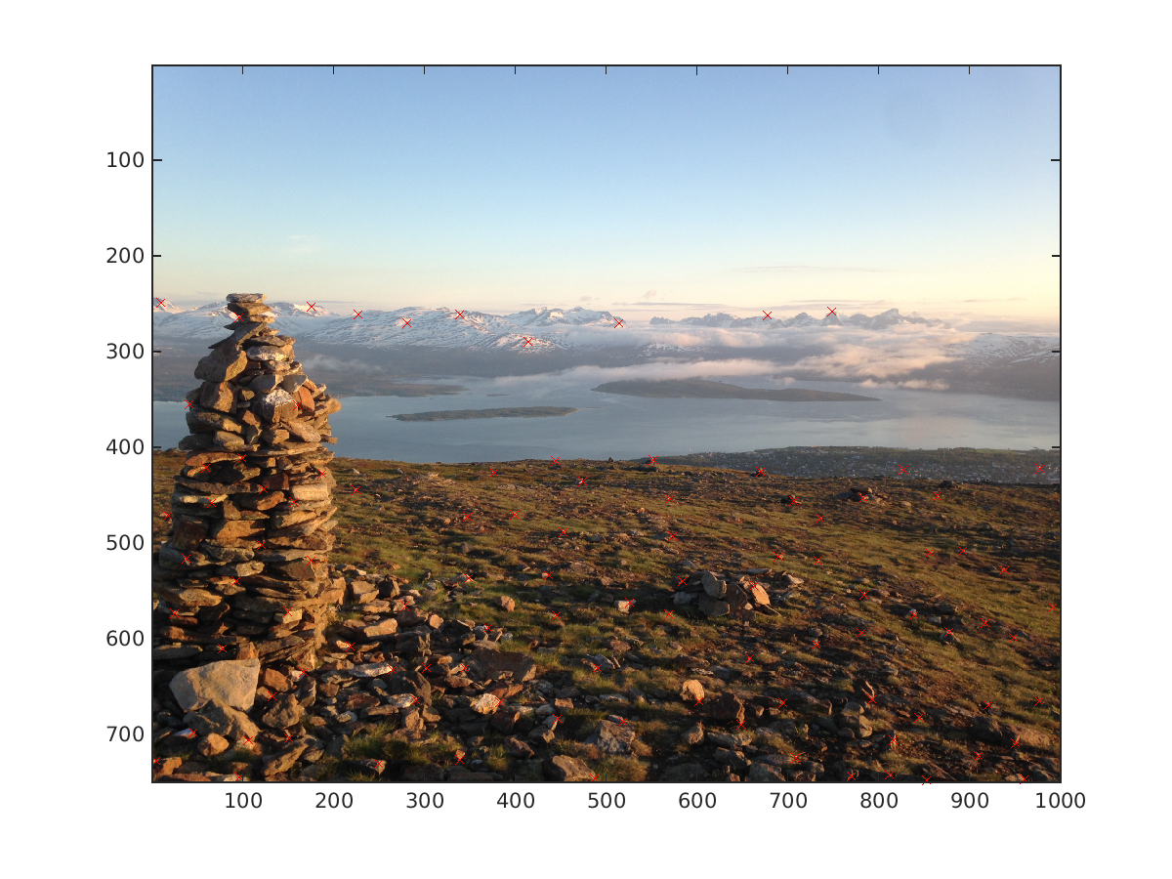
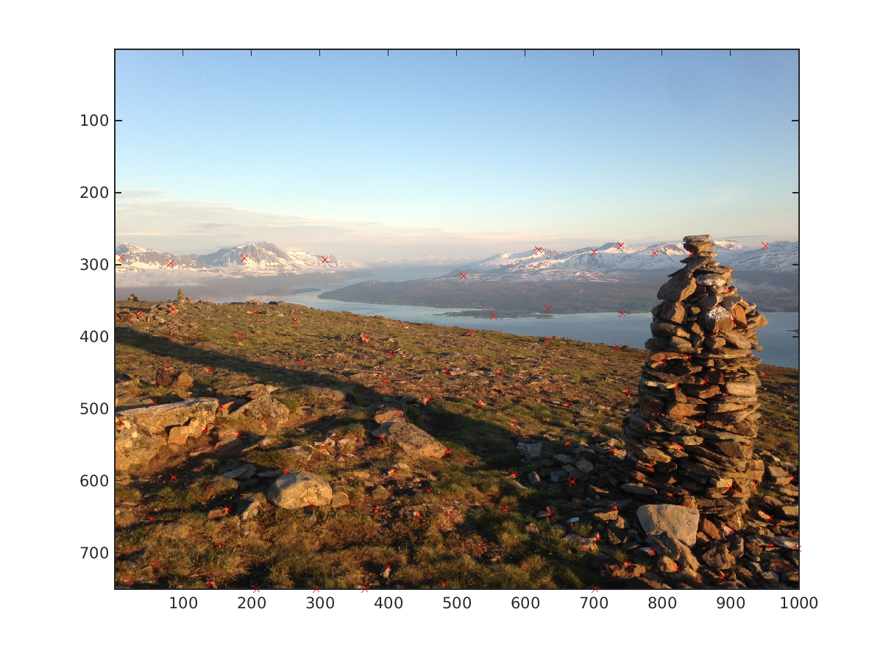

Pre-RANSAC feature matching:

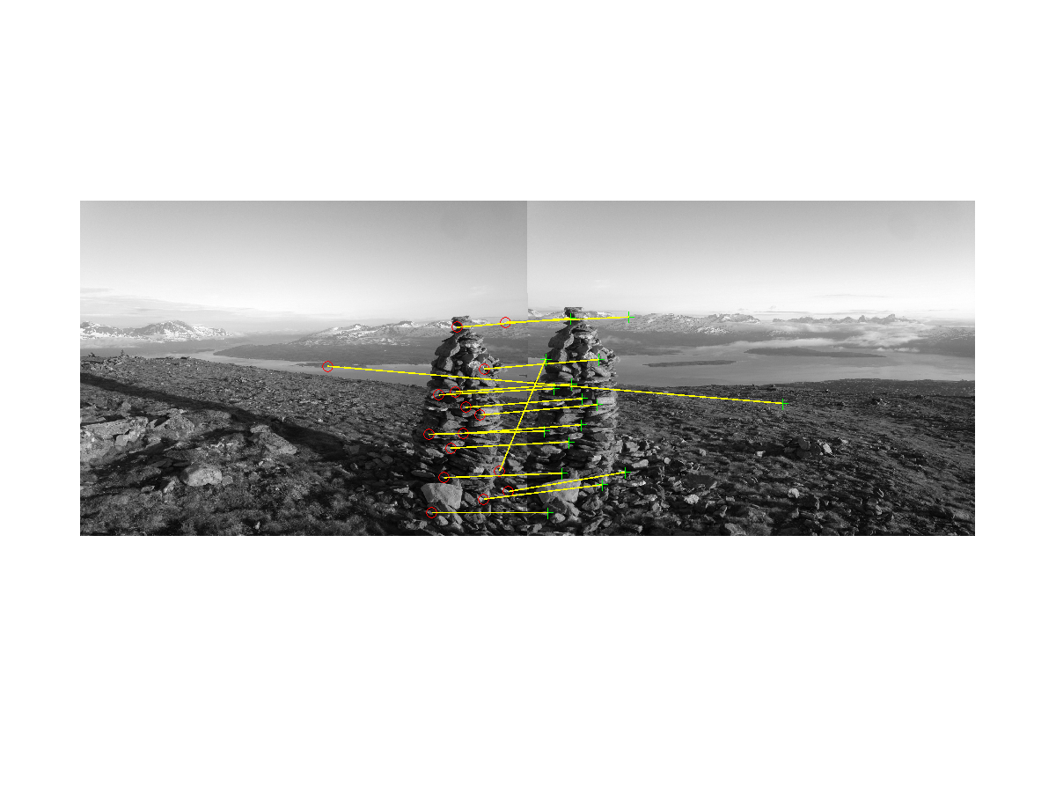

Post-RANSAC feature matching:

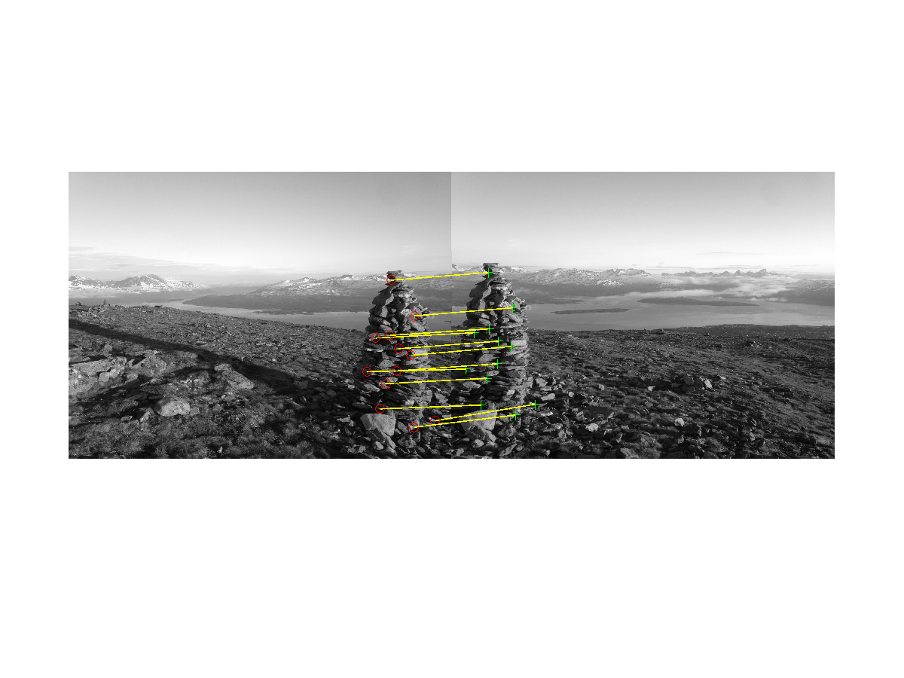

Final Result:

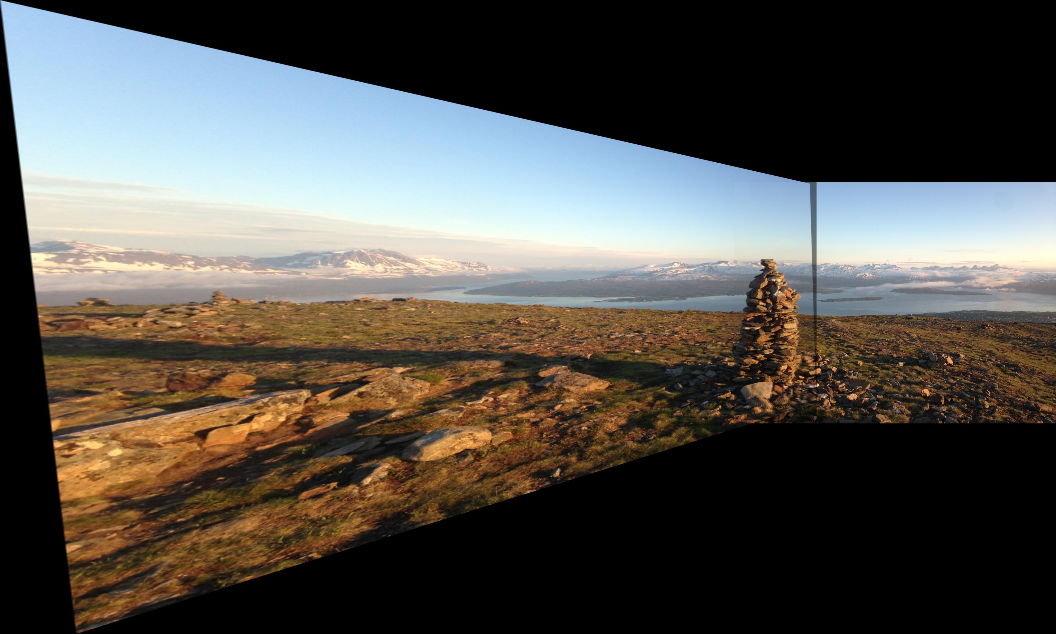

I have also included some of my other results; most are pictures of my trip but I saved the test script images as well to show you the results with three images.



