MsCV2 RTIC

Lab2 : State Machine

Describes the following state machine :

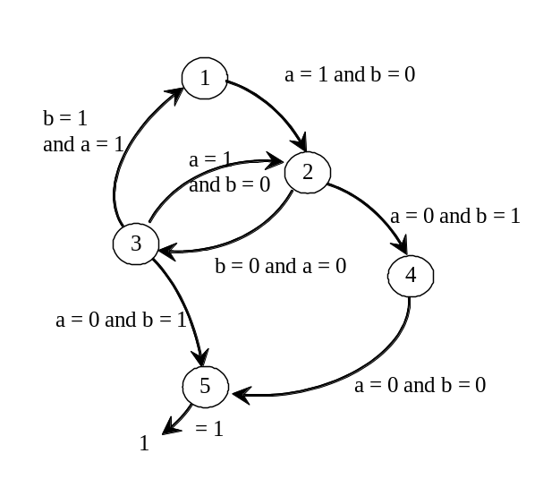
The state should be synchronous (CLK used as clock input) and should got an asynchronous reset input (named reset and active at high level). During the reset, the internal state should point on the State 1.
The two input a and b are coded on one bit. The output named S1 and S2 are coded on one bit and are defined as follow:
S1 = ‘1’ for State3 and State4 S1 =’0’ for other states
S2 =’1’ for State 4 S2 =’0’ for other states

Design the three following solutions:
1) Moore

2) One Hot Bit State machine

3) Decoded state machine

