## 1.3 Results

During 2019-2020, we captured 30 tuco-tucos, 20 females and 10 males. Each tuco-tuco received a biologging collar, mostly containing an accelerometer and a lightlogger. We were able to recapture 24 tuco-tucos and recover 21 collars (Table ??). One collar was lost because one tuco-tuco got predated and the collar was found malfunctioning. The other two lost collars fell or were taken out of the tuco’s neck between the time of capture and recapture. All 21 animals that were recapture received a collar containing an accelerometer. However, only 13 also received a lightlogger (Table ??). In total, we have 13 complete datasets, with acceleration and light exposure data, and 8 datasets with only acceleration data.

### 1.3.1 Daily Activity Levels across seasons

Tuco-tuco’s daily activity levels (24h average), measured by VeDBA, are significantly different across the year (ANOVA; F = 7.182, p < 0.01; Fig. 1.3). Post hoc comparisons using Tukey-Kramer’s Test shows significant group differences between July-October and July-February (p < 0.05). In both pairwise comparisons daily VeDBA in July levels are lower, showing a difference in means of 0.029g and 0.019g in comparison to October and February, respectively. In sum, daily VeDBA activity levels are lower in July in comparison to October and February (Fig 1.3).

* Tirar?:

The daytime VeDBA (Light Phase Average) is also significantly different between Months (ANOVA; F = 7.282, p < 0.001). Post hoc comparisons using Tukey-Kramer’s Test shows a difference in mean of 0.035 between October-July (p < 0.05). However, daytime activity levels are only significantly different between July and October.

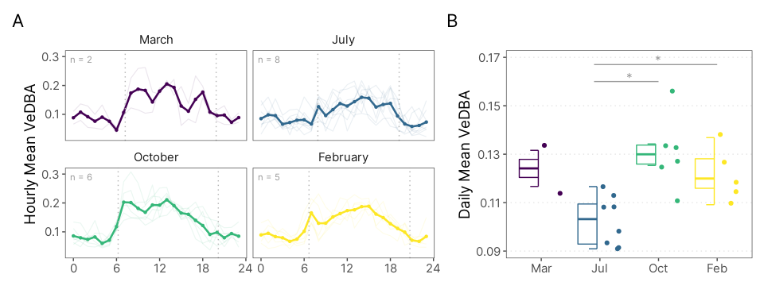

Figure 1.3: Tuco-tuco’s Daily VeDBA levels. (A) VeDBA was binned by hour (0-23). Background lines show data for individual animals. Thick lines show mean hourly VeDBA. (B) Points show daily (24h) VeDBA mean for each animal. In July Tuco-tuco’s exhibited lower Daily VeDBA than October and February. Dashed lines in Panel A shows time of civil dawn and dusk.

### 1.3.2 Activity State Classification

We modeled and classified VeDBA into three distinct behavioral states using Hidden Markov Models (HMM). We fitted two different models, one empty model, with no covariates, and a second one with *‘season’* as a covariate in the transition probability matrix. The second model was selected based on informational criterion ($Δ$ AIC > 2; REF Tabela AIC nos supps).

The estimated state-dependent distributions are shown in Figure 1.4. We interpreted and labelled these states as ‘rest,’ ‘medium intensity activity,’ and ‘high intensity activity’ corresponding to low, intermediate and high VeDBA values respectively. The marginal distribution (Fig. 1.4; dashed line) has a good correspondence to the empirical VeDBA distribution (Fig. 1.4, histogram). A visual analysis of the pseudo-residuals (See Appendix; REF) shows that the residuals deviate from the expected normal distribution, especially in the lower end values, and that there is still significant residual autocorrelation. Nevertheless, the overall fitting seems to be reasonable. The estimated state-dependent parameters are shown in the Appendix (Table ??).

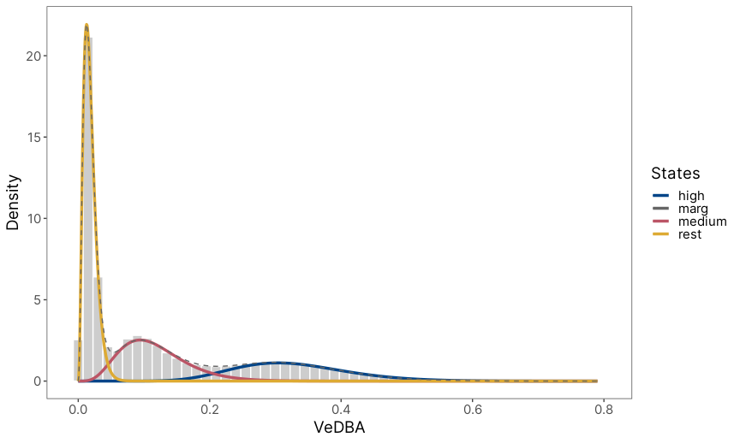

Figure 1.4: State-dependent distributions of the selected Hidden Markov model fitted to the VeDBA acceleration metric. Histogram, in grey, shows the Vectorial Dynamic Body Acceleration (VeDBA) from the data of 21 Anillaco’s tuco-tuco. State-dependent gamma distributions are shown above the histograms. These distributions are weighted accordingly to the proportion of observations assigned to each state.

We labelled VeDBA data using the Viterbi algorithm. With the state-labeled data we were able to dissociate and visualize the daily patterns of each different state. Actograms and time series plot, classic forms of data visualization in chronobiology. show how the different states are related to the calculated VeDBA (Fig 1.5). Visual analysis of diel rhythms in VeDBA and in the state-labelled data indicates the daily rhythm is more robust in the High Activity state in comparison to Medium Activity. However, despite being more concentrated during the daylight hours, High Activity episodes also occur sporadically during the night. Medium Activity, in turn, seems to be more disperse throughout the day with no clear daily rhythm. Individual Actograms for VeDBA and state-labelled data are presented in the Appendix (Figure ??).

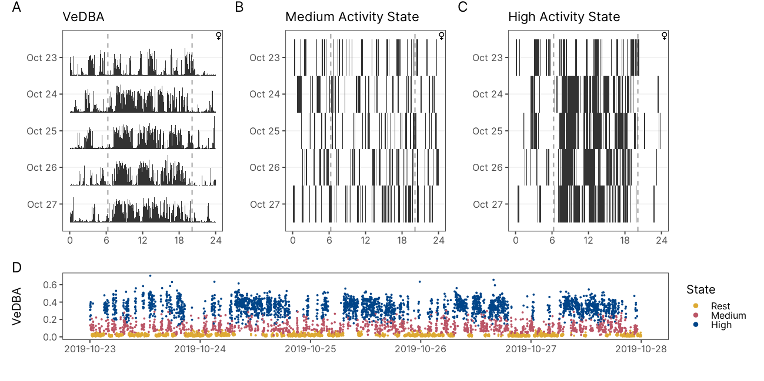

Figure 1.5: Actograms and Time Series Plot of VeDBA and state-labelled data of a representative animal (ID:OCT09). The actograms shows daily patterns of VeDBA (A) and of Medium and High State occurrences (B and C). Medium Activity State shows no clear pattern of a daily rhythm. High Activity is disperse throughout the day with a higher concentration during daylight hours. The time series (D) shows state-labelled VeDBA data. Dashed lines shows time of dawn and dusk.

### 1.3.3 Daily Time-Activity Budgets

On average, tuco-tucos spent between 45-50% of the 24 hours in the Rest State, depending on the month. ANOVA test shows no statistical difference between the percentage of time spent resting between groups (ANOVA; F = 1.93, p = 0.163).

Tuco-tucos spent a variable percentage of their daily active time in one of the two active states, High or Medium Activity, across seasons. Daily time spent in High Activity was lower in July (15.8%) and higher in October (29.4%; ??). In contrast, daily time spent in a Medium Activity State was higher in July (34.1%) and lower in October (24.8%). There is a significant difference in the percentage of time spent in Medium (Fig. 1.6; ANOVA: F = 4.457, p = 0.0175) and High Activity State across seasons (Fig. 1.6; ANOVA: F = 13.62, p = < 0.001). Tukey’s post hoc test shows that the mean percentage of time spent in the Medium Activity State is 9% lower in October than in July (p = 0.01). For the High Activity State, pairwise Tukey’s test shows a significant difference between October-July (p < 0.001) and February-July (p < 0.01). In comparison to July the mean daily percentage of time spent in a High Activity State is 13% higher in October and 8% higher in February (Fig. 1.6).

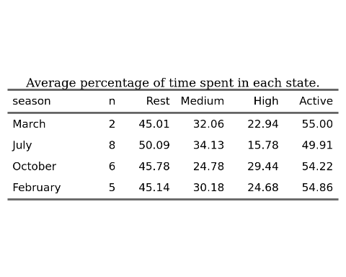

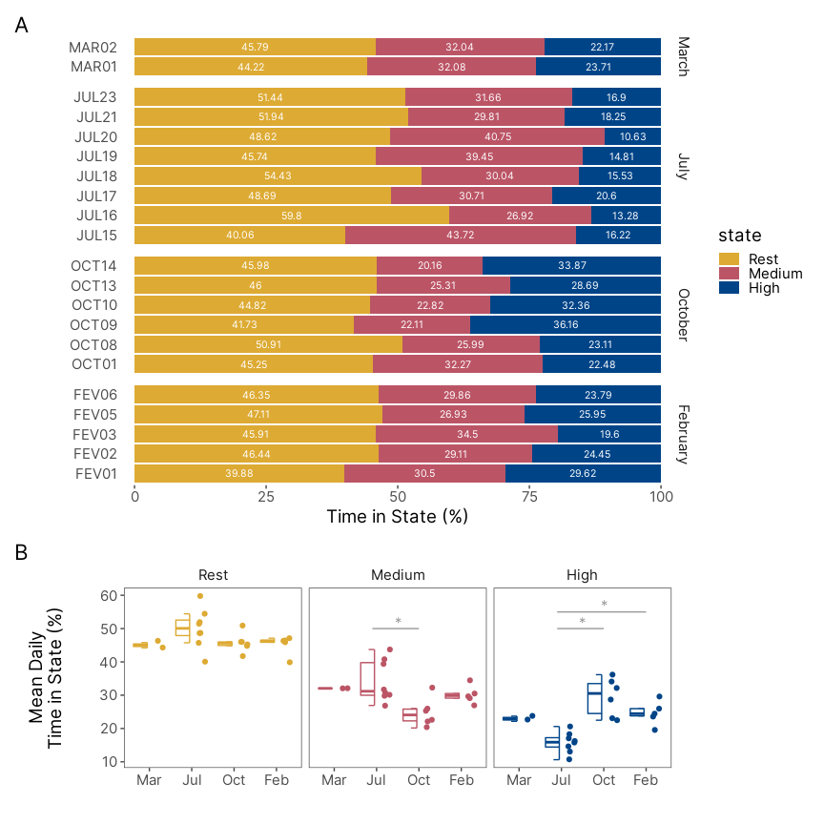

Figure 1.6: Daily time-activty budgets for the behavioral states. (A) Percentage of time spent in each behavioral state per animal. (B) Distribution of the mean percentage of time spent in each behavioral state calculated by animal. The mean pecentage of time spent in the High Activity State is lower in July in comparison to October and February. The mean percentage of time spent in the Medium Activity State, however, is higher in July in comparison with October.

### 1.3.4 Daily Activity Patterns

Daily activity rhythms for each behavioral state are shown in Figures REF. These plots show that, qualitatively, the timing of occurrence of High Activity and Light Exposure episodes follow a diurnal pattern. Medium Activity, however, is spread out along the 24h and do not follow a daily (24h) rhythm. It is important to note that the timing of peak occurrence of High Activity behavior does not appear to change dramatically along the year. In all four Months the peak of High Activity seems to be around 14:00. In turn, Light Exposure patterns changes along the year. In July, the peak of episodes of light exposure is more concentrated in the middle of the day. In other seasons the peak of Light Exposure episodes appears to be bimodal, with a higher peak in the first hours of daylight and a much smaller peak at the end of daylight.

* calculate peak
* adicionar linha do meio dia solar

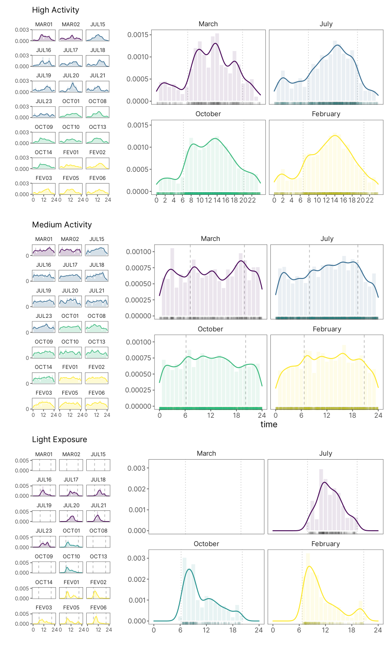

Figure 1.7: Density estimate of daily activity patterns of tuco-tucos’ behavioral states. Solid lines indicate the Gaussian kernel density estimates. Light-colored bars show observed distribution of each behavioral state occurrence. Rug lines above the x-axis shows individual occurrences. Dotted vertical lines show time of civil twilights. High Activity State shows a diurnal pattern independent of the time of the year. Medium Activity State shows no daily pattern. Light Exposure shows a diurnal rhythm that changes according to the season.

### 1.3.5 Diurnality

Only the High Activity State behavior is predominately diurnal. The average diurnality index for the High Activity State is higher than 70% for all seasons (Table @ref:(tab:table-mean-time-in-state)). Medium Activity is evenly spread out along the 24h with a diurnality that ranges from 50% in March to 56% in July and February (Table @ref:(tab:table-mean-time-in-state)). The Rest State is predominantly nocturnal with Diurnality lower than 38% for all season. An ANOVA test show no difference in the mean diurnality between Months for each state (Figure 1.8.

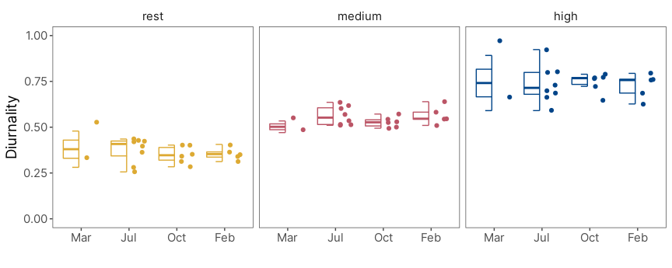

Figure 1.8: Distribution of each state’s diurnality index. Only the High Activity State is predominantly diurnal. High Activity State had an average diurnality greater than 70% across all seasons.

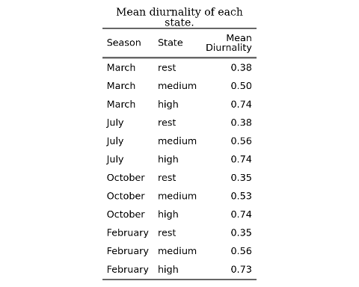

# 2 Rhythmicity

(…)

## 

# References

Placeholder

Abraham, E., H.F. del Valle, F. Roig, L. Torres, J.O. Ares, F. Coronato, and R. Godagnone. 2009. “Overview of the Geography of the Monte Desert Biome (Argentina).” *Journal of Arid Environments* 73 (2): 144–53. <https://doi.org/10.1016/j.jaridenv.2008.09.028>.

Amaya, Juan Pablo, Juan I. Areta, Veronica S. Valentinuzzi, and Emmanuel Zufiaurre. 2016. “Form and Function of Long-Range Vocalizations in a Neotropical Fossorial Rodent: The Anillaco Tuco-Tuco ( *Ctenomys* Sp.).” *PeerJ* 4 (October): e2559. <https://doi.org/10.7717/peerj.2559>.

Aranda-Rickert, Adriana, and Sebastián Fracchia. 2011. “Pogonomyrmexcunicularius as the Keystone Disperser of Elaiosome-Bearing Jatropha Excisa Seeds in Semi-Arid Argentina: Pogonomyrmex Cunicularius Ants as Keystone Seed Dispersers.” *Entomologia Experimentalis Et Applicata* 139 (2): 91–102. <https://doi.org/10.1111/j.1570-7458.2011.01111.x>.

Bivand, Roger, and Nicholas Lewin-Koh. 2020. “Maptools: Tools for Handling Spatial Objects.” <https://CRAN.R-project.org/package=maptools>.

Burnham, Kenneth P., David Raymond Anderson, and Kenneth P. Burnham. 2002. *Model Selection and Multimodel Inference: A Practical Information-Theoretic Approach*. 2nd ed. New York: Springer.

Fracchia, S., L. Krapovickas, A. Aranda-Rickert, and V.S. Valentinuzzi. 2011. “Dispersal of Arbuscular Mycorrhizal Fungi and Dark Septate Endophytes by Ctenomys Cf. Knighti (Rodentia) in the Northern Monte Desert of Argentina.” *Journal of Arid Environments* 75 (11): 1016–23. <https://doi.org/10.1016/j.jaridenv.2011.04.034>.

Jannetti, Milene G., C. Loren Buck, Veronica S. Valentinuzzi, and Gisele A. Oda. 2019. “Day and Night in the Subterranean: Measuring Daily Activity Patterns of Subterranean Rodents (Ctenomys Aff. Knighti) Using Bio-Logging.” *Conservation Physiology* 7 (1). <https://doi.org/10.1093/conphys/coz044>.

Langrock, Roland, Ruth King, Jason Matthiopoulos, Len Thomas, Daniel Fortin, and Juan M. Morales. 2012. “Flexible and Practical Modeling of Animal Telemetry Data: Hidden Markov Models and Extensions.” *Ecology* 93 (11): 2336–42. <https://doi.org/10.1890/11-2241.1>.

Leos-Barajas, Vianey, Theoni Photopoulou, Roland Langrock, Toby A. Patterson, Yuuki Y. Watanabe, Megan Murgatroyd, and Yannis P. Papastamatiou. 2017. “Analysis of Animal Accelerometer Data Using Hidden Markov Models.” Edited by Robert B. O’Hara. *Methods in Ecology and Evolution* 8 (2): 161–73. <https://doi.org/10.1111/2041-210X.12657>.

McClintock, Brett T., Roland Langrock, Olivier Gimenez, Emmanuelle Cam, David L. Borchers, Richard Glennie, and Toby A. Patterson. 2020. “Uncovering Ecological State Dynamics with Hidden Markov Models.” Edited by Tim Coulson. *Ecology Letters* 23 (12): 1878–1903. <https://doi.org/10.1111/ele.13610>.

McClintock, Brett T, and Theo Michelot. 2021. “momentuHMM: R Package for Analysis of Telemetry Data Using Generalized Multivariate Hidden Markov Models of Animal Movement,” 155.

Michelot, Theo, and Roland Langrock. 2019. “A Short Guide to Choosing Initial Parameter Values for the Estimation in moveHMM,” 10.

Papastamatiou, Yannis P., Yuuki Y. Watanabe, Urška Demšar, Vianey Leos-Barajas, Darcy Bradley, Roland Langrock, Kevin Weng, Christopher G. Lowe, Alan M. Friedlander, and Jennifer E. Caselle. 2018. “Activity Seascapes Highlight Central Place Foraging Strategies in Marine Predators That Never Stop Swimming.” *Movement Ecology* 6 (1): 9. <https://doi.org/10.1186/s40462-018-0127-3>.

Patterson, Toby A., Marinelle Basson, Mark V. Bravington, and John S. Gunn. 2009. “Classifying Movement Behaviour in Relation to Environmental Conditions Using Hidden Markov Models.” *Journal of Animal Ecology* 78 (6): 1113–23. <https://doi.org/10.1111/j.1365-2656.2009.01583.x>.

Pohle, Jennifer, Roland Langrock, Floris M. van Beest, and Niels Martin Schmidt. 2017. “Selecting the Number of States in Hidden Markov Models: Pragmatic Solutions Illustrated Using Animal Movement.” *Journal of Agricultural, Biological and Environmental Statistics* 22 (3): 270–93. <https://doi.org/10.1007/s13253-017-0283-8>.

Qasem, Lama, Antonia Cardew, Alexis Wilson, Iwan Griffiths, Lewis G. Halsey, Emily L. C. Shepard, Adrian C. Gleiss, and Rory Wilson. 2012. “Tri-Axial Dynamic Acceleration as a Proxy for Animal Energy Expenditure; Should We Be Summing Values or Calculating the Vector?” *PLOS ONE* 7 (2): e31187. <https://doi.org/10.1371/journal.pone.0031187>.

R Core Team. 2020. “R: A Language and Environment for Statistical Computing.” [https://www.R-project.org/.](https://www.R-project.org/)

Shepard, Elc, Rp Wilson, Lg Halsey, F Quintana, A Gómez Laich, Ac Gleiss, N Liebsch, Ae Myers, and B Norman. 2008. “Derivation of Body Motion via Appropriate Smoothing of Acceleration Data.” *Aquatic Biology* 4 (December): 235–41. <https://doi.org/10.3354/ab00104>.

Tomotani, Barbara M., Danilo E. F. L. Flores, Patrícia Tachinardi, José D. Paliza, Gisele A. Oda, and Verônica S. Valentinuzzi. 2012. “Field and Laboratory Studies Provide Insights into the Meaning of Day-Time Activity in a Subterranean Rodent (Ctenomys Aff. Knighti), the Tuco-Tuco.” Edited by Ralph E. Mistlberger. *PLoS ONE* 7 (5): e37918. <https://doi.org/10.1371/journal.pone.0037918>.

Valentinuzzi, Verónica Sandra, Gisele Akemi Oda, John Fontenele Araújo, and Martin Roland Ralph. 2009. “Circadian Pattern of Wheel-Running Activity of a South American Subterranean Rodent ( *Ctenomys Cf Knightii* ).” *Chronobiology International* 26 (1): 14–27. <https://doi.org/10.1080/07420520802686331>.

van de Kerk, Madelon, David P. Onorato, Marc A. Criffield, Benjamin M. Bolker, Ben C. Augustine, Scott A. McKinley, and Madan K. Oli. 2015. “Hidden Semi-Markov Models Reveal Multiphasic Movement of the Endangered Florida Panther.” Edited by Tim Coulson. *Journal of Animal Ecology* 84 (2): 576–85. <https://doi.org/10.1111/1365-2656.12290>.

Williams, Cory T., Kathryn Wilsterman, Amanda D. Kelley, André R. Breton, Herbert Stark, Murray M. Humphries, Andrew G. McAdam, Brian M. Barnes, Stan Boutin, and C. Loren Buck. 2014. “Light Loggers Reveal Weather-Driven Changes in the Daily Activity Patterns of Arboreal and Semifossorial Rodents.” *Journal of Mammalogy* 95 (6): 1230–39. <https://doi.org/10.1644/14-MAMM-A-062>.

Zucchini, Walter, Iain MacDonald, and Roland Langrock. 2016. *Hidden Markov Models for Time Series - An Introduction Using R*. Vol. 43.