Personal Activities Project

Jennifer Tsou

3/10/2018

## Personal Activities Analysis

Download file and read it in

download.file('https://d396qusza40orc.cloudfront.net/repdata%2Fdata%2Factivity.zip', destfile = 'PD.zip')  
unzip('PD.zip')  
PD = read.csv('activity.csv')

## Import Data

head(PD)

## steps date interval  
## 1 NA 2012-10-01 0  
## 2 NA 2012-10-01 5  
## 3 NA 2012-10-01 10  
## 4 NA 2012-10-01 15  
## 5 NA 2012-10-01 20  
## 6 NA 2012-10-01 25

pairs(PD)

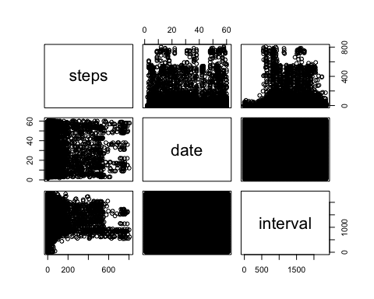

totalSteps = aggregate(steps ~ date, PD, sum)  
hist(totalSteps$steps, main = 'Total Steps per Day',xlab = 'Number of Steps', col='blue')

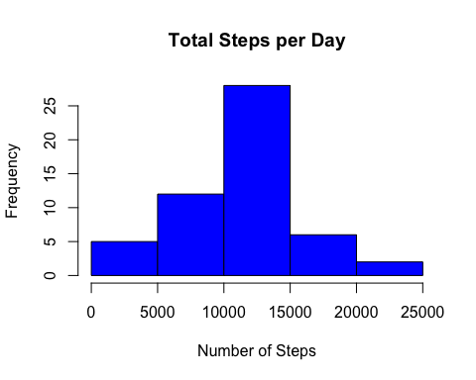

## Calculate and report the mean and median of the total number of steps taken per day

#mean  
mean(totalSteps$steps, na.rm = TRUE)

## [1] 10766.19

#median  
median(totalSteps$steps, na.rm=TRUE)

## [1] 10765

## What is the average daily activity pattern?

library(ggplot2)  
  
meanStep = aggregate( steps ~ interval, PD, mean)  
ggplot( aes(x=interval, y= steps), data=meanStep) +  
 geom_line()+   
 xlab('5-min interval') + ylab('Avg Number of Steps') + ggtitle('Average Daily Activity Pattern')

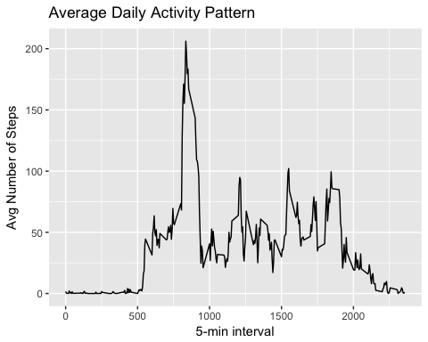

# Which 5-minute interval across all days contain the maximum number of steps  
meanStep[which.max(meanStep$steps),]

## interval steps  
## 104 835 206.1698

## Imputing missing values

Calculate and report the total number of missing values in the dataset (i.e. the total number of rows with NAs)

sum(is.na(PD$steps))

## [1] 2304

## Devise a strategy for filling in all of the missing values in the dataset. The strategy does not need to be sophisticated. For example, ## you could use the mean/median for that day, or the mean for that 5-minute interval, etc.

# find na positions to fill in  
na_pos = which(is.na(PD$steps))  
#use mean to fill in for that day  
vec = rep(mean(PD$steps, na.rm = TRUE), times = length(na_pos))  
PD[na_pos, 'steps'] = vec  
  
#compute total number of steps each day  
PDmeanDay = aggregate(steps ~date, PD,sum)  
  
hist(PDmeanDay$steps,  
 col = 'blue',  
 xlab = 'Total Number of Steps',  
 main = 'Histogram of Total Number of Steps taken each Day')

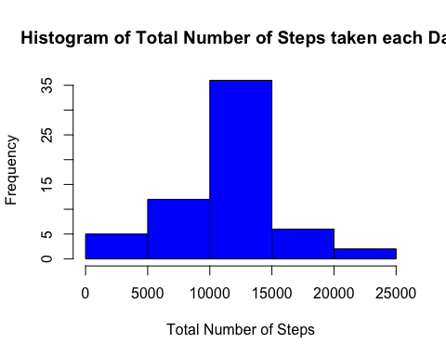

#mean  
mean(PDmeanDay$steps)

## [1] 10766.19

#median  
median(PDmeanDay$steps)

## [1] 10766.19

## Are there differences in activity patterns between weekdays and weekends?

#add days  
PD$date = as.POSIXct(PD$date, format="%Y-%m-%d")

## Warning in strptime(x, format, tz = tz): unknown timezone 'zone/tz/2018c.  
## 1.0/zoneinfo/America/Los_Angeles'

weekdays = (weekdays(PD$date))  
PD = cbind(PD, weekdays)  
PD = cbind(PD, daytype = ifelse(PD$weekdays =='Saturday'|  
 PD$weekdays == 'Sunday', 'Weekend','Weekday'))  
head(PD)

## steps date interval weekdays daytype  
## 1 37.3826 2012-10-01 0 Monday Weekday  
## 2 37.3826 2012-10-01 5 Monday Weekday  
## 3 37.3826 2012-10-01 10 Monday Weekday  
## 4 37.3826 2012-10-01 15 Monday Weekday  
## 5 37.3826 2012-10-01 20 Monday Weekday  
## 6 37.3826 2012-10-01 25 Monday Weekday

#Make a panel plot containing a time series plot (i.e. type = "l") of the 5-minute interval (x-axis) and the average number of steps taken, averaged across all weekday days or weekend days (y-axis).  
  
meanStepDay = aggregate(steps ~ interval+daytype, PD, mean)  
  
  
ggplot(meanStepDay, aes(x=interval, y= steps))+  
 geom_line(col ='blue') +  
 facet_grid(daytype ~.)+  
 ggtitle('Average Daily Activity Pattern')+  
 xlab('5-min Interval')+  
 ylab('Avg Number of Steps')

