**Computer Organization**

**1. The input fields of each pipeline register:**

**IF/ID:** {instr, PC_add1}

**ID/EX:** {ReadData1, ReadData2, signextend, PC_add1_id, ALUOP, RegDst, MemtoReg, RegWrite, ALUSrc, Branch, MemWrite, MemRead, instr_id[20:0]}

**EX/MEM:** {PC_add2, ALUResult, ReadData2_ex, zero, w2, MemtoReg_ex, RegWrite_ex, Branch_ex, MemRead_ex, MemWrite_ex}

**MEM/WB:** {ALUResult_mem, DM_ReadData, w2_mem, MemtoReg_mem, RegWrite_mem}

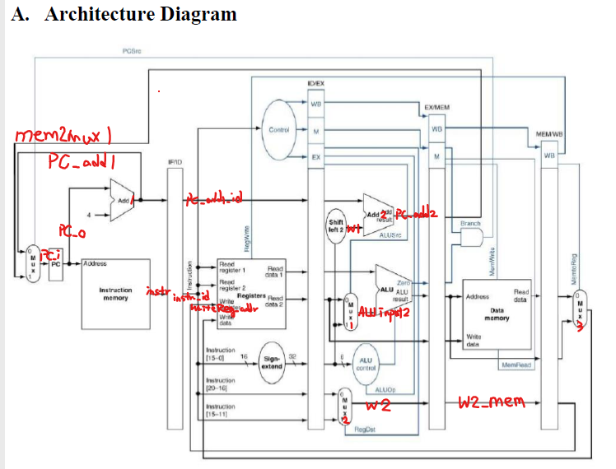

**2. Compared with lab4, the extra modules:**

**Pipe_Reg: the register for storing each stage**

**Pipe_CPU: combine all modules together**

**3. Explain your control signals in sixth cycle (both test patterns CO_P5_test_data1 and CO_P5_test_data2 are needed):**

**Picture:**

|  |  |
| --- | --- |
| **CO_P5_test_data1** | **CO_P5_test_data2** |
|  |  |

**4. Problems you met and solutions:**

**I should remember the wire name that I created. I have debugged for the names for several hours and Vivado is a terrible tool that it won’t tell me where I made a mistake on a wrong name. Next time, I should write on VScode and simulate on Vivado.**

**5. Summary:**

**This lab is a nightmare for me. Although this is the last homework for this class, I feel that I ‘m unfamiliar with Vivado. But in the better part, the coding homeworks let me learn more about how a computer works and be more organized.**