110550071 田松翰

Part I: Implementation

Part 1:

Part 2:

Part 4:

Part 6:

Part II: Result & Analysis

Result:

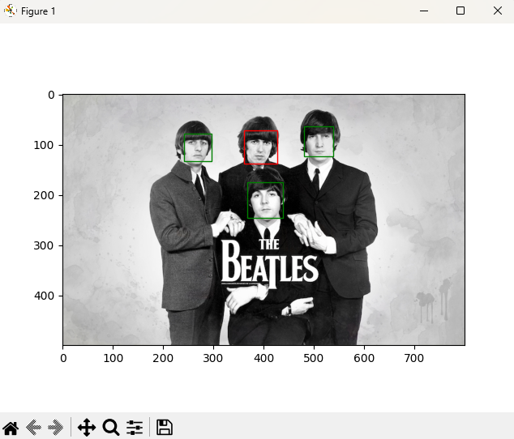

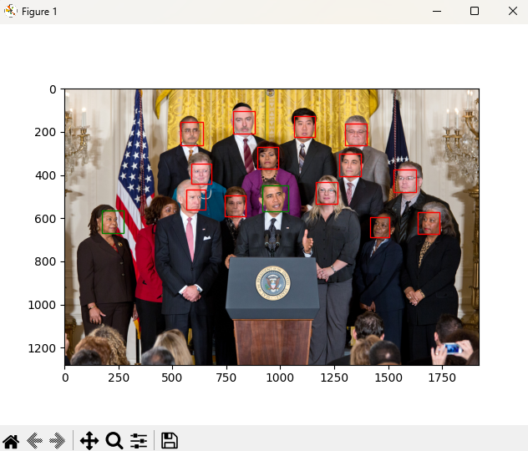

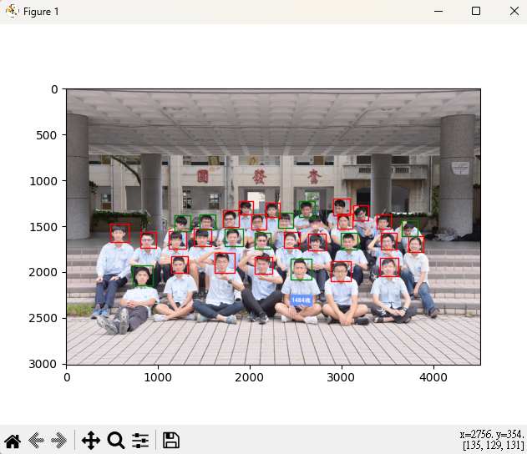

Analysis:

Training data has much higher accuracy than testing data.

And from t=3, training data accuracy has gradually stabilized.

It has not much influence from t bigger-than-3.

Original:

Change the threshold and polarity:

Part III:

1. Problem encountered and solution:

I don’t know how to use vscode to run python so I go to Pycharm. However, Pycharm will report error in some weird place, and I need to fix it. For example, in classify of classifier.py, it has some trouble identifying type of self.feature.computeFeature(x) causing it can’t return the correct value, so I need to deal with the different type and return the value respectively.

2. Limitations of Viola-Jones’ algorithm:

Size of image in training dataset need to be the same of testing dataset.

Face in front view has higher accuracy. It’s hard to detect if the face rotates.

3. How to improve the algorithm w/o changing dataset and T?

Reduce the not-face part in the rectangle we input to test.

Use composite features instead of the single feature we use originally.

4. Another possible face detection method:

Train a classifier that can simultaneously classify eyes, nose, ears…, and every part may give a weight for how it might be positively, and combining all weights from different parts and we can get the accuracy for whole image, while VJ algorithm need to divide into many weak classifiers.

The new classifier may identify many kinds of faces, like monkeys’, dogs’ or humans’, if we train different dataset. But VJ only can detect face or non-face.