**Jeremy Strauch**

**Python – Pandas Challenge**

**UPenn Data Analytics Bootcamp**

**January 27, 2021**

**Heroes of Pymoli**

**Background**

I’ve been assigned the task of analyzing player and game data for the latest fantasy game Heroes of Pymoli. Below are some brief insights found from the exercise followed by more detailed data analytics.

**Observations from Data Analysis**

* The data set contained 780 purchases by 576 unique players, generating approximately $2,400 in revenue.
* Male players were the highest contributors, responsible for approximately 83% of total purchase revenue. Of the 576 unique players, 652 or roughly 84% identified as male.
* Age demographic data showed highest contributions for players starting at 15 – 19 years of age and peaking for ages between 20 – 24 (roughly contributing 60% of total revenue).
* Oath Breaker, Final Critic and Nirvana were among both the top five most purchased games and top five in revenue generation.

**Data Analysis**

Player Count

* A total of 576 unique players were found in the dataset

Purchasing Analysis (Total)

* A total of 179 unique items were counted
* The Average Purchase Price paid by customers was $3.05
* The Total Number of Purchases in the data set was 780
* Total Revenue generated was $2379.77

Gender Demographics

* A total of 652 respondents answered “Male” or 83.6% of the players
* 113 players identified as “Female” representing 14.5% of the distribution
* Lastly, 15 players chose “Other / Non-Disclosed” for gender or 1.9% of players

Purchasing Analysis (Gender)

* An analysis was completed to determine spending contributions based on reported gender identity and summarized in Table 1.

Table . Purchase data based on reported gender identity.

|  |  |  |  |  |
| --- | --- | --- | --- | --- |
| **Gender** | **Purchase**  **Count** | **Average**  **Purchase**  **Price** | **Total**  **Purchase**  **Value** | **Average Purchase**  **Total per Person** |
| Female | 113 | $3.20 | $361.94 | $4.02 |
| Male | 652 | $3.02 | $1967.64 | $11.05 |
| Other / Non-disclosed | 15 | $3.35 | $50.19 | $3.86 |
| Total | 780 |  | $2379.77 |  |

Age Demographics

* An analysis was completed to understand spending contributions by player age group and summarized in Table 2.

Table . Purchasing data based on player age group.

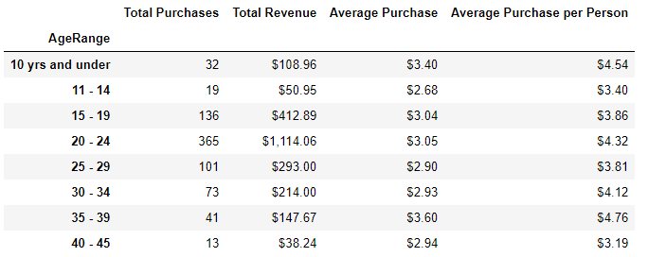

Top Spenders

* Table 3 outlines the top 5 spenders by total purchases

Table . Top five highest revenue per player

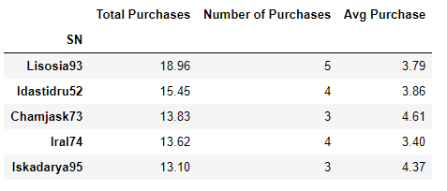

Most Popular Items

* The five most popular items purchased are listed in Table 4.

Table . List of top five most popular items by purchase count.

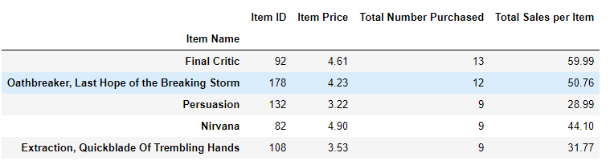

Most Profitable Items

* The five most popular items by total revenue are listed in Table 5.

Table . Five most popular items by sales revenue.

