#### COEN 146: Computer Networks

**Lab assignment 8: GNS3 network emulator**

**Objectives**

##### To setup install GNS3 as an all-in-on software on a local computer (Windows, MAC, Linux)

##### To emulate, configure, test and trouble show virtual networks

##### 

##### **Guidelines**

In this lab, you will be working on the GNS3 network emulator. GNS3[1] is used by network engineers to run a virtual network topology with a wide range of devices. GNS3[2] was introduced in 2008 and has been made available as a free and open-source software distributed under the BSD permissive free software license.

In this lab, you will install, run, and build simple network topologies using GNS3. You may install as a local host or on a virtual machine. For this lab, it is recommended to use GNS3 as a local host.

Because GNS3 requires root password, you will not be able to use the Lab computers.

**Getting started with GNS3**

To install and run GNS3 on a Windows, MAC or Linux computers.

Start by downloading GNS3 by <https://www.gns3.com/software/download>. Use your email to register on GNS3.

Select the installer for your Operating System and download GNS3 version 2.2.5. You may also install GNS3 VM, if you choose to run the GNS3 on a virtual machine.

When you launch GNS3, you will eventually be promoted to enter a root password.

The graphical user interface of the GNS3 allows you to build your network topology with standard virtual PCs and switches, which do not require a complex emulated software. For virtual routers, you need to have a vendor specific IOS image for the router device.

If you use a Cisco IOS router image, you need to manually create a new template for a cisco router and to configure a number of interfaces on the virtual router. You may choose to have all interfaces as Fastethernet. You need to give an idle-pc value to prevent IOS to use 100% of your processor on one of its cores. Choose the value: 0x6050b114.

Now you have your GNS3 ready for building your sample network topologies.

**Setting up a simple institutional access network that connects to an ISP**

Create the following network topology with PC1 and PC2 connected to a switch, and then connected to the internet via router R2. R2 connects to the ISP via router R3. Let us assume that PC3 is a server running a service on ISP.

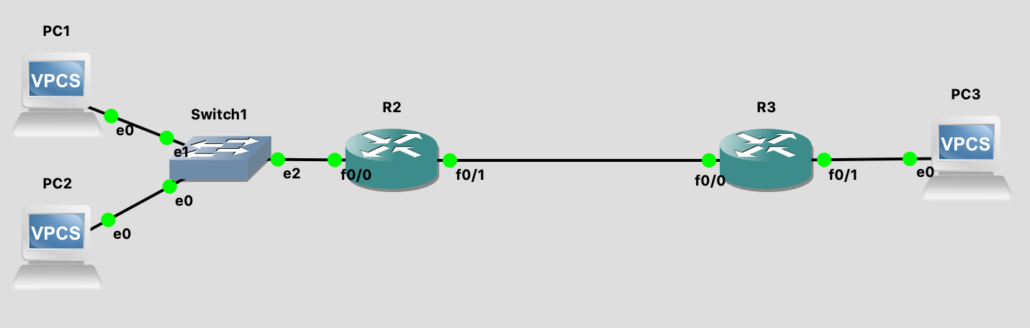

ISP

Access network

To test the network, you need to configure all the devices on the network topology as follows:

1. Create an IP addressing scheme for the access network. Assume you will use 10.1.1.0/24 network (private addresses network).
   1. Start R2 and assign to its interface f0/0 IP address 10.1.1.1/24 as follows:
      1. Open R2 Console
      2. Enter configure mode by typing config t
      3. Select interface f0/0 by typing interface FastEthernet0/0
      4. Assign IP address and mask by typing: ip addr 10.1.1.1 255.255.255.0
      5. Type no shut to bring the interface up
      6. Type exit the Config mode by type exit (or CTRL Z)
      7. Type show ip interface brief to check the assigned ip addresses. You may also type show run to see the full configuration
   2. Start PC1 and assign its e0 interface address 10.1.1.2/24 and a gateway to f0/0 on router 2 as follows:
      1. Open PC1 console
      2. Type ip 10.1.1.2/24, type show ip to check the assigned IP address
      3. Type ip 10.1.1.2/24 10.1.1.1
   3. Start PC2 and assign its e0 interface address 10.1.1.3/24 and a gateway to f0/0 on router 2 as in b.
2. Interface f0/1 on R2 gets an IP address from the ISP through a DHCP or can be assigned a static IP address. Let us assign address 192.1.1.1/24, then Interface f0/0 on R3 needs to be assigned an interface on the same network, e.g. 192.1.1.2/24. Follow the same steps as in 1.a.
3. Assign f0/1 on R3 IP address 10.2.1.1/24
4. Assign e0 on PC3 IP address 10.2.1.2/24 with a gateway to f0/1 on R3.

**Ping network devices:**

You will now check accessibility through the network using ping command.

Step 1. Verify which devices can PC1 ping, by typing ping …IP address….

Step 2. For PC1 to be able to ping 192.1.1.2, R2 needs to setup its default route to R3 interface by typing ip route 0.0.0.0 0.0.0.0 192.1.1.2. Similarly, R3 needs to setup its default route to R2 by typing ip route 0.0.0.0 0.0.0.0 192.1.1.1. Of course, with multiple routers connected, the routes are established through a routing protocol using either OSFP or RIP within the ISP.

Step 3. Now, check the accessibility of devices through the network.

Write your observation.

**NAT inside the access network:**

Configure router R2 with NAT as follows:

Step 4. Configure interface f0/0 as a NAT inside and interface f0/1 as a NAT outside by typing:

> interface f0/0

> ip nat inside

> interface f0/1

> ip nat outside

Step 5. Create the range of address inside that will be translated to the address of interface f0/1 by typing:

> exit

> access-list 10 permit 10.1.1.0 0.0.0.255

> ip nat inside source list 10 interface f0/1 overload

Step 6. Check the NAT table on R2 by typing

> debug ip nat

And ping on PC1 or PC2 to PC3, then write down the NAT table.

**Requirements to complete the lab**

1. Show the TA your running network topology.
2. Write up a description of your steps. Imagine you are writing a guide for a class-mate unfamiliar with setting up a GNS3, and provide instructions guiding them to the point where they can simulate different network topologies.

1. https://en.wikipedia.org/wiki/Graphical_Network_Simulator-3
2. https://www.gns3.com