Risk–Benefit Analysis of Introducing SmartSweep in Antenatal Care

1. Overview
SmartSweep is a handheld ultrasound-based device designed to assist antenatal care professionals—such as midwives—in the evaluation of five key parameters:
- Detection of multiple pregnancies
- Identification of non-cephalic fetal lie
- Measurement of deepest vertical pocket (DVP) of amniotic fluid
- Verification of cardiac activity
- Estimation of gestational age
The current standard of care relies on manual methods:
- Palpation to identify multiple pregnancies and fetal lie
- Measurement of fundal height or LMP date for amniotic fluid or gestational age
- Auscultation for fetal heartbeat
Manual palpation is known to have low diagnostic accuracy; for instance, its sensitivity for detecting fetal position can be as low as ~34%, with a specificity of ~71%.

2. Baseline Risk of Current Standard of Care
Parameter | Sensitivity (Approx.) | Specificity (Approx.) | False Negative Rate | False Positive Rate
Multiple pregnancies | 60% | 60% | 40% | 40%
Non-cephalic lie | 34% | 71% | 66% | 29%
Gestational age (LMP) | Varies | — | — | —
Amniotic fluid (DVP) | Varies with skill | — | — | —
Cardiac activity | Limited early | — | — | —

3. Probability Analysis and Failure Rate Margin (FRM)
We define a Failure Rate Margin (FRM) to quantify the statistical benefit of SmartSweep relative to current methods:
FRM = P_failure_manual – P_failure_SmartSweep
Where:
- P_failure_manual: Failure probability of the manual method (either false negative or false positive).
- P_failure_SmartSweep: Failure probability of SmartSweep, considering both user errors and device limitations.
SmartSweep Failure Probability:
P_failure = P_uf × P_ab_pred × P_prev_ab + (1 − P_uf) × P_ss_failure
Definitions:
- P_uf: Probability of User Failure (e.g., incorrect positioning or protocol)
- P_ab_pred: Condition prediction probability if user error occurs
- P_prev_ab: Prevalence of the condition in the population
- P_ss_failure: Device’s failure rate under proper usage

4. Example Simulations of FRM: Twins

Using the prediction of multiple pregnancies as an example, we can make a few assumptions based on our understanding of the system behavior:
- P_ab_pred (Failure probability if user error occurs) = 0.5. If the user fails to perform the protocol correctly, the parameter will be estimated at random.
- P_prev_ab (Prevalence of the condition in the population) = 0.98. 98% of pregnancies are singleton.
- P_ss_failure (Device’s failure rate under proper usage) = 0.1. SmartSweep is known to predict multiple pregnancies correct around 90% of the time if the user performs a proper exam.
Making these assumptions, we can simulate the effect of the likelihood of user failure P_uf on the FRM for the False Positive Rate of predicting multiple pregnancies

- If there is no chance of user failure, then the Failure Rate Margin (FMR) is positive (0.3). That is, the probability of a failure from the manual method—manual palpation, false positive rate, 0.4—is higher than the anticipated FPR of SmartSweep (0.1).
- If the user fails every time (P_uf = 1), then there is more benefit to the manual method. In this case, SmartSweep will randomly predict singleton or multiples, since P_ab_pred = 0.5.
- If the user fails occasionally (e.g. P_uf = 0.2), then the margin of benefit of SmartSweep starts to erode. The FRM drops to roughly 0.25, which means that SmartSweep, even with the user error rate of 20% will still statistically predict the right number of fetuses 25% more often than the manual method.

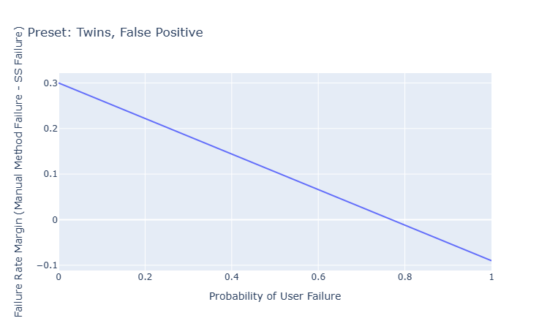

5. Assumptions Table

6. Assumptions Table

 | Probability of Failure if Poor Input | Prevalence of Abnormal Condition | Probability of Failure if Sufficient Input | Probability of Failure with Manual Method | Notes
Twins, False Negative | 0.5 | 0.02 | 0.1 | 0.4
Twins, False Positive | 0.5 | 0.98 | 0.1 | 0.4
Lie, False Negative | 0.5 | 0.04 | 0.042 | 0.30
Lie, False Positive | 0.5 | 0.96 | 0.01 | 0.40
DVP_Oligo, False Negative | 0.5
DVP_Oligo, False Positive | 0.5
DVP_Poly, False Negative | 0.5
DVP_Poly, False Positive | 0.5

7. Discussion
SmartSweep significantly lowers failure risk across scenarios (FRM ~35–36%), driven primarily by automated detection and lower intrinsic error. FRM is relatively robust to user error rates in this example. Actual values of P_uf, P_ab_pred, P_ss_failure, and P_prev_ab should be determined empirically for accuracy. Implementation success hinges on training to minimize P_uf and device calibration.

8. Next Steps
- tbd

