**Molecular Clock Analysis of Caninae Species and Ecological Inference of their Divergence**

Jade Tummino

**Introduction**

Caninae is one of three subfamilies within the family Canidae. The other two subfamilies, Hesperocyoninae (living from about 30 to 10 mya) and Borophaginae (living from about 36 to 2.5 mya), are all now extinct. The family Canidae is within the order Carnivora and suborder Caniformia, also known as Canoidea. This suborder includes other “dog-like” Carnivorans such as seals, raccoons, and bears. Caniformia’s sister suborder is Feliformia, consisting of the “cat-like” Carnivorans.

The subfamily Caninae is broken into three main groups: true dogs, true foxes, and the genus *Urocyon*. This division is mostly based on a maximum parsimony tree constructed from about 15 kb total of selected exons and introns (1). The most basal of the three is *Urocyon,* which has 3 species. The extant true foxes division is made up of 3 genera and 14 species. The extant true dogs division consists of 10 genera and 24 species. Of the 10 genera, 2 are extinct: *Cynotherium* (1 species) and *Dusicyon* (2 species). This does not include the numerous subspecies that exist for many of these species. The prehistoric records show that there are 49 extinct Caninae species, with 20 of them in the genus *Canis* (2).

Table 1. Fossil Caninae species along with their estimated age and relation to other extinct and extant species.

|  |  |  |
| --- | --- | --- |
| **Fossil Species** | **Estimated Age (mya)** | **Relation to Other Species** |
| *Canis lepophagus* | 8 | Ancestor of *C. Lupus* and *C. Latrans* |
| *Canis cedazoensis* | 1.05 | Descendant of *C. lepophagus*, ancestor of Golden Jackal |
| *Canis apolloniensis* | 1.1 | Ancestor of *C. Lupus* |
| *Canis dirus* | 0.067 | Ancestor of *C. Lupus* |
| *Canis (Xenocyon) falconeri* | 1.75 | Ancestor of *Cuon alpinus* and *Lycaon pictus* |
| *Vulpes riffautae* | 7 | Ancestor of *Vulpes* |
| *Vulpes qiuzhudingi* | 4.34 | Ancestor of *Vulpes lagopus* |
| *Vulpes stenognathus* | 2 | Ancestor of *Vulpes Vulpes* |
| *Nyctereutes donnezani* | 6.2 | Ancestor of *N. procyonoides* |
| *Eucyon davisi* | 8.3 | Ancestor of *Canis* |
| *Leptocyon vulpinus* | 18.2 | Ancestor of *Canis* and *Vulpes* |

**Methods**

NCBI was used to see what mitochondrial genes are available for multiple Caninae species. Many options for genes were available for the same 18 species. A lot of articles reference the same phylogeny published in 1997 that was based off of three cytochrome encoding genes: cytochrome b (COB), cytochrome c oxidase subunit I (COX1), and cytochrome c oxidase subunit II (COX2) (3). Since cytochrome c oxidase subunit III (COX3) was also available for the same species, it was included in the analysis in addition to the previously established three.

After these sequences were aligned, RaxML was used to construct two new phylogenetic trees with the parameters shown in Figure 1 and 2.



Figure 1. Executing code for obtaining the best maximum likelihood tree for the nucleotide alignment. Final LogLikelihood: -20320.864.

Based on the resulting tree (Figure 3), 11 fossil record species were chosen (Table 1). Those with known age estimates and direct ancestral relationships with the 18 extant species were used.

Through BEAST v2.5.2, these fossil species were incorporated into the sequence data and used to make a tree with a molecular clock. Since their DNA sequence is unknown, it is inputted into the Nexus file as a string of question marks. For all species, their estimated age is appended to their name (0 for the extant species). For the origin time, the age of *Leptocyon vulpinus* is used since this is an ancestor of both *Canis* and *Vulpes* genera. The estimated age range is 20.43 to 15.97 mya (4). The average of this range is used: 18.2 mya. For the taxon sets (Table 2), the published tree (1) is mostly used. For those that are different, other sources were used to decide which tree to follow. The RaxML tree (Figure 1) was used for those that were not a part on the published tree (1). The rest of the parameters were changed based on Dr Tracy Heath’s BEAST v2 Tutorial (5).

Table 2. The NEXUS file didn’t have taxon sets explicitly established so the following taxon sets were declared as priors.

|  |  |  |
| --- | --- | --- |
| **Taxon Set** | **Taxa** | **Citation** |
| A | All |  |
| B | Set A, except Leptocyon vulpinus  -the most primitive | Wang, Xiaoming; Tedford, Richard H. (2008). *Dogs, Their Fossil Relatives and Evolutionary History*. Columbia. p. 53. [ISBN](https://en.wikipedia.org/wiki/International_Standard_Book_Number) [978-0-231-13528-3](https://en.wikipedia.org/wiki/Special:BookSources/978-0-231-13528-3). |
| C | All Canini, no Vulpini |  |
| D | All Canis species and Eucyon davisi | Wang, Xiaoming; Tedford, Richard H. (2008). *Dogs, Their Fossil Relatives and Evolutionary History*. Columbia. p. 53. [ISBN](https://en.wikipedia.org/wiki/International_Standard_Book_Number) [978-0-231-13528-3](https://en.wikipedia.org/wiki/Special:BookSources/978-0-231-13528-3). |
| E | Canis cedazoensis and Canis anthus | Tedford, Richard H., Wang, Xiaoming, Taylor, Beryl E., Phylogenetic systematics of the North American fossil Caninae (Carnivora, Canidae). (Bulletin of the American Museum of Natural History, no. 325, p. 123 [.](http://digitallibrary.amnh.org/dspace/bitstream/2246/5999/1/B325.pdf) |
| F | Canis dirus and all Canis lupus | Cherin, Marco; Bertè, Davide F.; Rook, Lorenzo; Sardella, Raffaele (2013). "Re-Defining Canis etruscus (Canidae, Mammalia): A New Look into the Evolutionary History of Early Pleistocene Dogs Resulting from the Outstanding Fossil Record from Pantalla (Italy)". *Journal of Mammalian Evolution*. **21**: 95. [doi](https://en.wikipedia.org/wiki/Digital_object_identifier):[10.1007/s10914-013-9227-4](https://doi.org/10.1007%2Fs10914-013-9227-4) |
| G | Canis (Xenocyon) falconeri, Lyacon pictus, and Cuon alpinus | Wang, Xiaoming; Tedford, Richard H.; Dogs: Their Fossil Relatives and Evolutionary History. New York: Columbia University Press, 2008 |
| H | Vulpes riffautae, Otocyon megalotis, Nyctereutes, and all Vulpes | De Bonis, L.; Peigné, S.; Likius, A.; MacKaye, H.T.; Vignaud, P.; Brunet, M. (2007). ["The oldest African fox (*Vulpes riffautae* n. sp., Canidae, Carnivora) recovered in late Miocene deposits of the Djurab desert, Chad"](http://www.springerlink.com/index/D873832U57615708.pdf)(PDF). *Naturwissenschaften*. **94** (7): 575–580. [doi](https://en.wikipedia.org/wiki/Digital_object_identifier):[10.1007/s00114-007-0230-6](https://doi.org/10.1007%2Fs00114-007-0230-6) |
| I | Vulpes qiuzhudingi and Vulpes lagopus, Vulpes Corsac and Vulpes ferrilata,Vulpes vulpes and Vulpes Stenognathus | [""Out of Tibet" hypothesis: Cradle of evolution for cold-adapted mammals is in Tibet"](https://www.nsf.gov/discoveries/disc_summ.jsp?cntn_id=131678). [*National Science Foundation*](https://en.wikipedia.org/wiki/National_Science_Foundation). June 11, 2014. Retrieved 8 July 2014. |
| J | Vulpes stenognathus and Vulpes vulpes | D. E. Savage. 1941. American Midland Naturalist 25 |
| K | Nyctereutes donnezani and Nyctereutes procyonoides | Ikeda, Hiroshi (August 1986). "Old, new tricks: Asia's raccoon, a venerable member of the canid family is pushing into new frontiers". *Natural History*. **95** (8): 40, 44. |
| L | All Canini and Vulpini |  |

After running the analysis twice (both chain lengths of 10,000,000) the output files were imported into Tracer v1.7.1. Here, the kernel density estimate (KDE) (Figure 4) and the marginal density distribution of the turnover (Figure 5) can be compared for the two runs independent runs and prior.

LogCombiner was then used to combine the first and second runs with 20% burn-in and 10,000 resample states at lower frequency. This combined tree was then imported into TreeAnnotator for a Maximum clade credibility tree using median heights. The summary file was then opened and viewed using FigTree v1.4.4 (Figure 6).

The estimated ages were compared to that of established publications and the corresponding geological era, periods, or epochs. Ecological factors that could have stimulated some of the distinct divergences were investigated. Anatomical differences between sister taxa were compared to each other and to the local geography. Prey abundance and potential competitors for mutual resources are also considered.

**Results**

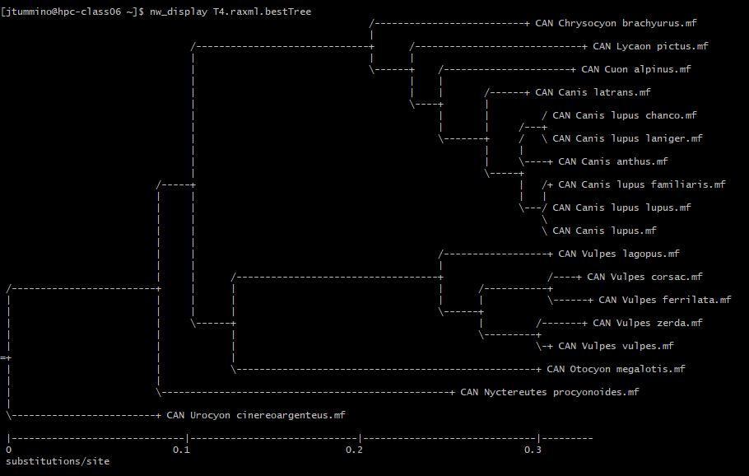

Figure 3. Best maximum likelihood tree for nucleotide sequence alignment.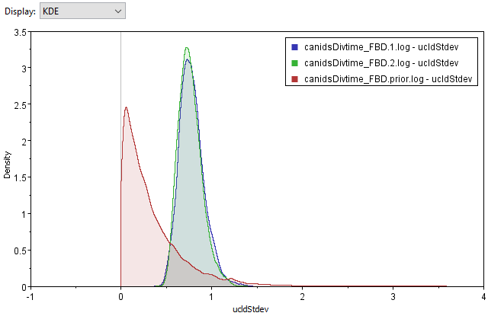

Figure 4. KDE of the marginal density of UCLD standard deviation of the two runs and the prior.

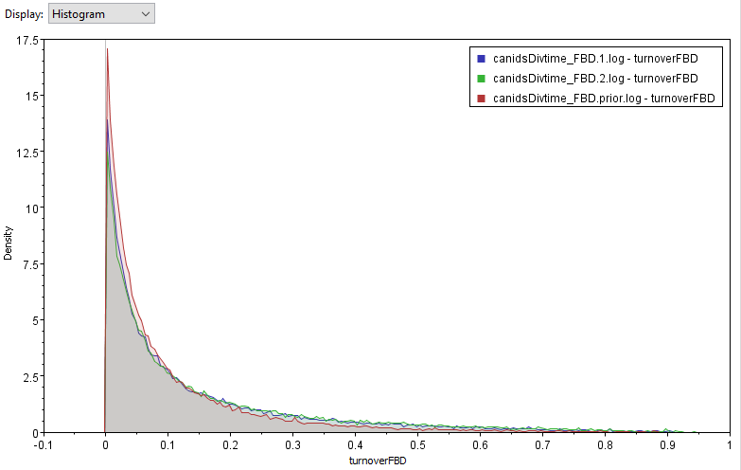

Figure 5. Histogram of the marginal density of the turnover of the two runs and the prior.

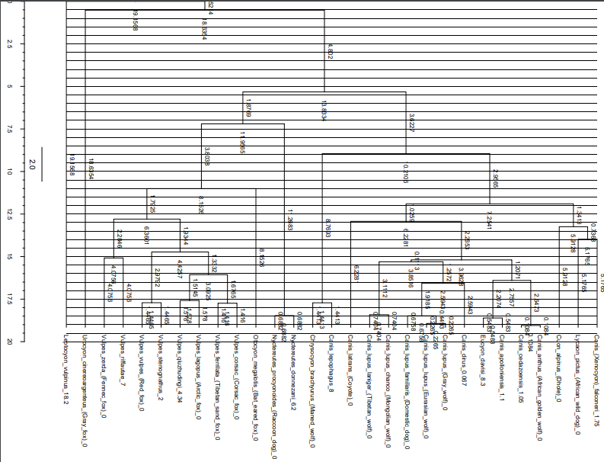

Figure 6. FigTree display of the combined tree summary for 29 taxa and age estimates on the x-axis.

**Discussion**

There are a lot of differences between the obtained maximum likelihood tree (Figure 3) and what was established in previous papers (1). With *Urocyon cinereoargenteus* as the outgroup, *Nyctereutes procyonoides* is sister taxa to the rest of the 16 species. In previous paper, *Nyctereutes procyonoides* is placed in the Vulpini clade. In this paper, the Vulpini clade is sister to Canini, which is also the case in this current study. However, there are further differences between the trees within both the Vulpini and Canini clades. For example, *Vulpes lagopus* is the most derived in the previous paper, but least derived in this current study. The obtained tree also places *Canis anthus* as sister taxa to *Canis lupus* instead of *Canis latrans*. With the fossil species included in declared taxon sets, the produced tree matched more with the published one.

**References**

1. Lindblad-Toh, Kerstin; Wade, Claire M; Mikkelsen, Tarjei S.; Karlsson, Elinor K.; Jaffe, David B.; Kamal, Michael; Clamp, Michele; Chang, Jean L.; Kulbokas, Edward J.; Zody, Michael C.; Mauceli, Evan; Xie, Xiaohui; Breen, Matthew; Wayne, Robert K.; Ostrander, Elaine A.; Ponting, Chris P.; Galibert, Francis; Smith, Douglas R.; Dejong, Pieter J.; Kirkness, Ewen; Alvarez, Pablo; Biagi, Tara; Brockman, William; Butler, Jonathan; Chin, Chee-Wye; Cook, April; Cuff, James; Daly, Mark J.; Decaprio, David; et al. (2005). "Genome sequence, comparative analysis and haplotype structure of the domestic dog". Nature. 438 (#7069): 803 in 803–19. Bibcode:2005Natur.438..803L. doi:10.1038/nature04338. PMID 16341006
2. Tedford, Richard; Wang, Xiaoming; Taylor, Beryl E. (2009). "Phylogenetic systematics of the North American fossil Caninae (Carnivora: Canidae)" . Bulletin of the American Museum of Natural History. 325: 1–218. doi:10.1206/574.1
3. Wayne, et al. (1997). “Molecular Systematics of the Canidae”
4. <http://fossilworks.org/?a=taxonInfo&taxon_no=47574>
5. <https://taming-the-beast.org/tutorials/FBD-tutorial/>