**Molecular Clock Analysis of Caninae Species and Ecological Inference of their Divergence**

Jade Tummino

**Introduction**

Caninae is one of three subfamilies within the family Canidae. The other two subfamilies, Hesperocyoninae (living from about 30 to 10 mya) and Borophaginae (living from about 36 to 2.5 mya), are all now extinct. The family Canidae is within the order Carnivora and suborder Caniformia, also known as Canoidea. This suborder includes other “dog-like” Carnivorans such as seals, raccoons, and bears. Caniformia’s sister suborder is Feliformia, consisting of the “cat-like” Carnivorans.

The subfamily Caninae is broken into three main groups: true dogs, true foxes, and the genus *Urocyon*. This division is mostly based on a maximum parsimony tree constructed from about 15 kb total of selected exons and introns (1). The most basal of the three is *Urocyon,* which has 3 species. The extant true foxes division is made up of 3 genera and 14 species. The extant true dogs division consists of 10 genera and 24 species. Of the 10 genera, 2 are extinct: *Cynotherium* (1 species) and *Dusicyon* (2 species). This does not include the numerous subspecies that exist for many of these species. The prehistoric records show that there are 49 extinct Caninae species, with 20 of them in the genus *Canis* (2).

**Methods**

NCBI was used to see what mitochondrial genes are available for multiple Caninae species. Many options for genes were available for the same 18 species. A lot of articles reference the same phylogeny published in 1997 that was based off of three cytochrome encoding genes: cytochrome b (COB), cytochrome c oxidase subunit I (COX1), and cytochrome c oxidase subunit II (COX2) (3). Since cytochrome c oxidase subunit III (COX3) was also available for the same species, it was included in the analysis in addition to the previously established three.

After these sequences were aligned, RaxML was used to construct two new phylogenetic trees with the parameters shown in Figure 1 and 2.



Figure 1. Executing code for obtaining the best maximum likelihood tree for the nucleotide alignment. Final LogLikelihood: -20320.864



Figure 2. Executing code for obtaining the best maximum likelihood tree for the protein alignment. Final LogLikelihood: -5164.078

// after Bootstrap tree #43, returns error: 

// not sure what’s wrong. Will stop at 43 and use best of these trees for now

Based on these trees, a few fossil record species were chosen. ((Haven't done this yet)) Through BEAST, these fossil species with estimated ages were incorporated into the data and used to make a tree with a molecular clock. Since their DNA sequence is unknown, it is inputted as a string of question marks. For all species, their estimated age is appended to their name (0 for the extant species). For the origin time, the age of *Urocyon cinereoargenteus* is used, which is estimated to be 3.6 mya (4). After running the analysis, the output files were imported into Tracer to see if the posterior distributions of the independent runs converged and combine the trees. This combined tree was then opened and viewed using FigTree.

The estimated ages were compared to that of established publications and the corresponding geologic era, periods, or epochs. Ecological factors that could have stimulated some of the distinct divergences were investigated. Anatomical differences between sister taxa were compared to each other and to the local geography. Prey abundance and potential competitors for mutual resources are also considered.

**Results**

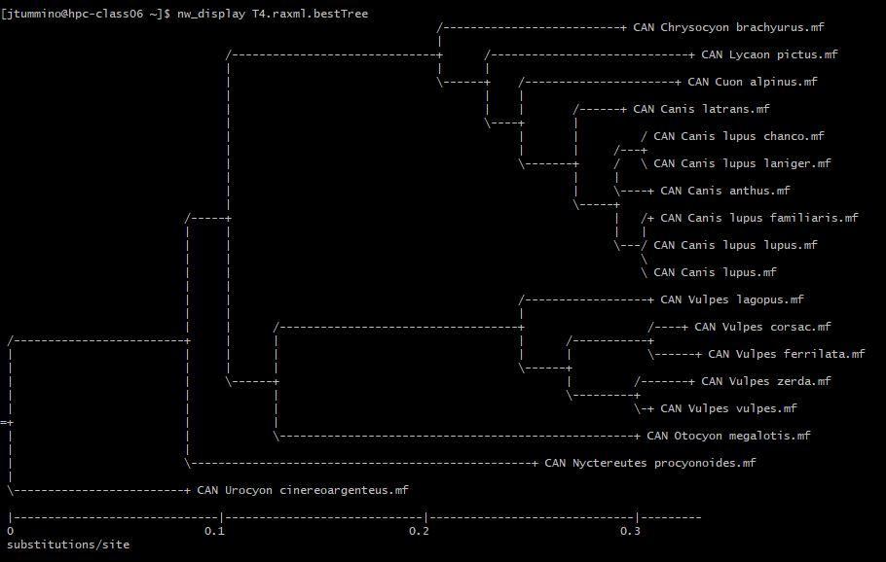

Figure 3. Best maximum likelihood tree for nucleotide sequence alignment.

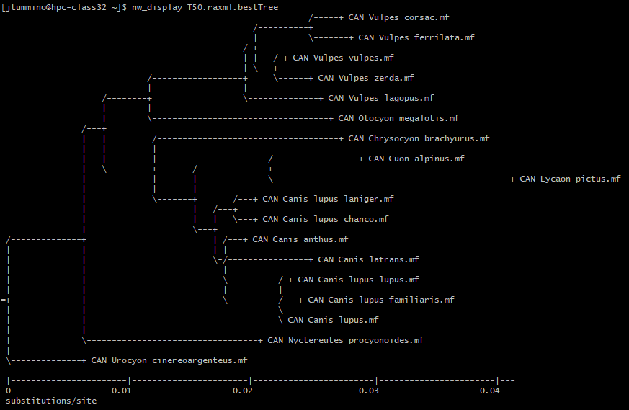

Figure 4. Best maximum likelihood tree for amino acid sequence alignment.

**Discussion**

**References**

1. Lindblad-Toh, Kerstin; Wade, Claire M; Mikkelsen, Tarjei S.; Karlsson, Elinor K.; Jaffe, David B.; Kamal, Michael; Clamp, Michele; Chang, Jean L.; Kulbokas, Edward J.; Zody, Michael C.; Mauceli, Evan; Xie, Xiaohui; Breen, Matthew; Wayne, Robert K.; Ostrander, Elaine A.; Ponting, Chris P.; Galibert, Francis; Smith, Douglas R.; Dejong, Pieter J.; Kirkness, Ewen; Alvarez, Pablo; Biagi, Tara; Brockman, William; Butler, Jonathan; Chin, Chee-Wye; Cook, April; Cuff, James; Daly, Mark J.; Decaprio, David; et al. (2005). "Genome sequence, comparative analysis and haplotype structure of the domestic dog". Nature. 438 (#7069): 803 in 803–19. Bibcode:2005Natur.438..803L. doi:10.1038/nature04338. PMID 16341006
2. Tedford, Richard; Wang, Xiaoming; Taylor, Beryl E. (2009). "Phylogenetic systematics of the North American fossil Caninae (Carnivora: Canidae)" . Bulletin of the American Museum of Natural History. 325: 1–218. doi:10.1206/574.1
3. Wayne, et al. (1997). “Molecular Systematics of the Canidae”
4. Paleobiology database, Collection 19656, Graham County, Arizona. Authority by the Dr. John Alroy, 18 February 1993.