LASERI-trajectories

Jouni Tuomisto

2020-09-25

## R Markdown

This analysis produces a model for trajectories of human body burdens of persistent organic pollutants (POPs).

library(foreign)  
  
df <- read.spss("~/Documents/priv/VS _Henkilökohtaiset_POP-trajektorit_LASERI-aineistossa/updated_korjattu_LASERI_data_2020_05_WORKCOPY.sav", to.data.frame = TRUE)

## Warning in read.spss("~/Documents/priv/VS  
## _Henkilökohtaiset_POP-trajektorit_LASERI-aineistossa/  
## updated_korjattu_LASERI_data_2020_05_WORKCOPY.sav", : ~/Documents/  
## priv/VS _Henkilökohtaiset_POP-trajektorit_LASERI-aineistossa/  
## updated_korjattu_LASERI_data_2020_05_WORKCOPY.sav: Compression bias (0) is not  
## the usual value of 100

## Warning in read.spss("~/Documents/priv/VS  
## _Henkilökohtaiset_POP-trajektorit_LASERI-aineistossa/  
## updated_korjattu_LASERI_data_2020_05_WORKCOPY.sav", : Undeclared level(s) 0  
## added in variable: bintup80

## Warning in read.spss("~/Documents/priv/VS  
## _Henkilökohtaiset_POP-trajektorit_LASERI-aineistossa/  
## updated_korjattu_LASERI_data_2020_05_WORKCOPY.sav", : Undeclared level(s) 0  
## added in variable: bintup01

library(psych)  
  
colnames(df)[grep("PI",toupper(colnames(df)))]

## [1] "PITUUS01" "waistpit01" "OPINNO01" "OPINVV01"

# Take all-male panel of interesting variables  
df <- df[df$SP=="Poika", c("PCB_Sum80","PCB_Sum01","SYNTVUOSI", "BMI80","BMI01","Paino01","bodyfat80","bodyfat92")]  
  
pairs.panels(df)

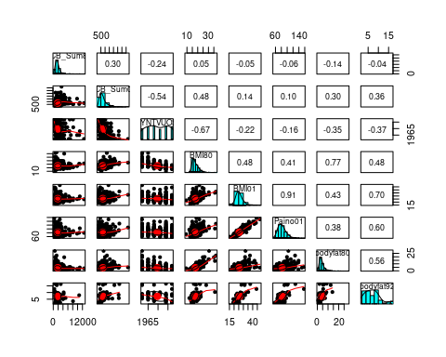

df$Age80 <- 1980 - df$SYNTVUOSI  
df$Age01 <- 2001 - df$SYNTVUOSI  
df <- merge(df, data.frame(  
 Age80 = c(0:20,21:30, 31:40),  
 Paino80 = c(5,10,13,15,17,20,22,26,28,31,35,38,44,48,55,60,65,68,70,71,72, rep(75,10),rep(80,10))  
 )  
)  
  
  
aggregate(df$Paino01, by=df[c("Age80")], FUN=function(x) mean(x, na.rm=TRUE))

## Age80 x  
## 1 3 77.98500  
## 2 6 81.73302  
## 3 9 83.04430  
## 4 12 84.77477  
## 5 15 83.33684  
## 6 18 86.66154

## Bayesian hierachical model

# This was forked from Dioxdistboys_individual_rows.Rmd and  
# originally from code Op_en3104/bayes on page [[EU-kalat]]  
  
if(FALSE){  
if(params$run_bayes) {  
 library(OpasnetUtils)  
 library(reshape2)  
 library(rjags) # JAGS  
 library(MASS) # mvrnorm  
 library(car) # scatterplotMatrix  
   
 N <- params$N # defined as render parameter  
   
 # Hierarchical Bayes model.  
   
 mod <- textConnection(  
 "  
 model{  
 for(p in POP) { # TEQ columns (after pcb9 columns)  
 tau[j] ~ dgamma(1.0, 1.0)  
 for(o in Observations) {   
 # below.LOQ[i,j] ~ dinterval(-conc[i,j], -LOQ[j])  
 teq[i,j] ~ dnorm(mu[i,j], tau[j])  
   
 mu[o,year] <- intake[year] / k - c * exp (-k * t) / bodyfat[o,year]  
 }  
 for(k in K) {  
 b[j,k] ~ dnorm(0, 0.0001) # Congener-specific coefficient for TEQs  
 }  
 }  
 }  
 ")  
   
 jags <- jags.model(  
 mod,  
 data = list(  
 Observations = 1:nrow(df),  
 POP = 1:2,  
 YEAR = 1:2,  
 conc = data.matrix(df[c("PCB_Sum80","PCB_Sum01")]),   
 teq = data.matrix(df[teq3]),  
 bodyfat = data.matrix(df[c("bodyfat80","bodyfat92")])  
 ),  
 n.chains = 4,  
 n.adapt = 1000  
 )  
   
 samps.j <- jags.samples(  
 jags,   
 c(  
 'mu',   
 'tau',  
 'b',  
 'teq'  
 ),   
 thin=100,  
 N*100  
 )  
  
   
}  
}