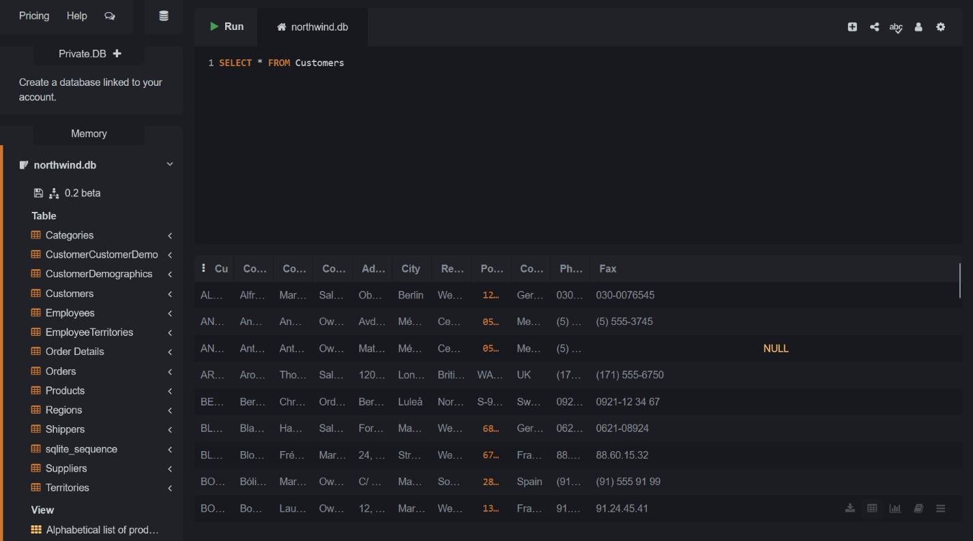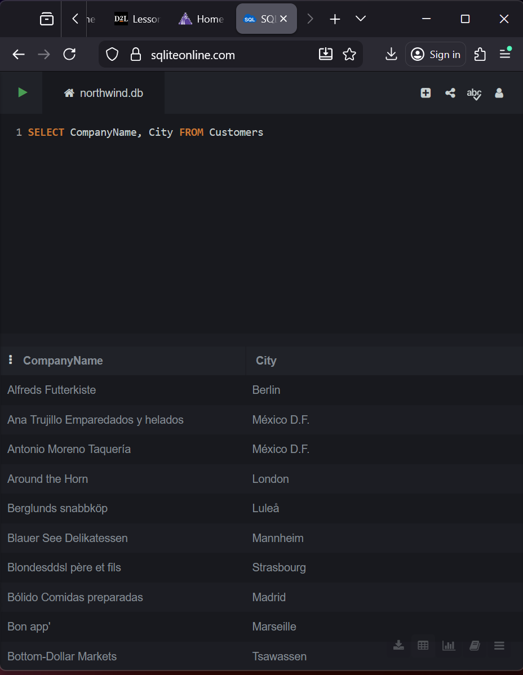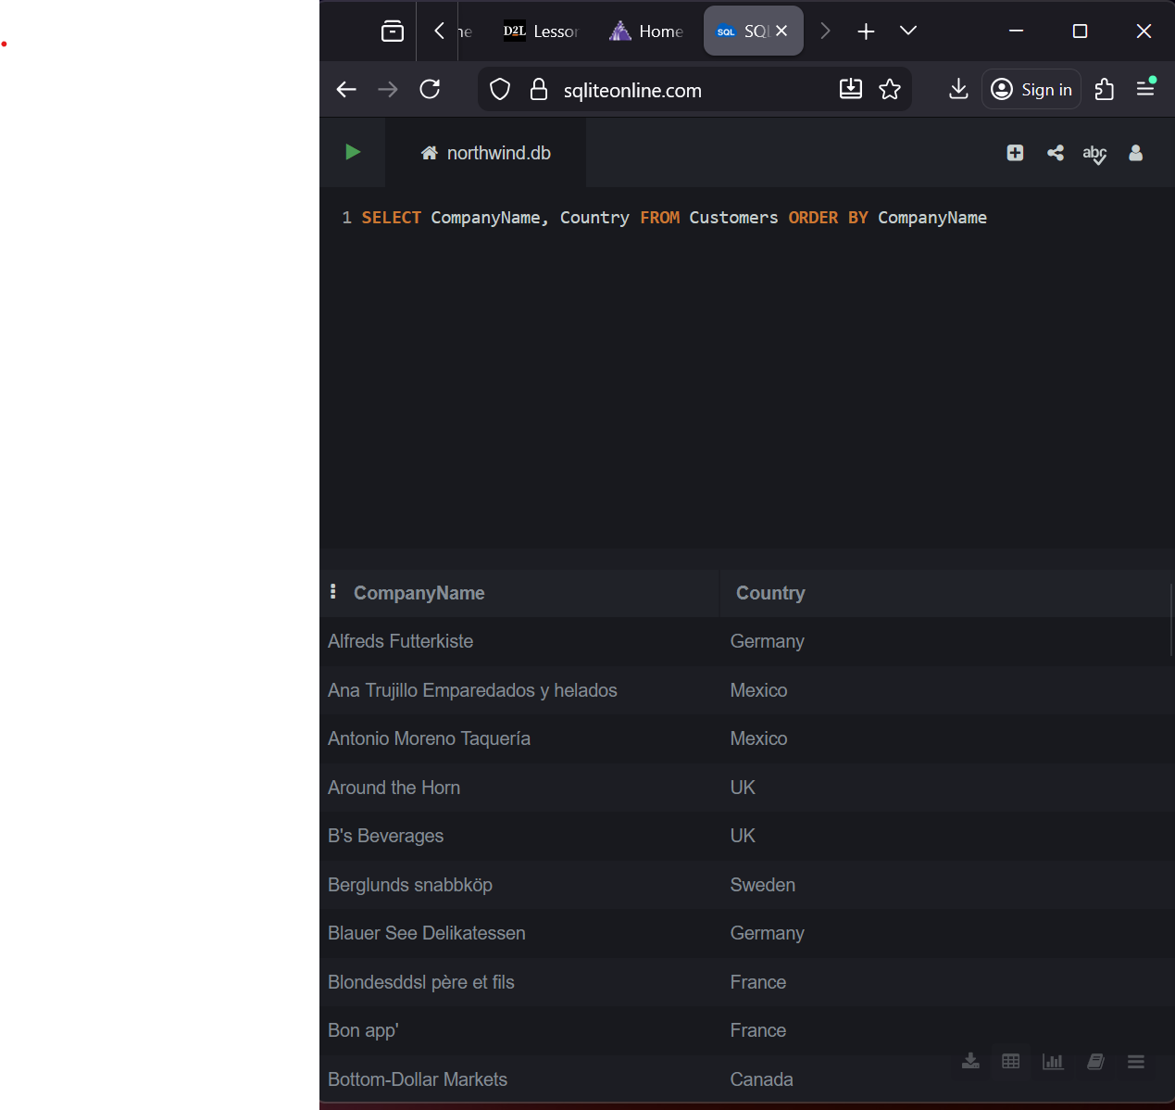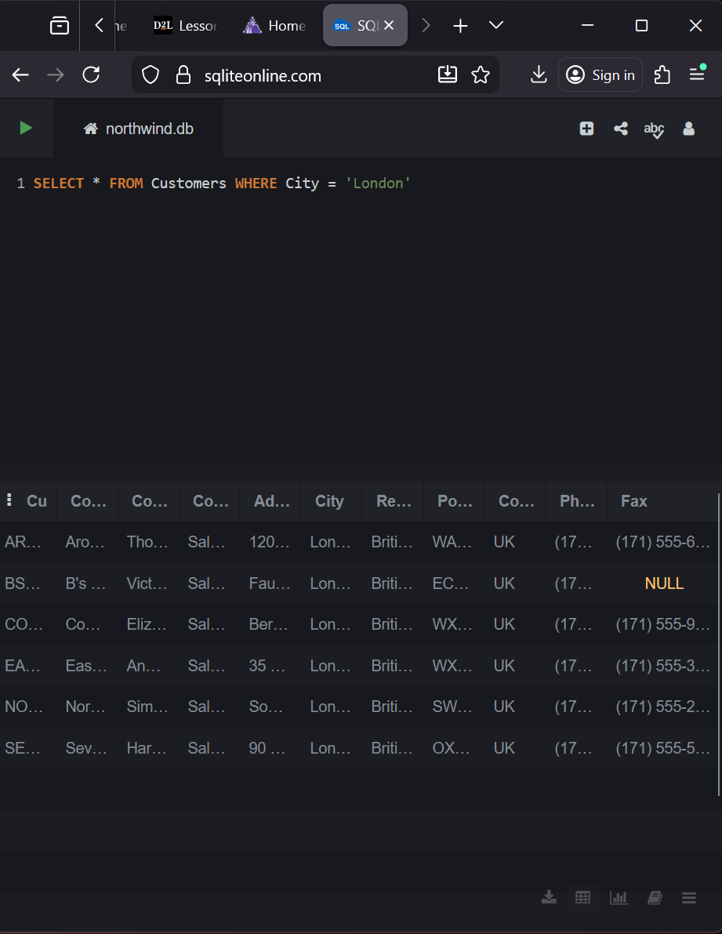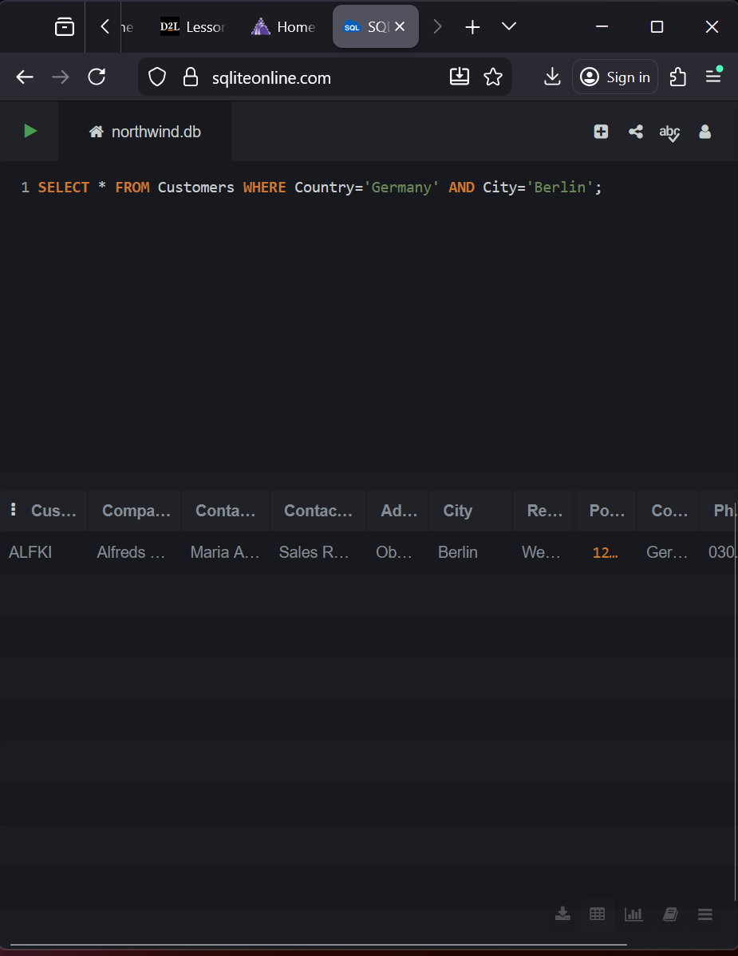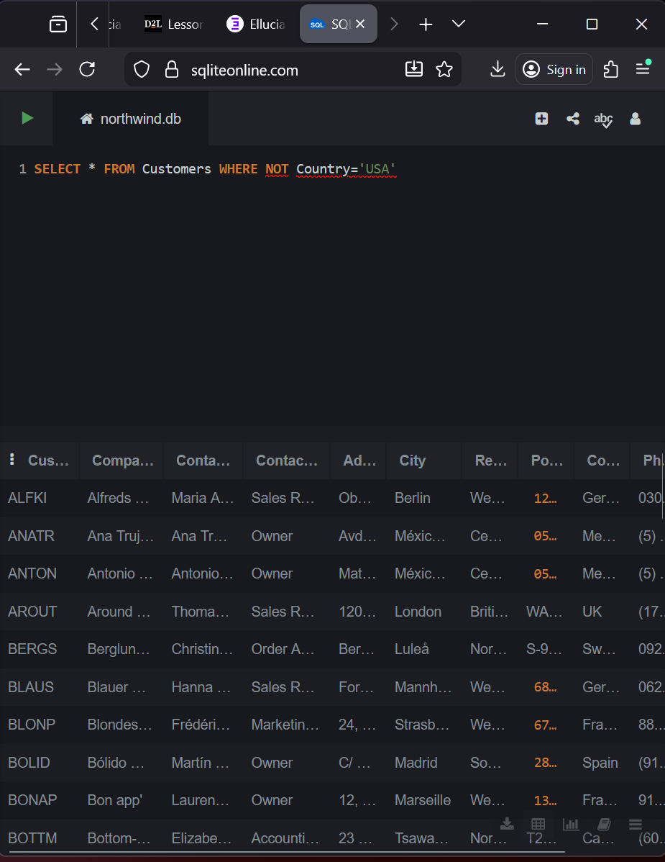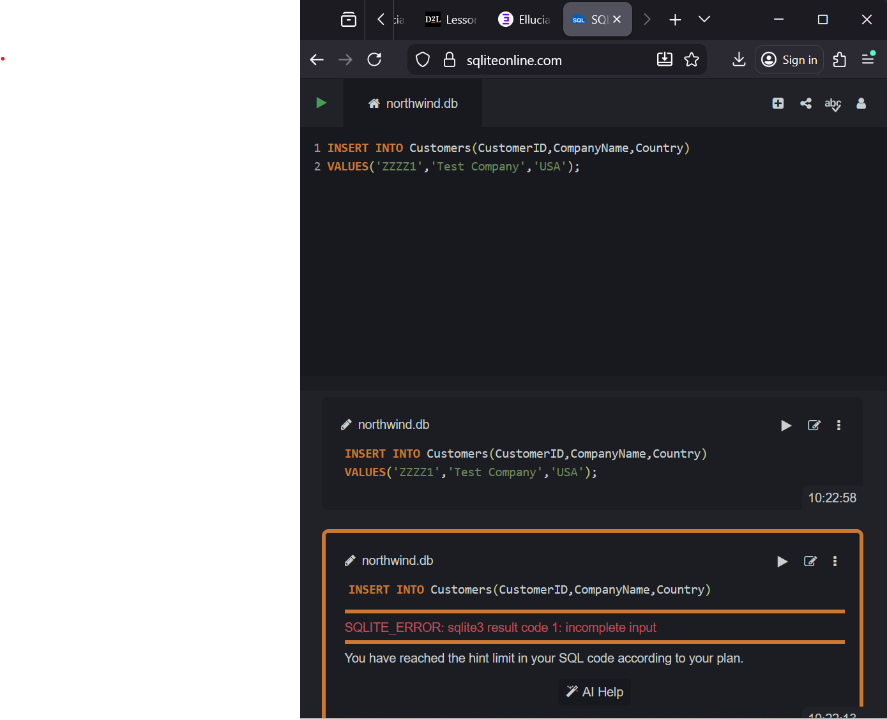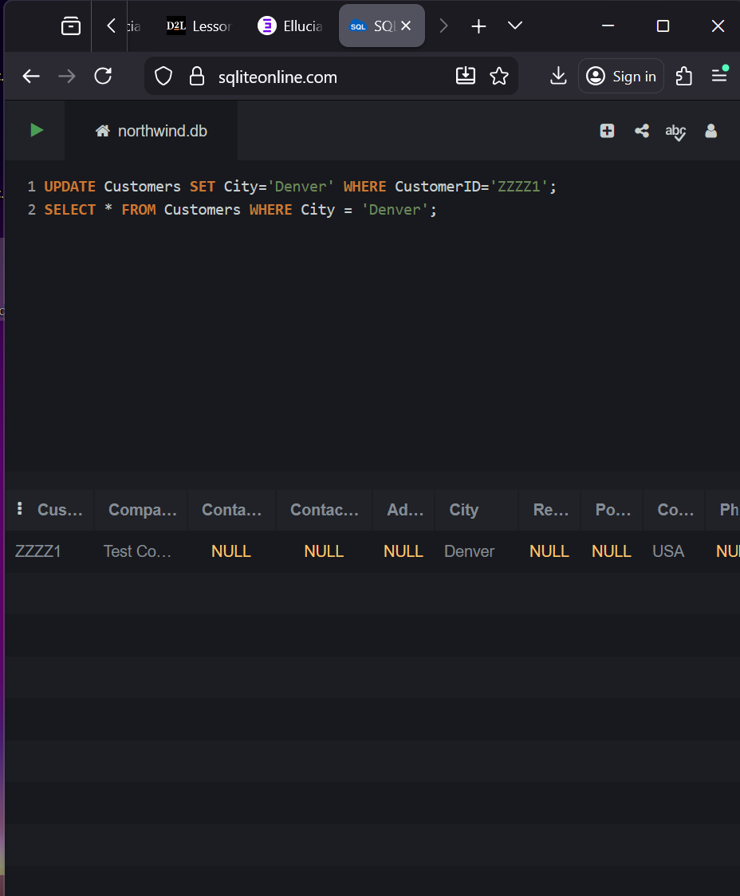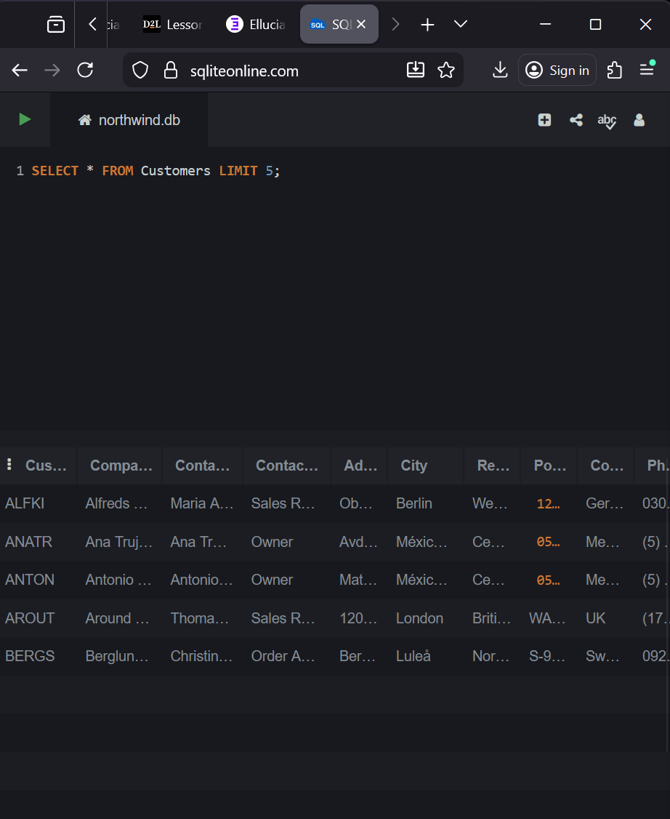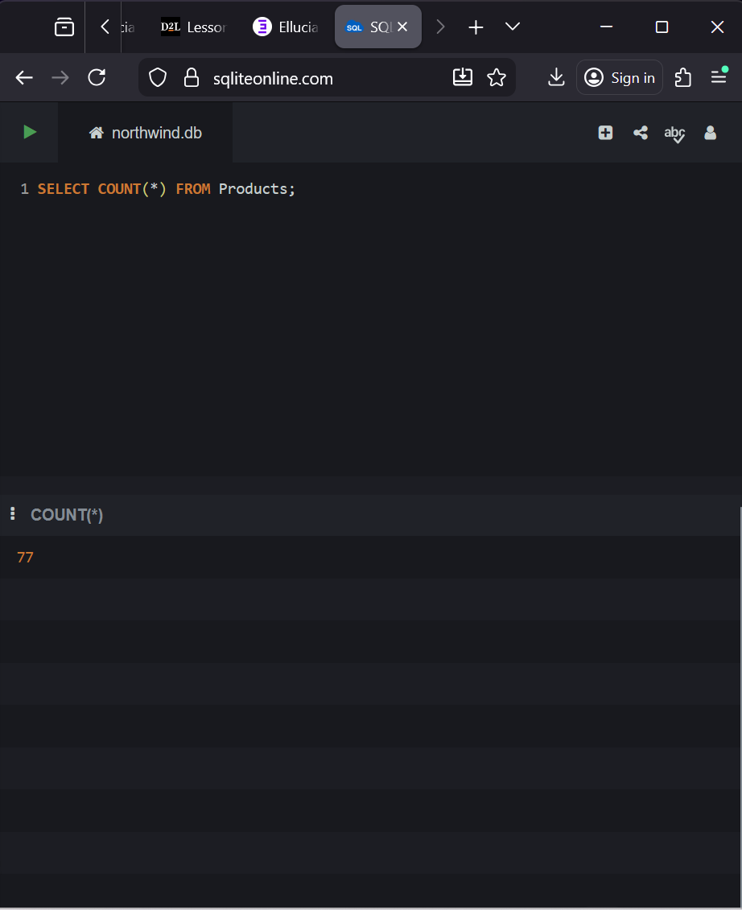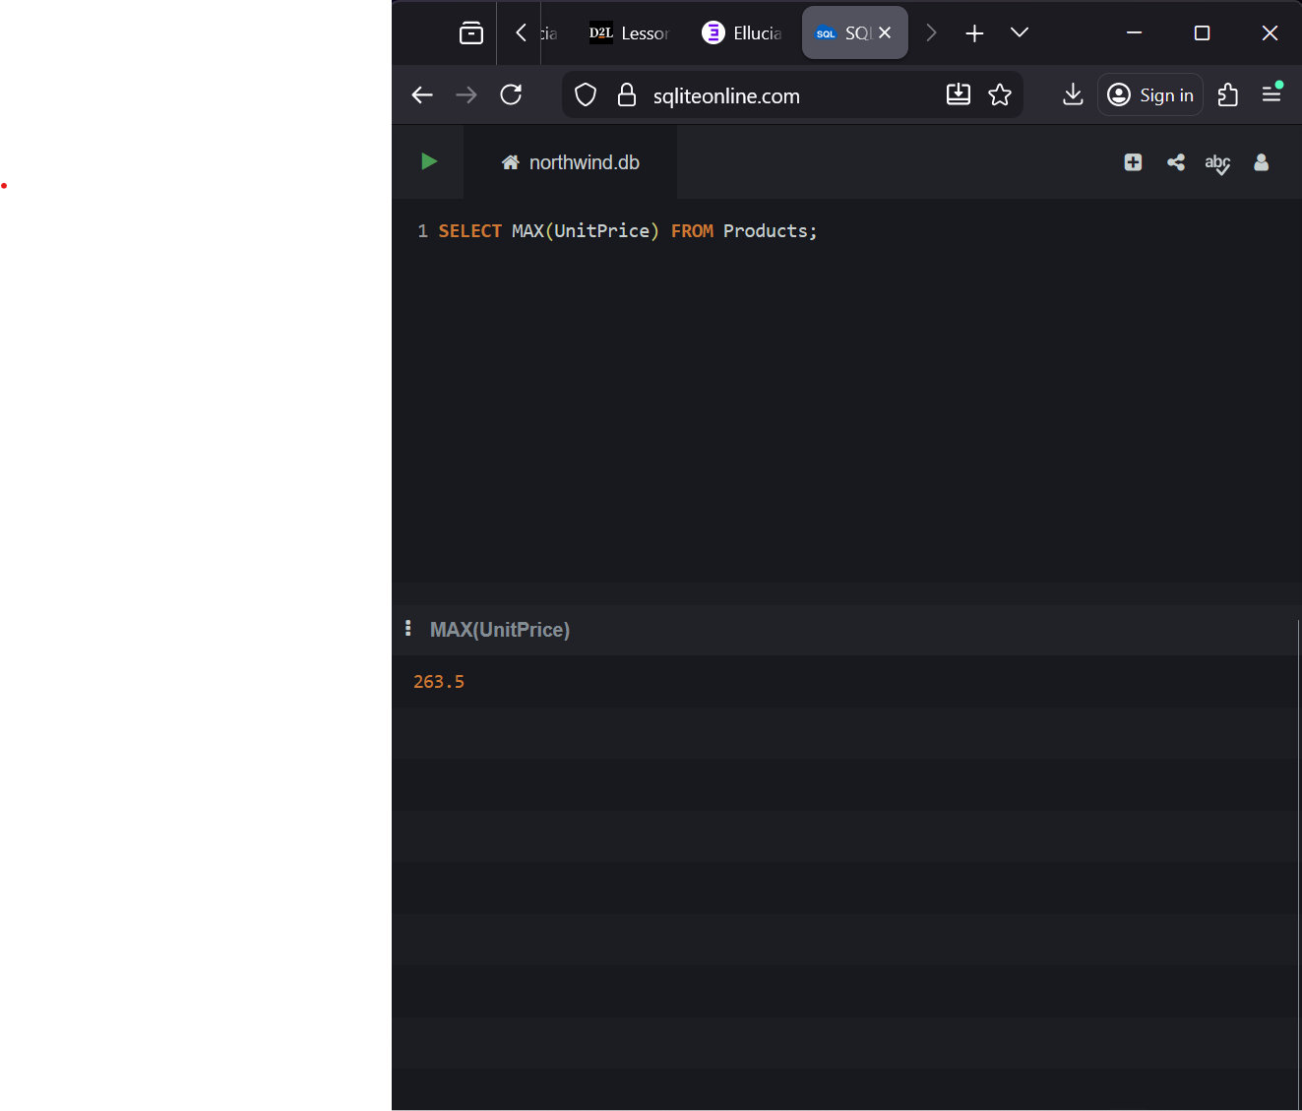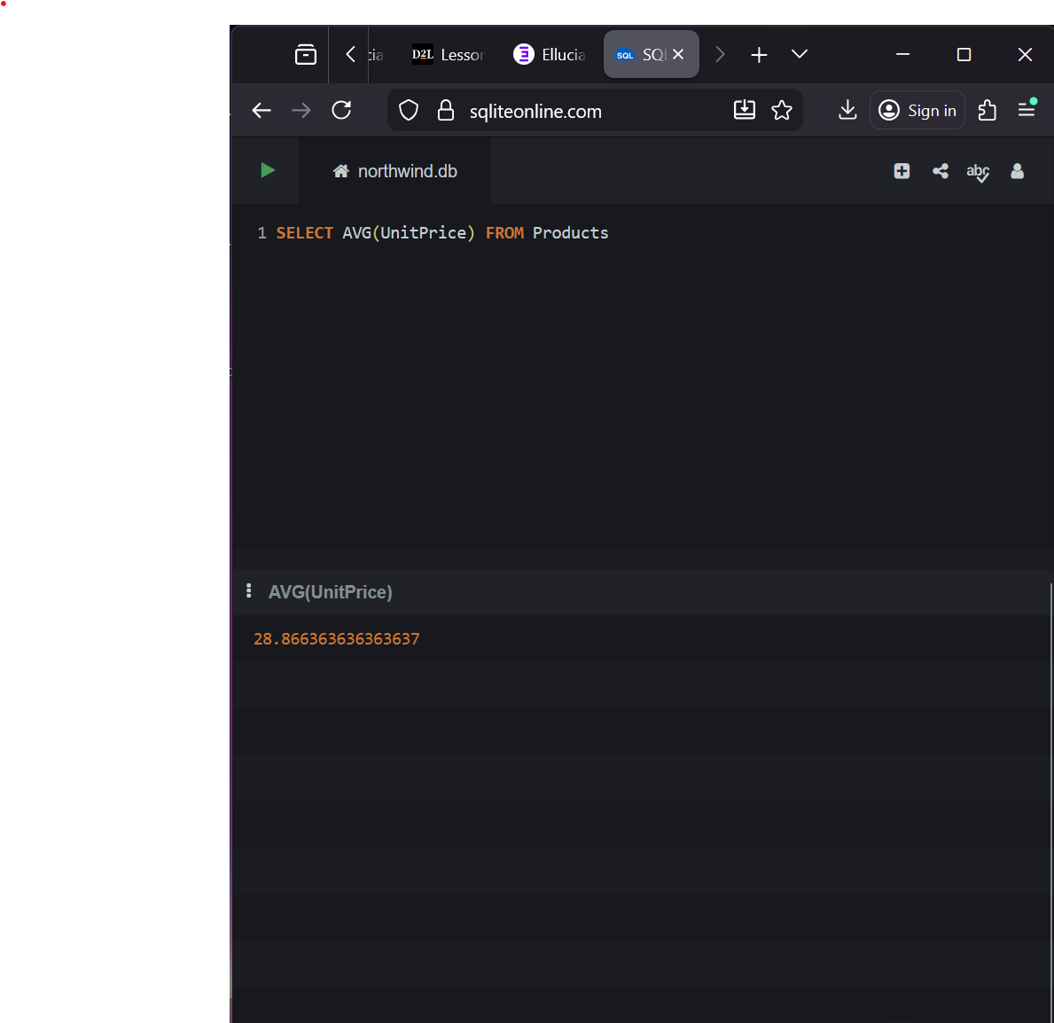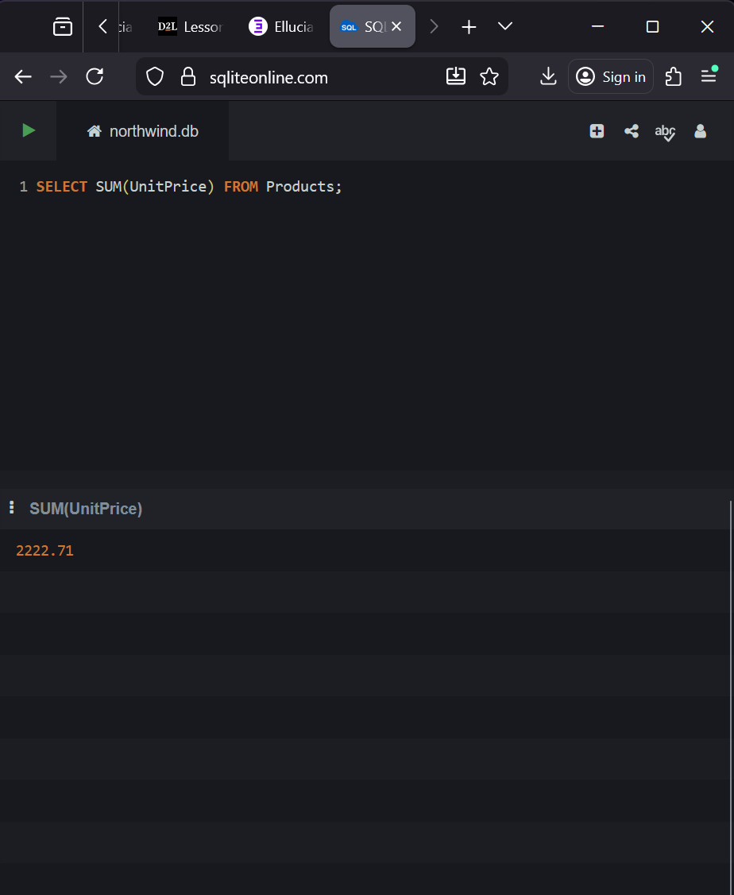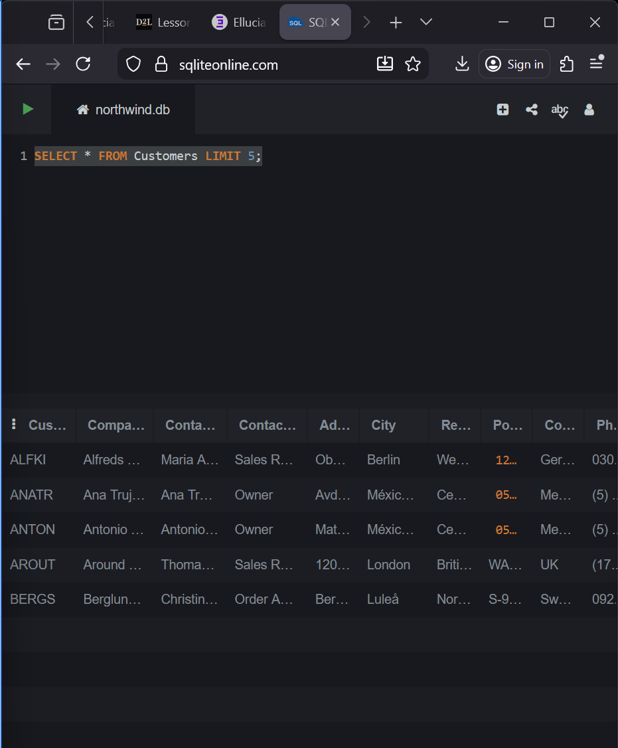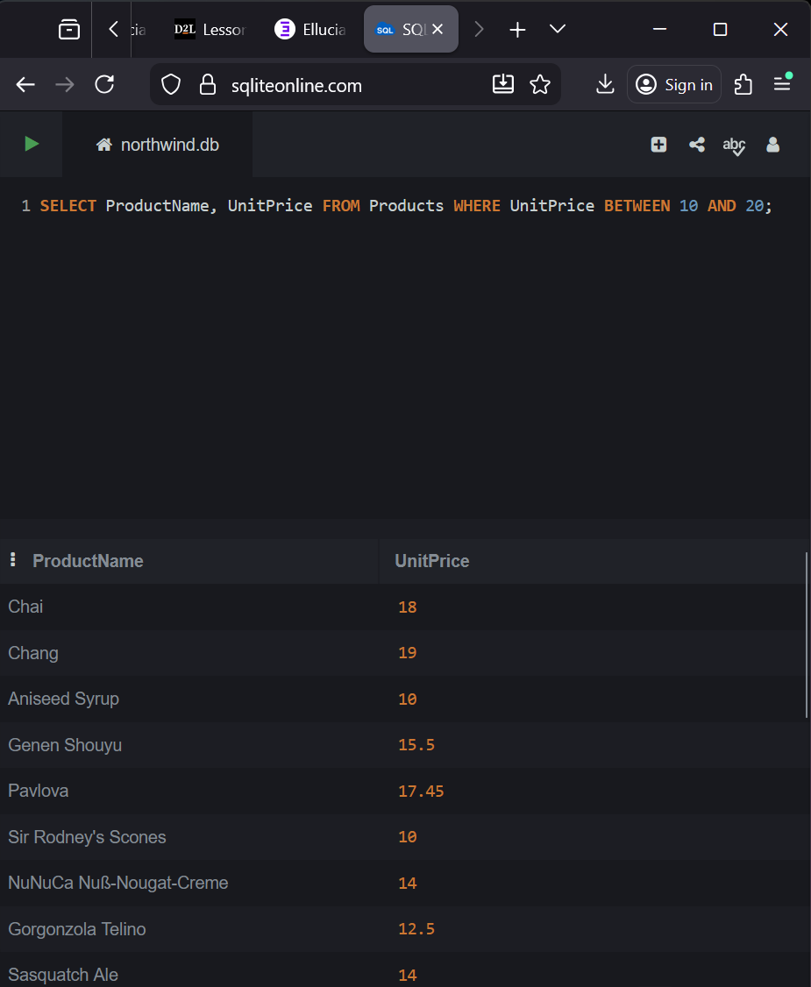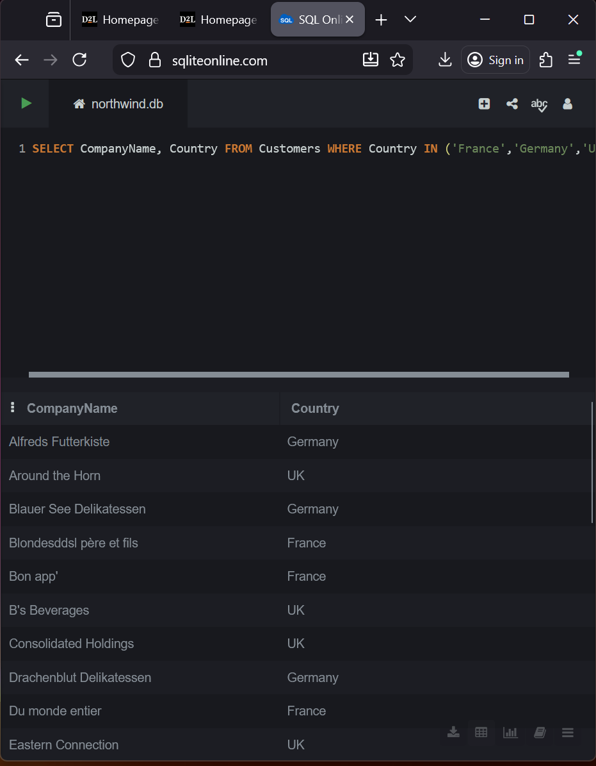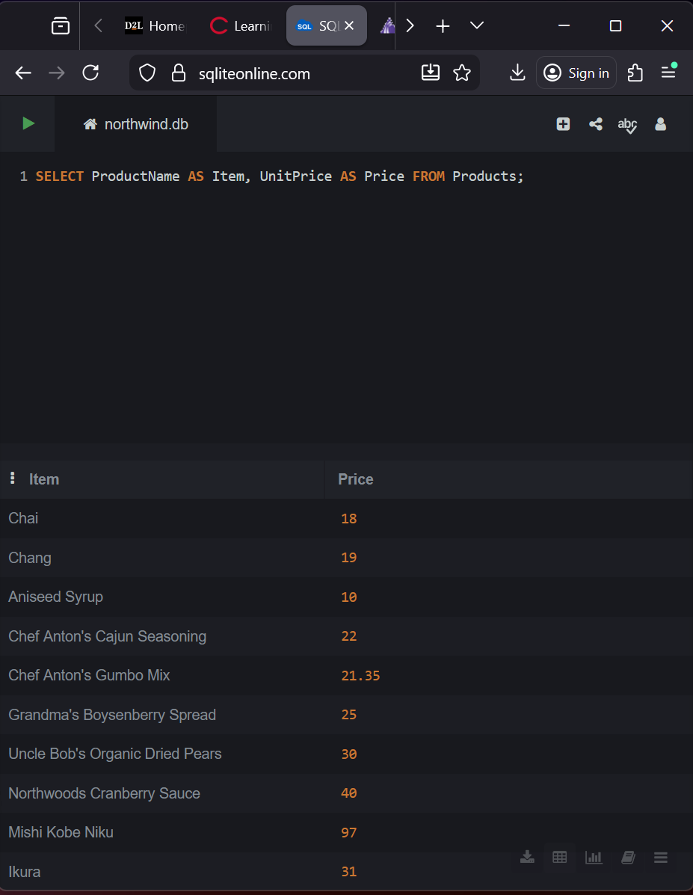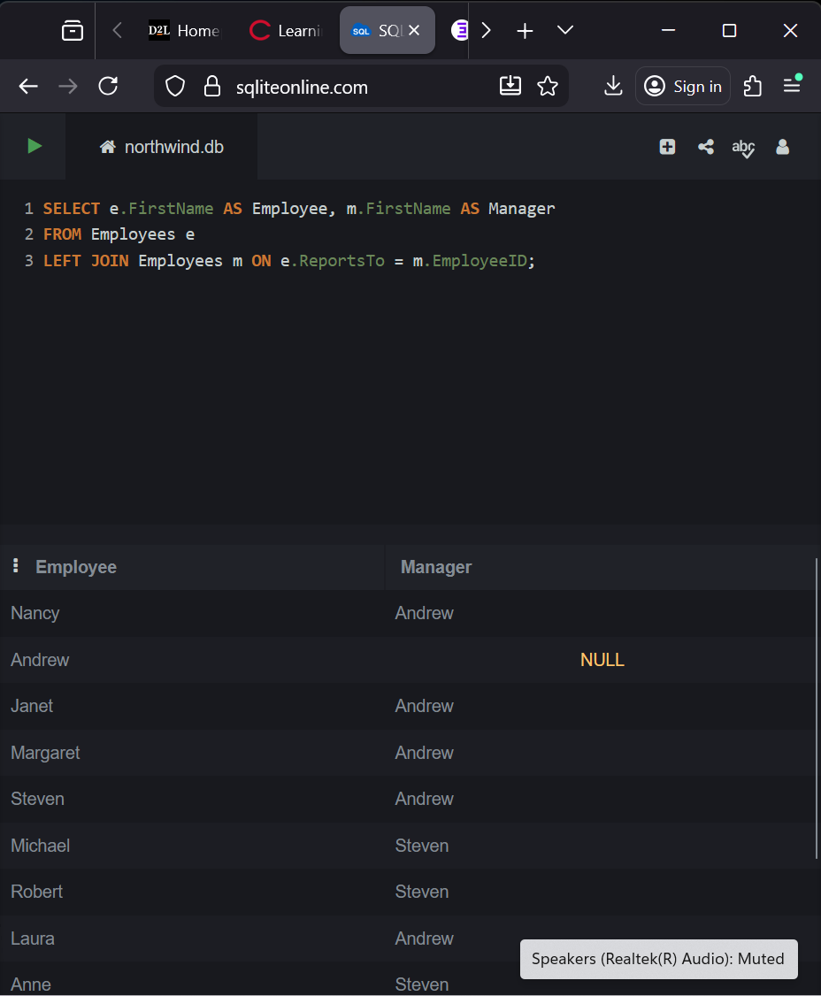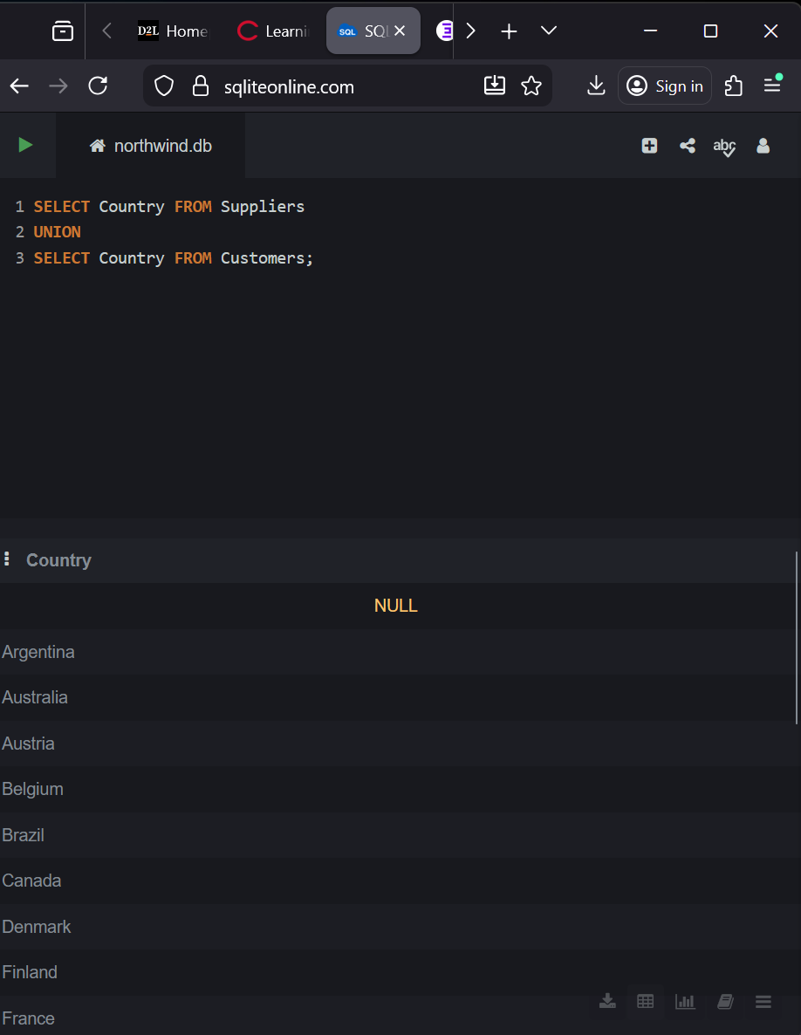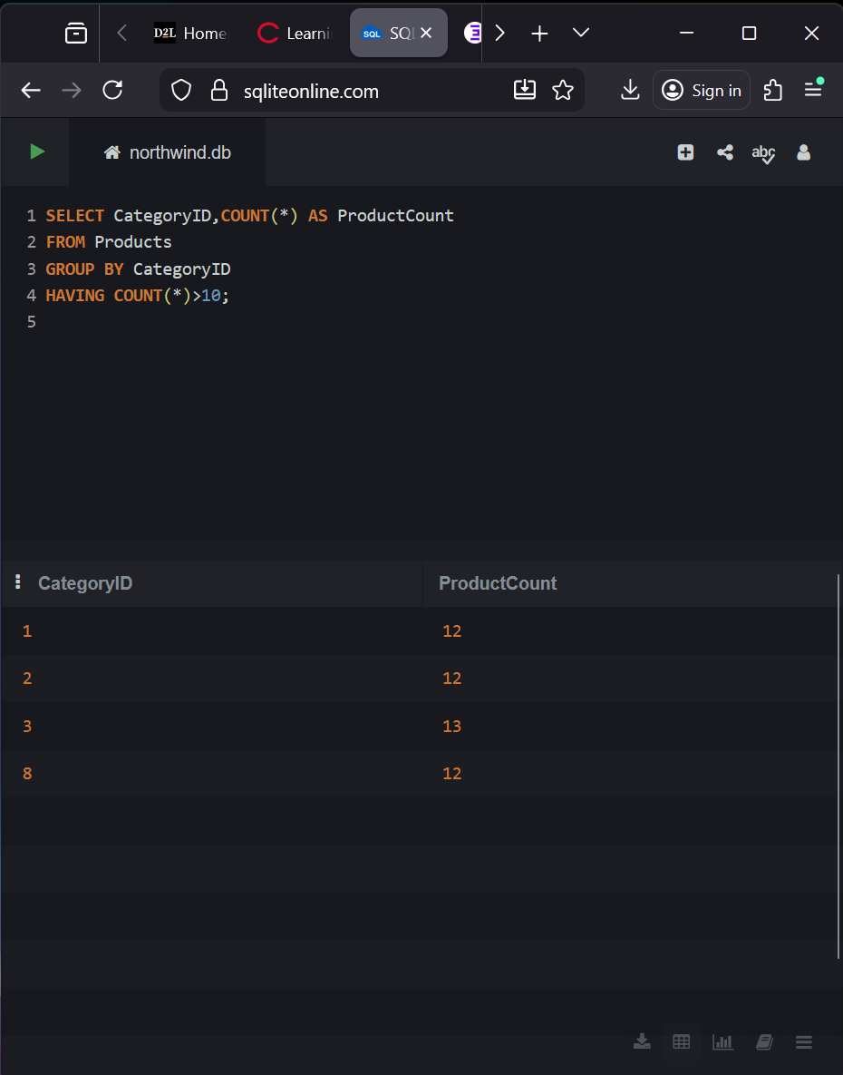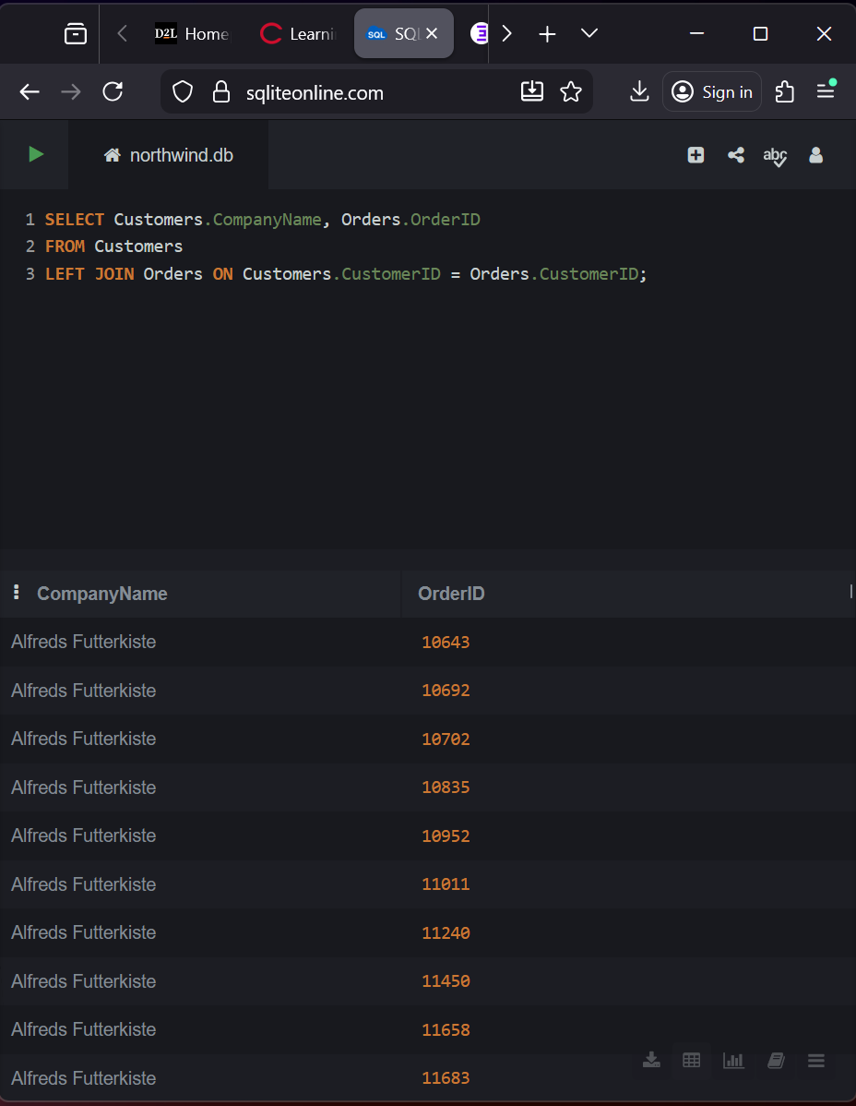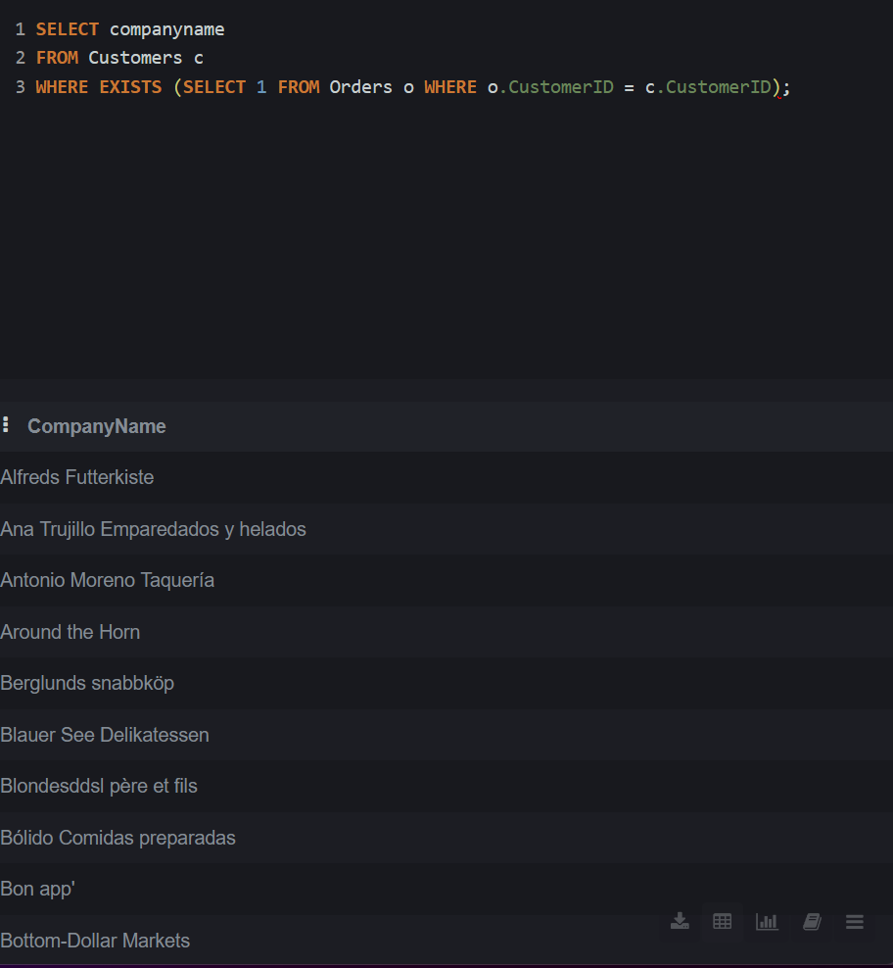

- Which countries or cities have the most customers?
USA, Germany, France
- Which customers have placed the most orders?
IT, B’s Beverages, Ricardio Adocicados
- What’s the average order value by customer or country?
Alfred Futterkiste – 744.74
- Which categories generate the most revenues
Beverages, confections, meat and poultry
- How many orders are pending, shipped, or cancelled?
Pending – 21 Shipped - 16261
- What is the average shipping time per carrier?
Federal Shipping AvgShippingDays 7.824749308314147
- Which orders cost the most in freight?
ORDER ID 13460, 587
- Who are our best shippers (most shipments, fewest delays)?
United Package, Federal Shipping, Speedy Express
- most/least expensive item?
Cote de Blaye – 263.5
Geitost – 2.5
- Which employees have handled the most orders?
Margaret – 1908, Nancy - 1846
- Who are each employee’s managers?
Nancy and Margaret - Andrew
- Which suppliers provide the most products?
Plutzer Lebensmittelgrossmarkte AG – 5
Pavolva, LTD – 5
Specialty Biscuits, LTD. - 4
- Are any suppliers located in the same countries as our customers?
Exotic Liquids – UK
New Orleans Cajun Delights – USA
Grandma Kelly’s Homestead - USA
- Which suppliers’ products are out of stock?
Chef Antons Gumbo Mix, Alice Mutton, Thuringer Rostbratwurst. Gorgonzola Telino, Parth Pasties
- What’s the total sales per month or year?
2012/07 $2066219.4

