Data Analytics: Project Report Format

This article contains the guidelines on the expected final report of your project. As much as possible, try to adhere to these general guidelines. Please note that the report should be concise but it should provide all the important information needed to evaluate your project. It looks long, but this is because it is very detailed. I recommend that you follow these guidelines. Nonetheless, there is some flexibility, and you can adjust some of the sections that are irrelevant in your case, to fit to your specific project.

If there are sections you would like to add, you are welcome to do so as long as you remain within the general framework.

General sections that should be added are:

Abstract
Introduction
Lit Review (or State-of-The-Art)
Methodology
Results
Conclusions and Future Work.

*Please add numbering into sections and subsections.

Your report for the final project should NOT exceed 40 single-spaced pages and should has at least 30 pages. NO HANDWRITTEN report will be marked.

Abstract

Brief summary of the objectives of the project and work developed (1 or 2 paragraphs).
Do not make it long! Also, conclusions should not be included here.

Acknowledgements

1. Introduction

Briefly specify the problem you are working on and give a brief background of the problem. It is recommended that you discuss in short traditional ways of solving it and related work, if you are aware of such. Give the motivation to work on this problem (why is it important?). How are you going to address it, abstractly specify how you will approach the problem carried in your report problem. (1 or 2 pages)

Things that you should include (possible subsections):
-Project Scope
-Objective
-Overview of the dissertation

2. Literature Review

Literature Review associated to your techniques (1 or 2 pages)

3. Problem definition

Formally define the problem you are addressing. That is, formally specifying the inputs and outputs, but not necessarily in the context of the specific learning system you are using).

4. Data description and data pre-processing

Which data sets are you using to train your learning system? Type, size, source. If you are using train/test/validation set, how did you split the data between these sets?

Types of Data
Think about any collected data that you have experience of; for example, weight, sex, ethnicity, job grade, and consider their different attributes. These variables can be described as categorical or quantitative.
The table summarises data types and their associated measurement level, plus some examples. It is important to appreciate that appropriate methods for summary and display depend on the type of data being used. This is also true for ensuring the appropriate statistical test is employed.
Type of data | Level of measurement | Examples
Categorical | Nominal  (no inherent order in categories) | Eye colour, ethnicity, diagnosis
Categorical | Ordinal  (categories have inherent order) | Job grade, age groups
Categorical | Binary  (2 categories – special case of above) | Gender
Quantitative (Interval/Ratio)  (NB units of measurement used) | Discrete  (usually whole numbers) | Size of household (ratio)
 | Continuous  (can, in theory, take any value in a range, although necessarily recorded to a predetermined degree of precision) | Temperature °C/°F (no absolute zero) (interval)  Height, age (ratio)

It could be divided in these points (if applicable):
- Overview of the data set.
- Data visualization (here you can include graphs, histograms, etc.)
- Missing data, outlier detection & scaling data (how do you deal with this?)
- Class imbalance (if you do classification, then explain how do you deal with class imbalance).
- Feature selection.

5. The learning systems

Describe briefly the learning systems that you have used by incorporating the following sub-sections.

a. The target function/performance measures for your type of problem

Define and show the target function employed.

b. Representation

Give the representation of the input, such as the mapping from instances to input neurons in neural network, or chromosomes representation in genetic algorithms, or vectors of attributes in decision trees.

c. System structure

For example in GAs - fitness functions, selection criterion, Crossover, mutation etc.

For neural networks - how many layers, how many hidden units, activation functions, etc.

Etc.

d. The learning algorithm

Specify and give an outline of the learning algorithm.

e. Improvements/modifications

If you introduce modifications, variations or improvements, this is the place to describe them. For example, if you employed special genetic operators for the genetic algorithm. Or if you balanced your data.

f. Explain the types of performance measures that you are using and justify why. Pros / Cons

6. Experimental Evaluation/tests/Results

Describe the experiments you did with the learning system in detail:

a. Learning

How many runs? Did you play with the parameters (list parameter sets)? What is the stopping criteria (convergence? number of iterations? threshold accuracy?)

Describe how you evaluated the performance of your system. Did you use validation set? test set? etc

b. Results & Data analysis

Give the quantitative results of your experiments using graphical data presentation such as graphs and histograms instead of confining yourself to tables. Example:
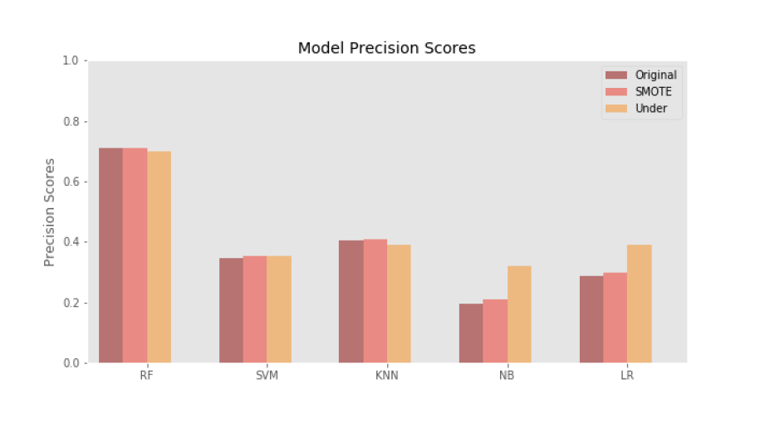
Discuss your results presented here. What observations & conclusions can the results explain in terms of the underlying properties of the algorithm and/or the data.

What are the basic properties revealed in the data. If you are using a neural network, do you have an interpretation of the weights (feature mapping)? If you are using GA and using various problem instances, is your GA problem instance dependent or independent?

What conclusions do you draw from the results about the strengths and weaknesses of one strategy over the other method(s)? Is one method uniformly superior to the other or it depends on the problem instance?

In addition, you should present specific conclusions that you consider that would be useful for the company associated with your project.

7. Concluding Remarks & Future work

Give a brief summary of the important results and conclusions presented in the report. What are the most important points illustrated by your work? What are the major shortcomings of your current method? If possible, can you propose future additions or enhancements that would help overcome the shortcomings and improve on your work.

