Cork Institute of Technology

A study on sentiment classification of news headlines using deep learning
by
Joao Tiago Viegas - R00157699

Supervised by Laura Climent
Higher Diploma in Science in Data Science and Analytics
December 2018

Attestation of authorship
This project report is the sole work of Joao Tiago Viegas unless otherwise indicated and is
submitted in the partial fulfilment of the degree of Higher Diploma in Science in Data Science
and Analytics. I understand that significant plagiarism, as determined by the examiner, may
result in the award of zero marks for the entire assignment. Anything taken from or based
upon the work of others has its source clearly and explicitly cited.
Date: 03 December 2018
Signature: Joao Tiago Viegas

Table of Contents
Attestation of authorship 1
Table of Contents 2
List of Tables 4
List of Figures 5
Dedication 6
Acknowledgements 6
Abstract 7
Chapter 1 - Introduction 8
Chapter 2 - Literature Review 10
Chapter 3 - Methodology 13
Deep Learning 13
Model Layers 13
The learning functions: loss and optimizer 15
Gradient descent 18
Dataset 20
Experimental Stages 21
Data preparation 21
class balance 21
text cleaning 22
Model definition 23
The Keras framework 23
Models ***describe functions 24
simple 3 layers model 24
3 layers with words embedding 25
3 layers with Glove pre-trained embeddings 25
One dimensional Convolutional Neural Network 25
Chapter 4 - Research Findings 26
Chapter 5 - Main Findings, Recommendations & Conclusion 27
References 29
Appendices 30

List of Tables

List of Figures

Dedication

Acknowledgements

Abstract

Chapter 1 - Introduction

In the latest years we’ve experienced an extreme growth of data in our daily lives, from Short-Message-Service(SMS), the internet, the social networks, blogs, posts, podcasts, smartphones to the Internet-of-Things (IOT) and the extensive availability of sensors and System-On-Chip solutions, it feels as if this phenomena is only starting yet.
This data is out there for us to tap into and leverage it in ways that we are still discovering nowadays.
As an example, daily news, apart from a stream of factual data and, to some degree, processed data, provide insight of what is the commonly perceived status of an entity, whether a product, an event, a person, a group or an organization, among other entities. This perceived status can convey several dimensions of information, that can be leveraged to understand the past, present and, eventually, to predict the future.
News, headlines, also tweets and social posts, can provide customer feedback to companies on how successfully their products are playing out in the market, and nudge them towards a change of their strategy to tackle unexpected hurdles and unknown variables.
To a similar extent, the info conveyed from these sources may act as a proxy for financial investor sentiment, regarding a specific corporation, and be used as a variable for predicting stock market volatility, or on its own or as an augmentation variable to other predictive models. This type of sentiment analysis, also called opinion analysis, can be defined as a Natural Language Processing (NLP) task that aims to identify the text polarity, as being positive, neutral or negative. It has been widely tested in behavioral finance, and frequently used lately by investors as an alternative tool to generate “alpha”, e.g., excess return against a benchmark.
Recently, a subfield of Machine Learning (ML) called Deep Learning (DL) has been playing a prominent role in solving NLP tasks. DL has been around for many years, but only in this decade has been recognized as an effective tool to solve historically difficult areas of machine learning.
In this study we aim to research the sentiment classification of news headlines using a set of deep learning algorithms, and then to use these same models to classify unseen data.
The input data for the research is a subset of the well known reuters dataset, data that we can categorize as financial or economics-related, ranging from January, 8th 2007 through October, 2nd 2018.
In the next chapter, a concise overview of latest researches and studies on the interrelated subjects of financial sentiment analysis, opinion analysis, machine learning and deep learning, is presented.
In Chapter 3 an explanation of the study, and it’s theoretical and technical basis, is provided. Deep Learning is introduced and the input data is described. We then describe the different stages of the experiment.
The results of the study and all the outcomes in every of the experimental stages are presented in the 4th chapter..
Finally, in the 5th chapter, we review the main findings of the study, we try to critically assess the relevance of the outcomes and a set of ideas and recommendations are lined up as a potential basis for a future work.

Chapter 2 - Literature Review

Deep Learning for Sentiment Analysis
Rojas-Barahona (2016), compiled a set of SA evaluation records across different models, recursive(i), not recursive(ii) and the combination of both(iii) on 3 datasets (movie review, the Sentiment Treebank and the twitter sentiment datasets), and concluded that on the first case CNN was the best one,
“...We have reviewed recent work on DL for SA. We presented the distinct proposed architectures and the results achieved so far. We grouped the models into three groups: (i) recursive, (ii) not recursive, and (iii) the combination of both. First, we compared the models for document‐level and sentence‐level SA, on two datasets, the movies reviews and the Sentiment Treebank, respectively. The best models on the first dataset were CNNs, showing that relevant features can be learned after applying convolutional filters. In addition, variants of LSTM are statistically indistinguishable from variants of recursive models. Models in the third group perform significantly better on the Sentiment Treebank. Unfortunately, these models were not evaluated on the first dataset. Moreover, we showed the importance of initializing the input layers with word embeddings trained on large amount of data. Indeed, CNNs were improved after initializing them with sentiment word embeddings on the SemEval‐2013 dataset. Deep learning models have been shown to perform well for polarity detection, being comparable to supervised models with features carefully designed by experts. It is clear that these are partial results of recent ongoing research, and these models will certainly be improved even more in the near future….”

Sentiment Analysis for Financial News Headlines using Machine Learning Algorithm
https://www.researchgate.net/publication/323730843_Sentiment_Analysis_for_Financial_News_Headlines_using_Machine_Learning_Algorithm
Shuhidan et al. (2018) studied various machine learning approaches in sentiment analysis of Malaysia financial news headlines. It applied both Opinion Lexicon-based algorithm and Naive Bayes algorithm to perform the sentiment analysis. In an initial phase the data was prepared, using techniques as stop word removal and stemming, before using both algorithms separately. Unfortunately there is no metrics assessment in this study

Deep Learning for Digital Text Analytics: Sentiment Analysis
Ganesh et al. (2018) applied Valence Aware Dictionary and sEntiment Reasoner (VADER) as a lexical classification approach, Support Vector Machine algorithm and Convolutional Neural Network (CNN) deep learning algorithm to a data set of news in order to identify the data with a positive sentiment and filter out the data with neutral or negative sentiment. This experiment yielded better results using CNN , with a training accuracy of 96% and a test accuracy above 85%.

A deep learning architecture for sentiment analysis
Cano (2018), presents a new neural network architecture designed for sentiment analysis of long text documents called NgramCNN, that uses pretrained word embeddings and a very simple single-layer classifier, and that achieved 91.2% accuracy on the popular IMDB movie reviews dataset. The experiment found NgramCNN to be more accurate than similar shallow convolution networks and deeper recurrent networks.
Sentiment Analysis of News Headlines for Stock Price Prediction
Kirange and Deshmukh (2016) studied the effect of emotion classification of financial news, available in the public domain, to the prediction of stock market prices. Using Naive Bayes, Knn and SVM for sentiment classification of news, they were able to establish a correlation between the sentiment and the stock price trends for a set of companies during a 10 years time span.

Big Data: Deep Learning for financial sentiment analysis
Sohangir et al.(2018) studied the impact that Deep Learning models such as LSTM, docvec and CNN can have in financial sentiment analysis. It used a dataset derived from the StockTwits social network, where investors share their info and knowledge. The conclusion underlined the best accuracy obtain by using a convolutional neural network.

Sentiment Analysis on Financial News Headlines using Training Dataset Augmentation
John and Vechtomova (2017) used text vectorization models, such as N-gram, TF-IDF and paragraph embeddings, coupled with regression model variants to predict the sentiment scores (Simple Linear Regression, Support Vector Regression, XGBoost Regression). Amongst the methods examined, unigrams and bigrams coupled with simple linear regression obtained the best baseline accuracy, and their study showed that text augmentation with content of articles and other content did not show any improvements to the accuracy of their models.

Chapter 3 - Methodology

In this chapter we aim to describe Deep Learning in general, and the used algorithms in more detail. We then describe the data used for the experiment, and the different stages of the experiment are then presented.

Deep Learning
Deep Learning (DL) is a subfield of machine learning (ML). Its rationale is to learn through a sequence of layers of increasingly meaningful representations. The “deep” in the name is related to the depth/number of these successive layers, also called the depth of the model.

Model Layers
These layers can amount to, some cases, hundreds of successive layers of representations, and in some other machine learning cases it might just aim to learn one or only two representations of the data, and are therefore sometimes called shallow learning. These layers will learn its parameters and weights automatically from exposure to training data, via neural networks, and it uses processes such as gradient descent, that we’ll describe later. In a simplified manner, we can think of these layers as equations, which parameters and weights are tuned during the training process, based on the difference on any iteration of their overall value and the desired output (training classification) which is called the loss. The tuning is most of the times done by a gradient descent, which tries to decrease this loss at every step of the training phase.
As an example of these layers and its learning process in a deep learning algorithm let’s look into one of the most common deep learning tasks, image recognition, specifically, let’s try to identify digits from images.
Taking as an example any digit representation, in this case a “4”:

fig 3.1
This image can be translated to a 28*28 matrix, where each position has a value, from 0 to 1, also called its activation value, corresponding to its “light effect” as if it is lighter or darker. Let’s think about this image as a matrix, and as the input to our deep learning network.
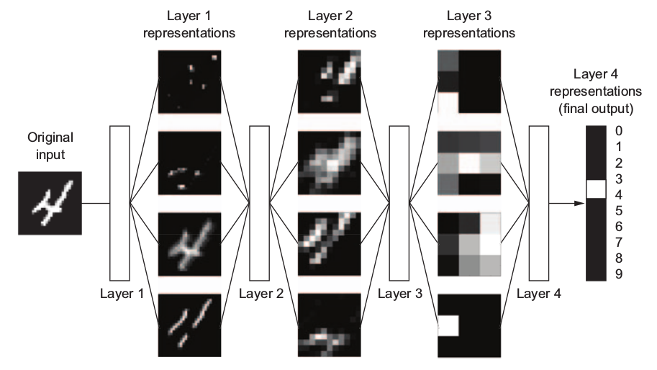
fig 3.2 (ref:dl book)
We have there one input layer, 3 hidden layers and one output layer. The hidden layers are as a set of transformation functions from the input to the output, which is in this case is nothing more than a vector, or a single column matrix, with what we call the possible classes, in this case the 10 existent digits. Here we’ll end up also with a value telling us how much the network thinks the digit is represented by input image. So the network works as a distillation operation, where the input data goes through a set of filters and becomes purified(ref: dl book), or in this case translated to a class, according to the task in question.
So thinking of an element of a layer as an equation element, with weights as parameters, any one of these elements will turn to be an input to the next layer equation. In a simplified network with one hidden layer we would have:
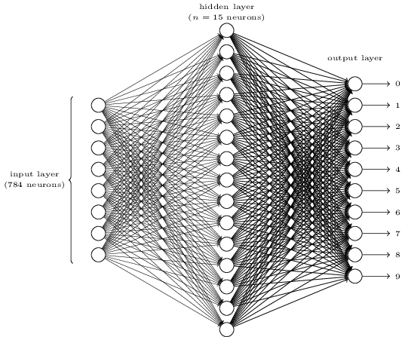
fig. 3.3 (ref: http://neuralnetworksanddeeplearning.com/chap1.html)
It is in fact a simple rationale, that when applied in scale can perform amazingly well.

The learning functions: loss and optimizer
But now one might ask, how are these transformations defined, or if we understood correctly, how are these transformations learned?
These transformations, or what the layer does to its input data, end up defined in the layer weights, which is nothing more than a vector, and this process of defining these weights in all layers, so that the network maps correctly the images to the digits, is in fact the actual learning.
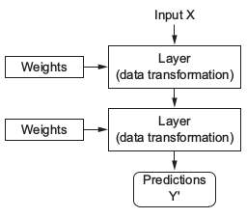
fig 3.4 weights as layers parameters (ref: dl book)

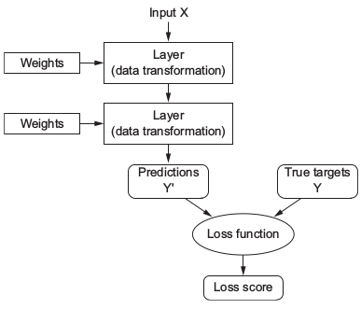
To do this efficiently, as neural networks might end up having millions of parameters, there is a loss function that measures the distance from predictions to the desired output, target values, in the training phase, in other words, assessing the quality of the output.
fig 3.5 the loss function (ref: dl book)
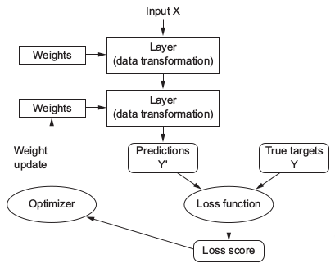
This loss function is then the feedback signal to properly adjust the layers parameters. Here the optimizer function is introduced, and it implements the backpropagation algorithm, which is the most important algorithm in deep learning. After an initial weights setup made in a random manner, the optimizer identifies the best changes to implement in the layers weights so that the network quickly minimizes its loss function outcomes.
fig 3.6 the optimizer (ref: dl book)
Before anything we also need to define the metrics, that will allow us to assess our model performance during training and testing, in terms of accuracy, recall, f1 score, etc.
The optimizer, it will at every stage notify about the ongoing state of the metrics, as it will be keeping score of the loss function at every stage.
At this point one might ask how does this optimizer implement the backpropagation and set up the best adjustment for the layers weights.
If we take the network defined in image 3.3, we have an input layer of a 28*28 = 784 dimensional vector, in which every value is the grey value for every pixel in the image.
If we take a single neuron in a layer, its output will be obtained from all the weights in the previous layer multiplied by the inputs plus a bias factor, and in the end the resulting value will be smoothed to a value somewhere between 0 and 1 by the activation function (remember the light effect on the pixel? it was between 0 and 1).
We define the output vector as y=y(x), a 10-dimensional vector. The end layer equation here can be defined as:

y = f(WX +b)  where:  f = activation function  W = weights vector  X = inputs vector  b = bias vector | (1)
So let’s define a loss function:
L(w,b) =  with:  n = number of all training inputs  a = vector of outputs | (2)
Here it’s implicit a depends on x,w and b, and it is there just to simplify the notation. We’ll call this the quadratic loss function, also known by mean squared error or just MSE.
Looking closely to the function, we see that L(w,b) is never negative. It is also simple to see that the loss function becomes small, L(w,b)≈0, when y(x) is approximately equal to a for all training inputs, which is what we want, on the other hand, we don’t want to L(w,b) to be large, that would mean that y(x) is “far away” from a for a large number of input. So our aim is to minimize the Loss L(w,b) as a function of the weights and biases, and for that we use an algorithm called gradient descent.

Gradient descent
Gradient descent is a common technique used in minimization problems and we’ll provide a generic introduction to it in this section.
Supposing we want to minimize some function, L(v), with variables v= , let’s imagine L as function of just two variables, and .
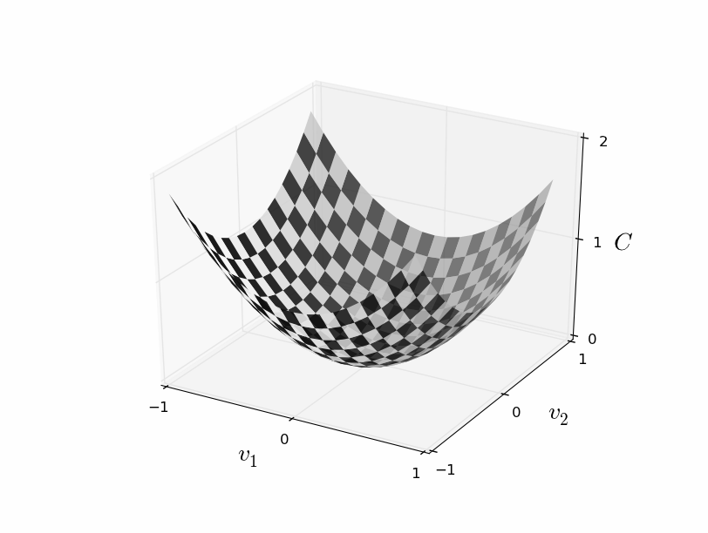
fiig 3.7 gradient descent surface on variables and (ref: http://neuralnetworksanddeeplearning.com/chap1.html)
In this case we want to find the minimum value of L, depicted as the surface above the variables space defined by and , of course the case of two variables is a simple one, but in cases where the number of variables is considerable higher, as in most cases of neural networks, this task is non trivial, even calculus won’t help. The gradient descent works by randomly choosing a starting point, and then based on the gradient vector lets us step by step approximate to the minimum.
( | (3)
This way with the gradient vector we can always figure out what movement allows us to minimize our position, finding a route to slide down in the function surface.
There are further details on the gradient descent that are not covered in this document, the reader is referred to the references for additional sources of info.

Convolutional Neural Networks
In this section we’ll introduce convolutional neural networks, using a simple example.
Let’s imagine that there were 4 ways of expressing emotion with what we are now going to define as images:
X / \ O
these 4 images can be described by a 3*3 matrix, and therefore we have
1
-1
-1
-1
1
-1
-1
-1
1
\
1
-1
1
-1
1
-1
1
-1
1
X
-1
-1
1
-1
1
-1
1
-1
-1
/
-1
1
-1
1
-1
1
-1
1
-1
O
fig x - simplified example of training data for a convolutional neural network
Our problem is we want to identify these images. And for a start let’s assume there is a previous knowledge that the model has already developed through training, in the form of sub-patterns with lower dimension, in this case 2*2 matrices:
-1
-1
1
1
1
1
-1
-1
\
/
fig x - simplified example for set of filters of a convolutional neural network
with this knowledge we can identify these patterns in the original messages and later map those findings to the correct emotion.

fig x - simplified example of a convolutional neural network model
1
-1
1
-1
1
-1
1
-1
1
-1
-1
1
-1
1
-1
1
-1
-1
-1
1
-1
1
-1
1
-1
1
-1
1
-1
-1
-1
1
-1
-1
-1
1
\
\
/
/
/
/
\
\
\
\
/
/
O
X
/
\
convolution layer
+
pooling layer
fully connected layer
In the convolutional neural network, in a first stage the convolutional layer and the pooling layer, split the image in pieces and match the known patterns, called filters, to the image data, it will then output a kind of map, made of that matching information. The fully connected layer then uses logic to relate that map with the images, as if the input map it receives is a transformed set of variables of the initial image data.
Convolutional neural networks are therefore combinations of pairs of convolution+pooling layers and fully, dense connected layers, but its inner rationale is still the same as explained before for deep learning networks, the convolutional and the dense layers do have an activation function, and the network learning is still driven by the loss and the optimizer functions.

Dataset
The data we used in this study are the news headlines retrieved from the US Reuters site using an available github project to retrieve and compile the data (ref. to https://github.com/philipperemy/Reuters-full-data-set). This data was then filtered out in order to use a subset that contained news related to a specific company, in this case International Business Machines (IBM), and the dates range from January, 8th 2007 through October, 2nd 2018. The dataset has 9385 observations, with the variables id, timestamp, headline and classification. The reason for this subset definition is that the author of this document wants in a future development of this study to relate these sentiment analysis outcomes with the history of this specific company stock market price.
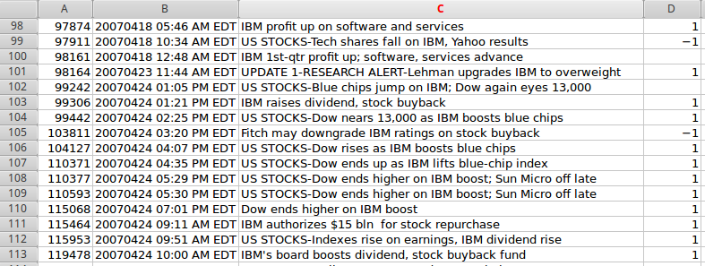
The data was then classified according to its perceived sentiment, using three classes: positive(1), neutral(0) and negative(-1). This task has undoubtedly a level of subjectiveness, as in certain cases it is hard to grasp the exact polarity of the text. By polarity we mean in what extent does the text conveys positive information regarding the financial health of the company or in terms of its attractiveness as possible investment product in the long term. We also included in this class any event regarding new technologies rollout/research or new business deals/agreements. In this light, we would classify as positive the following news headlines:
- “Dow ends higher on IBM boost”;
- “Red Hat, IBM form mainframe partnership”;
- “IBM, Chartered, Samsung unite on chip development”;
- “IBM profit up on software and services”;
We would accordingly classify the following headlines as negative:
- “US STOCKS-Tech shares fall on IBM, Yahoo results”;
- “IBM to cut 1,315 jobs in U.S.”;
- “SEC says IBM misled investors on expenses”;
- “US STOCKS-Dow turns negative as United Tech, IBM drag”;
All the remaining headlines were classified as neutral.
Be noted that before training our models we’d removed the word IBM from all the texts, so that it would not be taken into account, and that eventually we could test the model in other datasets.

Experimental Stages

Data preparation
For the purpose of the experient we’ve removed the id and timestamp columns, so we’ve ended with two columns only, the headline text and its classification.
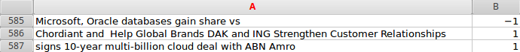
fig...

class balance
Overall the distribution of the dataset classification was imbalanced.
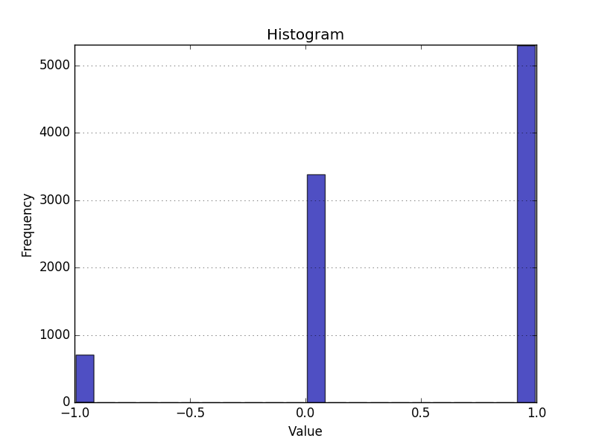
fig…
We had then to oversample the training data. We’ve thought to use SMOTE as an oversampler that creates new synthetic data, but due to the nature of the experiment, text classification, we found that it would be more precise to use a simple oversampler, as synthetic generated data would not make any cognitive sense in terms of text, and therefore we’ve replicated the classes so that all had the same number of samples.

text cleaning
Before translating the sentences to a matrix format we’ve applied a sequence of transformations on the text, we’ve identified and removed punctuations, remopved dangling apostrophes with suffixes, we’ve then lowercased it to properly remove stop words and to lemmatize the tokens.
We also shuffled the data at every experiment run.

Model definition
In this study code we’ve used the Keras library (http://keras.io) which is a deep learning framework for Python. We will now introduce Keras and later we’ll describe the different deep learning models used in this study.

The Keras framework
Keras provides an easy way of setting up almost any kind of deep learning model, with an user friendly API. Keras runs seamlessly on CPU or GPU, has built-in support for convolutional networks, recurrent networks and any combination of both, and is appropriate to build any deep learning model, from a generative adversarial network to a neural Turing machine. It has also large adoption in the academic community and more than 200,000 users, it is also very popular in Kaggle, where recently almost any deep learning competition has been won using Keras models.
We can think of Keras as a high-level level library to develop deep learning models, it relies on other libraries to handle low-level tensor (multi-dimensional arrays) operations, and allows different of these backend libraries to be plugged seamlessly into Keras.
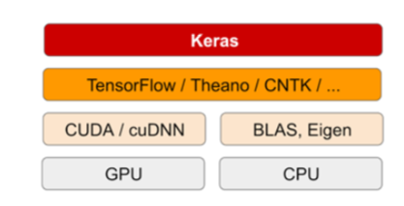
fig…(ref dl book)
The reader is referred to the references for additional source of info on Keras.
To develop a deep learning model with Keras framework, and in line with the methodology presented before, there is a common workflow encompassing 5 steps:
- define training data: input and output tensors;
- define the layers network that will connect the input to the desired output;
- choose the metrics, loss function and the optimizer function in order to learn from the data;
- run your data through the model, using the model fit() function;
- evaluate the model against test data

In a simple example with three layers:
x_train, y_train, x_val, y_val, x_test, y_test = load_data() | step 1
model = Sequential()  model.add(Dense(32, activation='relu', input_shape=(input_size,)))  model.add(Dense(32, activation='relu'))  model.add(Dense(3, activation='softmax')) | step 2
model.compile(optimizer='rmsprop', loss='categorical_crossentropy',metrics=['acc', recall]) | step 3
model.fit(x_train,y_train,epochs,batch_size,validation_data=(x_val,y_val)) | step 4
model.evaluate(x_test,y_test) | step 5

Based on this workflow, we’ve assessed a set of different models, testing different configurations, on the news headlines data set, which we’ll detail in the following section.

Models
In this study we’ve used a small set of networks, at maximum with two hidden layers (the ones between the input and output layers), except for the convolutional network.

Common characteristics of the models
Mostly we’ve tried simple Dense layers with the ‘relu’ activation function, as it is the most popular in deep learning (ref to dl book), with the exception of the output layers though, where we have applied the ‘softmax’ activation function that generates a probability vector matching the output classes and with values summing to 1, which is the most adequate for this case where the classes output probabilities are not independent.
Regarding the loss function, as we are dealing with a multiclass problem ( remember: positive, neutral and negative ), we are using the categorical_crossentropy function, which is a common selection in this case.
It is relevant the fact that in some models we are using a word embeddings layer, which is a optimized way of translating text to a vector, leading to lighter, more dense vectors as opposed to sparse vectors created with other techniques as, for instance, one-hot encoding technique.
In most of the cases we are using the Keras library Embedding layer that does the transformation from a sentences matrix and its word index to an embeddings dense matrix , in one case though we’ve tested with a pretrained embeddings layer (“3 layers with Glove pre-trained embeddings”), called the Global Vectors for Word Representation (https://nlp.stanford.edu/projects/glove) which was developed by Stanford researchers.
We use the same set of metrics across all the models, accuracy, recall, precision and f1-score.
Remembering the confusion matrix in a binary classification problem, for the sake of simplicity:

 | predicted value
actual value | values | yes | no
actual value | yes | true positive (TP) | false negative (FN)
actual value | no | false positive (FP) | true negative (TN)
table xx- confusion matrix
the definition of the metrics are then:

model: simple 3 layers

layers | learning
Dense(32, activation='relu')  Dense(32, activation='relu')  Dense(3, activation='softmax') | optimizer: rmsprop
 | loss: categorical_crossentropy
 | metrics: accuracy, recall, precision, f1_score

model: 3 layers with words embedding

layers | learning
Embedding(...)  Flatten()  Dense(32, activation='relu')  Dense(3, activation='softmax') | optimizer: rmsprop
 | loss: categorical_crossentropy
 | metrics: accuracy, recall, precision, f1_score

model: 3 layers with Glove pre-trained embeddings

layers | learning
Embedding(...)  Flatten()  Dense(32, activation='relu')  Dense(3, activation='softmax') | optimizer: rmsprop
 | loss: categorical_crossentropy
 | metrics: accuracy, recall, precision, f1_score

model: one dimensional Convolutional Neural Network

layers | learning
Embedding(...)  Conv1D(64, 12, activation='relu')  MaxPooling1D(3)  Conv1D(64, 12, activation='relu')  GlobalMaxPooling1D()  Dense(3) | optimizer: rmsprop
 | loss: categorical_crossentropy
 | metrics: accuracy, recall, precision, f1_score

Chapter 4 - Research Findings

model: simple 3 layers

model: 3 layers with words embedding

model: 3 layers with Glove pre-trained embeddings

model: one dimensional Convolutional Neural Network

Chapter 5 - Main Findings, Recommendations & Conclusion

=============================================================
=============================================================
=============================================================
“...Dealing with the of identification of sentiments hidden behind the news data is not an easy task as the sarcasm behind the news data cannot be evaluated by a normal human himself/herself if they are not aware of events happening around them. News which has been crawled between a specific period does not include the dependencies associated with it. The synopsis here is that the classification of positive and negative news depends entirely on a common users point of view and his/her awareness about the happenings. In such a state defining the positive/negative news are difficult, but news which contains negative shade in it could be identified to some extent and sent for reviewing (human…”

The input data for the research is a subset of the well known reuters dataset, data that we can categorize as financial or economics-related, ranging from January, 8th 2007 through October, 2nd 2018.
The data used for this purpose is a subset from the reuters dataset, obtained from an unofficial source (https://github.com/philipperemy/Reuters-full-data-set), filtered out by selecting the headlines related with a specific company, IBM in this case, and ranging from January, 8th 2007 through October, 2nd 2018.
The reason for this subset is that the author of this document wants in a future development of this study to relate these sentiment analysis outcomes with the history of this specific company stock market price.

“...Recently, deep learning (DL) has been proposed to solve different NLP tasks (Collobert et al., 2011). Its main advantage is that, contrary to supervised learning, it does not require manually tuned features based on expert knowledge and available linguistic resources....”
“...Three levels of SA have been presented in Liu (2012): (i) document level, (ii) sentence level, and (iii) entity and aspect level. Document level studies the polarity of a document with respect to a single entity (e.g., a product). Sentence level studies the polarity of sentences, analyzing clauses and phrases….”
“...One major difficulty is that the judgment of the polarity of an opinion can be subjective. Humans, for instance, usually disagree when judging the sentiment of a sentence, typically reaching only modest inter‐annotator agreement (Bermingham & Smeaton, 2009). Moreover, polarity has to be interpreted within a context (contextual polarity). Thus, the polarity of a word can be modified in a sentence due to linguistic phenomena such as negation, modality, intensifiers, diminishers, and word sense (Wilson et al., 2005)....”

References

Bibliography (optional)

Appendices

Formatting
12-point type on A4 paper, single sided, pages numbered consecutively, one and a half or double spacing. Hard copy and soft copy to be submitted.

