Assignment 1 – part 2
Joao Tiago Viegas
student n:R00157699

a) Nodes Sketch

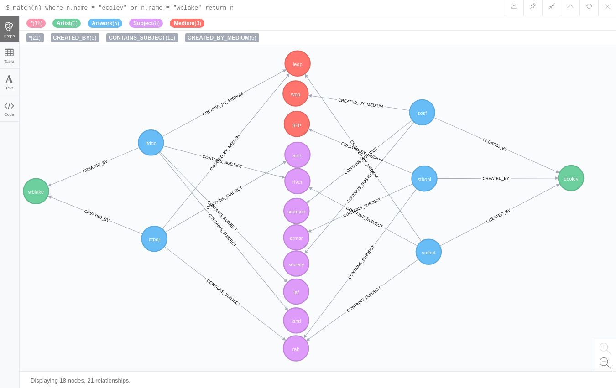
The nodes description is better defined by its creation command:
- artists: CREATE (wblake:Artist {name:'wblake', fullname:'William Blake', born:1757, birthplace: 'London'}), (ecoley:Artist {name:'ecoley', fullname:'Sir Edward Coley Burne-Jones, Bt', born:1833, birthplace: 'Birmingham'})
- artworks: CREATE (ittboj:Artwork {name:'ittboj',fullname:"Illustrations to 'The Book of Job'"}), (itddc:Artwork {name:'itddc',fullname:"Illustrations to Dante's 'Divine Comedy'"}), (sothot:Artwork {name:'sothot',fullname:"Study of the Head of Tristram"}), (sosf:Artwork {name:'sosf',fullname:"Study of Seated Figure"}), (stboni:Artwork {name:'stboni',fullname:"St Boniface"})
- mediums: CREATE (leop:Medium {name:'leop',fullname:'Line engraving on paper'}) , (gop:Medium {name:'gop',fullname:'Graphite on paper'}), (cop:Medium {name:'cop',fullname:'Chalk on paper'}), (wop:Medium {name:'wop',fullname:'Watercolour on paper'})
- subjects: (rab:Subject {name:'rab',fullname:'religion and belief'}) , (arch:Subject {name:'arch',fullname:'architecture'}) , (laf:Subject {name:'laf',fullname:'literature and fiction'}) , (land:Subject {name:'land',fullname:'landscape'}) , (river:Subject {name:'river',fullname:'river'}) , (society:Subject {name:'society',fullname:'society'}) , (armsr:Subject {name:'armsr',fullname:'arms raised'}) , (boat:Subject {name:'boat',fullname:'boat'}) , (seamon:Subject {name:'seamon',fullname:'sea monsters'}), ...

b) Nodes added

I’ve added extra nodes for mediums and subjects, as they are shared between several of the artworks. The case for the subjects is probably more prone to discussion due to its higher cardinality, but this solution, to define it as a relationship instead of a property, improves the queries perfomance;

c) queries

- match(n:Artwork)-[:CREATED_BY]->(a:Artist) where a.birthplace='Edinburgh' return n
- match(n:Artwork)-[:CONTAINS_SUBJECT]->(s:Subject) where s.fullname="arms raised" or s.fullname="royalty" or s.fullname="sea monsters" return n
- match (s:Subject)<-[:CONTAINS_SUBJECT]-(n:Artwork)-[:CREATED_BY_MEDIUM]->(m:Medium) where m.name="wop" and s.fullname="boat" and n.name <> "sosf" return n

