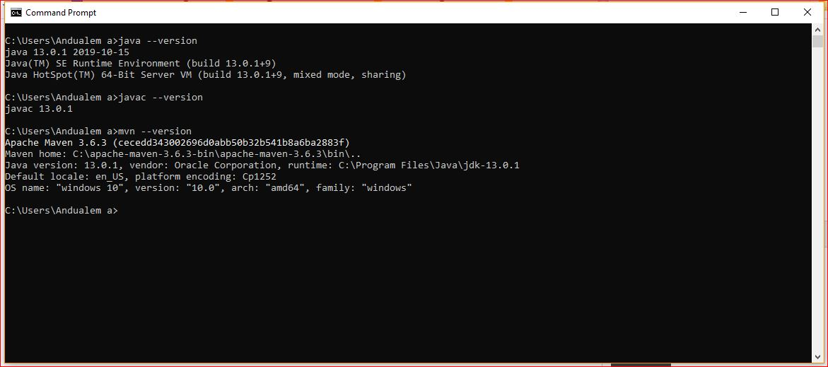

Picture 1: confirmation of java installation and maven configuration

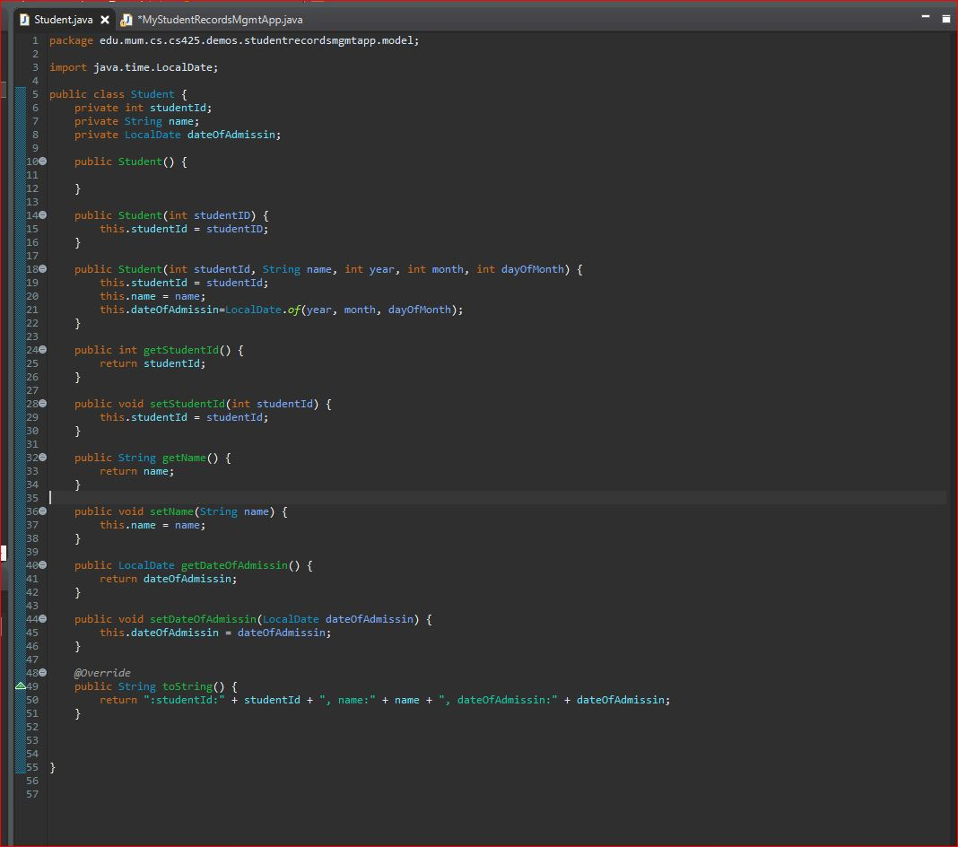

Picture 2.1 Student class

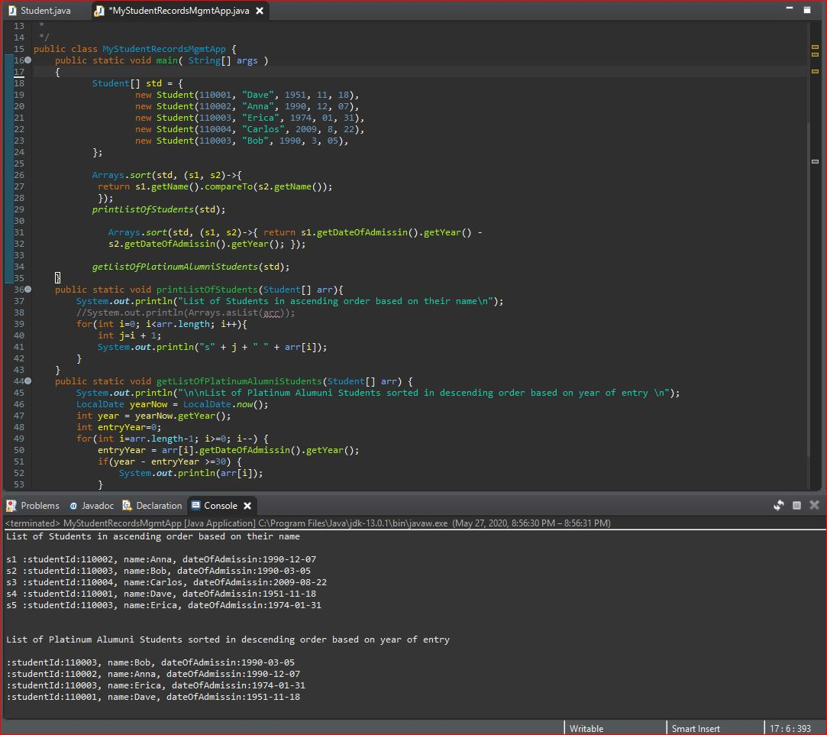

Picture 2.2 Student class application with output

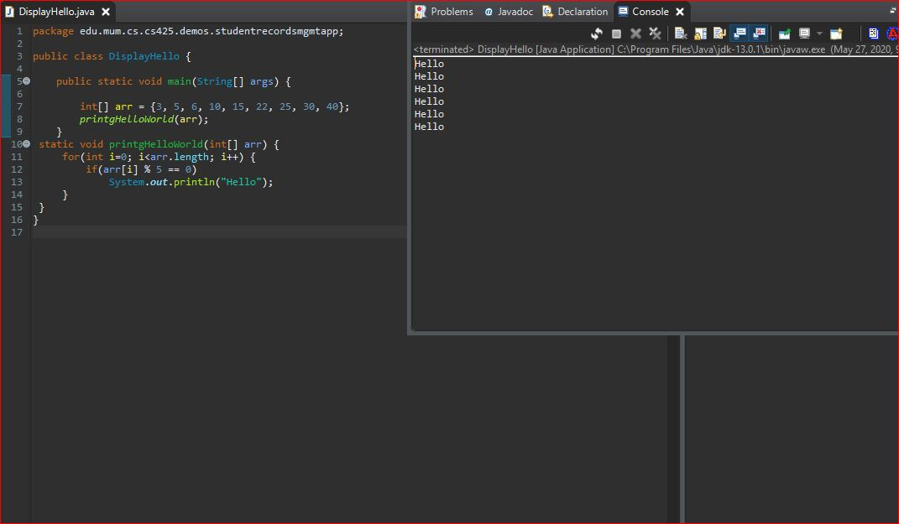

Picture 3: Display hello if a number from array is multiple of 5

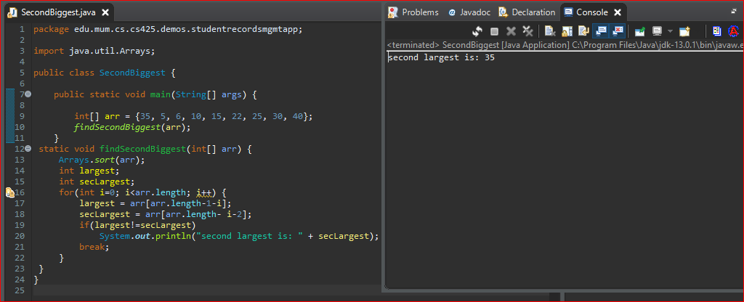

Picture 4: Find the second largest number