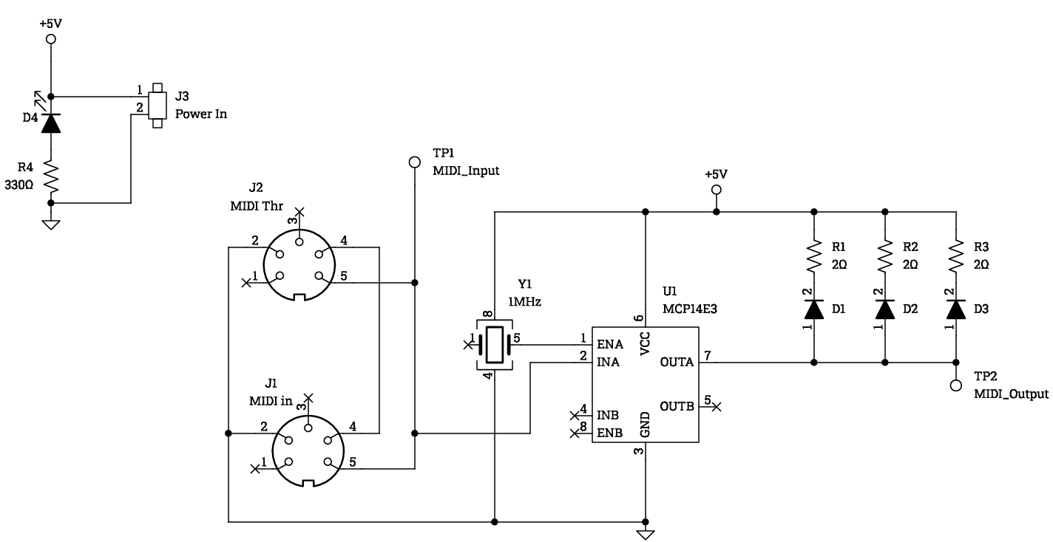
Figure One – MIDI IR Tx Rev B
To troubleshoot this circuit first ensure there is power to the board by seeing if D4 is lit. If D4 is lit, verify the power in is +5V, if this is not the case the external power supply is faulty. If both D4 is lit and +5V is present, apply a MIDI signal to the circuit and check the output for a signal. If the output (TP2) is as shown in figure x then the circuit is running normally. If the output is not normal verify a 31.25KHz MIDI signal is present at Pin 1 on the MCP14E3. If there is no signal at this pin verify you are sending a MIDI signal to the circuit and J1, MIDI in, is properly connected/soldered to the circuit. If the MIDI signal is at Pin 1 but there is no output signal, verify the crystal (Y1) is outputting a 50%DTC 1MHz signal. IF it is not verified it has power. If the crystal has +5V and ground but has no output replace the crystal. If the crystal is producing a signal and there is still no output waveform, ensure the MCP has +5V and ground. If the device has power, valid inputs but no output the device has failed and needs to be replaced. If U1 has no power, verify the physical solder connections.

