**Intel GPU and browser compatibility solutions**

Solutions 1

Update your computer system drivers and browser to the latest version

Solutions 2

Make sure your GPU is not blacklisted by your browser. To enable ignore blacklist

1. In the address bar, type: chrome://flags/#ignore-gpu-blocklist and press enter
2. Set this parameter to enable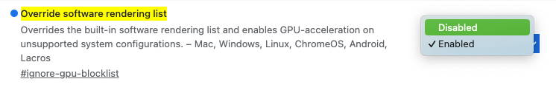

Choose the right "Angle graph"

1. In the address bar, type: chrome://flags/#use-angle and press enter
2. Select the Angle compatible with the video card (try one by one) and follow the prompts to effect the settings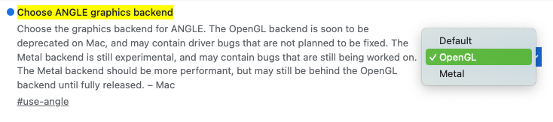

Solutions 3（Not recommend）

Turn off GPU acceleration

1. Go to the browser Settings page and search for GPU acceleration or image acceleration
2. Turn it off and follow the prompts to take effect