電通二甲微處理器實驗 實驗結報

實驗名稱 | Lab 06 – 音樂教室
組別 | 8 | 組員 | 陳冠宇03050052 / 沈揚智03051030

- 實驗目的
如何使 Arduino 發出特定旋律的聲音?
1. Arduino 接喇叭如何接線?
2. 如何使用 tone library?
3. 如何演奏一段音樂?
4. 如何使用 4x4 鍵盤演奏音樂?
5. 如何發報摩斯電碼?
- 實驗步驟
*Arduino 演奏一段特定的音樂, 旋律不得是小蜜蜂
* 使用 4x4 鍵盤演奏音樂
* 發報摩斯電碼
- 程式碼
Checkpoint1
int melody[] = {
NOTE_C4, NOTE_G3,NOTE_G3, NOTE_A3, NOTE_G3,0, NOTE_B3, NOTE_C4};
// note durations: 4 = quarter note, 8 = eighth note, etc.:
int noteDurations[] = {4, 8, 8, 4,4,4,4,4 };
void setup() {
int noteDuration = 1000/noteDurations[thisNote];
tone(8, melody[thisNote],noteDuration);
int pauseBetweenNotes = noteDuration * 1.30;
delay(pauseBetweenNotes);
// stop the tone playing:
noTone(8);
}
}
Checkpoint2
void loop() {
for (int x=0; x<length; x++)
x = xxxxxxxxx; // (如何透過 4x4 鍵盤讀出0 – 15?)
if (x!= NOKEY) { // 有按下按鍵
tone(8, tune[x]);
* delay(2500 *duration[x]); //改為固定的值(例如0.5 sec)
noTone(8);
}
delay(5000);
}
Checkpoint3
char *morse[]={
"01","1000","1010","100",
"0","0010","110","0000",
"00","0111","101","0100",
"11","10","111","0110",
"1101","010","000","1",
"001","0001","011","1001",
"1011","1100"};
實驗結果與分析
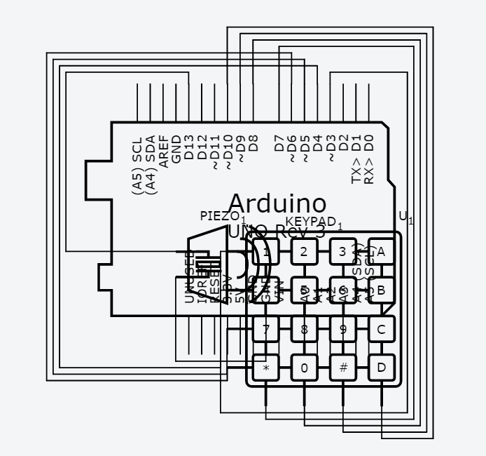
- 心得討論

這次的實驗重點在於如何讓蜂鳴器產生出對的頻率，還有就是要讓他發出一首歌曲，得要去注意他的音長，才能完美的發出我們要的歌曲。

- 程式碼
CHECKPOINT1
#include "pitches.h" // 引入音調的標頭檔 (包含8個八度音)
const byte Buzzer = 13; // 蜂鳴器的接腳 D10
const int rhythm = 500; // 定義每1拍的音長(ms)
int duration=200;
char index; // 音樂盒資料的讀取指標
int SoundLeng; // 音長的變數
char song_tone; // 音高的變數
char ch;
// 宣告一個第4 & 第5八度音 Do~Si 的音高陣列
int pitch[] = { 0,
NOTE_C4,NOTE_D4,NOTE_E4,NOTE_F4,NOTE_G4,NOTE_A4,NOTE_B4,
NOTE_C5,NOTE_D5,NOTE_E5,NOTE_F5,NOTE_G5,NOTE_A5,NOTE_B5 };
// 宣告歌譜的陣列資料, 第一筆為音高, 第二筆為音長, 結束代碼為-1
float song[] = {5,0.5, 1+7,0.5, 2+7,0.5, 3+7,0.5, 2+7,0.5, 3+7,0.5,
4+7,0.5, 5+7,0.5, 5+7,0.5, 5+7,0.5, 4+7,0.5,
3+7,0.5,
2+7,0.5, 2+7,1, 0,0.5, 5,0.5, 1+7,0.5, 2+7,0.5,
3+7,0.5,
2+7,0.5, 3+7,0.5, 4+7,0.5, 5+7,0.5, 5+7,0.5,
5+7,0.5,
6+7,0.5, 5+7,1, 2+7,0.5, 3+7,0.5, 1+7,1, 1+7,0.5,
6,0.5,
2+7,0.5, 2+7,0.5, 3+7,0.5, 3+7,0.5, 1+7,1, 5+7,0.5,
1+7,0.5, 5,0.5, 1+7,0.5, 7,0.5, 1+7,0.5, 0,1,
1+7,0.5,
6,0.5, 2+7,0.5, 2+7,0.5, 3+7,0.5, 3+7,0.5, 4+7,0.5,
4+7,0.5,
4+7,0.5, 3+7,0.5, 2+7,0.5, 1+7,0.5, 1+7,1, -1};

void setup() {
pinMode(Buzzer,OUTPUT);
Serial.begin(9600);
}

void loop() {
index=0; //指標歸 0, 從歌曲陣列song的第 0 筆開始讀取並發音
while (1) {
song_tone = char(song[index]); //讀出歌曲陣列中的音高
index++; //指標加 1
SoundLeng = int(song[index]*rhythm); //讀出音長並計算
index++; //指標加 1
if (song_tone==-1) //若是結束代碼-1, 則跳出 while 迴圈
break;
else if (song_tone==0) //休止符的處理
delay(SoundLeng*1.3); //暫停指定的音長時間(不發聲)
else {
tone(Buzzer, pitch[song_tone], SoundLeng); //讀出音高對應的頻率並發聲
delay(SoundLeng*1.3); //暫停指定的音長時間
}
}
}

CHECKPOINT2
#include <Keypad.h>
#include "pitches.h"
const byte ROWS=4;
const byte COLS=4;
int duration=200;
const byte Buzzer=13;
const int rhythm=500;
char index;
int SoundLeng;
char song_tone;
char ch;
char keys[ROWS][COLS]={
{'F','E','D','C'},
{'B','3','6','9'},
{'A','2','5','8'},
{'0','1','4','7'}
};
byte rowPins[ROWS]={7,8,9,10};
byte colPins[COLS]={3,4,5,6};
int
pitch[]={0,NOTE_C4,NOTE_D4,NOTE_E4,NOTE_F4,NOTE_G4,NOTE_A4,NOTE_B4,
NOTE_C5,NOTE_D5,NOTE_E5,NOTE_F5,NOTE_G5,NOTE_A5,NOTE_B5};

Keypad keypad = Keypad(makeKeymap(keys), rowPins, colPins, ROWS,
COLS);

void setup() {
pinMode(Buzzer,OUTPUT);
Serial.begin(9600);
}
void loop() {
char key = keypad.getKey();
if(key!=NO_KEY){
switch(key){
case '0':
tone(Buzzer,NOTE_B5,duration);
break;
case '1':
tone(Buzzer,NOTE_C4,duration);
break;
case '2':
tone(Buzzer,NOTE_D4,duration);
break;
case '3':
tone(Buzzer,NOTE_E4,duration);
break;
case '4':
tone(Buzzer,NOTE_F4,duration);
break;
case '5':
tone(Buzzer,NOTE_G4,duration);
break;
case '6':
tone(Buzzer,NOTE_A4,duration);
break;
case '7':
tone(Buzzer,NOTE_B4,duration);
break;
case '8':
tone(Buzzer,NOTE_C5,duration);
break;
case '9':
tone(Buzzer,NOTE_D5,duration);
break;
case 'A':
tone(Buzzer,NOTE_E5,duration);
break;
case 'B':
tone(Buzzer,NOTE_F5,duration);
break;
case 'C':
tone(Buzzer,NOTE_G5,duration);
break;
case 'D':
tone(Buzzer,NOTE_A5,duration);
break;
case 'E':
tone(Buzzer,NOTE_B5,duration);
break;
case 'F':
tone(Buzzer,NOTE_B5,duration);
break;
}
}
}
CHECKPOINT3
#include <Keypad.h>
#include "pitches.h"
const byte ROWS=4;
const byte COLS=4;
int duration=200;
const byte Buzzer=13;
const int rhythm=500;
char index;
int SoundLeng;
char song_tone;
char chr;
char *ptr;
char keys[ROWS][COLS]={
{'F','E','D','C'},
{'B','3','6','9'},
{'A','2','5','8'},
{'0','1','4','7'}
};
byte rowPins[ROWS]={7,8,9,10};
byte colPins[COLS]={3,4,5,6};
int
pitch[]={0,NOTE_C4,NOTE_D4,NOTE_E4,NOTE_F4,NOTE_G4,NOTE_A4,NOTE_B4,
NOTE_C5,NOTE_D5,NOTE_E5,NOTE_F5,NOTE_G5,NOTE_A5,NOTE_B5};

char *morse[]={
"01","1000","1010","100",
"0","0010","110","0000",
"00","0111","101","0100",
"11","10","111","0110",
"1101","010","000","1",
"001","0001","011","1001",
"1011","1100"};

Keypad keypad = Keypad(makeKeymap(keys), rowPins, colPins, ROWS,
COLS);

void setup() {
pinMode(Buzzer,OUTPUT);
Serial.begin(9600);
}
void loop() {
if (Serial.available()){
chr = Serial.read();
Serial.print(chr);
if((chr-'A')>=0 && (chr-'Z')<=0){
index=chr-'A';
ptr=morse[index];
while(*ptr!='\0'){
if(*ptr=='0'){
tone(Buzzer,440,100);
delay(100);
}
else {
tone(Buzzer,440,300);
delay(300);
}
ptr++;
delay(100);
}
delay(300);
}
}
}

